Preparation of low-cost functionalized diatomite and its effective removal of ammonia nitrogen from wastewater

Shuju Fang^{1†}, Gufeng Li^{1†}; Hongyu Shi¹; Junxiu Ye¹; Hongbin Wang¹; Xuemei Ding¹; Lijun Luo¹; Guizhen Li¹; Min Yang^{1*}

(1 Key Laboratory of Resource Clean Conversion in Ethnic Regions, Education Department of Yunnan, School of Chemistry and Environment, Yunnan Minzu University, Kunming 650500, P. R. China)

Email:
Gufeng Li^{1†} - 1250191263@qq.com
Min Yang^{1*} - 826677468@qq.com

† These authors contributed equally to this work
* Corresponding author
.
Captions of Supporting Figures
Fig. S1. N₂ adsorption/desorption isotherms of the DT_{R} (a), DT_{A} (b), DT_{A-Na} (c) and DTC_{A-Na} (d).
Fig. S2. Effect of concentration of the NaCl reagent on the desorption rate and removal efficiency.
Fig. S3. (a) Effect of contact time at different temperatures on the adsorption capacity of the DTC_{A-Na}, (b) The pseudo-first-order kinetics model fitting, (c) The pseudo-second-order kinetics model fitting, (d) The intraparticle diffusion model fitting.
Fig. S4. (a) The adsorption isotherms of NH+ 4-N on the DTC_{A-Na} at 25 ℃, (b) Non-linear fitting curve of Freundlich model, (c) Non-linear fitting curve of Langmuir model, (d) Non-linear fitting curve of Temkin model.

Captions of Supporting Tables
Table S1 Removal efficiency of NH+ 4-N by different diatomite.
Table S2 Effect of different modifiers on NH+ 4-N removal efficiency.
Table S3 Effect of different desorption reagents on the desorption rate and removal efficiency.
Supporting Figures
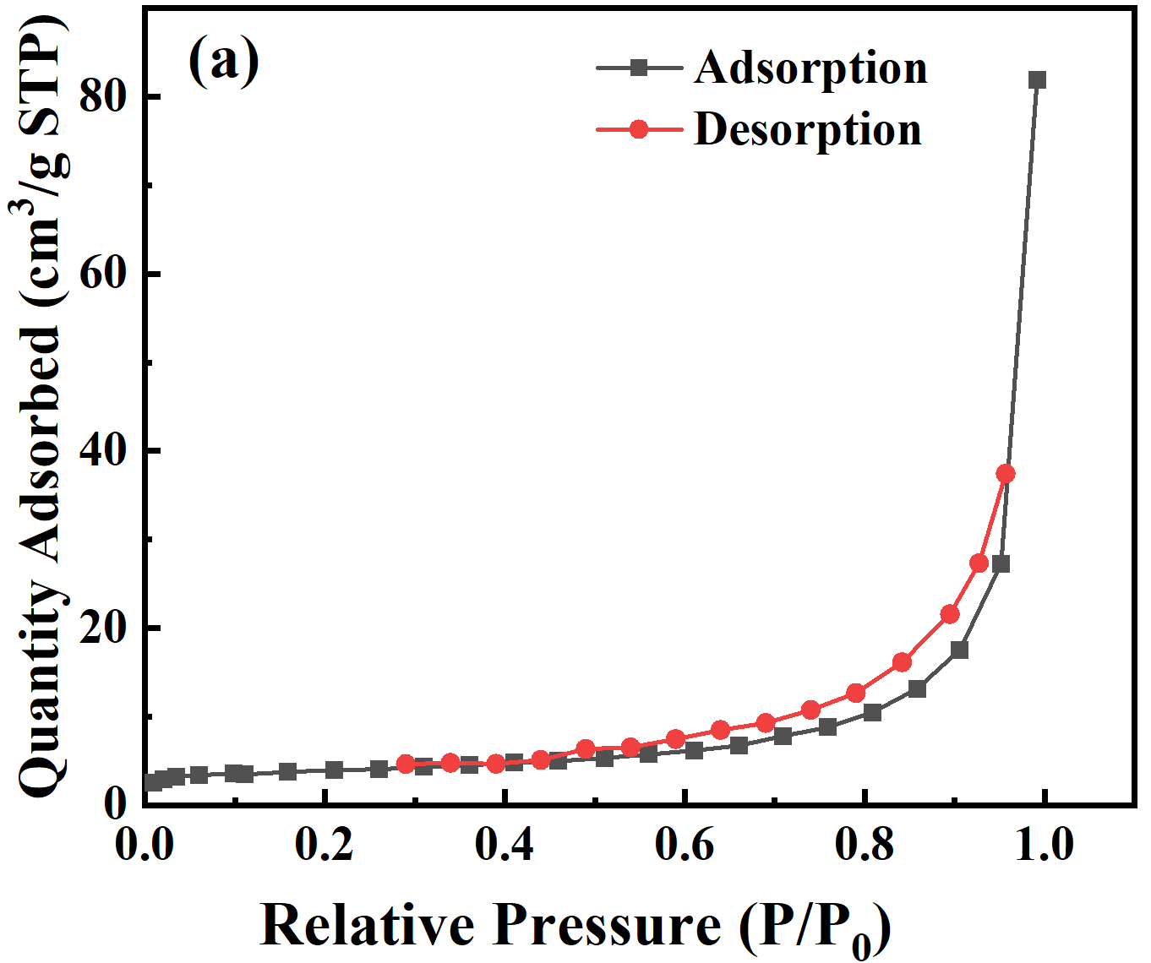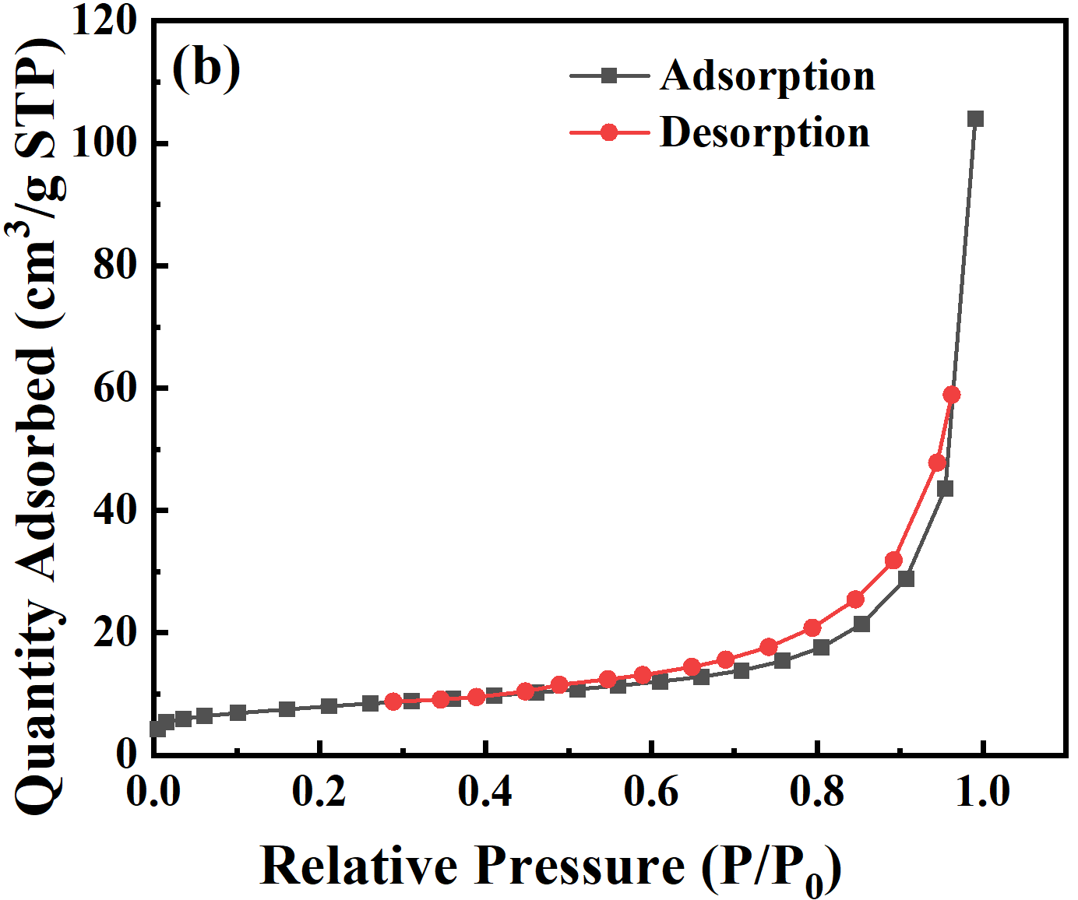
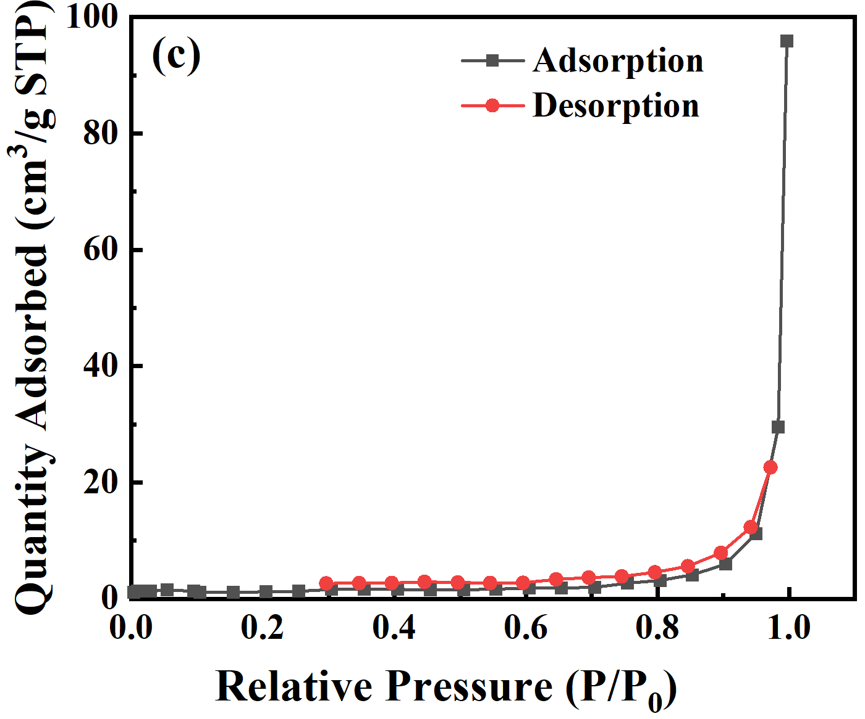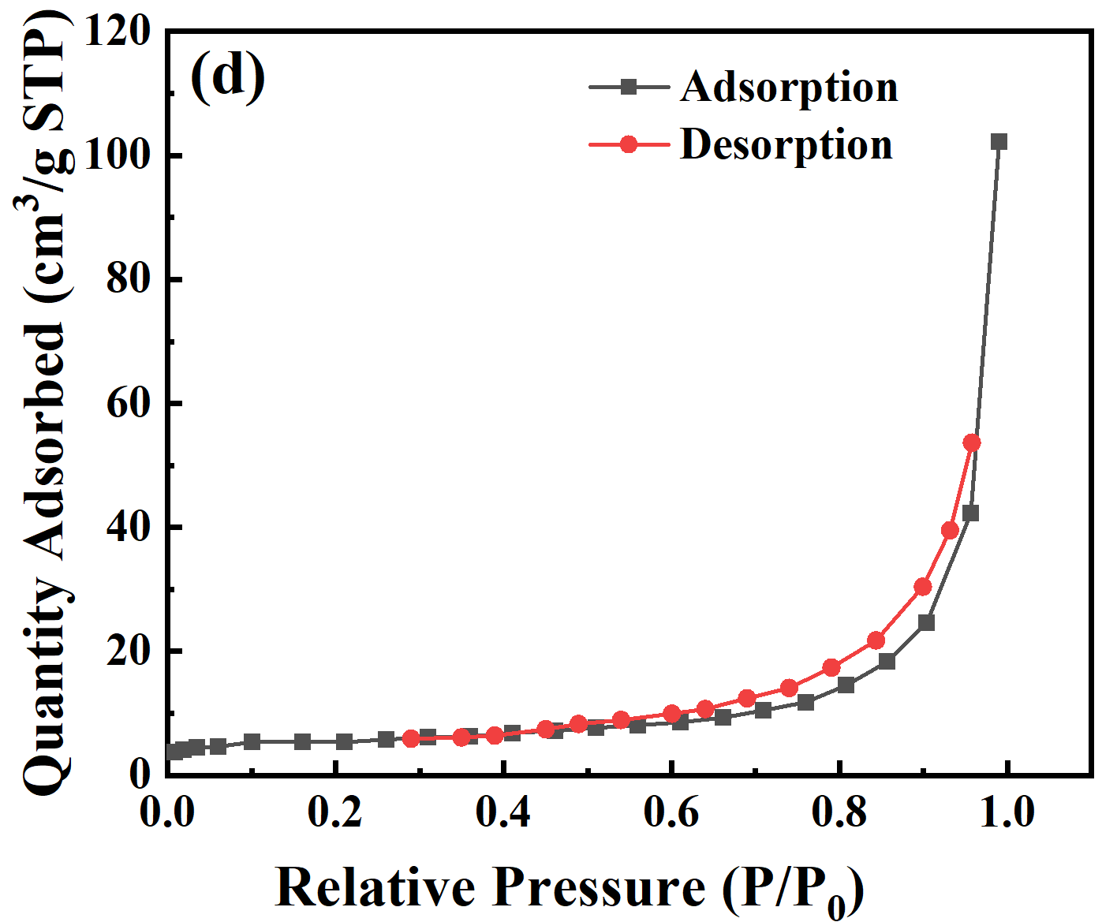
Fig. S1. N₂ adsorption/desorption isotherms of the DT_{R} (a), DT_{A} (b), DT_{A-Na} (c) and DTC_{A-Na} (d).

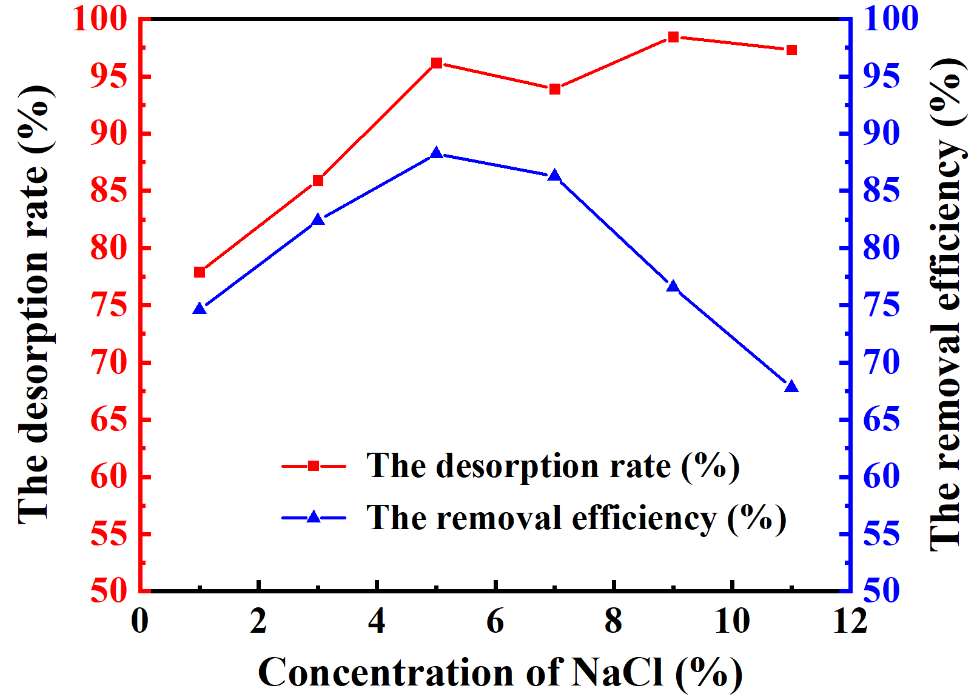
Fig. S2. Effect of concentration of the NaCl reagent on the desorption rate and removal efficiency.

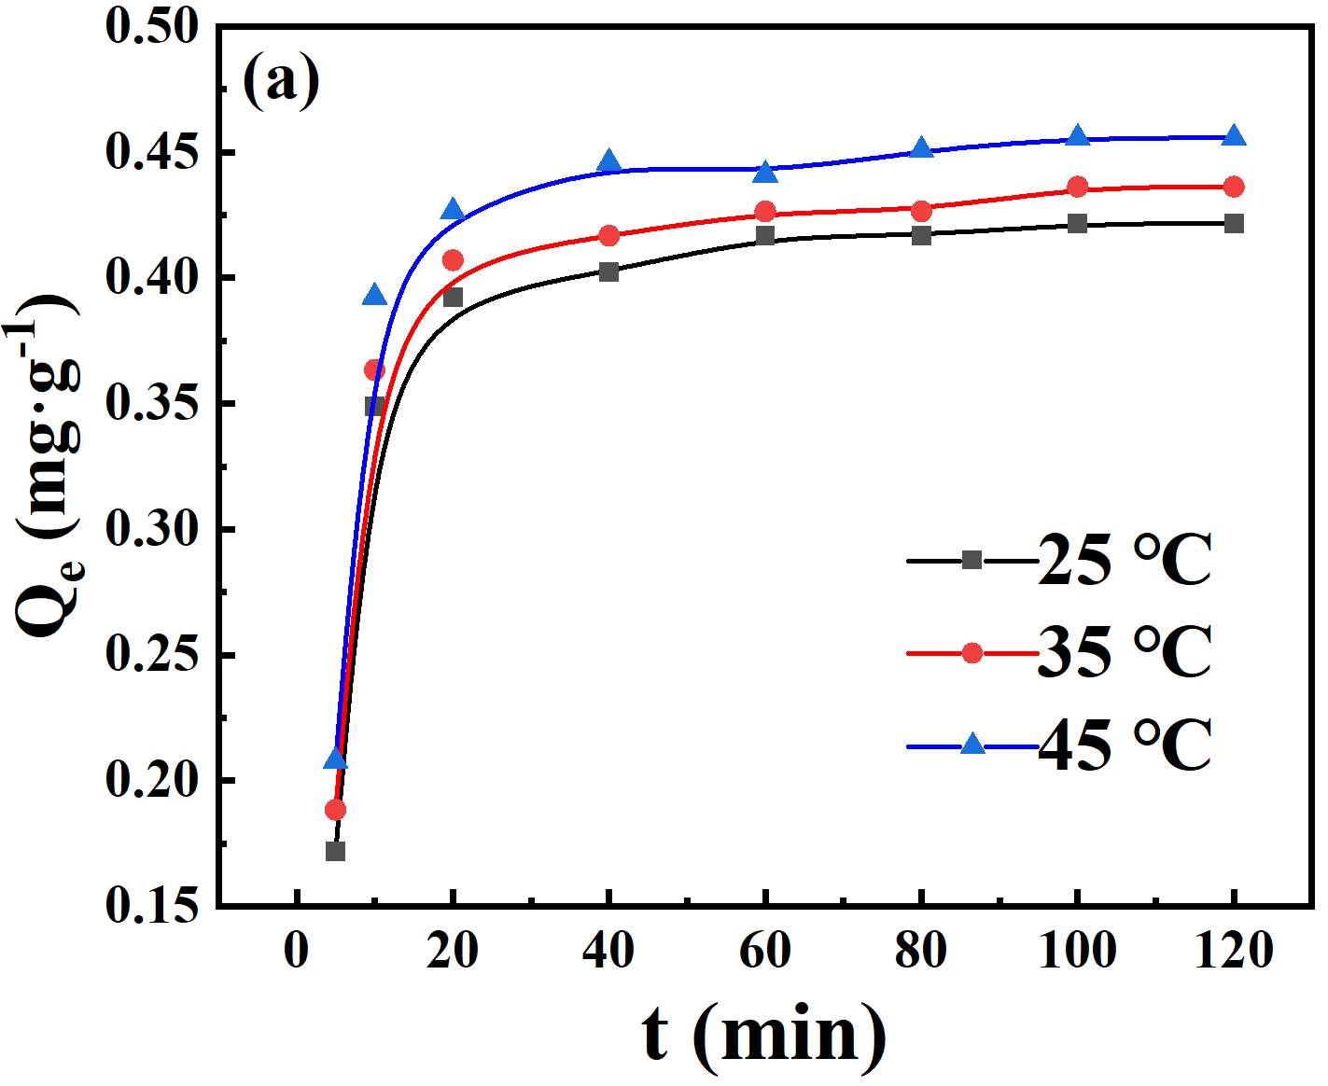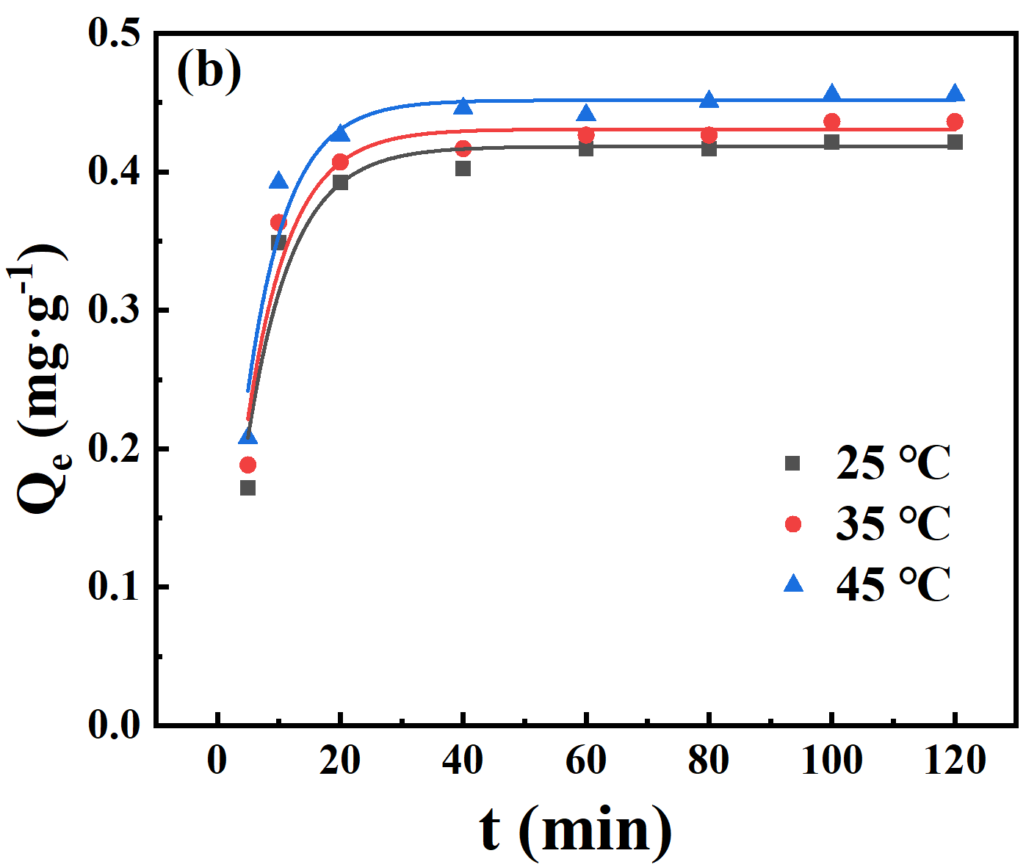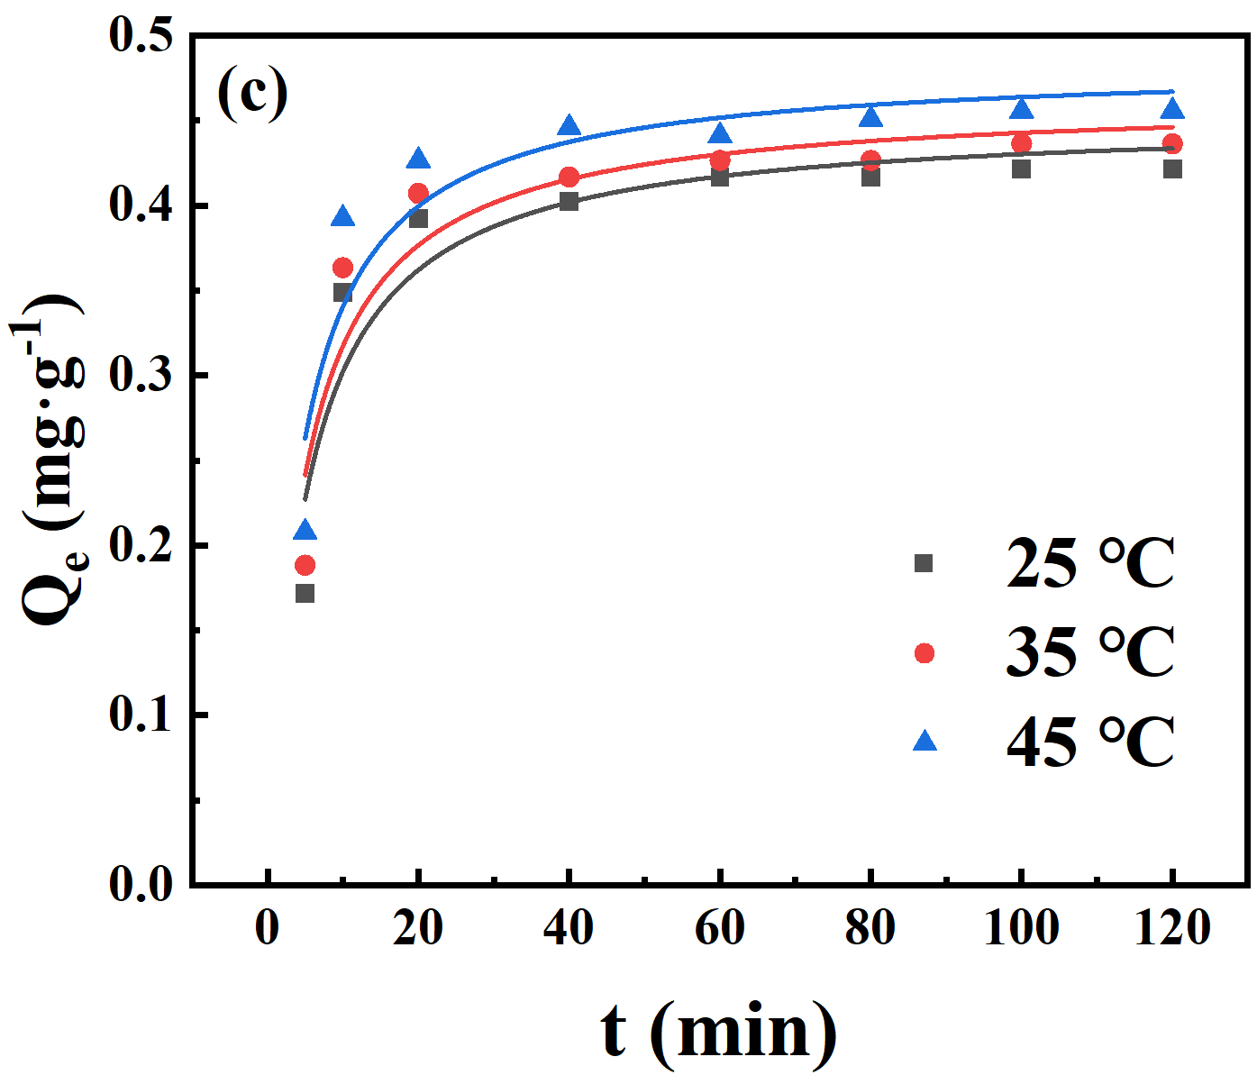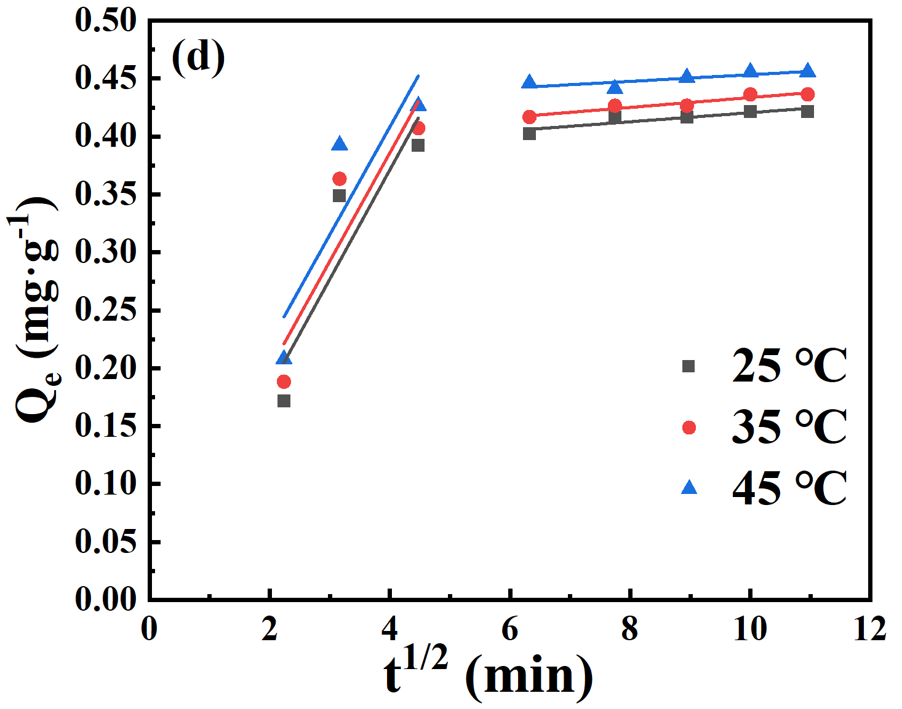
Fig. S3. (a) Effect of contact time at different temperatures on the adsorption capacity of the DTC_{A-Na}, (b) The pseudo-first-order kinetics model fitting, (c) The pseudo-second-order kinetics model fitting, (d)The intraparticle diffusion model fitting.

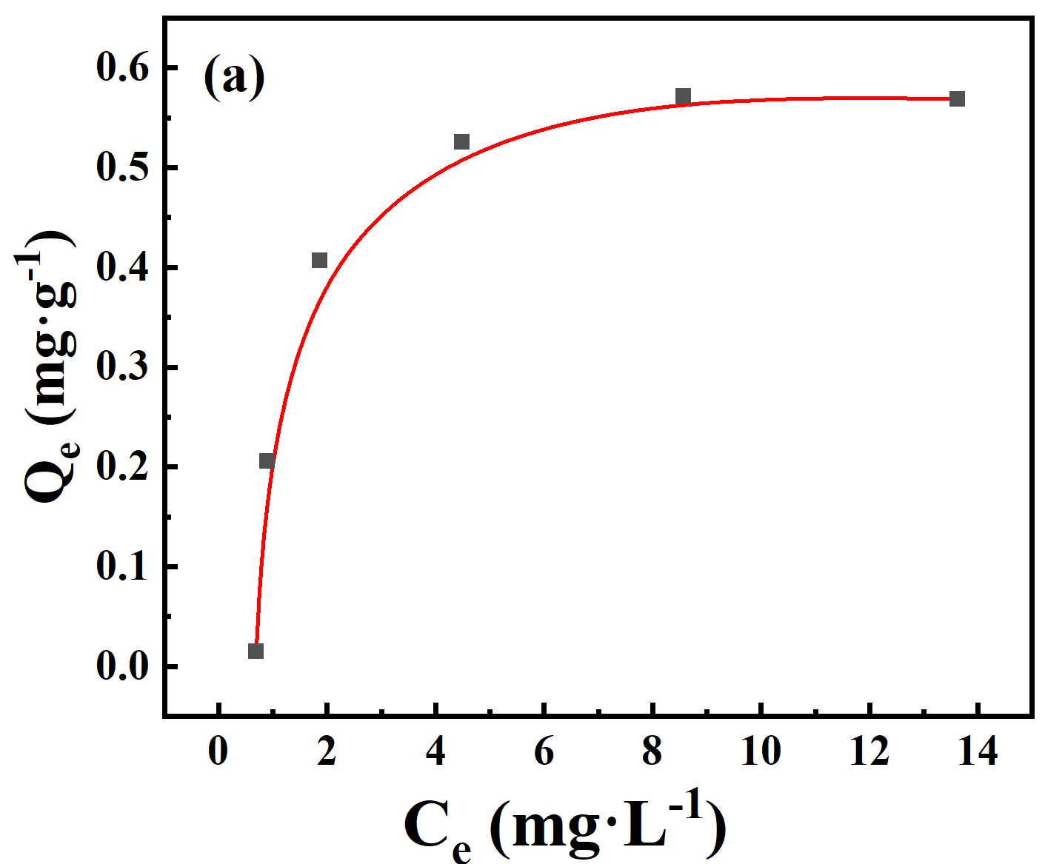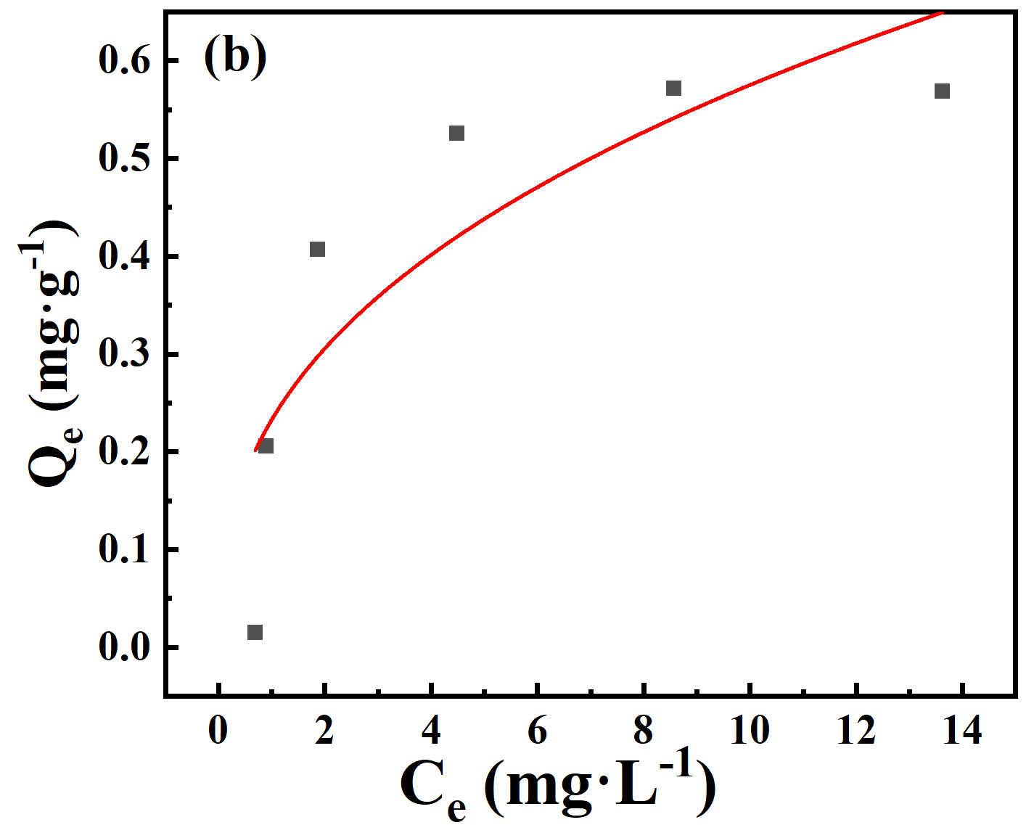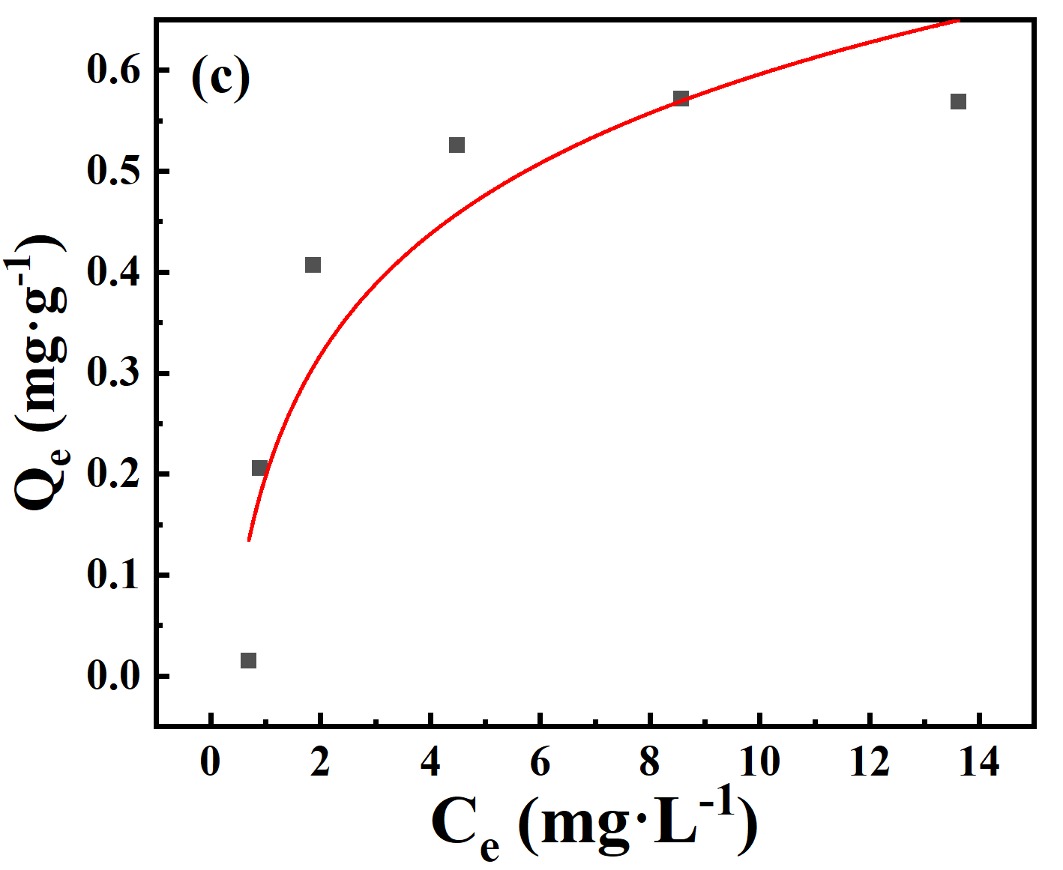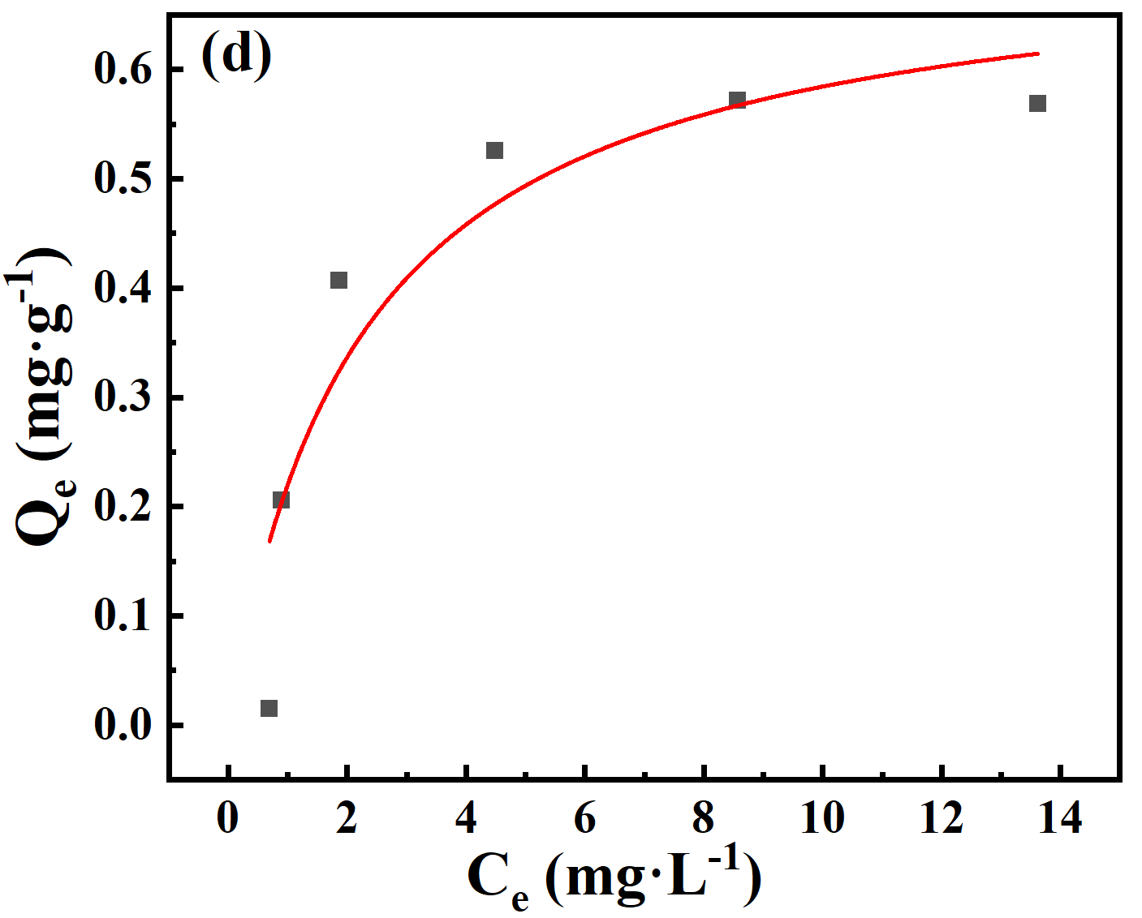
Fig. S4. (a) The adsorption isotherms of NH+ 4-N on the DTC_{A-Na} at 25 ℃, (b) Non-linear fitting curve of Freundlich model, (c) Non-linear fitting curve of Langmuir model, (d) Non-linear fitting curve of Temkin model.
Supporting Tables
Table S1
Removal efficiency of NH+ 4-N by different diatomite
Adsorbent | Dosage of adsorbent (g) | The removal efficiency (%)
DT_{R}  DT_{W}  DT_{A} | 0.80  0.80  0.80 | 0.74  1.72  43.51

Table S2
Effect of different modifiers on NH+ 4-N removal efficiency
Modifier | Dosage of adsorbent (g) | The mass fraction of the modifier (%) | The removal efficiency (%)
La₂O₃  NaCl  LaCl₃ | 0.80  0.80  0.80 | 5.00  5.00  5.00 | 69.76  73.64  2.69

Table S3
Effect of different desorption reagents on the desorption rate and removal efficiency
Regenerant | The desorption rate (%) | The removal efficiency (%)
NaCl | 96.19 | 81.42
Na₂CO₃ | 87.04 | 70.73
NaOH | 80.18 | 57.12
HCl | 77.89 | 27.96
Distilled water | 11.57 | 4.63
The mass fraction of all regenerants were 5.00%.

