Supplementary information

Figure S1
+C

+C

+C

+C

Figure S2

First Round

Second Round

Figure S3
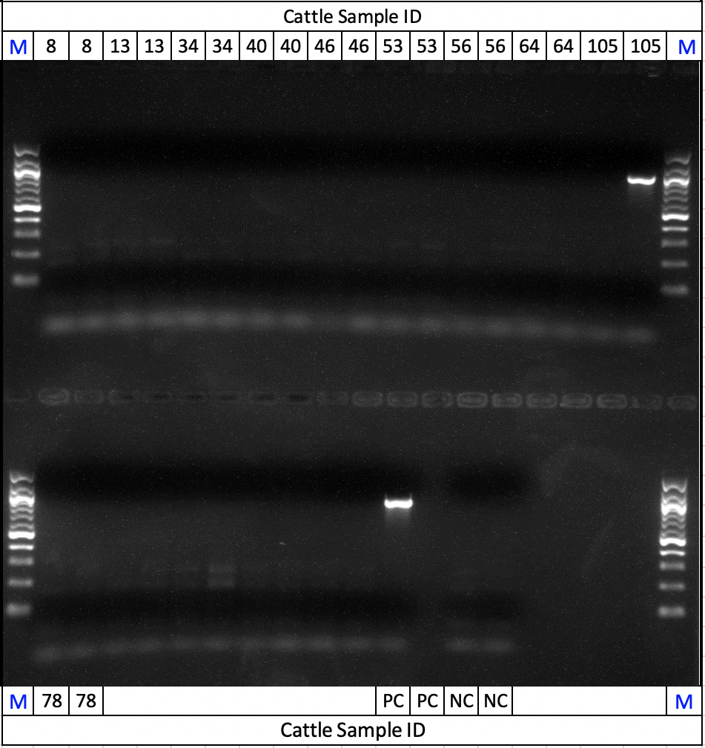

Figure S4

Cattle Sample: 8Be

Cattle Sample: 34Da

Cattle Sample: 53Da

Cattle Sample: 105Da

