Mega-analysis of brain structural covariance, genetics, and clinical phenotypes

Junhao Wen^{1*}, Ilya M. Nasrallah^{1,2}, Ahmed Abdulkadir¹, Theodore D. Satterthwaite^{1,3}, Guray Erus¹, Timothy Robert-Fitzgerald⁴, Ashish Singh¹, Aristeidis Sotiras⁵, Aleix Boquet-Pujadas⁶, Zhijian Yang¹, Elizabeth Mamourian¹, Jimit Doshi¹, Yuhan Cui¹, Dhivya Srinivasan¹, Mark Bergman¹, Jingxuan Bao⁷, Yogasudha Veturi⁸, Zhen Zhou¹, Shu Yang⁷, Paola Dazzan⁹, Rene S. Kahn¹⁰, Hugo G. Schnack¹¹, Marcus V. Zanetti¹², Eva Meisenzahl¹³, Geraldo F. Busatto¹², Benedicto Crespo-Facorro¹⁴, Christos Pantelis¹⁵, Stephen J. Wood¹⁶, Chuanjun Zhuo¹⁷, Russell T. Shinohara^{1,4}, Ruben C. Gur³, Raquel E. Gur³, Nikolaos Koutsouleris¹⁸, Daniel H. Wolf^{1,3}, Andrew J. Saykin¹⁹, Marylyn D. Ritchie⁸, Li Shen⁷,
Paul M. Thompson²⁰, Olivier Colliot²¹, Katharina Wittfeld²², Hans J. Grabe²², Duygu Tosun²³, Murat Bilgel²⁴, Yang An²⁴, Daniel S. Marcus²⁵, Pamela LaMontagne²⁵, Susan R. Heckbert²⁶, Thomas R. Austin²⁶, Lenore J. Launer²⁷, Mark Espeland²⁸, Colin L Masters²⁹, Paul Maruff²⁹, Jurgen Fripp³⁰, Sterling C. Johnson³¹, John C. Morris³², Marilyn S. Albert³³, R. Nick Bryan², Susan M. Resnick²⁴, Yong Fan¹, Mohamad Habes³⁴, David Wolk^{1, 35}, Haochang Shou^{1,4}, and Christos Davatzikos^{1*}, for the iSTAGING, the BLSA, the BIOCARD, the PHENOM, the ADNI studies, and the AI4AD consortium

¹Artificial Intelligence in Biomedical Imaging Laboratory (AIBIL), Center for Biomedical Image Computing and Analytics, Perelman School of Medicine, University of Pennsylvania, Philadelphia, USA.
²Department of Radiology, University of Pennsylvania, Philadelphia, USA.
³Department of Psychiatry, Perelman School of Medicine, University of Pennsylvania, Philadelphia, USA
⁴Penn Statistics in Imaging and Visualization Center, Department of Biostatistics, Epidemiology, and Informatics, Perelman School of Medicine, University of Pennsylvania, Philadelphia, USA
⁵Department of Radiology and Institute for Informatics, Washington University School of Medicine, St. Louis, USA
⁶Biomedical Imaging Group, EPFL, Lausanne, Switzerland
⁷Department of Biostatistics, Epidemiology and Informatics University of Pennsylvania Perelman School of Medicine, Philadelphia, USA
⁸Department of Genetics and Institute for Biomedical Informatics, Perelman School of Medicine, University of Pennsylvania, Philadelphia, PA, USA
⁹Department of Psychological Medicine, Institute of Psychiatry, Psychology and Neuroscience, King's College London, London, UK
¹⁰Department of Psychiatry, Icahn School of Medicine at Mount Sinai, New York, USA
¹¹Department of Psychiatry, University Medical Center Utrecht, Utrecht, Netherlands
¹²Institute of Psychiatry, Faculty of Medicine, University of São Paulo, São Paulo, Brazil
¹³ Department of Psychiatry and Psychtherapy, HHU Düsseldorf, Germany
¹⁴Hospital Universitario Virgen del Rocio, University of Sevilla-IBIS; IDIVAL-CIBERSAM, Sevilla, Spain
¹⁵Melbourne Neuropsychiatry Centre, Department of Psychiatry, University of Melbourne and Melbourne Health, Carlton South, Australia
¹⁶Orygen and the Centre for Youth Mental Health, University of Melbourne; and the Scool of Psychology, University of Birmingham UK
¹⁷key Laboratory of Real Tine Tracing of Brain Circuits in Psychiatry and Neurology(RTBCPN-Lab), Nankai University Affiliated Tianjin Fourth Center Hospital; Department of Psychiatry, Tianjin Medical University, Tianjin, China
¹⁸Department of Psychiatry and Psychotherapy, Ludwig-Maximilian University, Munich, Germany
¹⁹Radiology and Imaging Sciences, Center for Neuroimaging, Department of Radiology and Imaging Sciences, Indiana Alzheimer's Disease Research Center and the Melvin and Bren Simon Cancer Center, Indiana University School of Medicine, Indianapolis
²⁰Imaging Genetics Center, Mark and Mary Stevens Neuroimaging and Informatics Institute, Keck School of Medicine of USC, University of Southern California, Marina del Rey, California
²¹Sorbonne Université, Institut du Cerveau - Paris Brain Institute - ICM, CNRS, Inria, Inserm, AP-HP, Hôpital de la Pitié Salpêtrière, F-75013, Paris, France
²²Department of Psychiatry and Psychotherapy, University Medicine Greifswald, Germany
²³Department of Radiology and Biomedical Imaging, University of California, San Francisco, CA, USA
²⁴Laboratory of Behavioral Neuroscience, National Institute on Aging, NIH, USA
²⁵Department of Radiology, Washington University School of Medicine, St. Louis, Missouri, USA
²⁶Cardiovascular Health Research Unit, University of Washington, Seattle, WA, USA
²⁷Neuroepidemiology Section, Intramural Research Program, National Institute on Aging, Bethesda, Maryland, USA
²⁸Sticht Center for Healthy Aging and Alzheimer's Prevention, Wake Forest School of Medicine, Winston-Salem, North Carolina, USA
²⁹Florey Institute of Neuroscience and Mental Health, The University of Melbourne, Parkville, VIC, Australia
³⁰CSIRO Health and Biosecurity, Australian e-Health Research Centre CSIRO, Brisbane, Queensland, Australia
³¹Wisconsin Alzheimer's Institute, University of Wisconsin School of Medicine and Public Health, Madison, Wisconsin, USA
³²Knight Alzheimer Disease Research Center, Washington University in St. Louis, St. Louis, MO, USA
³³Department of Neurology, Johns Hopkins University School of Medicine, USA
³⁴Glenn Biggs Institute for Alzheimer's & Neurodegenerative Diseases, University of Texas Health Science Center at San Antonio, San Antonio, USA
³⁵Department of Neurology and Penn Memory Center, University of Pennsylvania, Philadelphia, USA

*Corresponding authors:
Junhao Wen, Ph.D. – junhao.wen89@gmail.com
Christos Davatzikos, Ph.D. – Christos.Davatzikos@pennmedicine.upenn.edu
3700 Hamilton Walk, 7th Floor, Philadelphia, PA 19104

eMethod 1: Empirical validation of sopNMF

eMethod 2: Reproducibility index

eMethod 3: Inter-site image harmonization

eMethod 4: Quality check of the image processing pipeline

eMethod 5 Definition of the index, candidate, independent significant, and SNP and genomic locus

eMethod 6 Cross-validation procedure for PAML

eFigure 1: Comparison between opNMF and sopNMF

eFigure 2: Reproducibility of the sopNMF brain parcellation

eFigure 3: PSC-WAS results for binary disease diagnoses

eFigure 4: PSC-WAS results for continuous cognitive measures

eFigure 5: Scatter plot for the h² estimates from the discovery and replication sets

eFigure 6: Machine learning performance for disease classification and age prediction

eFigure 7: Annotation of MUSE PSCs to MuSIC PSCs based on the overlap index

eFigure 8: Summary statistics of the multi-scale PSCs of MuSIC

eTable 1: Study cohort characteristics

eTable 2: Clinical phenotypes used in PSC-WAS in the current study

eTable 3: Comparison of variants identified via MuSIC with other studies

eTable 4: Selected studies for previously published GWAS summary statistics for six clinical traits

eTable 5: Classification balanced accuracy for disease classification and effect size of these imaging signatures

eTable 6: 119 MUSE gray matter regions of interest

eAlgorithm 1: Algorithm for sopNMF

eMethod 1: Empirical validation of sopNMF.
For the empirical validation of sopNMF, the comparison population (Method 1 in the main manuscript) was used so that the machine's memory could be sufficient to read the entire data for opNMF. For sopNMF, different choices of batch size (i.e., BS=32, 64, 128, and 256) were tested. We hypothesized that sopNMF could approximate the optima of opNMF during optimization, i.e., resulting in similar parts-based representation, training loss, and sparsity. TensorboardX was embedded into the sopNMF framework to monitor the training process dynamically. All experiments were performed on an Ubuntu machine with a maximum RAM of 32 GB and 8 CPUs. The predefined maximum number of epochs for all experiments is 50,000, and the tolerance of early stopping criteria is 100 epochs based on the training loss.
We qualitatively compared the extracted PSCs and quantitatively for the training loss, the sparsity of the component matrix W, and the memory consumption for C=20 (number of PSCs). The 20 PSCs were spatially consistent between opNMF and sopNMF, despite that some regions were decomposed into different PSCs (i.e., the white ellipse in eFig. 1A). For the training loss, opNMF obtained the lowest loss (1.103 x 10⁶), and the loss of sopNMF were 1.107 x10⁶, 1.108 x10⁶, 1.111 x10⁶ and 1.210 x10⁶ for BS =256, 128, 64, and 32, respectively (eFig. 1D). For the sparsity of the component matrix, all models obtained comparable results (sparsity $≈$ 0.83, eFig. 1E). The estimated memory consumptions during the training process were 28.65, 4.02, 3.81, 2.60, 1.47 GB for opNMF and sopNMF (BS =256, 128, 64, and 32), respectively
(Fig. e1F).

eMethod 2: Reproducibility index.
We proposed a reproducibility index (RI) to test the reproducibility of sopNMF for brain parcellation:
- We used the Hungarian match algorithm¹ to match the pairs of PSCs between two splits under the specific condition that maximizes the similarity (i.e., minimize the cost of worker/jobs in its original formulation).
- For each pair of PSCs, we calculated the inner product of the vectors ($R^{d}$), referred to as RI. This index takes values between [0, 1], with higher values indicating higher reproducibility.
- For each scale C, we presented the mean/standard deviation of the RIs for all PSCs.

eMethod 3: Inter-site image harmonization
We used an extensively validated statistical harmonization approach, i.e., ComBat-GAM,² to harmonize the extracted multi-scale PSCs. This method estimates the variability in volumetric measures due to differences in site/cohort-specific imaging protocols based on variances observed within and across control groups while preserving normal variances due to age, sex, and intracranial volume (ICV) differences. The model was initially trained on the discovery set and then applied to the replication set.

eMethod 4: Quality check of the image processing pipeline.
Raw T1-weighted MRIs were first quality checked (QC) for motion, image artifacts, or restricted field-of-view. Another QC was performed as follows: First, the images were examined by manually evaluating for pipeline failures (e.g., poor brain extraction, tissue segmentation, and registration errors). Furthermore, a second step automatically flagged images based on outlying values of quantified metrics (i.e., PSC values); those flagged images were re-evaluated.

eMethod 5: Definition of the index, candidate, independent significant, and lead SNP and genomic locus.
Index SNP
They are defined as SNPs with a p-value threshold ≤ 5e-8 (clump-p1) from GWAS summary statistics.
Independent significant SNP
They are defined as the index SNPs, which are independent of each other (not in linkage disequilibrium) with r2 ≤ 0.6 (clump-r2) within 250 kilobases (non-overlapping, clump-kb) away from each other.
lead SNP and genomic loci
They are defined as the independent significant SNPs, which are independent of each other with a more stringent r2 ≤ 0.1 (clump-r2) within 250 kilobases (non-overlapping, clump-kb) away from each other. Each of these clumps is defined as a genomic locus.
Candidate SNP
With each genomic locus, candidate SNPs are defined as the SNPs whose association p-values are smaller than 0.05 (clump-p2). The definitions followed instructions from FUMA³ and Plink⁴ software.

eMethod 6: Cross-validation procedure for PAML.
Nested cross-validation was adopted for all tasks following the good-practice guidelines proposed in our previous works^{5–7}. In particular, an outer loop was used to evaluate the task performance (250 repetitions of random hold-out splits with 80% of data for training). In contrast, an inner loop focused on tuning the hyperparameters (10-fold splits). We computed the balanced accuracy (BA) to evaluate the classification tasks. We calculated the effect size (Cohen's d) and p-value for each SPARE index to quantify its discriminative power.

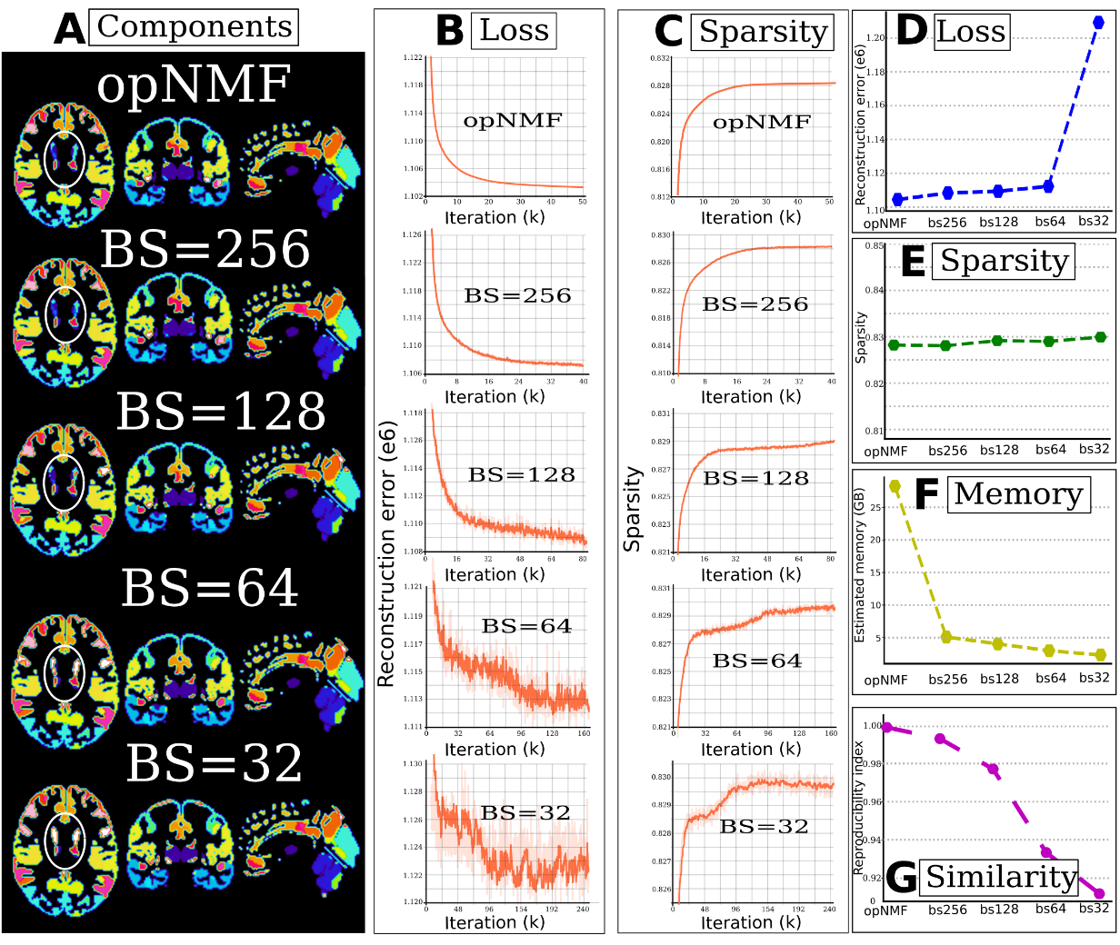

eFigure 1: Comparison between opNMF and sopNMF. (A) The extracted components are
shown in the original image space, with each PSC displayed in a distinct color.
The white ellipse indicates the region where the models diverge. Training loss (B, D) and sparsity (C, E) demonstrated similar patterns between models, except that batch size (BS) = 32 had a larger loss than the other models. Comparing the estimated memory consumption during training across models shows significant advantages for all sopNMF models compared to opNMF.

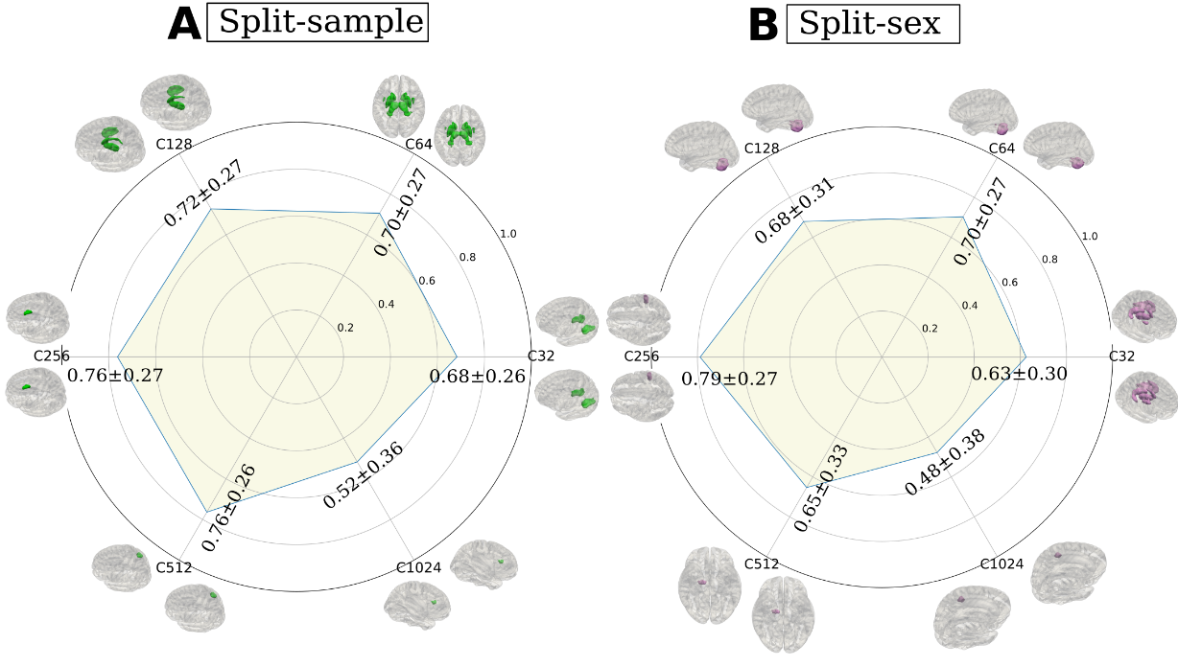

eFigure 2: Reproducibility of the sopNMF brain parcellation. In general, sopNMF demonstrated high reproducibility under various conditions. For each brain PSC, the reproducibility index (RI) was calculated (Supplementary eMethod 2). (A) Split-sample analyses, where the training population (N=4000) was randomly split into two halves while maintaining similar age, sex, and site distribution between groups. (B) Split-sex analyses, where the training population was divided into males and females. Colored PSCs on the brain template illustrates the same PSC independently derived from the two splits.

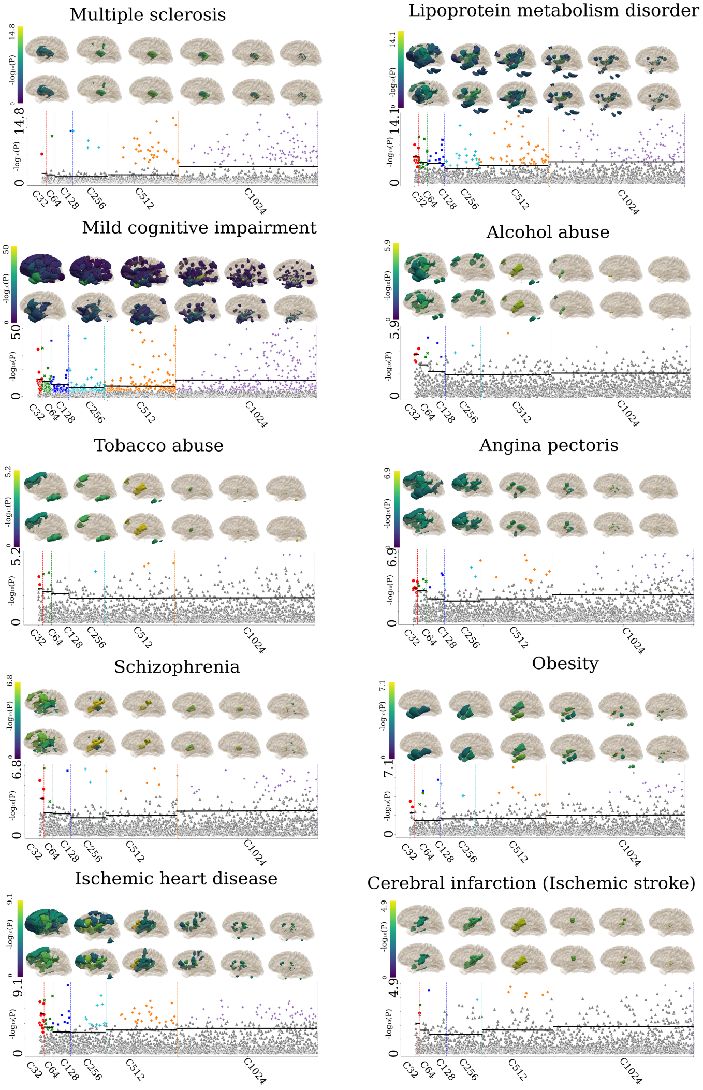

eFigure 3: PSC-WAS results for binary disease diagnoses. PSC-WAS was performed to associate each PSC to disease diagnosis (39 binary traits) using linear regressions. Here we present the diagnosis traits, except those shown in the main manuscript and those that did not show significant associations. PSCs surviving Bonferroni correction are denoted in color by scale (gray otherwise) in each Manhattan plot. Each PSC's statistic value, i.e., –log10[p-value], was projected into the 3D image space to show a brain statistic map for each scale (C). The first row shows all significant PSCs; the second row presents the top 10% of most significant PSCs (significant PSCs above the dashed horizontal lines in the Manhattan plot). The cerebellum is not included in the template brain, but cerebellar PSCs are displayed when significant.
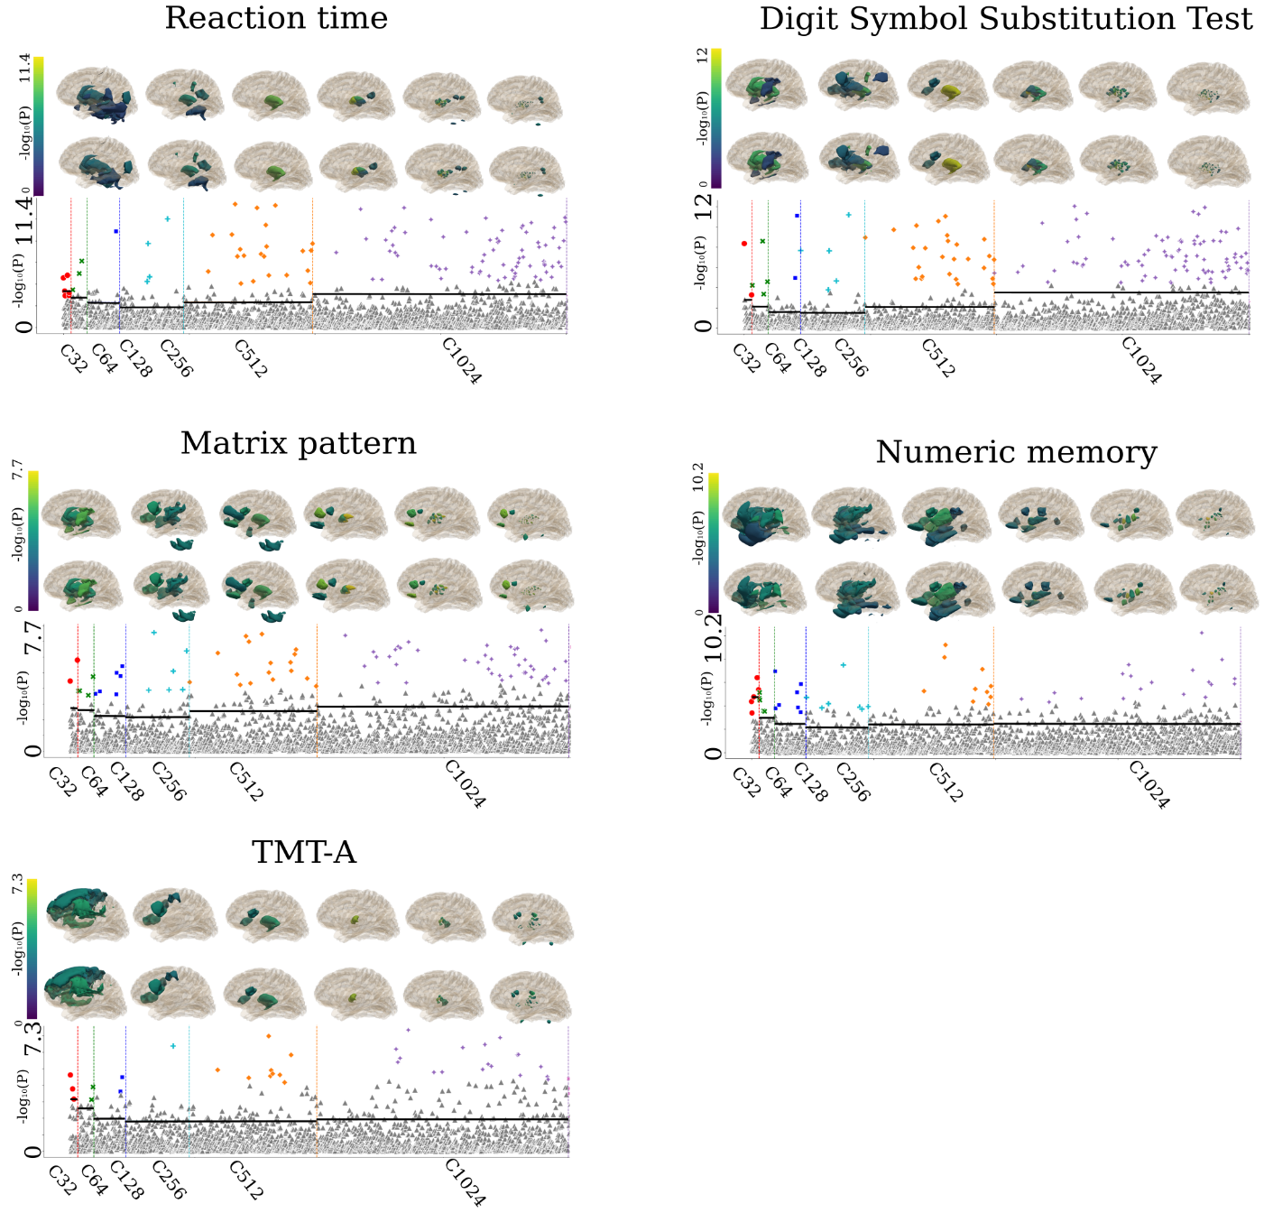

eFigure 4: PSC-WAS results for continuous cognitive measures. PSC-WAS was performed to associate each PSC to cognition (10 continuous traits) using multiple linear regressions. We present the cognitive traits, except those shown in the main manuscript and those that did not show significant associations. PSCs surviving Bonferroni correction are denoted in color by scale (gray otherwise) in each Manhattan plot. Each PSC's statistic value, i.e., –log10[p-value], was projected into the 3D image space to show a brain statistic map for each scale (C). The first row shows all significant PSCs; the second row presents the top 10% of most significant PSCs (significant PSCs above the dashed horizontal lines in the Manhattan plot). The cerebellum is not included in the template brain, but cerebellar PSCs are displayed when significant.

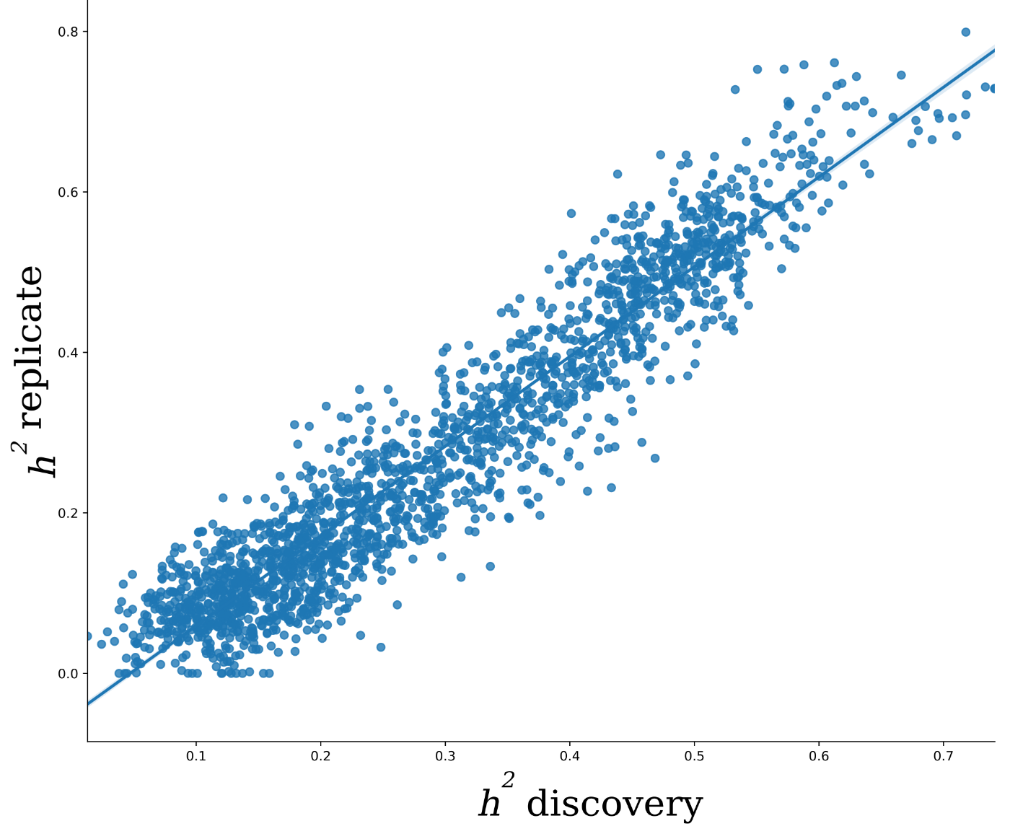

eFigure 5: Scatter plot for the h² estimates from the discovery and replication sets. The SNP-based heritability was estimated independently for the discovery set (N=18,052) and replication set (N=15,243). In particular, the two estimates were highly correlated (r = 0.94, p-value < 10⁻⁶), demonstrating a highly similar genetic architecture across different sets of UKBB data.

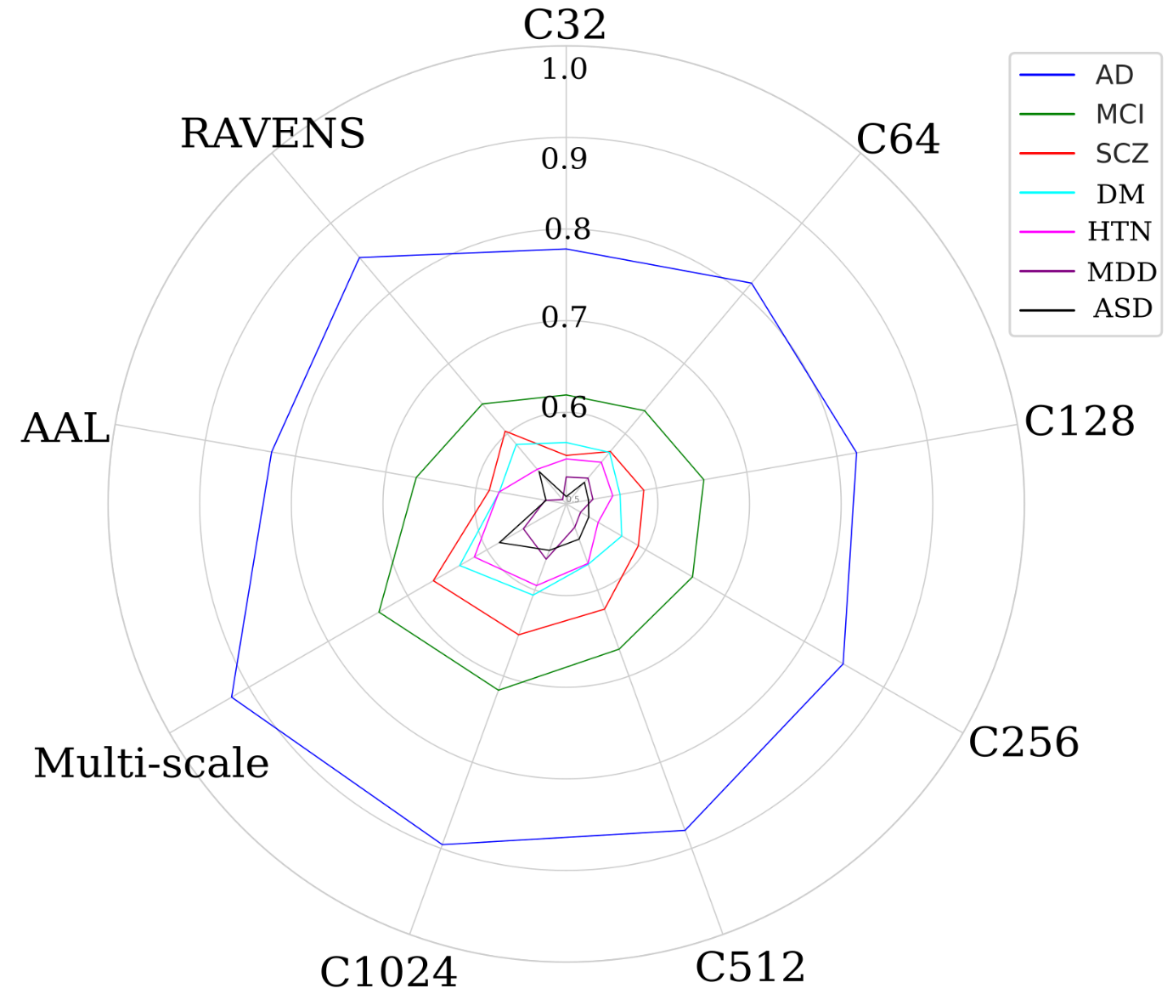

eFigure 6: Machine learning performance for disease classification. Balanced accuracy (BA) for each classification task using different features from multi-scale MuSIC, AAL, and RAVENS (higher score better). Details are presented in eTable 5.

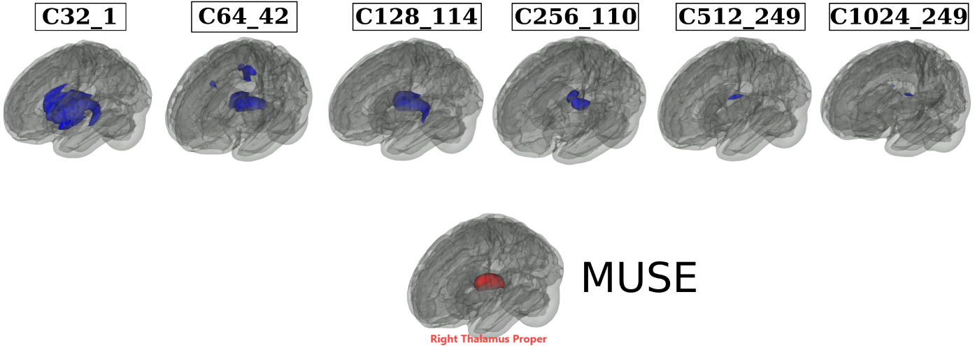

eFigure 7: Annotation of MUSE ROIs to MuSIC PSCs based on the overlap index. We automatically annotated the 119 MUSE GM PSCs to the MuSIC atlases at all six scales (C=32, 64, 128, 256, 512, and 1024). To this end, we calculated an overlap index (OI) to quantify the spatial overlaps between MUSE and MuSIC. For instance, for each MUSE PSC (eTable 6) vs. each of the 32 PSCs of MuSIC at C=32 scale, the OI equals the proportion of the number of overlap voxels and the total number of voxels in the MUSE PSC. Here we illustrate by mapping the right thalamus of MUSE to all 6 MuSIC atlases. The highest OIs are 0.82, 0.70, 0.86, 0.30, 0.09, 0.05 for C32_1, C64_42, C128_114, C256_110, C512_249 and C1024_249 PSCs. This functionality is available in BRIDGEPORT: https://www.cbica.upenn.edu/bridgeport/MUSE/Right%20Thalamus%20Proper

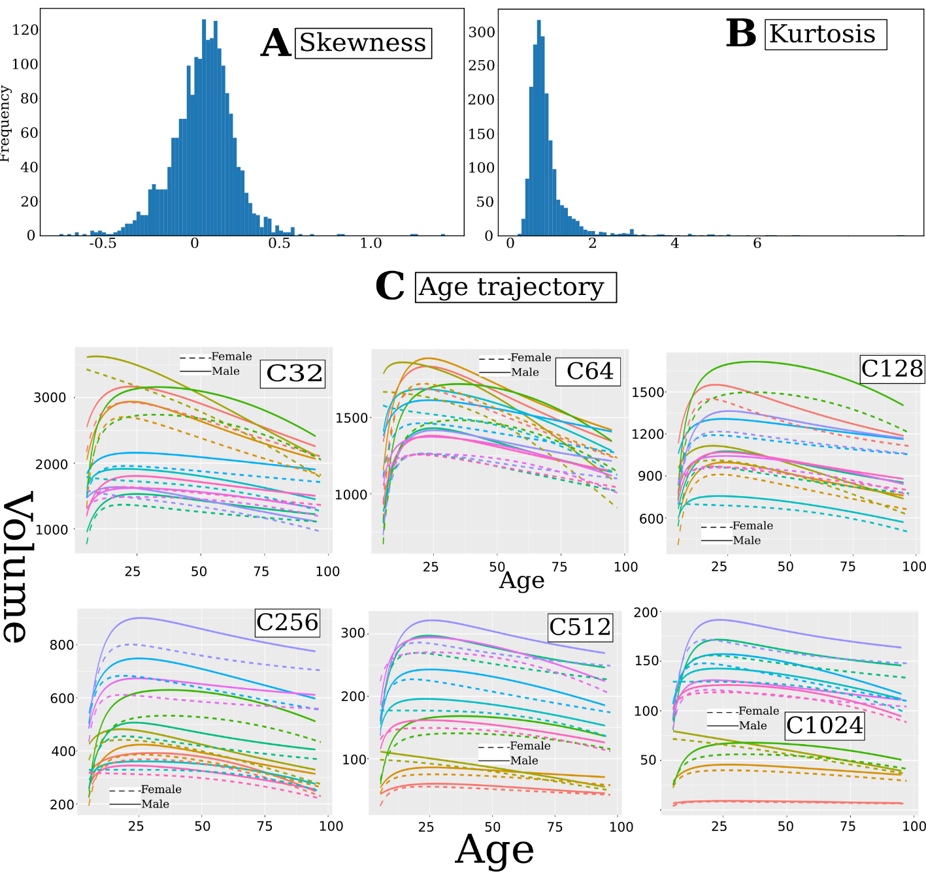

eFigure 8: Summary statistics of the multi-scale PSCs of MuSIC. Multi-scale PSCs show considerable normal distributions, i.e., symmetrical distribution (A) with a low kurtosis (B). Moreover, we fit the Generalized Additive Model for Location, Scale, and Shape (GAMLSS)⁸ model (fractional polynomials with 2 degrees) to each PSC to delineate the age trajectory over the lifespan in males (solid lines) and females (dotted lines), respectively (C). For visualization purposes, we selectively display the first 10 PSCs from each scale of the MuSIC atlases. In general, males have larger brain volumes than females.

eTable 1. Study cohort characteristics.
The current study consists of two main populations/sets: the discovery set (N=32,440, including participants from the first download of the UKBB data) and the replication set (N=18,259, the second download of the UKBB data). To train the sopNMF model for MuSIC, we selected 250 patients (PT) and 250 healthy controls (CN) for each decade of the discovery set, resulting in 4000 participants in total, referred to as the training population. Age ranges from 5 to 97 years and is shown with mean and standard deviation. Sex is displayed with the number and percentage of female participants. Data were collected from 12 studies, 130 sites, and 12 countries. The number of sites (country) per study is detailed as follows:
- ADNI: 63 sites (USA)
- UKBB: 5 sites (UK)
- AIBL: 2 sites (Australia)
- BIOCARD: 2 sites (USA)
- BLSA: 1 site (USA)
- CARDIA: 3 sites (USA)
- OASIS: 1 site (USA)
- PENN: 1 site (USA)
- WHIMS: 14 sites (USA)
- WRAP 1 site (USA)
- PHENOM: 12 sites (China, Brazil, Australia, Germany, Spain, USA, Netherlands)
- ABIDE: 25 sites (USA, Netherlands, Belgium, Germany, Ireland, Switzerland, France)
Abbreviations: CN: healthy control; AD: Alzheimer's disease; MCI: mild cognitive impairment; SCZ: schizophrenia; ASD: autism spectrum disorder; MDD: major depressive disorder; DM: diabetes; HTN: hypertension.
ªUKBB data were separately downloaded two times: the first was the N=21,305 in the discovery set, and the second was the replication set.
^{b}We define CN (healthy controls) as participants that do not have any of the diseases listed here. In reality, these CN participants might have diagnoses of other illnesses or comorbidities (e.g., participants from UKBB have a wide range of pathology based on ICD-10).

Study | N  (50,699) | Age  (5-97 year) | Sex (female/%) | CN^{b} | AD | MCI | SCZ | ASD | MDD | DM | HTN
Discovery  set | 32,440 | 60.04$±$  14.87 | 16,868/52 | 24,980 | 954 | 1288 | 1094 | 597 | 1476 | 1093 | 958
ADNI | 1765 | 73.66$±$  7.19 | 798/45 | 297 | 343 | 875 | NA | NA | NA | NA | 250
UKBBª | 21,305 | 62.58$±$  7.48 | 10,101/53 | 18,735 | 1 | NA | NA | NA | 1476 | 1093 | NA
AIBL | 830 | 71.36$±$  6.78 | 471/57 | 625 | 86 | 115 | NA | NA | NA | NA | 4
BIOCARD | 288 | 58.15$±$  10.54 | 115/60 | 283 | 1 | 4 | NA | NA | NA | NA | NA
BLSA | 1114 | 65.44$±$  14.11 | 589/53 | 729 | 9 | 11 | NA | NA | NA | NA | 365
CARDIA | 892 | 51.21$±$  3.98 | 471/53 | 620 | NA | NA | NA | NA | NA | NA | 272
OASIS | 983 | 69.92$±$  9.75 | 557/57 | 759 | 220 | NA | NA | NA | NA | NA | 4
PENN | 807 | 72.63$±$  10.65 | 333/59 | 173 | 294 | 283 | NA | NA | NA | NA | 57
WHIMS | 995 | 69.61$±$  3.64 | 995/100 | 986 | NA | NA | NA | NA | NA | NA | 6
WRAP | 116 | 63.36$±$  6.06 | 79/68 | 116 | NA | NA | NA | NA | NA | NA | NA
PHENOM | 2125 | 30.21$±$  10.60 | 854/40 | 1031 | NA | NA | 1094 | NA | NA | NA | NA
ABIDE | 1220 | 17.92$±$  9.01 | 203/17 | 623 | NA | NA | NA | 597 | NA | NA | NA
Replication  setª | 18,259 | 54.70$±$  7.43 | 9742/53 | NA | NA | NA | NA | NA | NA | NA | NA

We present the age distribution of the discovery population for all 12 studies.

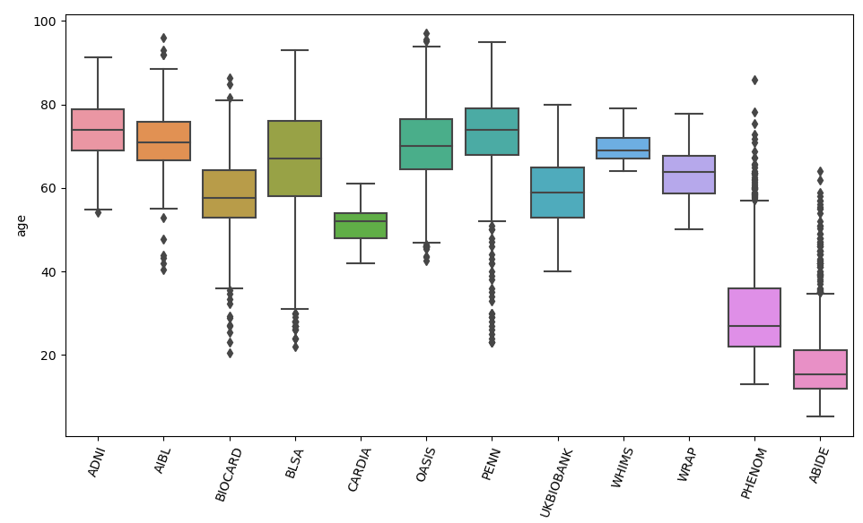

eTable 2: Clinical phenotypes used in PSC-WAS in the current study.
We harmonized the population of the phenotypes of interest per study definitions:
- we combined AD and MCI patients from ADNI, PENN, and AIBL but excluded OASIS subjects because of the different diagnostic criteria of an AD patient in OASIS.
- For several binary disease phenotypes, we used the ICD-10 diagnosis (https://biobank.ndph.ox.ac.uk/ukb/field.cgi?id=41270). Note that ICD-10 diagnoses are generally collected from the participants' medical inpatient records. We first included diseases from the following categories:
  - Diseases of the blood and blood-forming organs and certain disorders involving the immune mechanism (D-XXX, XXX represents the ID of a specific disease);
  - Endocrine, nutritional and metabolic diseases (E-XXX);
  - Mental and behavioral disorders (F-XXX);
  - Diseases of the nervous system (G-XXX);
  - Diseases of the circulatory system (I-XXX).
We then set a threshold of 75 patients for any ICD-10 diagnosis. We finally randomly selected age and sex-matched healthy controls (excluding all patients in all diagnoses). ª: For major depressive disorder, we used the inclusion criteria from our previous work.⁹
- For cognitive scores, we included:
  - Tower rearranging (https://biobank.ndph.ox.ac.uk/showcase/field.cgi?id=21004)
  - Matrix pattern (https://biobank.ndph.ox.ac.uk/showcase/field.cgi?id=6373)
  - TMT-A (https://biobank.ndph.ox.ac.uk/showcase/field.cgi?id=6348)
  - TMT-B (https://biobank.ndph.ox.ac.uk/showcase/field.cgi?id=6350)
  - DSST (https://biobank.ndph.ox.ac.uk/showcase/field.cgi?id=23324)
  - Pairs matching (https://biobank.ndph.ox.ac.uk/showcase/field.cgi?id=399)
  - Numerical memory (https://biobank.ndph.ox.ac.uk/showcase/field.cgi?id=4282)
  - Prospective memory (https://biobank.ndph.ox.ac.uk/showcase/field.cgi?id=4288)
  - Reaction time (https://biobank.ndph.ox.ac.uk/showcase/field.cgi?id=20023)
  - Fluid intelligence (https://biobank.ndph.ox.ac.uk/showcase/field.cgi?id=20016)
AD: Alzheimer's disease; MCI: mild cognitive impairment; SCZ: schizophrenia; DM: diabetes mellitus; MDD: major depressive disorder; HTN: hypertension; ASD: autism spectrum disorder; CN: healthy control; PT: patient; N: number of participants. We decided not to harmonize cognitive scores from different studies.

Trait (ICD-10 code or ID) | Sample size (CN/PT or N) | Site | Trait (ICD-10 code or ID) | Sample size (CN/PT or N) | Site
AD | 1095/723 | ADNI, PENN, & AIBL | Carpal tunnel syndrome (G560) | 901/901 | UKBB
MCI | 1273/1095 | ADNI, PENN, & AIBL | Lesion of ulnar nerve (G562) | 104/104 | UKBB
SCZ | 1031/1094 | PHENOM | Lesion of plantar nerve (G576) | 163/163 | UKBB
DM | 1093/1093 | UKBB | Angina pectoris (I20) | 1535/1535 | UKBB
MDDª | 1476/1476 | UKBB | Acute myocardial infarction (I21) | 769/769 | UKBB
HTN | 934/887 | ADNI, BLSA & CARDIA | Chronic ischaemic heart disease (I25) | 2217/2217 | UKBB
ASD | 623/597 | ABIDE | Pulmonary embolism (I20) | 351/351 | UKBB
Iron deficiency anemia (D50) | 1012/1012 | UKBB | Cardiomyopathy (I42) | 116/116 | UKBB
Vitamin B12 deficiency anemia (D50) | 78/78 | UKBB | Paroxysmal tachycardia (I47) | 320/320 | UKBB
Agranulocytosis (D70) | 245/245 | UKBB | Heart failure (I50) | 436/436 | UKBB
Thyrotoxicosis (E05) | 205/205 | UKBB | Cerebral infarction (I63) | 291/291 | UKBB
Vitamin D deficiency (E55) | 180/180 | UKBB | Vitamin B deficiency (E53) | 130/130 | UKBB
Obesity (E66) | 1481/1481 | UKBB | Hemiplegia (G81) | 111/111 | UKBB
Lipoprotein metabolism disorder (E78) | 3880/3880 | UKBB | Facial nerve disorders (G51) | 95/95 | UKBB
Mineral metabolism disorder (E83) | 291/291 | UKBB | Tower rearranging (21004) | 8412 | UKBB
Volume depletion | 240/240 | UKBB | Matrix pattern (6373) | 8501 | UKBB
Delirium | 92/92 | UKBB | TMT-A (6348) | 8599 | UKBB
Alcohol abuse | 341/341 | UKBB | TMT-B (6350) | 8599 | UKBB
Tobacco abuse | 863/863 | UKBB | DSST (23324) | 8523 | UKBB
Bipolar affective disorder | 77/77 | UKBB | Pairs matching (399) | 20945 | UKBB
Phobic anxiety disorder | 84/84 | UKBB | Numerical memory (4282) | 9323 | UKBB
Multiple sclerosis | 109/109 | UKBB | Prospective memory (4288) | 19681 | UKBB
Epilepsy | 250/250 | UKBB | Reaction time (20023) | 21258 | UKBB
Migraine | 508/508 | UKBB | Fluid intelligence (20016) | 19184 | UKBB
Sleep disorders | 590/590 | UKBB

eTable 3: Comparison of variants identified via MuSIC with other studies. Using the AAL atlas, we found (using the same data in the current study) that 269 independent significant SNPs had 356 pairwise associations with 54 AAL brain regions. 230 out of the 269 SNPs matched with the SNPs in MuSIC. Among the 39 unmatched SNPs, 15 SNPs were in linkage disequilibrium (LD, r² > 0.6) with MuSIC SNPs (Supplementary eFile 6). As a second example, Zhao et al.¹⁰ reported that 251 independent significant SNPs had 346 pairwise associations with 43 GM regions using the Mindboggle atlas on the UKBB (N=19,629).¹¹ 129 of the 251 SNPs matched with SNPs identified by MuSIC. Among those non-coinciding (127), 31 SNPs were in LD with MuSIC SNPs (Supplementary eFile 7). Similarly, Elliot et al.¹² (N=8428) discovered that 20 independent significant SNPs had 58 pairwise associations with 52 GM regions from atlases in Freesurfer and FSL software. Out of the 20 SNPs, 16 coincided with MuSIC SNPs. Among the four unmatched SNPs, 1 SNP was in LD with MuSIC SNPs (Supplementary eFile 8). Note that the definition of independent significant SNPs or genomic loci might slightly differ between studies.
Study/Atlas | Identified variants/loci | Matched variants | Variants in LD | Unique for MuSIC | Database | Sample size | Ancestry
AAL | 269 | 230 | 15 | 1365 | UKBB | 18,052 | European
Zhao et al.¹⁰ | 251 | 129 | 31 | 1450 | UKBB | 19,629 | European
Elliot et al.¹² | 20 | 16 | 1 | 1593 | UKBB | 8428 | European

eTable 4: Selected studies for previously published GWAS summary statistics for six clinical traits. We selected the candidate studies from the GWAS Catalog for specific traits, including neurodegenerative diseases, psychiatric disorders, etc. The inclusion criteria are i) GWAS summary statistics are publicly available; ii) the study population is European ancestry in the majority; iii) the heritability estimates (h²) via LDSC are not spuriously low (h²>0.05). This resulted in six clinical traits. We present the clinical trait, the dataset used, the URL link, the Pubmed ID, and the sample size.
Abbreviations: PGC: Psychiatric genomics consortium; ADHD: attention deficit hyperactivity disorder; ASD: autism spectrum disorder; MDD: major depressive disorder; OCD: obsessive-compulsive disorder; SCZ: schizophrenia; BPD: bipolar disorder.
Trait | Dataset | URL | PubMed ID | Sample size
ADHD | PGC | https://figshare.com/articles/dataset/adhd2019/14671965 | - 30478444 | 53,293 European
ASD | PGC | https://figshare.com/articles/dataset/asd2019/14671989 | - 30804558 | 46,350 European
BPD | PGC | https://figshare.com/articles/dataset/bip2019/14671998 | - 31043756 | 51,710 European
MDD | Meta analysis | https://figshare.com/articles/dataset/mdd2013/14672082 | - 22472876 | 18,759 European
SCZ | PGC | https://figshare.com/articles/dataset/scz2013sweden/14672154 | - 23974872 | 11,244 European
OCD | Meta analysis | https://figshare.com/articles/dataset/ocd2018/14672103 | - 28761083 | 9,725 European

eTable 5: Classification balanced accuracy for disease classification and effect size of these imaging signatures.
Disease classification performance is presented using balanced accuracy. The mean and standard deviation are presented. Cohen's d was computed to compare the SPARE scores between groups.
Multi-scale classificationª: All 2003 PSCs from multiple scales were fit into the classifier.
Multi-scale classification^{b}: PSCs from all scales were fit into the classifier with a nested feature selection procedure (SVM-REF). The motivation is that PSCs from different scales are hierarchical and correlated. The nested feature selection can select the features most relevant to the specific task. We avoided any statistical comparison of the performance of machine learning models because available statistical tests are liberal and often lead to false-positive conclusions due to the complexity of the cross-validation procedure.¹³
PSC | AD | d | MCI | d | SCZ | d | DM | d | HTN | d | MDD | d | ASD | d
C32 | 0.78$±$0.02 | 1.52 | 0.62$±$0.02 | 0.59 | 0.55$±$0.02 | 0.30 | 0.56$±$0.02 | 0.35 | 0.55$±$0.02 | 0.28 | 0.52$±$0.02 | 0.16 | 0.50$±$0.02 | 0.07
C64 | 0.81$±$0.02 | 1.73 | 0.63$±$0.02 | 0.66 | 0.57$±$0.02 | 0.41 | 0.57$±$0.02 | 0.40 | 0.56$±$0.02 | 0.31 | 0.53$±$0.02 | 0.17 | 0.53$±$0.02 | 0.19
C128 | 0.82$±$0.02 | 1.82 | 0.65$±$0.02 | 0.76 | 0.59$±$0.02 | 0.47 | 0.56$±$0.02 | 0.33 | 0.55$±$0.02 | 0.30 | 0.52$±$0.02 | 0.15 | 0.52$±$0.02 | 0.15
C256 | 0.85$±$0.02 | 2.08 | 0.66$±$0.02 | 0.91 | 0.59$±$0.02 | 0.50 | 0.56$±$0.02 | 0.47 | 0.54$±$0.02 | 0.31 | 0.51$±$0.02 | 0.13 | 0.52$±$0.02 | 0.16
C512 | 0.88$±$0.02 | 2.34 | 0.67$±$0.02 | 1.06 | 0.62$±$0.02 | 0.62 | 0.57$±$0.02 | 0.54 | 0.56$±$0.02 | 0.42 | 0.52$±$0.02 | 0.05 | 0.54$±$0.02 | 0.24
C1024 | 0.90$±$0.02 | 2.50 | 0.72$±$0.02 | 1.12 | 0.65$±$0.02 | 0.75 | 0.60$±$0.02 | 0.59 | 0.59$±$0.02 | 0.46 | 0.56$±$0.02 | 0.13 | 0.55$±$0.02 | 0.29
Multi-scaleª | 0.91$±$0.02 | 2.54 | 0.72$±$0.02 | 1.12 | 0.66$±$0.02 | 0.77 | 0.61$±$0.02 | 0.64 | 0.59$±$0.02 | 0.47 | 0.55$±$0.02 | 0.23 | 0.56$±$0.02 | 0.30
Multi-scale^{b} | 0.92$±$0.02 | 2.61 | 0.73$±$0.02 | 1.13 | 0.67$±$0.02 | 0.78 | 0.64$±$0.02 | 0.67 | 0.61$±$0.02 | 0.49 | 0.55$±$0.02 | 0.26 | 0.58$±$0.02 | 0.32
AAL | 0.82$±$0.02 | 1.81 | 0.66$±0.02$ | 0.75 | 0.59$±$0.02 | 0.46 | 0.57$±$0.02 | 0.32 | 0.57$±$0.02 | 0.35 | 0.52$±$0.02 | 0.08 | 0.52$±$0.02 | 0.14
RAVENS | 0.85$±$0.02 | 2.04 | 0.64$±0.02$ | 0.74 | 0.60$±$0.02 | 0.45 | 0.58$±$0.02 | 0.33 | 0.55$±$0.02 | 0.34 | 0.50$±$0.02 | 0.05 | 0.54$±$0.02 | 0.15

eTable 6: 119 MUSE gray matter regions of interest.
L: Left hemisphere; R: Right hemisphere; ROI: region of interest.
MUSE ROI | MUSE ROI | MUSE ROI
Precentral gyrus (R) | Occipital fusiform gyrus (R) | Anterior insula (L)
Precentral gyrus (L) | Planum temporale (R) | Anterior orbital gyrus (R)
Accumbens area (R) | Cerebellar vermal lobules I-V | Anterior orbital gyrus (L)
Accumbens area (L) | Cerebellar vermal lobules VI-VII | Angular gyrus (R)
Amygdala (R) | Cerebellar vermal lobules VIII-X | Angular gyrus (L)
Amygdala (L) | Basal forebrain (R) | Calcarine cortex (R)
Occipital pole (L) | Basal forebrain (L) | Calcarine cortex (L)
Caudate (R) | Middle temporal gyrus (L) | Central operculum (R)
Caudate (L) | Occipital pole (R) | Central operculum (L)
Cerebellum exterior (R) | Planum temporale (L) | Cuneus (R)
Cerebellum exterior (L) | Parietal operculum (L) | Cuneus (L)
Planum polare (L) | Postcentral gyrus (R) | Entorhinal area (R)
Middle temporal gyrus (R) | Postcentral gyrus (L) | Entorhinal area (L)
Hippocampus (R) | Posterior orbital gyrus (R) | Frontal operculum (R)
Hippocampus (L) | Temporal pole (R) | Frontal operculum (L)
Precentral gyrus medial segment (R) | Temporal pole (L) | Frontal pole (R)
Precentral gyrus medial segment (L) | Triangular part of the inferior frontal gyrus (R) | Frontal pole (L)
Superior frontal gyrus medial segment (R) | Triangular part of the inferior frontal gyrus (L) | Fusiform gyrus (R)
Superior frontal gyrus medial segment (L) | Transverse temporal gyrus (R) | Fusiform gyrus (L)
Pallidum (R) | Superior frontal gyrus medial segment (L) | Gyrus rectus (R)
Pallidum (L) | Planum polare (R) | Gyrus rectus (L)
Putamen (R) | Transverse temporal gyrus (L) | Inferior occipital gyrus (R)
Putamen (L) | Anterior cingulate gyrus (R) | Inferior occipital gyrus (L)
Thalamus proper (R) | Anterior cingulate gyrus (L) | Inferior temporal gyrus (R)
Thalamus proper (L) | Anterior insula (R) | Inferior temporal gyrus (L)
Lingual gyrus (R) | Occipital fusiform gyrus (L) | Subcallosal area (R)
Lingual gyrus (L) | Opercular part of inferior frontal gyrus (R) | Subcallosal area (L)
Lateral orbital gyrus (R) | Opercular part of inferior frontal gyrus (L) | Superior frontal gyrus (R)
Lateral orbital gyrus (L) | Orbital part of inferior frontal gyrus (R) | Superior frontal gyrus (L)
Middle cingulate gyrus (R) | Orbital part of inferior frontal gyrus (L) | Supplementary motor cortex (R)
Middle cingulate gyrus (L) | Posterior cingulate gyrus (R) | Supplementary motor cortex (L)
Medial frontal cortex (R) | Posterior cingulate gyrus (L) | Supramarginal gyrus (R)
Medial frontal cortex (L) | Precuneus (R) | Supramarginal gyrus (L)
Middle frontal gyrus (R) | Precuneus (L) | Superior occipital gyrus (R)
Middle frontal gyrus (L) | Parahippocampal gyrus (R) | Superior occipital gyrus (L)
Middle occipital gyrus (R) | Parahippocampal gyrus (L) | Superior parietal lobule (R)
Middle occipital gyrus (L) | Posterior insula (R) | Superior parietal lobule (L)
Medial orbital gyrus (R) | Posterior insula (L) | Superior temporal gyrus (R)
Medial orbital gyrus (L) | Parietal operculum (R) | Superior temporal gyrus (L)
Superior frontal gyrus medial segment (R) | Posterior orbital gyrus (L)

eAlgorithm 1: Algorithm for sopNMF.
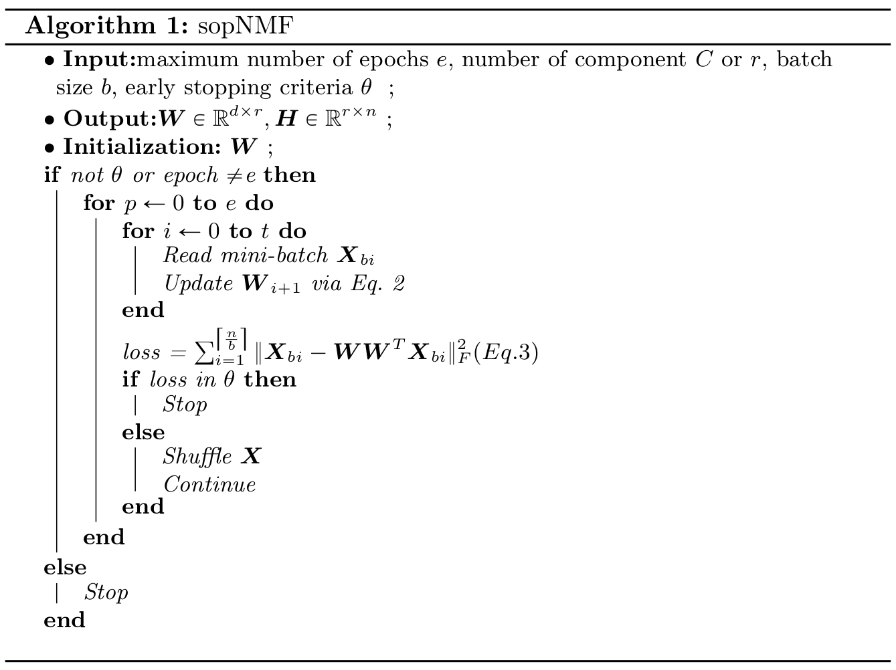

References
1. Kuhn, H. W. The Hungarian method for the assignment problem. Naval Research Logistics Quarterly 2, 83–97 (1955).
2. Pomponio, R. et al. Harmonization of large MRI datasets for the analysis of brain imaging patterns throughout the lifespan. Neuroimage 208, 116450 (2020).
3. Watanabe, K., Taskesen, E., van Bochoven, A. & Posthuma, D. Functional mapping and annotation of genetic associations with FUMA. Nat Commun 8, 1826 (2017).
4. Purcell, S. et al. PLINK: A Tool Set for Whole-Genome Association and Population-Based Linkage Analyses. Am J Hum Genet 81, 559–575 (2007).
5. Samper-González, J. et al. Reproducible evaluation of classification methods in Alzheimer’s disease: Framework and application to MRI and PET data. NeuroImage 183, 504–521 (2018).
6. Wen, J. et al. Convolutional neural networks for classification of Alzheimer’s disease: Overview and reproducible evaluation. Medical Image Analysis 63, 101694 (2020).
7. Wen, J. et al. Reproducible Evaluation of Diffusion MRI Features for Automatic Classification of Patients with Alzheimer’s Disease. Neuroinformatics 19, 57–78 (2021).
8. Stasinopoulos, D. M. & Rigby, R. A. Generalized Additive Models for Location Scale and Shape (GAMLSS) in R. Journal of Statistical Software 23, 1–46 (2008).
9. Wen, J. et al. Characterizing Heterogeneity in Neuroimaging, Cognition, Clinical Symptoms, and Genetics Among Patients With Late-Life Depression. JAMA Psychiatry (2022) doi:10.1001/jamapsychiatry.2022.0020.
10. Zhao, B. et al. Genome-wide association analysis of 19,629 individuals identifies variants influencing regional brain volumes and refines their genetic co-architecture with cognitive and mental health traits. Nat Genet 51, 1637–1644 (2019).
11. Klein, A. & Tourville, J. 101 Labeled Brain Images and a Consistent Human Cortical Labeling Protocol. Frontiers in Neuroscience 6, 171 (2012).
12. Elliott, L. T. et al. Genome-wide association studies of brain imaging phenotypes in UK Biobank. Nature 562, 210–216 (2018).
13. Nadeau, C. & Bengio, Y. Inference for the Generalization Error. in Advances in Neural Information Processing Systems 12 (eds. Solla, S. A., Leen, T. K. & Müller, K.) 307–313 (MIT Press, 2000).

