Online supplementary document

in
6D dynamic tractography visualizes the effective connectivity supporting specific linguistic stages in the developing brain

Masaki Sonoda; Brian H. Silverstein; Jeong-won Jeong; Ayaka Sugiura; Yasuo Nakai;
Takumi Mitsuhashi; Robert Rothermel; Aimee F. Luat; Sandeep Sood; Eishi Asano.

Contents:
Tables S1-S15.
Figures S1-S2.
Videos S1-S2 Legend.

 |  |  |  | 95% CI
Variables | Estimate | SE | t | LL | UL
Intercept | 22.024 | 12.179 | 1.808 | -1.850 | 45.897
Interaction of HGA in PC1s* | 91.412 | 6.610 | 13.830 | 78.455 | 104.368
Euclidean distance | -0.694 | 0.040 | -17.430 | -0.772 | -0.616
Age | 1.177 | 0.587 | 2.006 | 0.027 | 2.327
Sampled hemisphere, Left | 4.507 | 3.537 | 1.274 | -2.427 | 11.441
Number of AEDs | -7.025 | 3.087 | -2.276 | -13.075 | -0.974
Median of response time | 3.384 | 4.739 | 0.714 | -5.906 | 12.673
Seizure onset zone
Frontal | -6.130 | 5.973 | -1.026 | -17.840 | 5.580
Temporal | -6.416 | 5.243 | -1.224 | -16.695 | 3.862
Parietal/Occipital | -4.680 | 4.394 | -1.065 | -13.293 | 3.933
MRI-visible cortical lesion | 4.582 | 4.213 | 1.087 | -3.678 | 12.841

Table S1 Mixed model-based prediction of the strength of direct effective connectivity from the temporal lobe sites supporting the PC1 linguistic stage.
The early CCSR amplitude was treated as the dependent variable to be predicted by the mixed model. The fixed-effect predictors included (*) the interaction of naming-related high-gamma activity (HGA) at temporal and extratemporal lobe sites involved in the PC1 linguistic stage (computed as a multiplication of magnitudes of PC1s at temporal and extratemporal lobe sites). For example, a connectivity pair bridging temporal and extratemporal lobe sites, if each showed a +1.0 (+100%) at temporal and +1.0 (+100%) at extratemporal lobe site increase in PC1, was associated with an increased early CCSR amplitude by 91.4%. Significant predictors (p < 0.05, FDR-corrected) are denoted in bold typeface. The degrees of freedom (DF) = 7087. SE = Standard error. AEDs = Antiepileptic drugs. CI = Confidence interval. LL = Lower limit. PC = Principal component. UL = Upper limit.
 |  |  |  | 95% CI
Variables | Estimate | SE | t | LL | UL
Intercept | 15.869 | 12.270 | 1.293 | -8.183 | 39.922
Interaction of HGA in PC2s* | 23.839 | 9.801 | 2.432 | 4.627 | 43.050
Euclidean distance | -0.516 | 0.031 | -16.651 | -0.577 | -0.455
Age | 0.835 | 0.590 | 1.415 | -0.321 | 1.991
Sampled hemisphere, Left | 4.679 | 3.579 | 1.307 | -2.336 | 11.695
Number of AEDs | -7.173 | 3.097 | -2.316 | -13.244 | -1.101
Median of response time | 6.040 | 4.733 | 1.276 | -3.237 | 15.317
Seizure onset zone
Frontal | -6.120 | 6.074 | -1.008 | -18.026 | 5.786
Temporal | -5.682 | 5.373 | -1.058 | -16.213 | 4.850
Parietal/Occipital | -2.684 | 4.586 | -0.585 | -11.673 | 6.305
MRI-visible cortical lesion | 3.033 | 4.268 | 0.711 | -5.333 | 11.399
Table S2 Mixed model-based prediction of the strength of direct effective connectivity from the temporal lobe sites supporting the PC2 linguistic stage.
The early CCSR amplitude was treated as the dependent variable to be predicted by the mixed model. The fixed-effect predictors included (*) the interaction of naming-related high-gamma activity (HGA) at temporal and extratemporal lobe sites involved in the PC2 linguistic stage (computed as a multiplication of magnitudes of PC2s at temporal and extratemporal lobe sites). Significant predictors (p < 0.05, FDR-corrected) are denoted in bold typeface. The degrees of freedom (DF) = 11275. SE = Standard error. AEDs = Antiepileptic drugs. CI = Confidence interval. LL = Lower limit. PC = Principal component. UL = Upper limit.

 |  |  |  | 95% CI
Variables | Estimate | SE | t | LL | UL
Intercept | 11.035 | 5.395 | 2.045 | 0.459 | 21.612
Interaction of HGA in PC3s* | 106.060 | 20.006 | 5.301 | 66.843 | 145.277
Euclidean distance | -0.491 | 0.039 | -12.527 | -0.568 | -0.414
Age | 1.212 | 0.248 | 4.886 | 0.725 | 1.698
Sampled hemisphere, Left | 2.205 | 1.900 | 1.161 | -1.519 | 5.929
Number of AEDs | -7.485 | 1.441 | -5.195 | -10.310 | -4.661
Median of response time | 2.467 | 1.809 | 1.364 | -1.079 | 6.012
Seizure onset zone
Frontal | -3.634 | 2.254 | -1.612 | -8.053 | 0.785
Temporal | -1.664 | 2.009 | -0.828 | -5.603 | 2.275
Parietal/Occipital | 2.059 | 1.828 | 1.127 | -1.523 | 5.642
MRI-visible cortical lesion | 5.544 | 1.626 | 3.410 | 2.357 | 8.732
Table S3 Mixed model-based prediction of the strength of direct effective connectivity from the temporal lobe sites supporting the PC3 linguistic stage.
The early CCSR amplitude was treated as the dependent variable to be predicted by the mixed model. The fixed-effect predictors included (*) the interaction of naming-related high-gamma activity (HGA) at temporal and extratemporal lobe sites involved in the PC3 linguistic stage (computed as a multiplication of magnitudes of PC3s at temporal and extratemporal lobe sites). Significant predictors (p < 0.05, FDR-corrected) are denoted in bold typeface. The degrees of freedom (DF) = 7697. SE = Standard error. AEDs = Antiepileptic drugs. CI = Confidence interval. LL = Lower limit. PC = Principal component. UL = Upper limit.

 |  |  |  | 95% CI
Variables | Estimate | SE | t | LL | UL
Intercept | 31.031 | 36.320 | 0.854 | -40.175 | 102.236
Interaction of HGA in PC1s* | 155.585 | 24.361 | 6.387 | 107.825 | 203.345
Euclidean distance | -1.548 | 0.125 | -12.348 | -1.794 | -1.303
Age | 5.945 | 1.882 | 3.158 | 2.255 | 9.635
Sampled hemisphere, Left | -13.205 | 13.530 | -0.976 | -39.731 | 13.322
Number of AEDs | -10.054 | 10.111 | -0.994 | -29.877 | 9.770
Median of response time | 7.068 | 13.796 | 0.512 | -19.978 | 34.115
Seizure onset zone
Frontal | -5.122 | 18.754 | -0.273 | -41.890 | 31.645
Temporal | 19.896 | 16.605 | 1.198 | -12.658 | 52.449
Parietal/Occipital | -9.029 | 14.254 | -0.633 | -36.974 | 18.917
MRI-visible cortical lesion | 8.234 | 12.598 | 0.654 | -16.464 | 32.933
Table S4 Mixed model-based prediction of the strength of direct effective connectivity from the extratemporal lobe sites supporting the PC1 linguistic stage.
The early CCSR amplitude was treated as the dependent variable to be predicted by the mixed model. The fixed-effect predictors included (*) the interaction of naming-related high-gamma activity (HGA) at temporal and extratemporal lobe sites involved in the PC1 linguistic stage (computed as a multiplication of magnitudes of PC1s at temporal and extratemporal lobe sites). Significant predictors (p < 0.05, FDR-corrected) are denoted in bold typeface. The degrees of freedom (DF) = 4448. SE = Standard error. AEDs = Antiepileptic drugs. CI = Confidence interval. LL = Lower limit. PC = Principal component. UL = Upper limit.

 |  |  |  | 95% CI
Variables | Estimate | SE | t | LL | UL
Intercept | 34.138 | 17.814 | 1.916 | -0.789 | 69.066
Interaction of HGA in PC2s* | 97.462 | 40.956 | 2.380 | 17.161 | 177.763
Euclidean distance | -0.504 | 0.122 | -4.144 | -0.743 | -0.266
Age | 3.280 | 0.956 | 3.432 | 1.406 | 5.155
Sampled hemisphere, Left | -3.389 | 6.669 | -0.508 | -16.465 | 9.687
Number of AEDs | -2.170 | 4.772 | -0.455 | -11.526 | 7.185
Median of response time | -6.917 | 6.334 | -1.092 | -19.335 | 5.502
Seizure onset zone
Frontal | 0.154 | 8.087 | 0.019 | -15.703 | 16.010
Temporal | 5.290 | 6.988 | 0.757 | -8.410 | 18.991
Parietal/Occipital | -16.903 | 6.066 | -2.786 | -28.797 | -5.009
MRI-visible cortical lesion | -3.179 | 6.549 | -0.485 | -16.018 | 9.661
Table S5 Mixed model-based prediction of the strength of direct effective connectivity from the extratemporal lobe sites supporting the PC2 linguistic stage.
The early CCSR amplitude was treated as the dependent variable to be predicted by the mixed model. The fixed-effect predictors included (*) the interaction of naming-related high-gamma activity (HGA) at temporal and extratemporal lobe sites involved in the PC2 linguistic stage (computed as a multiplication of magnitudes of PC2s at temporal and extratemporal lobe sites). Significant predictors (p < 0.05, FDR-corrected) are denoted in bold typeface. The degrees of freedom (DF) = 3447. SE = Standard error. AEDs = Antiepileptic drugs. CI = Confidence interval. LL = Lower limit. PC = Principal component. UL = Upper limit.

 |  |  |  | 95% CI
Variables | Estimate | SE | t | LL | UL
Intercept | 17.316 | 36.502 | 0.474 | -54.242 | 88.874
Interaction of HGA in PC3s* | 254.331 | 68.287 | 3.724 | 120.462 | 388.199
Euclidean distance | -1.299 | 0.111 | -11.716 | -1.517 | -1.082
Age | 5.473 | 1.850 | 2.958 | 1.846 | 9.101
Sampled hemisphere, Left | -22.234 | 13.638 | -1.630 | -48.969 | 4.502
Number of AEDs | -11.243 | 9.849 | -1.142 | -30.550 | 8.065
Median of response time | 5.098 | 14.447 | 0.353 | -23.224 | 33.420
Seizure onset zone
Frontal | -0.802 | 18.264 | -0.044 | -36.606 | 35.002
Temporal | 30.042 | 16.575 | 1.812 | -2.451 | 62.534
Parietal/Occipital | 0.004 | 13.851 | 0.000 | -27.150 | 27.157
MRI-visible cortical lesion | 16.536 | 12.936 | 1.278 | -8.824 | 41.895
Table S6 Mixed model-based prediction of the strength of direct effective connectivity from the extratemporal lobe sites supporting the PC3 linguistic stage.
The early CCSR amplitude was treated as the dependent variable to be predicted by the mixed model. The fixed-effect predictors included (*) the interaction of naming-related high-gamma activity at temporal and extratemporal lobe sites involved in the PC3 linguistic stage (computed as a multiplication of magnitudes of PC3s at temporal and extratemporal lobe sites). Significant predictors (p < 0.05, FDR-corrected) are denoted in bold typeface. The degrees of freedom (DF) = 5628. SE = Standard error. AEDs = Antiepileptic drugs. CI = Confidence interval. LL = Lower limit. PC = Principal component. UL = Upper limit.

 |  |  |  | 95% CI
Variables | Estimate | SE | t | LL | UL
Intercept | 36.812 | 8.276 | 4.448 | 20.589 | 53.036
Interaction of HGA in PC3s** | 106.060 | 20.006 | 5.301 | 66.843 | 145.277
Euclidean distance | -0.592 | 0.048 | -12.379 | -0.686 | -0.498
Language proficiency-adjusted age * | -0.245 | 0.161 | -1.520 | -0.561 | 0.071
Sampled hemisphere, Left | 8.472 | 2.346 | 3.611 | 3.873 | 13.072
Number of AEDs | -6.406 | 2.070 | -3.095 | -10.464 | -2.349
Median of response time | 2.715 | 2.801 | 0.969 | -2.777 | 8.206
Seizure onset zone
Frontal | -4.061 | 3.048 | -1.333 | -10.035 | 1.913
Temporal | -1.693 | 2.415 | -0.701 | -6.428 | 3.042
Parietal/Occipital | 4.089 | 2.367 | 1.727 | -0.552 | 8.730
MRI-visible cortical lesion | 0.901 | 2.222 | 0.405 | -3.455 | 5.256
Table S7 Effect of language proficiency-adjusted age on the strength of direct effective connectivity from the temporal lobe sites supporting the PC3 linguistic stage.
The early CCSR amplitude was treated as the dependent variable to be predicted by the mixed model. *: The language proficiency-adjusted age was defined as the square root of the multiplication of age and core language standard score on CELF-4. **: The fixed-effect predictors included the interaction of naming-related high-gamma activity (HGA) at temporal and extratemporal lobe sites involved in the PC3 linguistic stage (computed as a multiplication of magnitudes of PC3s at temporal and extratemporal lobe sites). Significant predictors (p < 0.05, FDR-corrected) are denoted in bold typeface. The degrees of freedom (DF) = 5770. SE = Standard error. AEDs = Antiepileptic drugs. CELF-4: Clinical Evaluation of Language Fundamentals-Fourth Edition. CI = Confidence interval. LL = Lower limit. PC = Principal component. UL = Upper limit.
 |  |  |  | 95% CI
Variables | Estimate | SE | t | LL | UL
Intercept | 25.368 | 9.354 | 2.712 | 7.030 | 43.705
Interaction of HGA in PC3s** | 101.362 | 24.115 | 4.203 | 54.087 | 148.638
Euclidean distance | -0.594 | 0.048 | -12.408 | -0.688 | -0.500
Receptive language proficiency-adjusted age* | 0.070 | 0.206 | 0.341 | -0.334 | 0.474
Sampled hemisphere, Left | 7.247 | 2.465 | 2.941 | 3.873 | 13.072
Number of AEDs | -8.536 | 2.113 | -4.040 | -12.678 | -4.394
Median of response time | 4.801 | 2.882 | 1.666 | -0.849 | 10.451
Seizure onset zone
Frontal | -3.140 | 3.022 | -1.039 | -9.064 | 2.784
Temporal | -0.264 | 2.460 | -0.107 | -5.086 | 4.558
Parietal/Occipital | 5.911 | 2.451 | 2.412 | 1.107 | 10.716
MRI-visible cortical lesion | 3.183 | 2.360 | 1.349 | -1.442 | 7.809
Table S8 Effect of receptive language proficiency-adjusted age on the strength of direct effective connectivity from the temporal lobe sites supporting the PC3 linguistic stage.
The early CCSR amplitude was treated as the dependent variable to be predicted by the mixed model. *: The receptive language proficiency-adjusted age was defined as the square root of the multiplication of age and receptive language standard score on CELF-4. **: The fixed-effect predictors included the interaction of naming-related high-gamma activity (HGA) at temporal and extratemporal lobe sites involved in the PC3 linguistic stage (computed as a multiplication of magnitudes of PC3s at temporal and extratemporal lobe sites). Significant predictors (p < 0.05, FDR-corrected) are denoted in bold typeface. The degrees of freedom (DF) = 5770. SE = Standard error. AEDs = Antiepileptic drugs. CELF-4: Clinical Evaluation of Language Fundamentals-Fourth Edition. CI = Confidence interval. LL = Lower limit. PC = Principal component. UL = Upper limit.

 |  |  |  | 95% CI
Variables | Estimate | SE | t | LL | UL
Intercept | 36.297 | 8.393 | 4.324 | 19.842 | 52.751
Interaction of HGA in PC3s** | 97.223 | 24.164 | 4.024 | 66.843 | 145.277
Euclidean distance | -0.592 | 0.048 | -12.375 | -0.686 | -0.498
Expressive language proficiency-adjusted age* | -0.241 | 0.173 | -1.393 | -0.580 | 0.098
Sampled hemisphere, Left | 8.336 | 2.335 | 3.569 | 3.873 | 13.072
Number of AEDs | -6.383 | 2.137 | -2.986 | -10.464 | -2.349
Median of response time | 2.979 | 2.767 | 1.076 | -2.777 | 8.206
Seizure onset zone
Frontal | -4.267 | 3.088 | -1.382 | -10.035 | 1.913
Temporal | -1.809 | 2.466 | -0.733 | -6.428 | 3.042
Parietal/Occipital | 4.144 | 2.386 | 1.736 | -0.552 | 8.730
MRI-visible cortical lesion | 1.156 | 2.182 | 0.530 | -3.455 | 5.256
Table S9 Effect of expressive language proficiency-adjusted age on the strength of direct effective connectivity from the temporal lobe sites supporting the PC3 linguistic stage.
The early CCSR amplitude was treated as the dependent variable to be predicted by the mixed model. *: The expressive language proficiency-adjusted age was defined as the square root of the multiplication of age and expressive language standard score on CELF-4. **: The fixed-effect predictors included the interaction of naming-related high-gamma activity (HGA) at temporal and extratemporal lobe sites involved in the PC3 linguistic stage (computed as a multiplication of magnitudes of PC3s at temporal and extratemporal lobe sites). Significant predictors (p < 0.05, FDR-corrected) are denoted in bold typeface. The degrees of freedom (DF) = 5770. SE = Standard error. AEDs = Antiepileptic drugs. CELF-4: Clinical Evaluation of Language Fundamentals-Fourth Edition. CI = Confidence interval. LL = Lower limit. PC = Principal component. UL = Upper limit.

 |  |  |  | 95% CI
Variables | Estimate | SE | t | LL | UL
Intercept | 27.467 | 28.444 | 0.966 | -28.305 | 83.239
Interaction of HGA in PC1s* | 97.813 | 10.621 | 9.210 | 76.987 | 118.638
Euclidean distance | -0.740 | 0.081 | -9.126 | -0.899 | -0.581
Age | 1.325 | 1.360 | 0.974 | -1.341 | 3.991
Sampled hemisphere, Left | 32.500 | 7.297 | 4.454 | 18.193 | 46.808
Number of AEDs | -4.930 | 7.163 | -0.688 | -18.975 | 9.114
Median of response time | 4.252 | 11.112 | 0.383 | -17.537 | 26.041
Seizure onset zone
Frontal | 12.956 | 14.191 | 0.913 | -14.869 | 40.781
Temporal | -22.746 | 12.188 | -1.866 | -46.645 | 1.152
Parietal/Occipital | -11.004 | 10.340 | -1.064 | -31.279 | 9.271
MRI-visible cortical lesion | -2.496 | 9.836 | -0.254 | -21.783 | 16.791

Table S10 Mixed model-based prediction of the strength of indirect effective connectivity from the temporal lobe sites supporting the PC1 linguistic stage.
The late CCSR amplitude was treated as the dependent variable to be predicted by the mixed model. The fixed-effect predictors included (*) the interaction of naming-related high-gamma activity (HGA) at temporal and extratemporal lobe sites involved in the PC1 linguistic stage (computed as a multiplication of magnitudes of PC1s at temporal and extratemporal lobe sites). Significant predictors (p < 0.05, FDR-corrected) are denoted in bold typeface. The degrees of freedom (DF) = 2831. SE = Standard error. AEDs = Antiepileptic drugs. CI = Confidence interval. LL = Lower limit. PC = Principal component. UL = Upper limit.

Table S11 Mixed model-based prediction of the strength of indirect effective connectivity from the temporal lobe sites supporting the PC2 linguistic stage.
The late CCSR amplitude was treated as the dependent variable to be predicted by the mixed model. The fixed-effect predictors included (*) the interaction of naming-related high-gamma activity (HGA) at temporal and extratemporal lobe sites involved in the PC2 linguistic stage (computed as a multiplication of magnitudes of PC2s at temporal and extratemporal lobe sites). Significant predictors (p < 0.05, FDR-corrected) are denoted in bold typeface. The degrees of freedom (DF) = 4309. SE = Standard error. AEDs = Antiepileptic drugs. CI = Confidence interval. LL = Lower limit. PC = Principal component. UL = Upper limit.
 |  |  |  | 95% CI
Variables | Estimate | SE | t | LL | UL
Intercept | 28.192 | 30.351 | 0.929 | -31.312 | 87.695
Interaction of HGA in PC2s* | 60.769 | 14.947 | 4.066 | 31.466 | 90.072
Euclidean distance | -0.634 | 0.059 | -10.711 | -0.751 | -0.518
Age | 1.065 | 1.444 | 0.737 | -1.766 | 3.895
Sampled hemisphere, Left | 28.620 | 7.262 | 3.941 | 14.384 | 42.857
Number of AEDs | -8.488 | 7.499 | -1.132 | -23.191 | 6.215
Median of response time | 8.800 | 11.697 | 0.752 | -14.133 | 31.733
Seizure onset zone
Frontal | 2.741 | 15.006 | 0.183 | -26.679 | 32.161
Temporal | -19.754 | 12.997 | -1.520 | -45.234 | 5.726
Parietal/Occipital | -5.465 | 11.179 | -0.489 | -27.382 | 16.451
MRI-visible cortical lesion | -4.991 | 10.496 | -0.476 | -25.568 | 15.586

 |  |  |  | 95% CI
Variables | Estimate | SE | t | LL | UL
Intercept | 12.350 | 27.578 | 0.448 | -41.725 | 66.424
Interaction of HGA in PC3s* | 199.370 | 33.284 | 5.990 | 134.107 | 264.634
Euclidean distance | -0.618 | 0.071 | -8.686 | -0.758 | -0.479
Age | 2.277 | 1.288 | 1.767 | -0.249 | 4.803
Sampled hemisphere, Left | 17.954 | 8.146 | 2.204 | 1.982 | 33.926
Number of AEDs | -15.176 | 7.208 | -2.105 | -29.310 | -1.043
Median of response time | 13.981 | 10.507 | 1.331 | -6.622 | 34.583
Seizure onset zone
Frontal | -0.269 | 13.011 | -0.021 | -25.780 | 25.243
Temporal | -13.965 | 12.356 | -1.130 | -38.192 | 10.262
Parietal/Occipital | 6.319 | 10.395 | 0.608 | -14.063 | 26.702
MRI-visible cortical lesion | -4.003 | 9.271 | -0.432 | -22.181 | 14.175

Table S12 Mixed model-based prediction of the strength of indirect effective connectivity from the temporal lobe sites supporting the PC3 linguistic stage.
The late CCSR amplitude was treated as the dependent variable to be predicted by the mixed model. The fixed-effect predictors included (*) the interaction of naming-related high-gamma activity (HGA) at temporal and extratemporal lobe sites involved in the PC3 linguistic stage (computed as a multiplication of magnitudes of PC3s at temporal and extratemporal lobe sites). Significant predictors (p < 0.05, FDR-corrected) are denoted in bold typeface. The degrees of freedom (DF) = 2907. SE = Standard error. AEDs = Antiepileptic drugs. CI = Confidence interval. LL = Lower limit. PC = Principal component. UL = Upper limit.

 |  |  |  | 95% CI
Variables | Estimate | SE | t | LL | UL
Intercept | -25.221 | 14.234 | -1.772 | -53.128 | 2.685
Interaction of HGA in PC1s* | 20.151 | 8.081 | 2.494 | 4.308 | 35.994
Euclidean distance | -0.393 | 0.044 | -8.868 | -0.480 | -0.306
Age | 3.343 | 0.718 | 4.657 | 1.935 | 4.750
Sampled hemisphere, Left | -1.644 | 5.272 | -0.312 | -11.980 | 8.692
Number of AEDs | -4.269 | 3.917 | -1.090 | -11.948 | 3.410
Median of response time | 10.117 | 5.414 | 1.869 | -0.496 | 20.731
Seizure onset zone
Frontal | 6.533 | 7.301 | 0.895 | -7.781 | 20.846
Temporal | 6.070 | 6.463 | 0.939 | -6.600 | 18.741
Parietal/Occipital | 3.061 | 5.570 | 0.550 | -7.859 | 13.981
MRI-visible cortical lesion | 13.010 | 4.918 | 2.646 | 3.369 | 22.651

Table S13 Mixed model-based prediction of the strength of indirect effective connectivity from the extratemporal lobe sites supporting the PC1 linguistic stage.
The late CCSR amplitude was treated as the dependent variable to be predicted by the mixed model. The fixed-effect predictors included (*) the interaction of naming-related high-gamma activity (HGA) at temporal and extratemporal lobe sites involved in the PC1 linguistic stage (computed as a multiplication of magnitudes of PC1s at temporal and extratemporal lobe sites). Significant predictors (p < 0.05, FDR-corrected) are denoted in bold typeface. The degrees of freedom (DF) = 3973. SE = Standard error. AEDs = Antiepileptic drugs. CI = Confidence interval. LL = Lower limit. PC = Principal component. UL = Upper limit.

 |  |  |  | 95% CI
Variables | Estimate | SE | t | LL | UL
Intercept | -20.485 | 16.869 | -1.214 | -53.561 | 12.590
Interaction of HGA in PC2s* | 10.183 | 17.657 | 0.577 | -24.439 | 44.804
Euclidean distance | -0.110 | 0.056 | -1.963 | -0.220 | 0.000
Age | 3.053 | 0.843 | 3.622 | 1.400 | 4.705
Sampled hemisphere, Left | 4.196 | 6.225 | 0.674 | -8.009 | 16.400
Number of AEDs | -5.908 | 4.511 | -1.310 | -14.753 | 2.936
Median of response time | 10.651 | 6.475 | 1.645 | -2.045 | 23.347
Seizure onset zone
Frontal | -8.826 | 7.972 | -1.107 | -24.457 | 6.804
Temporal | -6.481 | 7.491 | -0.865 | -21.168 | 8.207
Parietal/Occipital | -3.482 | 6.314 | -0.551 | -15.862 | 8.898
MRI-visible cortical lesion | 9.767 | 5.979 | 1.634 | -1.956 | 21.490
Table S14 Mixed model-based prediction of the strength of indirect effective connectivity from the extratemporal lobe sites supporting the PC2 linguistic stage.
The late CCSR amplitude was treated as the dependent variable to be predicted by the mixed model. The fixed-effect predictors included (*) the interaction of naming-related high-gamma activity (HGA) at temporal and extratemporal lobe sites involved in the PC2 linguistic stage (computed as a multiplication of magnitudes of PC2s at temporal and extratemporal lobe sites). Significant predictors (p < 0.05, FDR-corrected) are denoted in bold typeface. The degrees of freedom (DF) = 3042. SE = Standard error. AEDs = Antiepileptic drugs. CI = Confidence interval. LL = Lower limit. PC = Principal component. UL = Upper limit.

 |  |  |  | 95% CI
Variables | Estimate | SE | t | LL | UL
Intercept | -22.234 | 16.296 | -1.364 | -54.181 | 9.713
Interaction of HGA in PC3s* | 30.042 | 24.318 | 1.235 | -17.632 | 77.716
Euclidean distance | -0.266 | 0.043 | -6.231 | -0.350 | -0.183
Age | 3.282 | 0.810 | 4.053 | 1.695 | 4.870
Sampled hemisphere, Left | 1.359 | 6.063 | 0.224 | -10.528 | 13.246
Number of AEDs | -4.891 | 4.328 | -1.130 | -13.376 | 3.594
Median of response time | 7.838 | 6.418 | 1.221 | -4.744 | 20.421
Seizure onset zone
Frontal | 2.999 | 8.060 | 0.372 | -12.802 | 18.800
Temporal | 2.028 | 7.332 | 0.277 | -12.346 | 16.402
Parietal/Occipital | 2.063 | 6.142 | 0.336 | -9.978 | 14.103
MRI-visible cortical lesion | 11.350 | 5.741 | 1.977 | 0.094 | 22.605

Table S15 Mixed model-based prediction of the strength of indirect effective connectivity from the extratemporal lobe sites supporting the PC3 linguistic stage.
The late CCSR amplitude was treated as the dependent variable to be predicted by the mixed model. The fixed-effect predictors included (*) the interaction of naming-related high-gamma activity (HGA) at temporal and extratemporal lobe sites involved in the PC3 linguistic stage (computed as a multiplication of magnitudes of PC3s at temporal and extratemporal lobe sites). Significant predictors (p < 0.05, FDR-corrected) are denoted in bold typeface. The degrees of freedom (DF) = 5007. SE = Standard error. AEDs = Antiepileptic drugs. CI = Confidence interval. LL = Lower limit. PC = Principal component. UL = Upper limit.

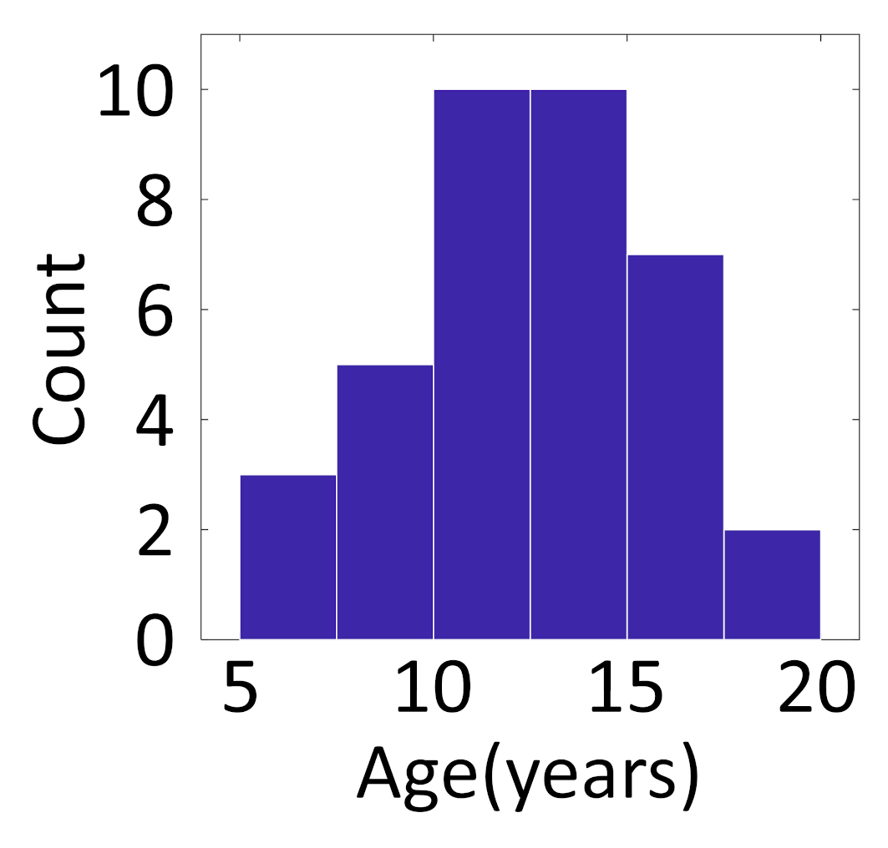

Fig.S1|Distribution of patients’ age.
The histogram shows the distribution of all 37 patients’ age included in the present study. The mean age of patients was 12.7±0.6 (±standard error: SE). The Shapiro-Wilk W suggests that the patients’ age is normally distributed (W: 0.981; p-value: 0.779; DF: 37). DF = The degree of freedom.
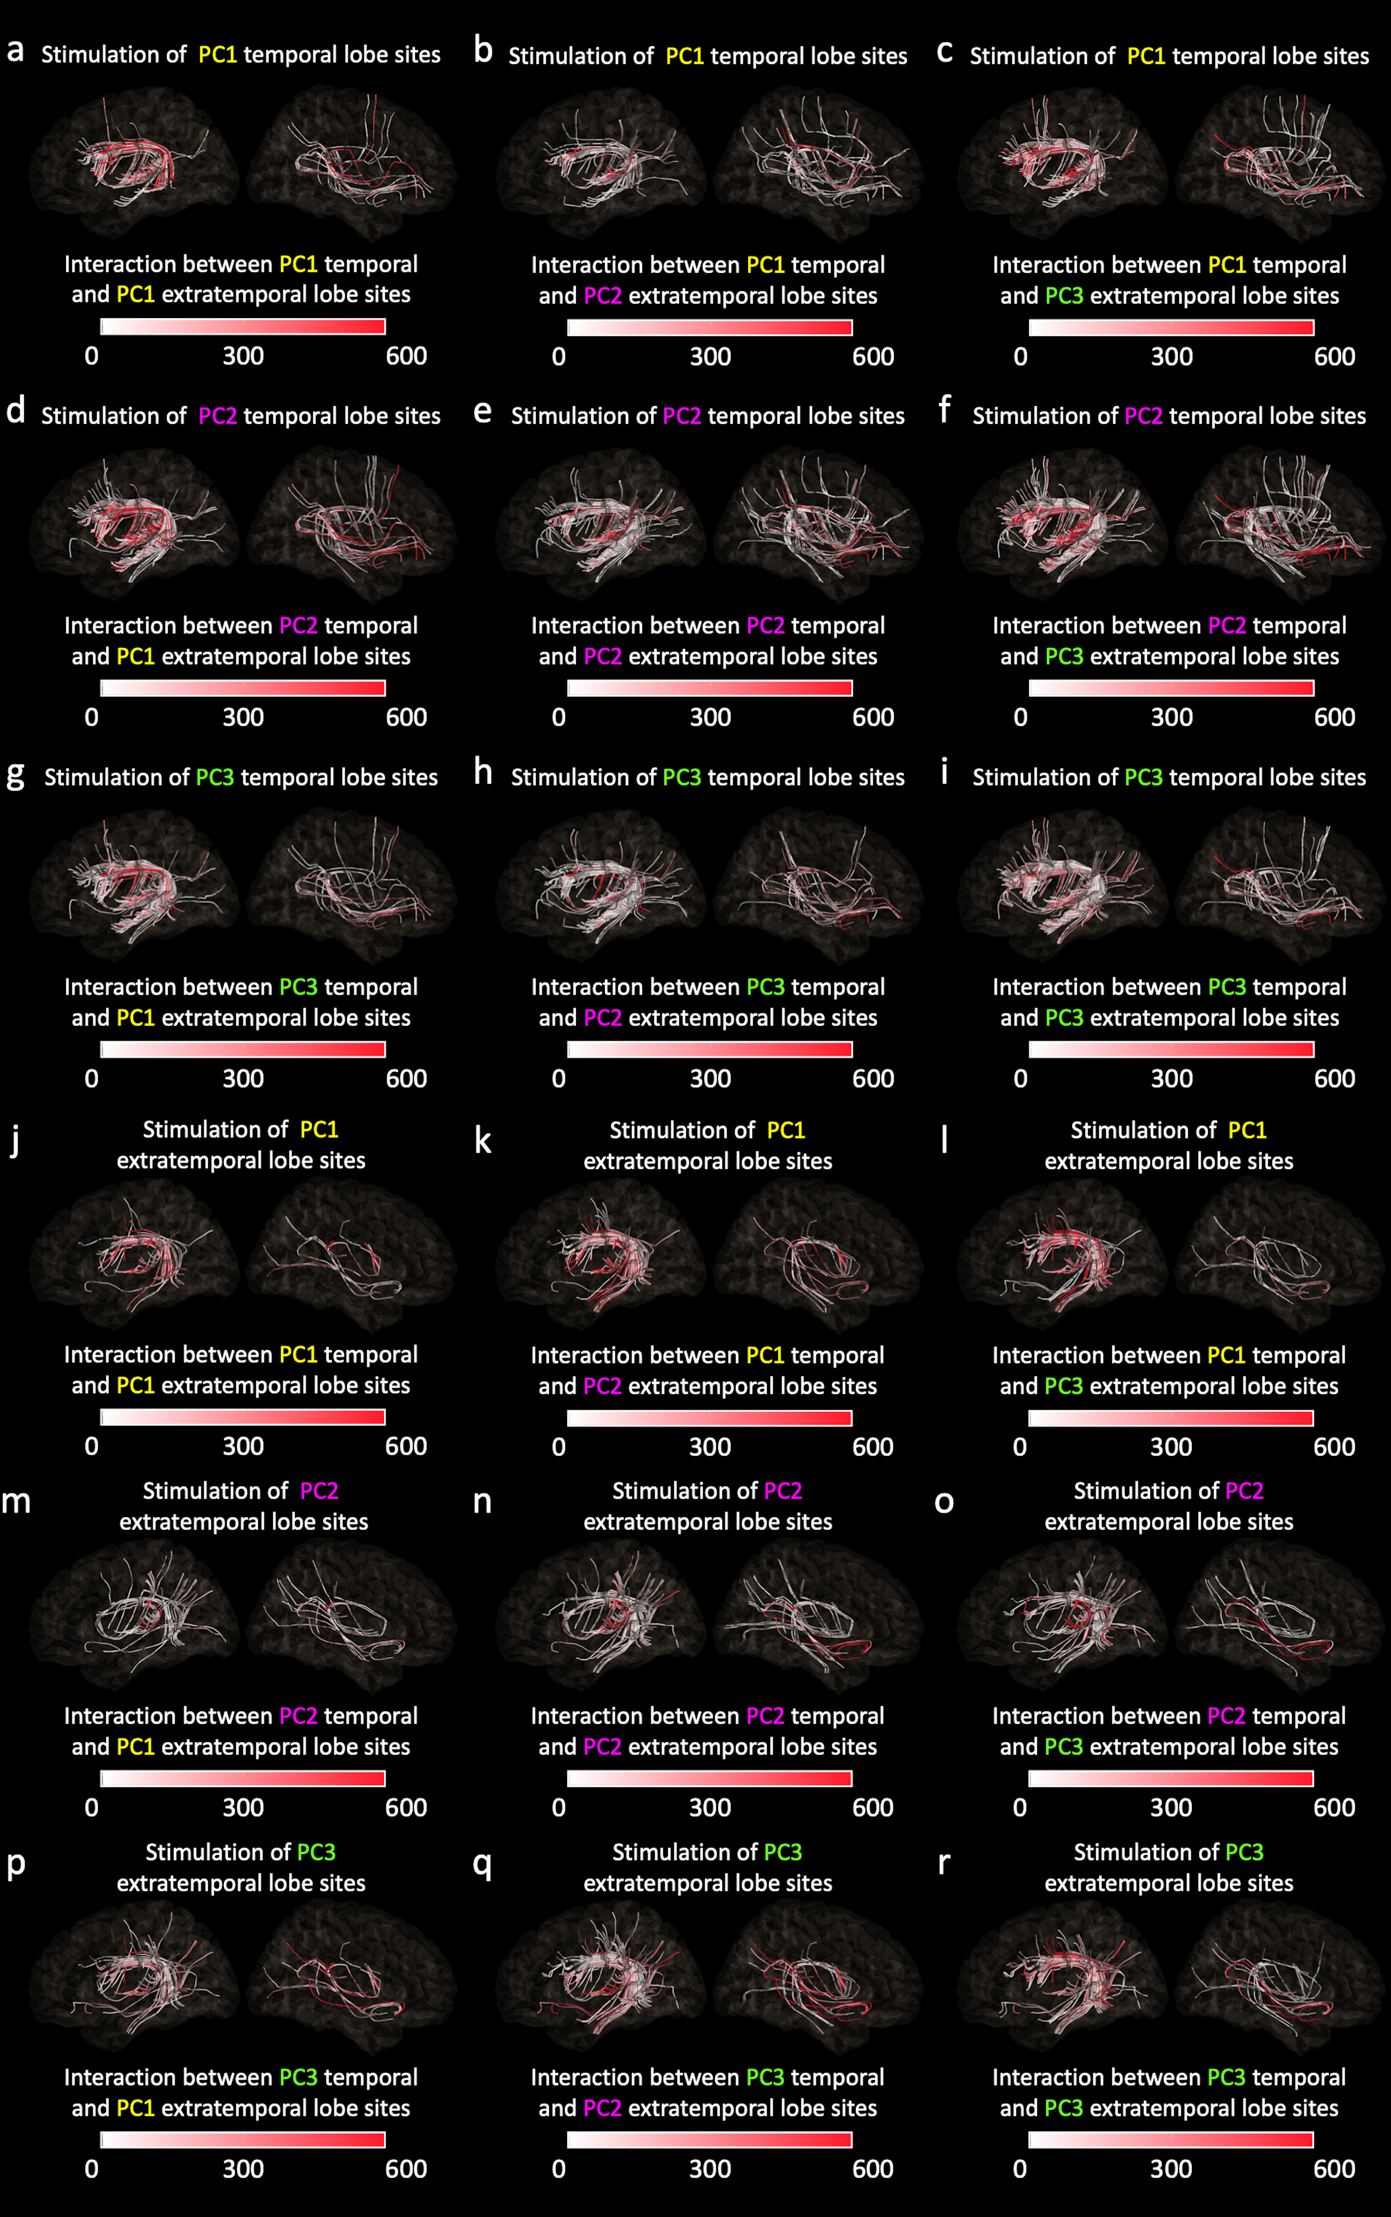

Fig.S2|Direct effective connectivity pathways delineated on open-source diffusion-weighted imaging (DWI) tractography.
Each figure shows the group-level inter-lobar effective connectivity pathways based on the early cortico-cortical spectral response (CCSR) data derived from all 37 study patients. The open-source DWI dataset (referred to as HCP1065) was used to reconstruct the anatomical white matter pathways connecting temporal and extratemporal lobe sites. In each figure, we present streamlines satisfying the following criteria: [A] naming-related high-gamma activity was augmented at temporal and extratemporal lobe sites during specific PCA-based linguistic stages, and [B] a given streamline was associated with a significant early CCSR. The streamline color reflects the interaction (i.e., multiplication) of high-gamma activity at temporal and extra-temporal lobe sites during a given linguistic stage. Thus, more reddish streamlines reflect larger high-gamma co-augmentation at both stimulus and recording sites. a-i, Temporal-to-extratemporal lobe effective connectivity pathways. j-r, Extratemporal-to-temporal lobe pathways. The data presented in this figure were used to determine what anatomical pathways supported how much proportion of effective connectivity between given linguistic stages in each direction (Table 2).

Video S1|6D dynamic tractography demonstrating early CCSR-based neural propagations from the temporal lobe sites.
Each animation movie demonstrates the trajectories of rapid neural propagations elicited by single-pulse electrical stimulation at temporal lobe sites supporting a specific linguistic stage. It shows group-level effective connectivity data derived from 27 patients who underwent diffusion-weighted imaging preoperatively. To optimize the visibility, each movie delineates the effective connectivity pathways satisfying the following criteria: [a] stimulus sites showed naming-related high-gamma augmentation during a specific PCA-based linguistic stage, [b] the interaction of high-gamma activity was above 200, and [c] a given streamline was associated with a significant early cortico-cortical spectral response (CCSR). The streamline color reflects the interaction of high-gamma activity at temporal and extra-temporal lobe sites during a given linguistic stage. Thus, red streamlines reflect high-gamma co-augmentation at both stimulus and recording sites, whereas blue ones indicate high-gamma augmentation at the stimulus sites but suppression at the recording sites. The size of each white dot reflects the strength of effective connectivity rated by early CCSR. The location of each white dot indicates the location of stimulation-induced neural propagation estimated by the propagation velocity. A.U. = arbitrary unit. HGA: high-gamma activity. PC: principal component. PCA: principal component analysis.

Video S2|6D dynamic tractography demonstrating early CCSR-based neural propagations from the extratemporal lobe sites.
Each animation movie demonstrates the trajectories of rapid neural propagations elicited by single-pulse electrical stimulation at extratemporal lobe sites supporting a specific linguistic stage. It shows group-level effective connectivity data derived from 27 patients who underwent diffusion-weighted imaging preoperatively. To optimize the visibility, each movie delineates the effective connectivity pathways satisfying the following criteria: [a] stimulus sites showed naming-related high-gamma augmentation during a specific PCA-based linguistic stage, [b] the interaction of high-gamma activity was above 200, and [c] a given streamline was associated with a significant early cortico-cortical spectral response (CCSR). The streamline color reflects the interaction of high-gamma activity at temporal and extra-temporal lobe sites during a given linguistic stage. Thus, red streamlines reflect high-gamma co-augmentation at both stimulus and recording sites, whereas blue ones indicate high-gamma augmentation at the stimulus sites but suppression at the recording sites. The size of each white dot reflects the strength of effective connectivity rated by early CCSR. The location of each white dot indicates the location of stimulation-induced neural propagation estimated by the propagation velocity. A.U. = arbitrary unit. HGA: high-gamma activity. PC: principal component. PCA: principal component analysis.

