Table 1: Bacteroidota and Firmicutes were the most abundant phylum across the CC strains. Average, minimum, and maximum abundance of various phyla by strain, arranged in order through decreasing overall abundance.
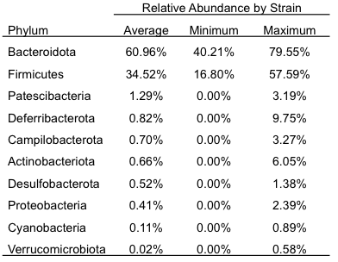

Table 2: Bacterial composition differs across the CC strains. Distance between bacterial communities measured by Bray-Curtis and Unweighted UniFrac metrics was used to analyze statistical significance between CC strains. Analysis of similarity (ANOSIM) and Permutational multivariate analysis of variance (PERMANOVA) was performed with 999 permutations and the R and Pseudo-F test statistics are reported along with the P-values.

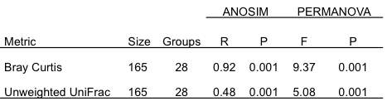

Table 3: Analysis of bacterial abundances identifies numerous QTL. Bacterial abundance in the feces of 28 CC strains was used to calculate QTL using rQTL2. 26 statistically significant peaks were identified on 15 different chromosomes. Chr, chromosome; Pos, Position; LOD, Logarithm of the odds; Proximal and Distal are in Mbp.
