Supplementary Figures
Figure S1: Sequence counts significantly decreased after DADA2 processing. (A) Raw sequence counts from Illumina paired end sequencing. (B) Sequence counts after filtering, denoising, chimeric removal and merging using DADA2 pipeline.
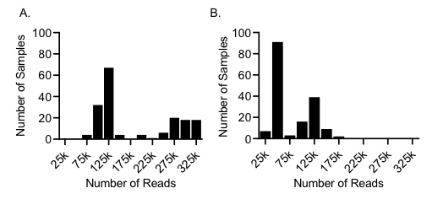

Figure S2: CC strains have rich and diverse bacterial communities. Within sample diversity measured by Shannon entropy. Bars represent mean and standard deviation for each strain. Kruskal-Wallis test was performed to analyze the statistical significance (p < 0.001).
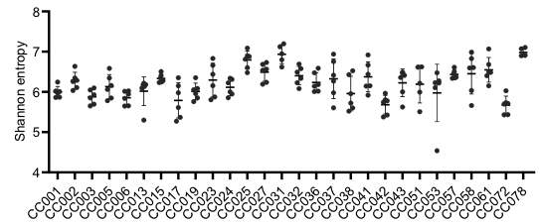

Figure S3: Principal component analysis shows better grouping by CC strains. PCoA 2D plots of between-sample dissimilarities measured by Bray-Curtis distance (A) and Unweighted UniFrac distance (B). Each color represents a CC strain.
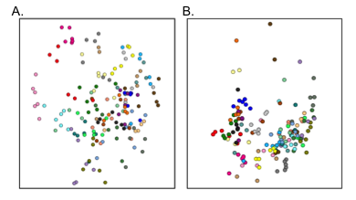

Figure S4: Diverse genus communities are observed across the CC strains. Shows the levels of top 50 abundant genera after grouping by CC strains. The same genera were also identified by differential abundance testing using ANCOM.
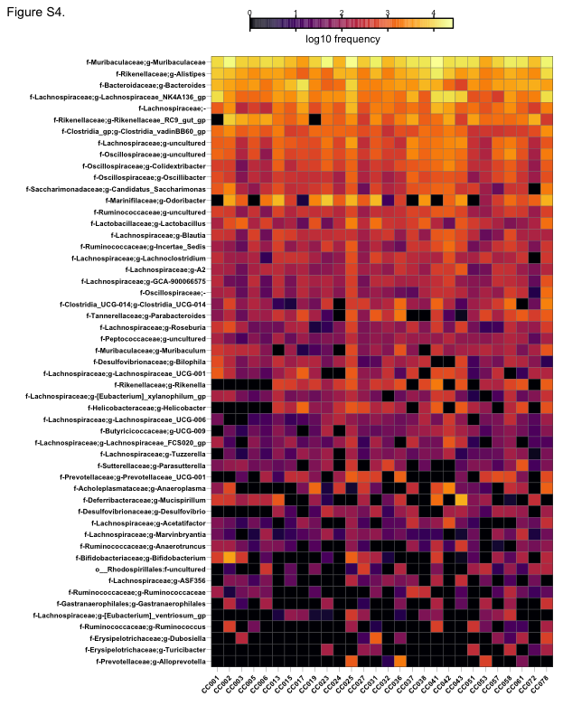

Figure S5: Machine learning algorithm accurately predicts the metadata columns. Random forest classifier was trained using the bacterial composition data and predict the CC strain type (A) and Health status (B).
