Nebulized Exosomes Derived from Allogenic Adipose Tissue Mesenchymal Stromal Cells in Patients with Severe COVID-19: A Pilot Study
Supplementary Materials

Supplementary Panel 1. The eligibility criteria of the MEXCOVID-19 study
Inclusion criteria:
1. The subjects or their family members voluntarily participated in the study and signed the informed consent.
2. Ages are differing from 18 years old to 75 years old.
3. Confirmed infection with SARS-CoV-2.
4.According to the fifth version of the guidelines on the Diagnosis and Treatment of COVID-19 by the National Health Commission, COVID-19 severity is classified as severe or critical type:
Severe type:
(1) Respiratory, distress, respiratory rate 30 per minute.
(2) Oxygen saturation on ambient air at rest ≤ 93%.
(3) Partial pressure of oxygen in arterial blood/ fraction of inspired oxygen ≤300 mmHg.
Critical type:
(1) Respiratory failure occurs, and mechanical ventilation is required.
(2) Shock occurs.
(3) Patients with other organ dysfunction needing intensive care unit monitoring treatment.

Exclusion criteria:
1. Patients with severe allergy history.
2. Pneumonia caused by bacteria, mycoplasma, chlamydia, Legionella, fungi, parasites, or other viruses.
3. HAP/VAP (hospital-acquired pneumonia/ventilator-acquired pneumonia) caused by lung cancer or other known reasons.
4. Suffering from carcinoid tumor or carcinoid syndrome.
5. Recent use of immunosuppressive drugs.
6. History of epilepsy, needing continuous anticonvulsant therapy, or having received anticonvulsant therapy in the past three years.
7. History of severe chronic lung diseases or requiring long-term home oxygen therapy.
8. Undergoing hemodialysis or peritoneal dialysis.
9. According to the local laboratory values, the creatinine clearance rate less than 15ml/min.
10. Moderate or severe hepatic failure (child Pugh score >12).
11. Expecting to receive any of the following drugs during the study period: valproic acid or sodium dipropionate used within 2 weeks before screening; 5-tryptamine reuptake inhibitors, tricyclic antidepressants, 5-HT1 receptor agonists (triptans), or monoamine oxidase inhibitors (or MAOIs used within 2 weeks before screening).
12. Cannot understand and implement the investigation plan.
13. Suffering from lower extremities deep venous thrombosis or pulmonary embolism in the past 3 months.
14. Undergoing ECMO or high-frequency oscillatory ventilation.
15. People with HIV, hepatitis virus, or syphilis.
16. Pregnant or nursing females.
17. According to the judgment of the researcher, the one who has a low probability of being included in the group (such as frailty, etc.).

Supplementary Figure and Legend

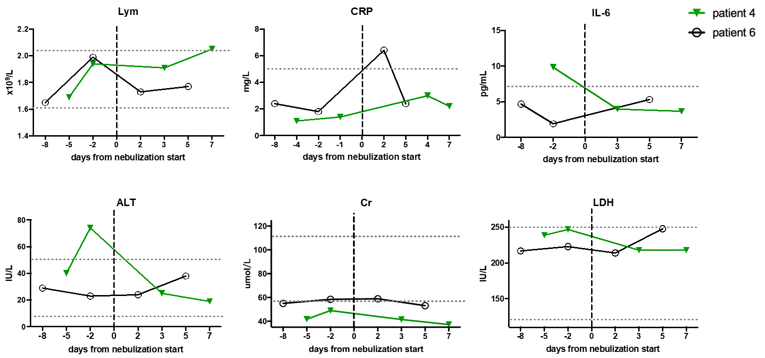
Figure S1. Dynamic changes of laboratory parameters in patient 4 and patient 6 before and after haMSCs-Exo nebulization. The dotted horizontal line represents the reference value range.
Lym: lymphocyte; CRP: C reactive protein; IL-6: interleukin-6; ALT: alanine aminotransferase; Cr: creatinine; LDH: lactate dehydrogenase.

