Domain | E-value | Sites | Width | Logo
Motif 1  Motif 2  Motif 3  Motif 4  Motif 5  Motif 6 | 3.4e-816  3.5e-779  3.9e-742  1.9e-455  4.1e-229  8.1e-116 | 57  66  68  59  63  15 | 50  50  50  50  41  50 | 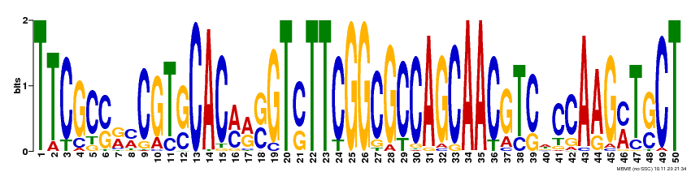  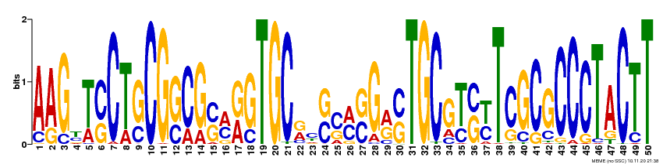  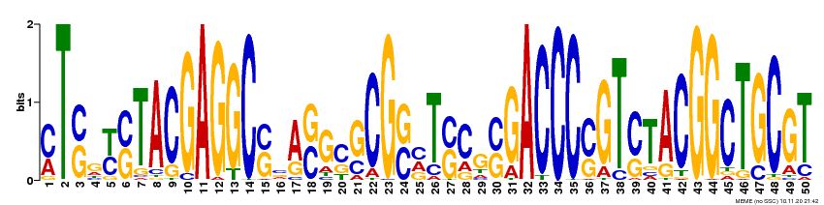  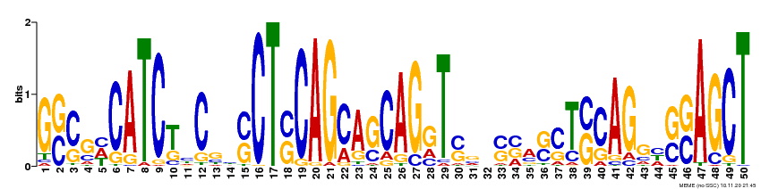  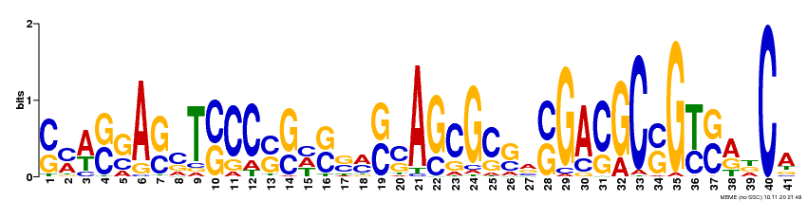  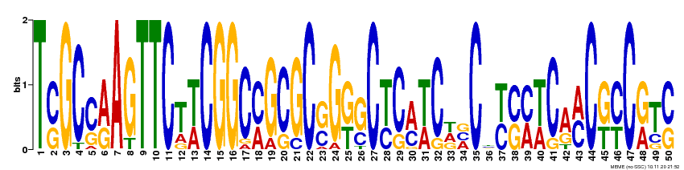
Table S1 Details of six domains conserved among LBD TFs in switchgrass

Table S2 qRT-PCR primers for expression in the analysis of PvLBD
Gene ID | Forward Primer (5’- 3’) | Reverse Primer (5’- 3’)
Pavir.Eb02853  Pavir.Da02090  Pavir.Eb00458  Pavir.Fa00011  Pavir.Ib00283  Pavir.J03238  Pavir.J03307  Pavir.J19063  Pavir.J13923  Pavir.J18260  Pavir.J03376  PvUBIQUITIN  Ubi1301 | CAGGTCCCGTGAGAACTTTG  GCTGGCCATCAATCACAATG  CCTTACGCTTCCATGGCTAAT  TATGCATGCCCGACTACAAC  GGACTCGTCGTCGTTCG  GCACGCAGAACTTCATCAAC  CAAGGAGCTACGATGGAGAAG  CAGCCGCAAGACCCTTAC  CAATCGCCATCGCAACAAC  CGTGTTCGCACCCTACTT  GGCACTCAACAAGACAACATTTA  CAGCGAGGGCTCAATAATTCCA  TGATGGCCCTGCCTTCATACGCT | TCCGGATGGAAACCTCTGTA  CGTCGTCGTCATGTCGTAAT  GTGATCCAACCCAATGTTCTCT  GAGATAGGCAAAGGCTACTGAC  TGAGCGATGGTTCAGGTAAG  CTTCTCCATCGTAGCTCCTTG  GATGAGTACCCGAAACCGTAG  GAGAGTTGTGGCTGCGT  CTGATGATGAGCGGCACTAC  GAGCATCTTGCTGACATTGC  AAGTATTGCTGGCTCTCATTCT  TCTGGCGGACTACAATATCCA  TATTGCCAAATGTTTGAACG

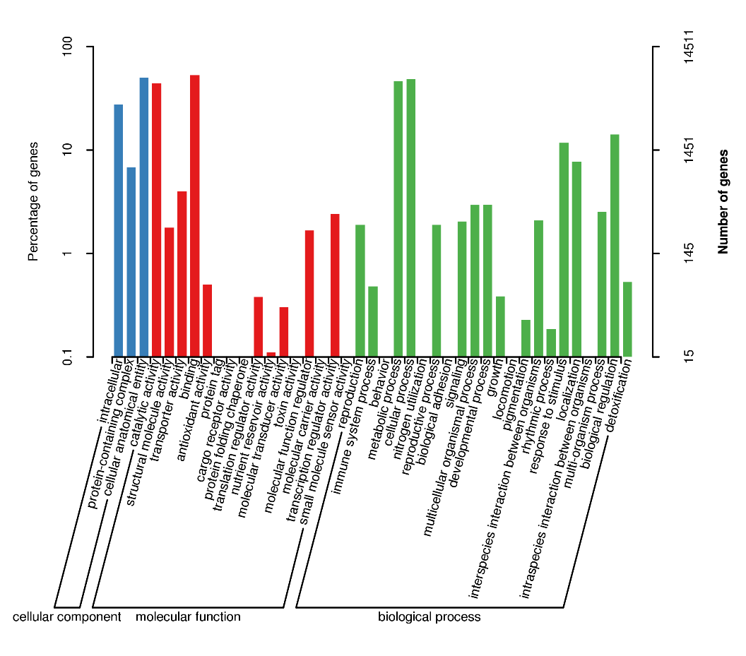
Figure S1 GO terms of enriched candidate PvLBD target genes.

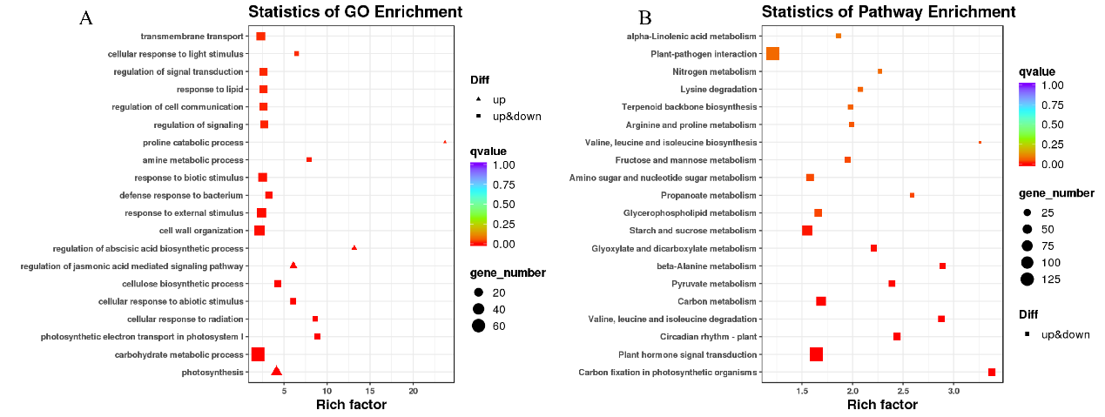
Figure S2 The top 20 GO terms (A) and KEGG pathways (B) of enriched candidate PvLBD target genes between salt vs. drought stress. The black circles indicate the number of target genes, and different colors indicate the P- value, ranging from 0 to 1.00.

