Synoptic Climatology of Pre-Monsoon Severe Lightning Events in Bangladesh
Supplement figure-1

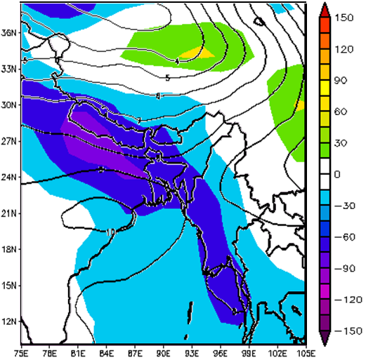
Supplement Fig. 1. Composite geographical distributions of June SLP (in Pa, shaded) and 500 hPa GpH (in gpm, solid line) anomalies compared with the climatology from 1981 to 2010.

Supplement Table 1. Atmospheric stability indices for Dhaka radiosonde station from March through June with their means and standard deviations

