Supplementary information
Operando nanoscale imaging reveals Fe doping of Ni oxide enhancing oxygen evolution reaction via fragmentation and formation of dual active sites
Yunchang Liang,^{1,2} Sofia O. Parreiras,³ Seunghwa Lee,^{4,5} Karla Banjac,^{1,2} Victor Boureau,⁶ José María Gallego,^{3,7} Xile Hu,⁴ David Écija,^{3,*} Magalí Lingenfelder^{1,2,*}
¹ Max Planck-EPFL Laboratory for Molecular Nanoscience and Technology, École Polytechnique Fédérale de Lausanne (EPFL), 1015 Lausanne, Switzerland.
² Institut of Physics (IPHYS), Ecole Polytechnique Fédérale de Lausanne (EPFL), 1015 Lausanne, Switzerland.
³ IMDEA-Nanociencia, C/Faraday 9, Ciudad Universitaria de Cantoblanco, 28049 Madrid, Spain.
⁴ Laboratory of Inorganic Synthesis and Catalysis, Institute of Chemical Sciences and Engineering, École Polytechnique Fédérale de Lausanne (EPFL), 1015 Lausanne, Switzerland.
⁵ Department of Chemical Engineering, Changwon National University, 51140 Changwon, South Korea.
⁶ Interdisciplinary Center for Electron Microscopy (CIME), École Polytechnique Fédérale de Lausanne (EPFL), 1015 Lausanne, Switzerland.
⁷ Instituto de Ciencia de Materiales de Madrid, CSIC, Cantoblanco, 28049 Madrid, Spain.

These authors contributed equally: Yunchang Liang, Sofia O. Parreiras
*e-mail: david.ecija@imdea.org; magali.lingenfelder@epfl.ch

XPS analysis
The chemical structure of MBE-prepared nanoislands of Ni and NiFe oxides has been analyzed by XPS, regarding the Ni2p, Fe2p and O1s peaks. The Ni2p spectra have many compounds (metallic Ni, NiO, NiFe₂O₄, Ni(OH)₂ and NiOOH), each with multiple peaks, summing up 28 components only for the Ni2p_{3/2} peak,. This prevents a quantitative analysis. The Ni2p spectra were qualitatively analyzed, considering only the components corresponding to more than 10% of the total intensity. Importantly, the displayed spectra are shown after the subtraction of a single background covering the whole 2p region¹. After background subtraction, all spectra are normalized to have the same area in order to avoid any effect of varying beam intensity. Following this procedure, it is possible to compare how the proportions of the different components change between experiments.
Reference energy values for all considered components are listed in Table S1 as also indicated by vertical lines in Figures S1a and b, which present selected spectra taken before (red) and after (blue) the exposure to water. The high-intensity peak around 852.6 eV (purple line 1) in all spectra indicates the presence of a significant amount of metallic Ni. The high intensity of this peak is explained by the fact that the component indicated by the purple line 1 concentrates 81.2% of the total metallic signal, while the Ni and NiFe oxides signals are divided into 5 components². Part of the signal of this peak also came from the NiO component indicated by the green line 1. After the Fe doping, there is a clear change in the shape of the spectrum; for instance, this peak is wider and shifted to the left. It is explained by the addition of a new oxide phase due to the formation of a NiFe alloy. The rise of a shoulder at the left of the main peak is consistent with the formation of NiFe₂O₄, which has peaks at 854.3 and 856.0 eV² and is highly active towards the OER,.
Ni oxide spectra before and after water exposure (Figure S1a) are very similar. The minor changes are difficult to interpret because of the complex multipeak structure. In this case, the effect of the hydroxylation can be observed more clearly in the O1s spectra, as discussed in the main text (Fig. 2e-h). On the other side, for Fe doped oxide samples, the hydroxylation is evident also in the Ni2p spectra (Figure S1b). After water exposure, the peak around 852.6 eV is narrowed and shifted to the right. This happens due to the decrease of NiO and NiFe₂O₄ components (green and brown lines 3). Besides that, a new peak appears around 855.3 eV. There are two components at this energy, namely NiO (green line 1) and NiOOH (orange line 4). The first one should decrease as the component indicated by the green line 3, so the peak emergence can be attributed to the formation of an amount of NiOOH that is large enough to compensate for the decrease of NiO. Similar behavior was observed in all Fe doped samples (Figures S1c-i), with a decrease of NiO and NiFe₂O₄ and an increase of NiOOH components.
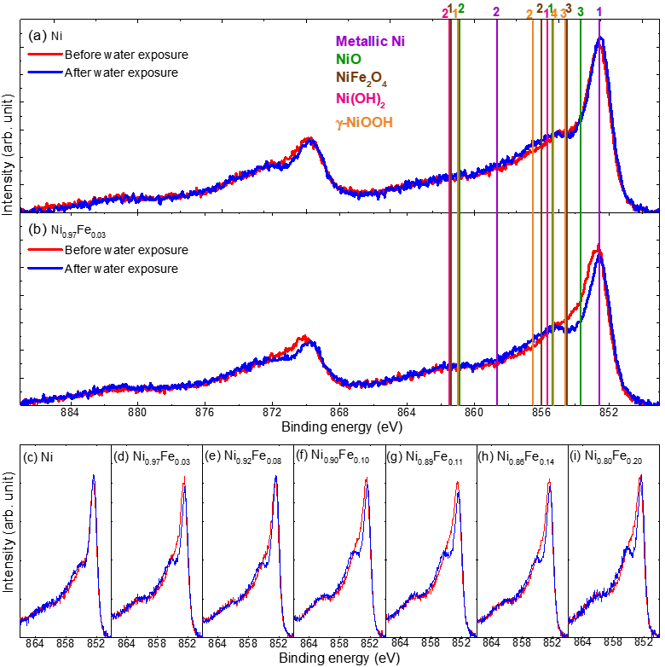
Figure S1 | XPS spectra of Ni2p region of MBE-prepared nanoislands of Ni and NiFe oxides. (a,b) XPS spectra of Ni2p region before (red) and after (blue) water exposure for samples of (a) Ni and (b) Ni_{0.97}Fe_{0.03} oxides. The vertical lines indicate the position of the most intense peaks of metallic Ni (purple), NiO (green), NiFe₂O₄ (brown), Ni(OH)₂ (pink), and NiOOH (orange)². Only peaks that correspond to more than 10% of the total intensity are shown. (c-i) XPS spectra of Ni2p_{3/2} region before (red) and after (blue) water exposure for samples of (c) Ni; (d) Ni_{0.97}Fe_{0.03}; (e) Ni_{0.92}Fe_{0.08}; (f) Ni_{0.90}Fe_{0.10}; (g) Ni_{0.89}Fe_{0.11}; (h) Ni_{0.86}Fe_{0.14}; (i) Ni_{0.80}Fe_{0.20}.

Compound | Peak 1 |  |  | Peak 2 |  |  | Peak 3 |  |  | Peak 4
Compound | Energy (eV) | FWHM  (eV) | % | Energy (eV) | FWHM  (eV) | % | Energy (eV) | FWHM(eV) | % | Energy (eV) | FWHM(eV) | %
Metallic Ni | 852.6 | 0.94 | 81.2 | 858.7 | 2.70 | 12.5
NiO | 855.4 | 3.20 | 44.2 | 860.9 | 3.85 | 34.0 | 853.7 | 0.98 | 14.3
NiFe₂O₄ | 861.4 | 4.49 | 38.5 | 856.0 | 3.03 | 38.2 | 854.5 | 1.35 | 17.3
Ni(OH)₂ | 855.7 | 2.25 | 45.3 | 861.5 | 4.62 | 39.2
γ-NiOOH | 861.0 | 4.00 | 23.3 | 856.5 | 1.40 | 20.7 | 854.6 | 1.40 | 13.8 | 855.3 | 1.50 | 12.4
Table S1 | Reference XPS parameters for the most intense peaks of Ni2p_{3/2} compounds. Binding energy, FWHM (10 eV pass energy), and percentage of total area². Only peaks with areas of at least 10% are listed.

All Fe doped oxide samples have low amounts of Fe, and the Fe2p spectra are very noisy and difficult to analyze. However, when comparing with a spectrum of metallic Fe (Figure S2), the Fe 2p_{3/2} peak of the oxides samples is shifted to the left, confirming the oxide formation. The shift is consistent with the NiFe₂O₄, though it is not possible to discard the formation of a different oxide. After the water exposure, there is a change in the spectrum shape, likely due to the hydroxylation. Although the bad resolution of Fe spectra does not allow unequivocal identification of the Fe oxide, the structure of Ni spectra evidences the formation of a NiFe alloy with a chemical structure that resembles the NiFe₂O₄.
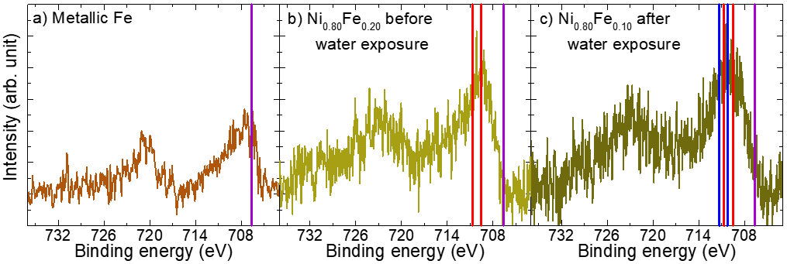
Figure S2 | XPS spectra of Fe2p peak of metallic Fe and Ni_{0.80}Fe_{0.20} oxides. Spectra of samples of (a) metallic Fe; (b) Ni_{0.80}Fe_{0.20} oxide before water exposure; and (c) Ni_{0.80}Fe_{0.20} oxide after water exposure. The vertical lines indicate the position of the most intense peaks of metallic Fe (purple), NiFe₂O₄ (red), and FeOOH (blue)². Only peaks that have more than 25% of the total intensity are shown.

The analysis of O1s spectra shown in the main text (Fig. 2e-h) has taken into account the components listed in Table S2. Although the spectra can have a number of components, three Gaussian peaks were enough to fit the peak. The peak at (529.3 ± 0.2) eV represents the lattice oxygen (O²⁻) from the NiO. In the case of the Fe doped samples, there is another peak at (529.9 ± 0.1) eV, which is ascribed to NiFe₂O₄². The third peak, at (531.1 ± 0.2) eV and labeled as (OH)⁻/def., can arise from Ni defects or (OH)⁻, which are very close in energy (see Table S2) and cannot be resolved in separated peaks by XPS. As the samples were prepared and measured in-situ in UHV, the presence of (OH)⁻ is not expected before the water exposure. For the pure NiO sample (see Figure S3a), the defects are 30.7% of the total area, which is consistent with the 30% reported in the literature¹. The defects peak comes from O atoms adjacent to Ni vacancies. After the Fe doping, there is a decrease in the Ni defects percentage (Figures S3a), while no component from Fe defective sites was observed. It is evident that Fe atoms are adsorbed on the Ni vacancies, which agrees with the NiFe alloying observed in Ni2p spectra.
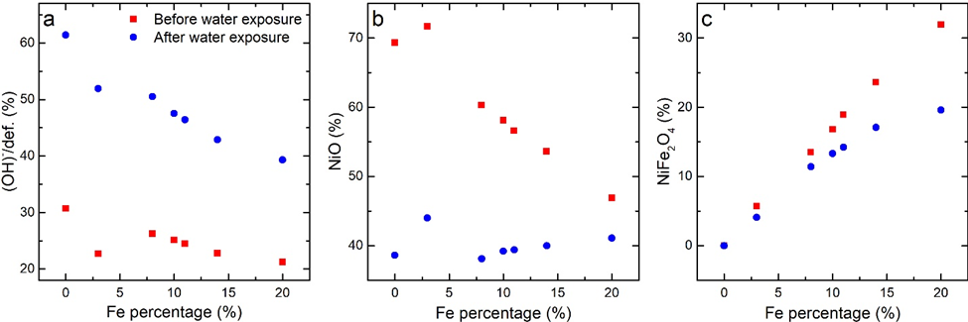
Figure S3 | XPS analysis of O1s region of MBE-prepared nanoislands of Ni and NiFe oxides. Percentage distribution of the fitted components on O1s spectra presented in Fig. 2e-h in the main text (a) (OH)- and defective oxygen; (b) NiO; and (c) NiFe₂O₄. The sample with 3% of Fe has an anomalous behavior, having more NiO than all the other samples both, before and after, the exposure to water.

Compound | O²⁻ |  |  | Defective oxide |  |  | (OH)⁻ |  |  | Adsorbed water
Compound | Energy (eV) | FWHM(eV) | % | Energy (eV) | FWHM(eV) | % | Energy (eV) | FWHM(eV) | % | Energy (eV) | FWHM(eV) | %
NiO² | 529.30 | 0.85 | 69 | 531.10 | 1.50 | 29 |  |  |  | 532.80 | 1.50 | 2
Ni(OH)₂² |  |  |  |  |  |  | 530.90 | 1.46 | 100
γ-NiOOH | 529.5 | 0.95 | 37 |  |  |  | 531.2 | 1.59 | 52
β-NiOOH | 529.3 |  |  |  |  |  | 530.8
NiFe₂O₄² | 529.80 | 1.38 | 54 | 531.76 | 2.25 | 46
α-FeOOH² | 529.90 | 1.11 | 39 |  |  |  | 531.20 | 1.11 | 49 | 532.50 | 1.11 | 12
γ-FeOOH² | 529.90 | 1.21 | 40 |  |  |  | 531.30 | 1.21 | 37 | 532.30 | 1.21 | 15
Table S2 | Reference XPS parameters for the most intense peaks of O1s compounds. Binding energy, FWHM (10 eV pass energy), and percentage of total area^{2,5,6}.

After the exposure to water, the conversion of oxide into hydroxide is expected. Table S2 lists the XPS peaks of three Ni hydroxides phases: Ni(OH)₂, γ-NiOOH and β-NiOOH. The Ni(OH)₂ has only one component, (OH)⁻ at 530.9 eV. However, NiOOH phases have two components: (OH)⁻ and lattice oxygen (O²⁻),. That means that if the NiO is converted to Ni(OH)₂, all the XPS signal is transferred from the O²⁻ peak to the (OH)⁻. For the NiOOH phases, the transference is only partial, and the increase/decrease of (OH)⁻/O²⁻ components is less evident. Something similar happens for the Fe hydroxides, Fe(OH)₂ and FeOOH^{2,}.
When comparing the O1s before and after the exposure to water (Figure S3a), there is an increase in the (OH)⁻ peak for all samples, though this increment is less intense for samples with Fe. Greater amounts of Fe also lead to smaller decreases in the NiO peak (Figure S3b). Conversely, there is a clear emergence of a NiOOH component in Ni2p spectra of Fe doped samples, while no evident change is observed for NiO. A possible explanation for this could be that, for pure Ni oxide, Ni(OH)₂ is being formed and cannot be identified in Ni2p spectra due to the proximity with NiO peaks. On the other side, Fe doping favors the formation of NiOOH, and this effect increases with the increment of Fe doping. Consequently, the (Ni_{0.80}Fe_{0.20})_{x}O_{y} sample exhibits a more pronounced hydroxide peak at Ni2p_{3/2} spectrum (Figure S1i) and a smaller decrease of NiO peak at O1s (Figure S3b), since this peak is partially arising from the formation of NiOOH instead of Ni(OH)₂. Concerning the Fe, the hydroxylation is confirmed by the decrease of the NiFe₂O₄ after the water exposure. Due to the impossibility of analyzing the Fe2p spectra, it is not possible to determine whether Fe(OH)₂ or FeOOH is being formed. However, considering the NiFe alloying and the observation of NiOOH after the Fe doping, it should be expected the formation of a Ni_{1−x}Fe_{x}OOH phase.

EDS-STEM measurements after the OER
It should be noted that all n-ECSTM measurements (active site identifications) at the OER on conditions are conducted at low OER overpotentials to prevent catalyst, especially the Fe atoms, dissolving and gas bubble formation. Therefore, catalyst dissolution is not in the scope of this work. However, higher overpotentials were used to study how the OER affects the structural and chemical compositions of the 2D catalyst islands. A clear decrease in the activity of NiFeO_{x}H_{y} samples was noticed. A typical chronoamperometry showing the activity of a NiFeO_{x}H_{y} sample decreasing over time is shown in Figure S4. When comparing the EDS-STEM images before and after the OER, fewer Fe-rich clusters can be seen on NiFeO_{x}H_{y} islands. This is likely due to the high dissolution rate of Fe atoms in Fe-free electrolytes, which is in agreement with the studies of Farhat et al. and Chung et al.. Moreover, the lateral resolution of EDS-STEM is limited. Due to the fragmentation of the islands, a large amount of NiFeO_{x}H_{y} islands became too small after the OER to resolve the uneven distribution of Fe atoms. On larger islands, for instance, the island in Extended Data Figure 3j, the Ni atoms were likely more homogeneously distributed than Fe atoms. It seems like there were small Fe clusters. However, the limited EDS-STEM resolution prevents clear interpretation. Nevertheless, the n-ECSTM measurements were conducted at different overpotentials where the chemical compositions of the catalysts are rather stable and similar to that measured on freshly prepared samples.
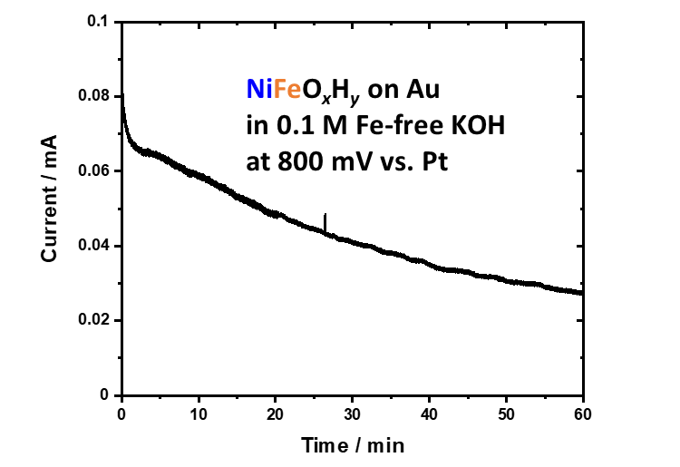
Figure S4 | Chronoamperometry of a NiFeO_{x}H_{y} sample in 0.1 M Fe-free KOH at 800 mV for 1 hour with a Pt wire as the RE.

References

Biesinger, M.C., Payne, B.P., Lau, L.W.M., Gerson, A. & Smart, R.St.C. X-ray photoelectron spectroscopic chemical state quantification of mixed nickelmetal, oxide and hydroxide systems. Surf. Interface Anal. 41, 324–332 (2009).
Biesinger, M.C., Payne, B.P., Grosvenor, A.P., Lau, L.W.M., Gerson, A. & Smart, R.St.C. Resolving surface chemical states in XPS analysis of first row transition metals, oxides and hydroxides: Cr, Mn, Fe, Co and Ni. Appl. Surf. Sci. 257, 2717–2730 (2011).
Xie, Z., Zhang, C., He, X., Liang, Y., Meng, D., Wang, J., Liang, P., and Zhang, Z. Iron and Nickel Mixed Oxides Derived from Ni^{II}Fe^{II}-PBA for Oxygen Evolution Electrocatalysis. Front. Chem. 7, 539 (2019).
Li, Y. & Selloni, A. Mechanism and Activity of Water Oxidation on Selected Surfaces of Pure and Fe-Doped NiO_{x}. ACS Catal. 4, 1148-1153 (2014).
Payne, B.P., Biesinger, M.C., & McIntyre, N.S. Use of oxygen/nickel ratios in the XPS characterisation of oxide phases on nickel metal and nickel alloy surfaces. J. Electron Spectros. Relat. Phenomena 185, 159–166 (2012).
Payne, B.P., Biesinger, M.C., & McIntyre, N.S. The study of polycrystalline nickel metal oxidation by water vapour. J J. Electron Spectros. Relat. Phenomena 175, 55–65 (2009).
Payne, B.P., Biesinger, M.C., & McIntyre, N.S. Use of oxygen/nickel ratios in the XPS characterisation of oxide phases on nickel metal and nickel alloy surfaces. J. Electron Spectros. Relat. Phenomena 185, 159–166 (2012).
Payne, B.P., Biesinger, M.C., & McIntyre, N.S. The study of polycrystalline nickel metal oxidation by water vapour. J J. Electron Spectros. Relat. Phenomena 175, 55–65 (2009).
Grosvenor, A.P., Kobe, B.A., & McIntyre, N.S. Studies of the oxidation of iron by water vapour using X-ray photoelectron spectroscopy and QUASES. Surf. Sci. 572, 217–227 (2004).
Farhat, R., Dhainy, J. & Halaoui, L. I. OER Catalysis at Activated and Codeposited NiFe-Oxo/Hydroxide Thin Films Is Due to Postdeposition Surface-Fe and Is Not Sustainable without Fe in Solution. ACS Catal. 10, 20–35 (2020).
Chung, D.Y., Lopes, P.P., Farinazzo Bergamo Dias Martins, P. et al. Dynamic stability of active sites in hydr(oxy)oxides for the oxygen evolution reaction. Nat Energy 5, 222–230 (2020).

