Extended Data Figure 1: Height profiles of NiO_{x} nanoislands and NiO_{x}H_{y} islands.
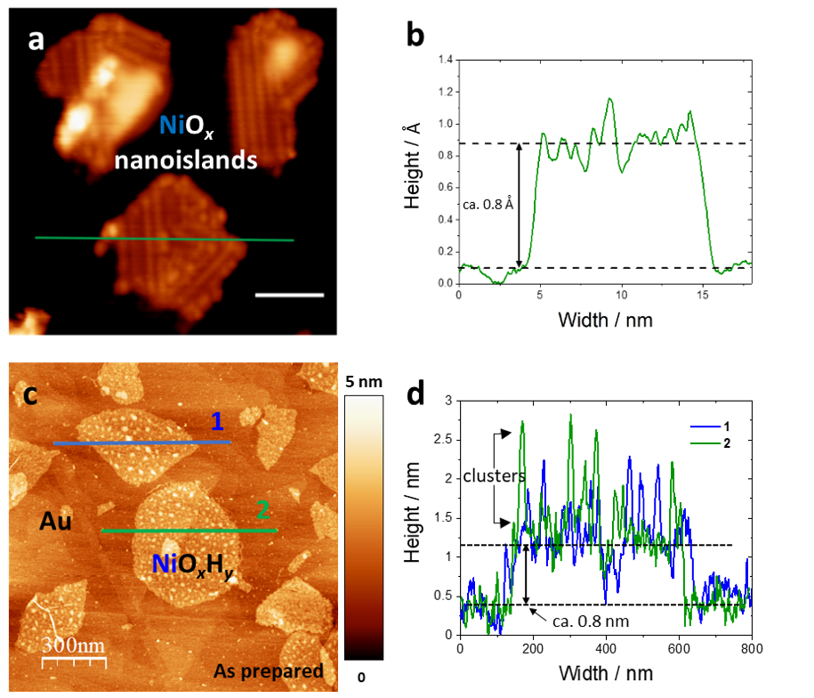
Extended Data Figure 1 | Height profiles of MBE-prepared NiO_{x} nanoislands and NiO_{x}H_{y} islands. a, STM image of a NiO_{x} MBE-prepared sample (scanning parameters: I = 600 pA, Vbias = 541 mV). b Height (apparent STM height) profile of a NiO_{x} MBE-prepared nanoisland. The thickness of the islands is around 0.8 nm, and there are clusters on the surface of them. c, AFM image of a NiO_{x}H_{y} sample shown in Fig. 1e. d, Height profiles of two NiO_{x}H_{y} islands.

Extended Data Figure 2: Height profiles of different areas on NiO_{x}H_{y} and NiFeO_{x}H_{y} samples.
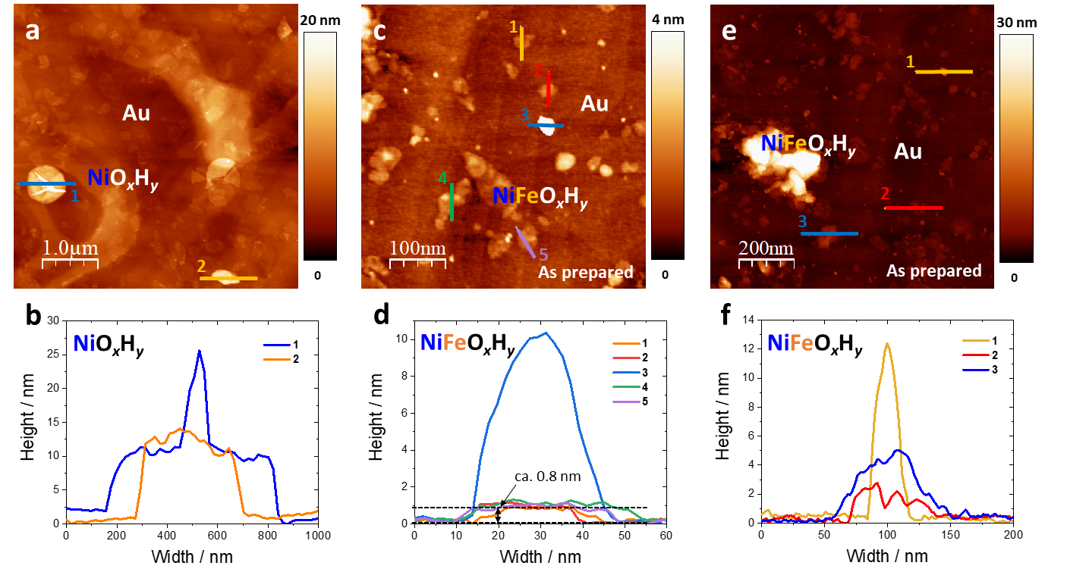
Extended Data Figure 2 | AFM images of different areas on a NiO_{x}H_{y} and c,e, NiFeO_{x}H_{y} samples; and b,d,f corresponding height profiles of lines marked in the images.

Extended Data Figure 3: STEM and EDS (elemental net count maps) images of different NiO_{x}H_{y} and NiFeO_{x}H_{y} islands.
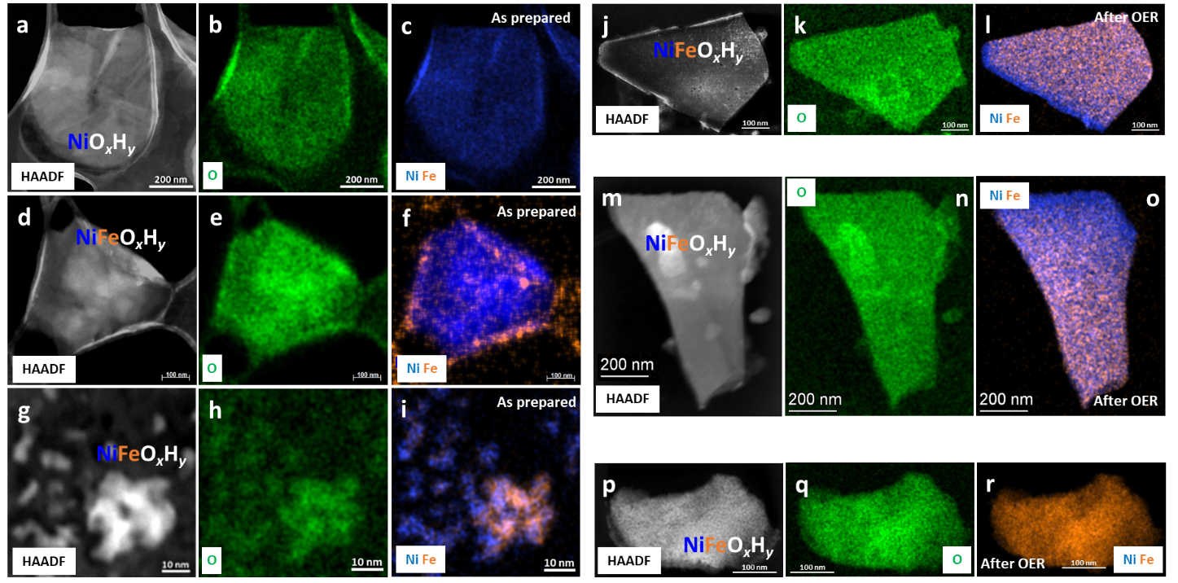
Extended Data Figure 3 | STEM and EDS (elemental net count maps) images of a NiO_{x}H_{y} and different NiFeO_{x}H_{y} islands before and after the OER. a-c, Images of an as-prepared NiO_{x}H_{y} island (Fig.1h) where no Fe signal can be detected. d-f, Images of a NiFeO_{x}H_{y} island (Fig.1i) before the OER. Enriched Fe signals are located at large clusters and island edges. g-i, two NiFeO_{x}H_{y} island structures with different Ni and Fe distributions before the OER. j-l, An thick NiFeO_{x}H_{y} island with evenly distributed Ni signal after the OER, and Fe seems to form clusters at the surface. However, the resolution is not enough to attest to such a conclusion, likely due to the thickness of the island. m-o, An NiFeO_{x}H_{y} island with evenly distributed Ni signal after the OER, and the lower part of the island has higher Fe content compared to the upper part. p-r, An NiFeO_{x}H_{y} island with no visible Ni signal after the OER.

Extended Data Figure 4: Average change of the morphology of the islands.
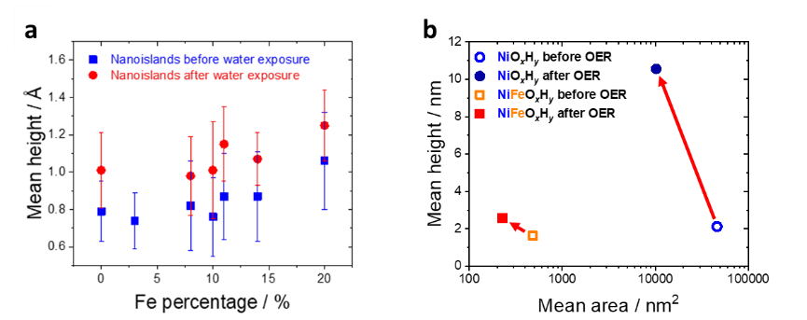
Extended Data Figure 4 | Average change of the morphology of the a nanoislands due to the water exposure (apparent STM height) and b hydroxide islands due to the OER. For all samples, an increase of the average apparent height after the exposure to water or OER as a consequence of the formation of clusters was observed. Note that real height values cannot be taken from STM images (as this is measurement convoluted with the electronic structure). The comparison in a shows the overall trend of height change, but is not quantitative.

Extended Data Figure 5: SEM images of NiO_{x}H_{y} islands before and after the OER.
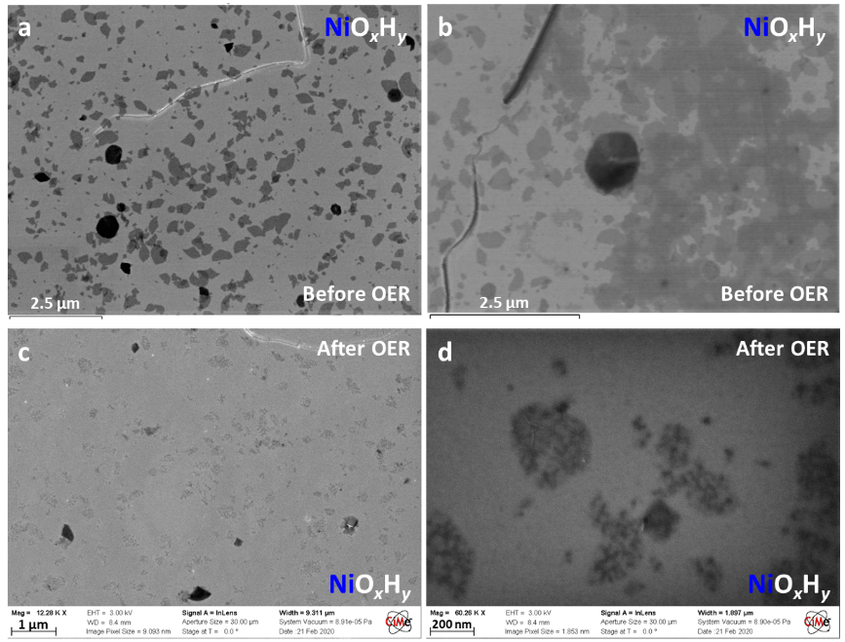
Extended Data Figure 5 | SEM images of NiO_{x}H_{y} islands on a Au substrate a,b before and c,d after the OER. After the OER, the islands were cracked.
Extended Data Figure 6: AFM images of NiO_{x}H_{y} islands before and after OER.
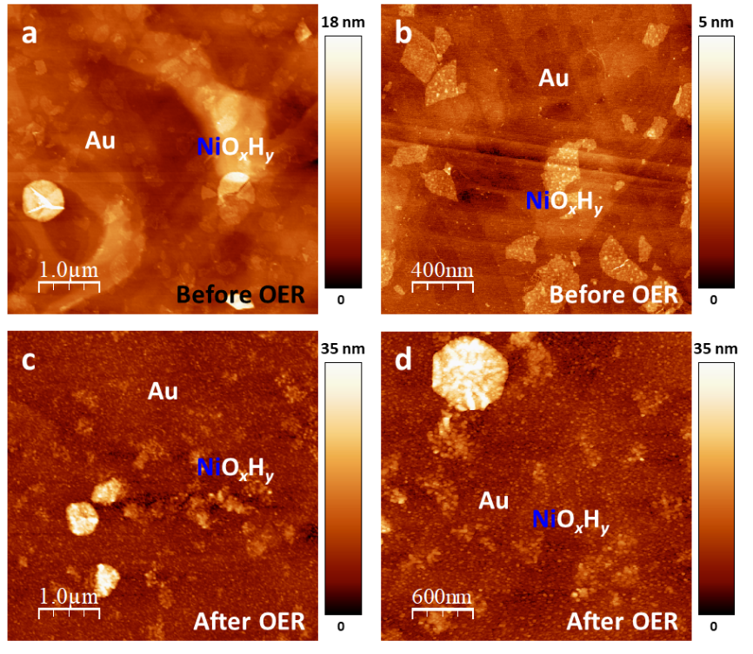
Extended Data Figure 6 | AFM images of NiO_{x}H_{y} islands deposited on a Au surface a,b before and c,d after the OER. Clusters and cracking lines already appeared on the islands before the OER. However, more clusters and cracking can be seen after the OER, and the monolayer islands were more damaged than the thicker ones. The Au surface was also roughened after the OER.

Extended Data Figure 7: Typical CVs of NiO_{x}H_{y} and NiFeO_{x}H_{y} samples in 0.1 M Fe-free KOH measured in the ECSTM cell at a scan rate of 50 mV/s.
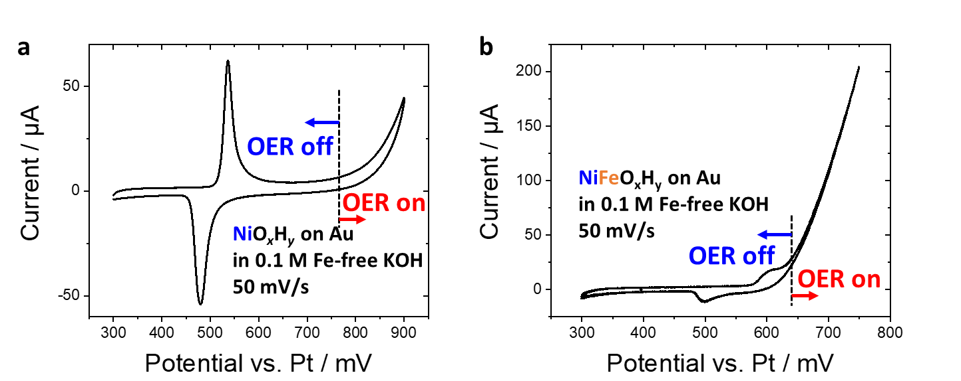
Extended Data Figure 7 | Typical CVs of a NiO_{x}H_{y} and b NiFeO_{x}H_{y} samples in 0.1 M Fe-free KOH measured in the ECSTM cell at a scan rate of 50 mV/s. Pt and Au wires were used as the reference and the counter electrodes, respectively.

