Supplementary Figures

Fig. S1. These panels show aftershocks occurring during the first hour after the main shock, which is indicated by a small red circle. The occurrence date and magnitude of the main shock are labeled. The AIC values of all four models relative to the null model are listed in respective panels, where the model of the smallest AIC value is adopted for the forecast.

Fig. S2. The black and colored dots of all panels show common epicenter locations of earthquakes of M ≥ 4.0 in inland Japan for the target period 1923–2008, where frequency-linearized color scales are given. The top left panel shows Delaunay tessellations connecting the epicenters (black points) and boundary points on the rectangular, which are used to define the locally linear function for interpolations. The other five panels show the optimal MAP estimate of the primary parameters of the HIST-ETAS-5pa model.

Fig. S3. The same images as in Fig. 3, but with rainbow color scale.

Fig. S4. The optimal μ(x,y) intensity of the HIST-ETAS-5pa model for the periods (a) 1926–1995 and (b) 1923–2018. The color table for both panels indicates the expected number of M ≥ 4 earthquakes / km² / day) by the optimal MAP estimate.

Fig. S5. Estimated background intensity image of the HIST-ETAS-5pa model for M ≥ 4 earthquake data for the period of interest 1926-1995 (same as Fig. 4a and S6a). The circles on the image show (a) shallow M ≥ 6 earthquakes from 1996-2019 and (b) blue and red circles show the locations of historical damaging earthquakes from 599-1884.

Fig. S6. Histrical earthquakes. (a) Detected earthquakes versus time in year. Red vertical line indicate 1585. (b) Locations of earthquakes. Blue and red circles are before and after 1585, respectively. Horizontal dotted line indicates 38°N in latitude.

Supplementary Figures

Fig. S1

Fig. S2

Fig. S3
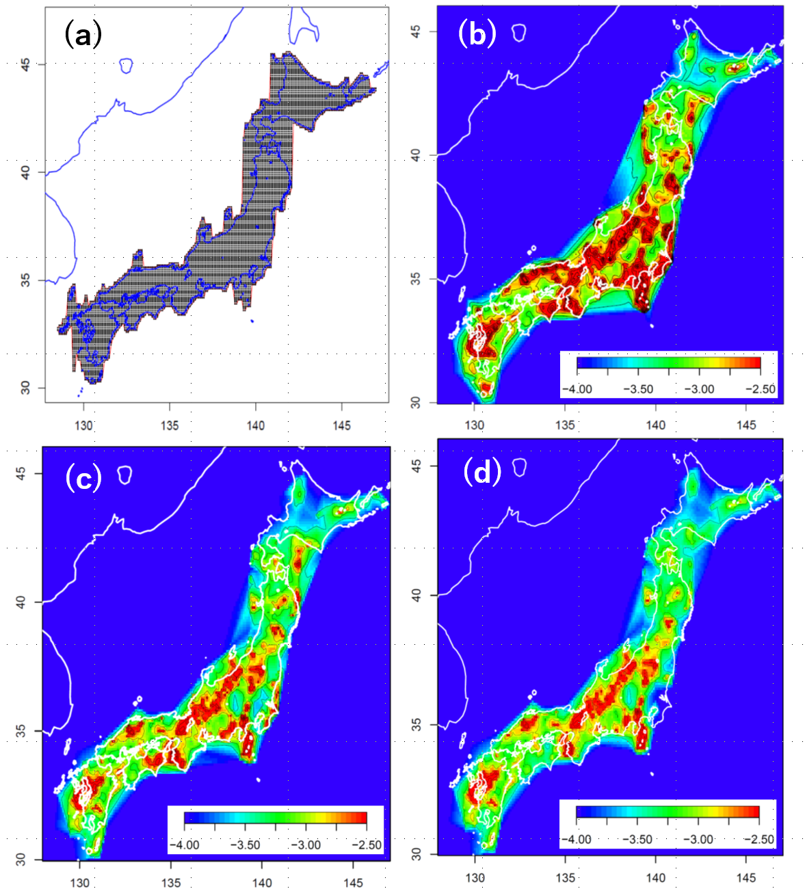

Fig. S4

Fig. S5

Fig. S6

