Antifungal compound from marine Serratia marcescens BKACT and its potential activity against Fusarium sp.

Bharat A. Kharat ^{1, 3}, Madhukar S. Said^{2, 3}, and Syed G Dastager ^{1, 3*}

¹ NCIM-Resource Center, CSIR-National Chemical Laboratory, Dr. Homi Bhabha Road, Pune-411008, India.
² Division of Organic Chemistry, CSIR-National Chemical Laboratory, Dr. Homi Bhabha Road, Pune-411008,
India.
³ Academy of Scientific and Innovative Research (AcSIR), Ghaziabad 201002, India Pune-411008, India.

List of Contents

Sr. No | Description
1 | Figure S1: Antagonistic activity of BKACT against Fusarium spp. by dual culture assay
2 | Figure S2: TLC profile of crude extract and its bio autography
3 | Figure S3: Schematic diagram for the purification
4 | Figure S4: NMR Data ¹H, ¹³C and DEPT
5 | Figure S5: GC-MS profile of the compound
6 | Figure S6. Identification of purified compound by HPLC and TLC
7 | Figure S7: Antifungal activity, time kill curve and minimum inhibitory concentration of 2, 4- DTBP

Supplementary figure. 1 Antagonistic activity of BKACT against Fusarium spp. on dual culture plate and microscopic examination of antifungal effect.

Supplementary figure. 2 TLC profile of crude extract at UV 254nm and its bio autography against F. foetens NCIM 1330

Supplementary figure. 3 Schematic diagram for the purification of antifungal compound from crude extract of BKACT.

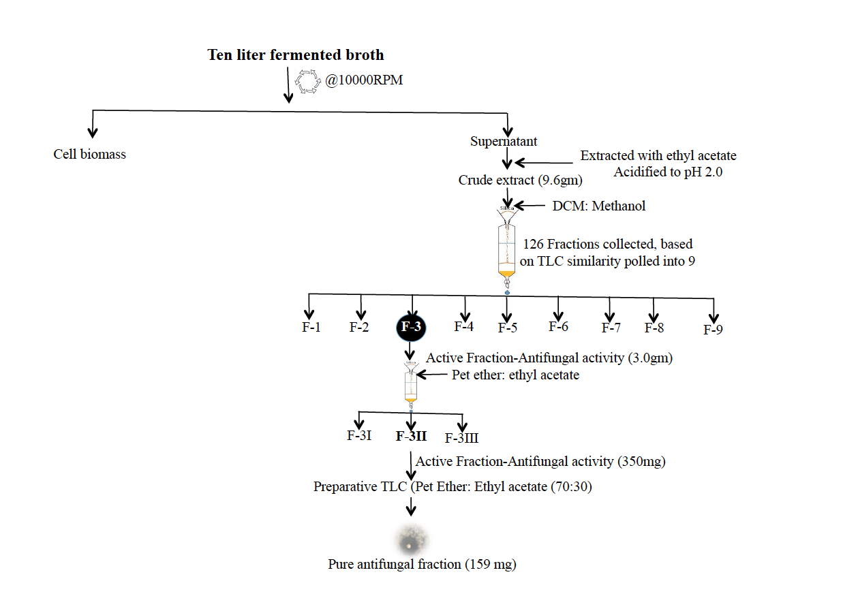

Supplementary figure. 4 Structure elucidation of purified compound by NMR, a. ¹H NMR spectrum, b. ¹³C NMR spectrum, c. DEPT NMR spectra.

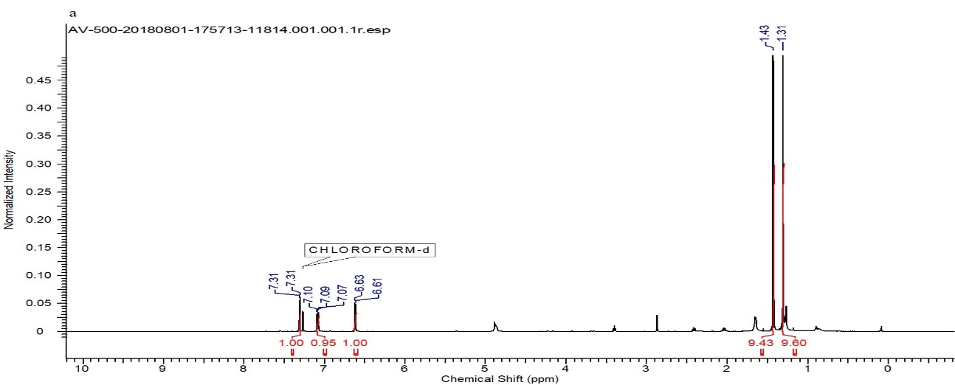

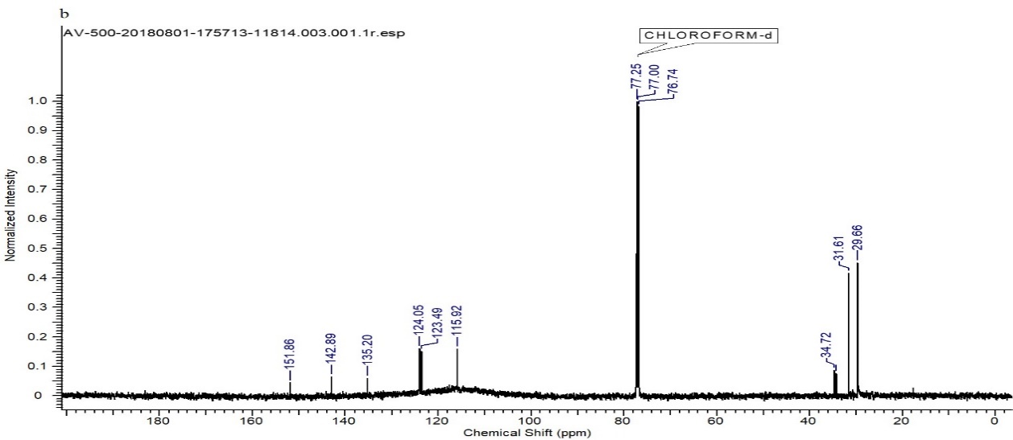

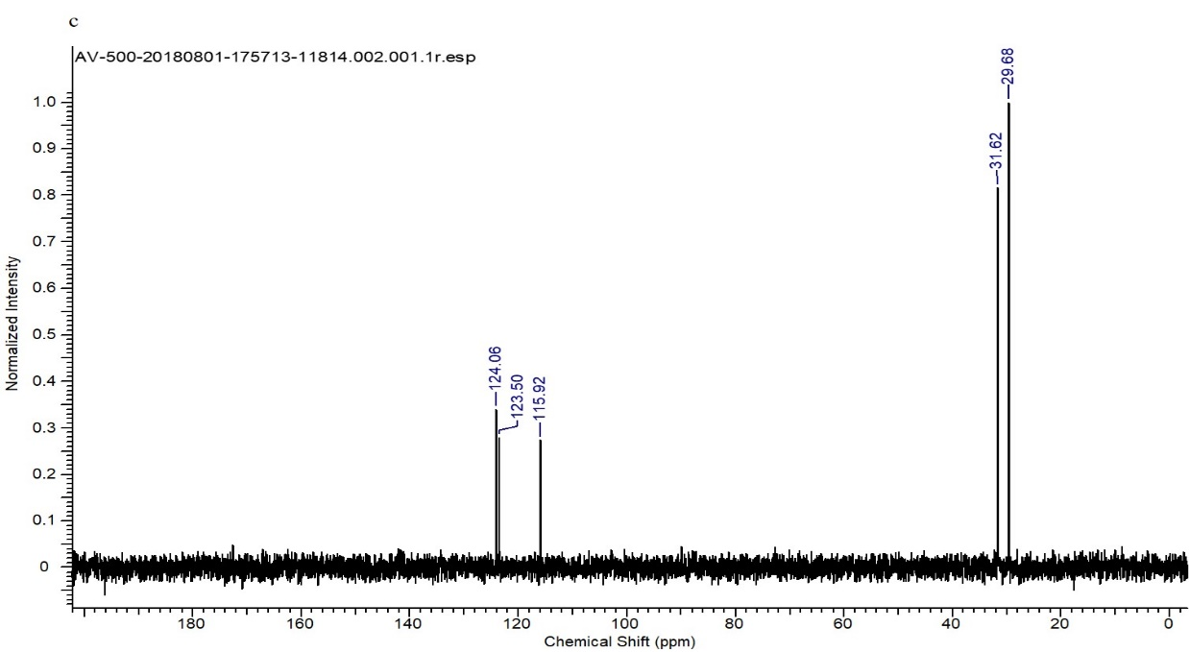

Supplementary figure. 5 GC-MS of the crude extract from BKACT, Ion [M] + at m/z 206, the fragment ion [M –CH3] + at m/z 191 are characteristic for 2, 4- DTBP.

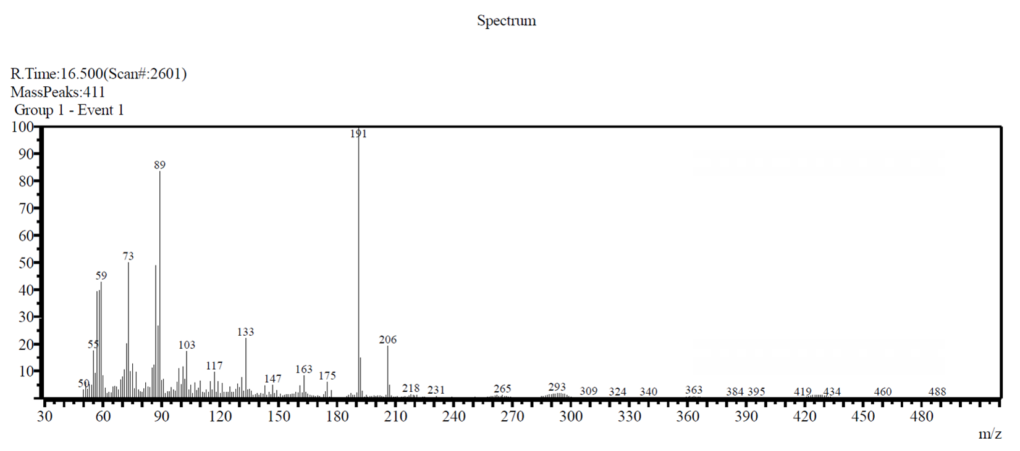

Supplementary figure. 6 Comparative analysis of purified compound with standard reference compound (1. purified compound, 2. Standard 2, 4- DTBP) by TLC & HPLC. a. TLC image shows compound 1 and 2 at same retention factor (Rf) and b. HPLC chromatogram shows compound 1&2 peaks identified at the same retention time (Rt).

Supplementary figure. 7 Antifungal activity of 2, 4-DTBP against F. foetens NCIM 1330, a. MIC determination in 96 well plate assay on the basis of visual growth, b. Time kill curve and c. Determination of MFC value.

