Table 1: Performance of the classifiers for cases and control
 | With all Features
Classifiers | Measures | T2DM | Non-T2DM | Weighted avg. | Accuracy
NB | Precision | 0.93 | 0.81 | 0.87 | 87%
NB | Recall | 0.82 | 0.93 | 0.87 | 87%
NB | F1- score | 0.87 | 0.86 | 0.87 | 87%
SVM | Precision | 0.97 | 0.75 | 0.97 | 84%
SVM | Recall | 0.73 | 0.98 | 0.73 | 84%
SVM | F1- score | 0.84 | 0.85 | 0.84 | 84%
KNN | Precision | 0.90 | 0.77 | 0.84
KNN | Recall | 0.78 | 0.90 | 0.84 | 83%
KNN | F1- score | 0.84 | 0.83 | 0.83
DT | Precision | 0.80 | 0.78 | 0.79
DT | Recall | 0.82 | 0.76 | 0.79 | 81%
DT | F1- score | 0.81 | 0.77 | 0.79
Where NB-Naïve-Bayes, SVM -support vector machine, KNN- K-nearest neighbor and DT- Decision tree.

Table 2: Confusion Matrix and ROC curve for each of the classifiers
Confusion Matrix | ROC Curve
Naïve-Bayes  AUC= 87.2 (0.872) | 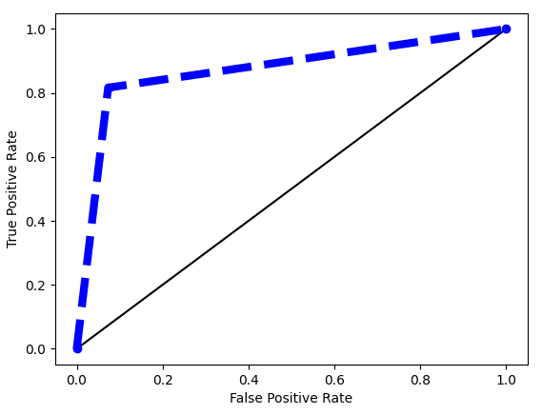
   |  | PREDICTED
  ACTUAL |  | T2DM | Non-T2DM
  ACTUAL | T2DM | 40 | 1
  ACTUAL | Non-T2DM | 13 | 36

K-Nearest Neighbor  AUC = 83.9 (0.839) | 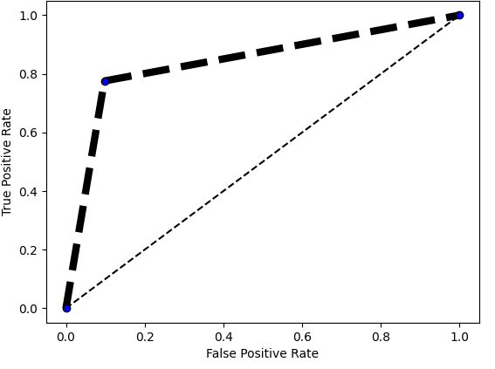
   |  | PREDICTED
  ACTUAL |  | T2DM | Non-T2DM
  ACTUAL | T2DM | 37 | 4
  ACTUAL | Non-T2DM | 11 | 38
Support Vector Machines  AUC = 85.5% (0.855) | 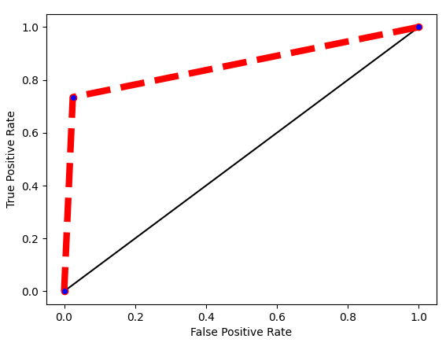
   |  | PREDICTED
  ACTUAL |  | T2DM | Non-T2DM
  ACTUAL | T2DM | 38 | 3
  ACTUAL | No- T2DM | 9 | 40

Decision Tree  AUC = 80.9 (0.809) | 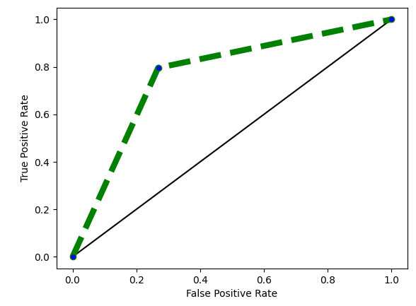
   |  | PREDICTED
  ACTUAL |  | T2DM | Non-T2DM
  ACTUAL | T2DM | 30 | 11
  ACTUAL | No- T2DM | 9 | 40

