Supplementary figures
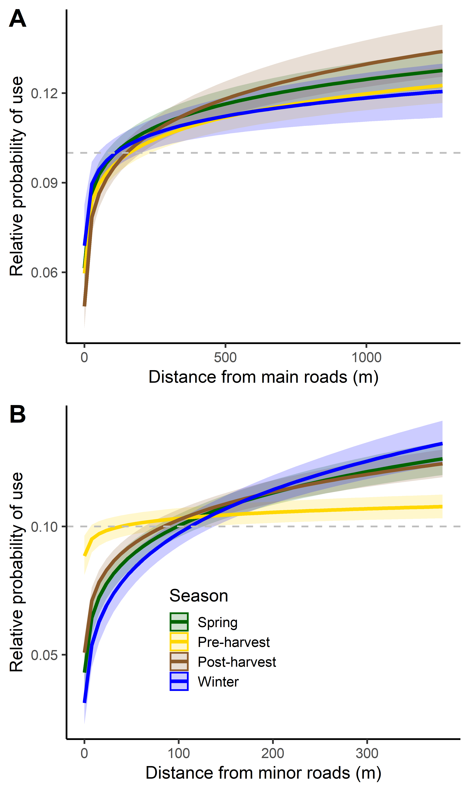
Fig. S1: The predicted effect of (A) distance to main roads (interaction with season was not included in most parsimonious model), and (B) the interaction of season × distance to minor roads on the relative probability of use by European hares (Lepus europaeus) in Denmark during daytime (hares mostly inactive). Values >0.1 indicate selection, whereas values <0.1 indicate avoidance. The 95% confidence intervals are given as shading.
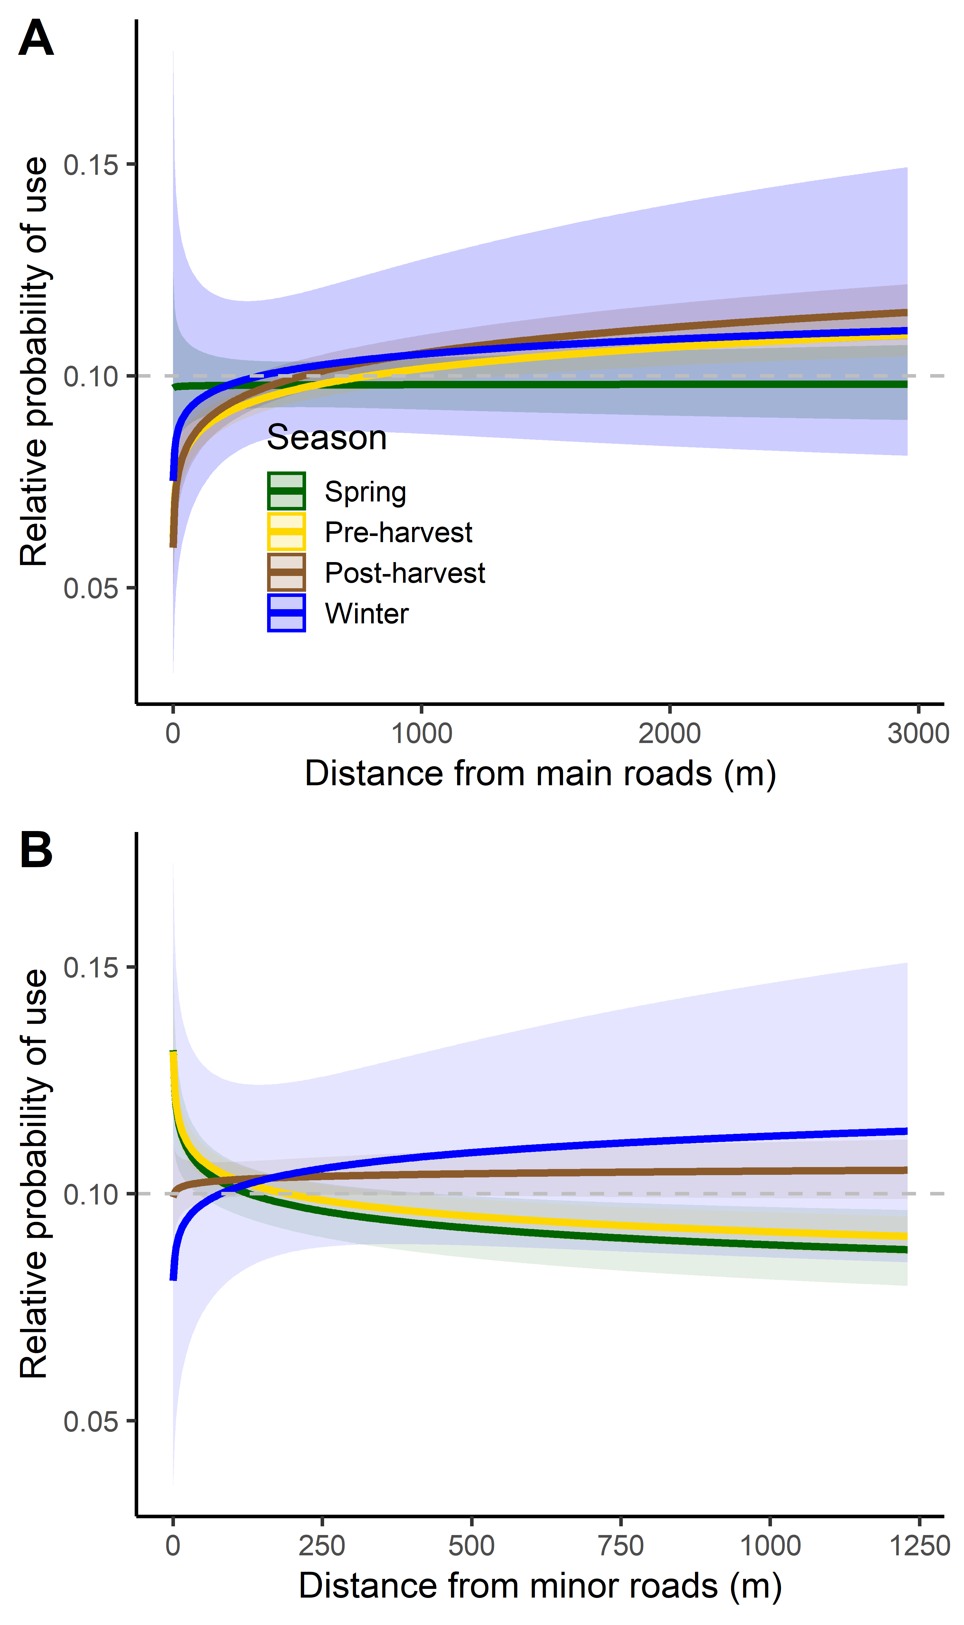
Fig. S2: The predicted effect of the interaction of (A) season × distance to main roads and (B) season × distance to minor roads on the relative probability of use by European hares (Lepus europaeus) in Northern Germany during daytime (hares mostly inactive). Values >0.1 indicate selection, whereas values <0.1 indicate avoidance. The 95% confidence intervals are given as shading.
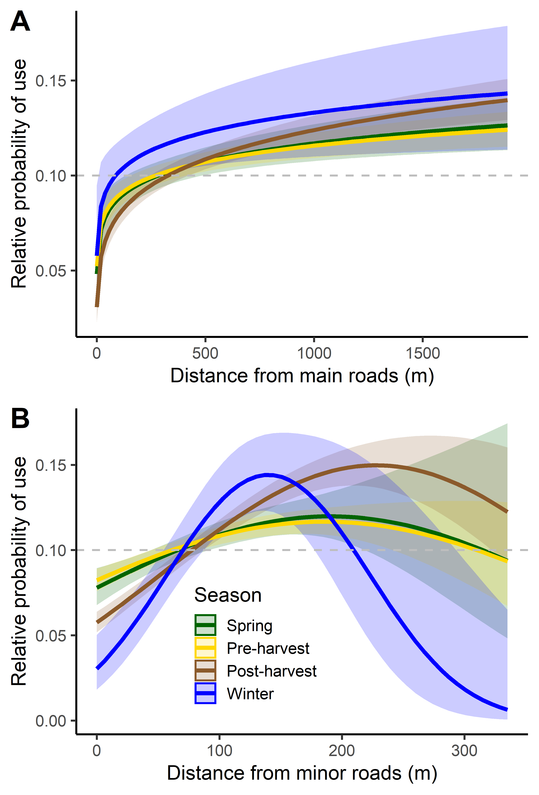
Fig. S3: The predicted effect of the interaction of (A) season × distance to main roads, and (B) season × distance to minor roads on the relative probability of use by European hares (Lepus europaeus) in Southern Germany during daytime (hares mostly inactive). Values >0.1 indicate selection, whereas values <0.1 indicate avoidance. The 95% confidence intervals are given as shading.

