Extended Data Figures
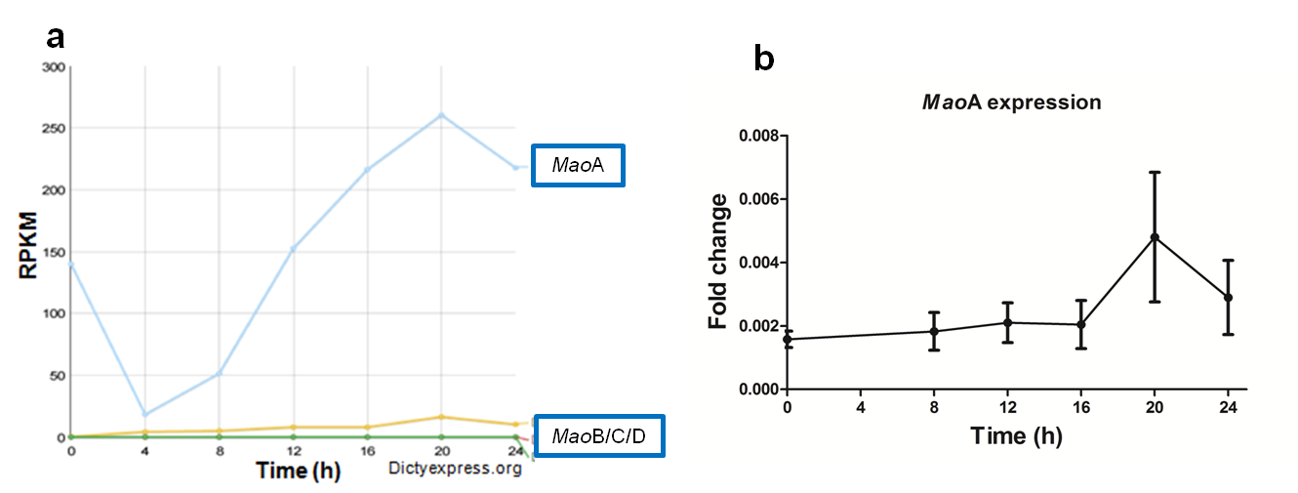
c
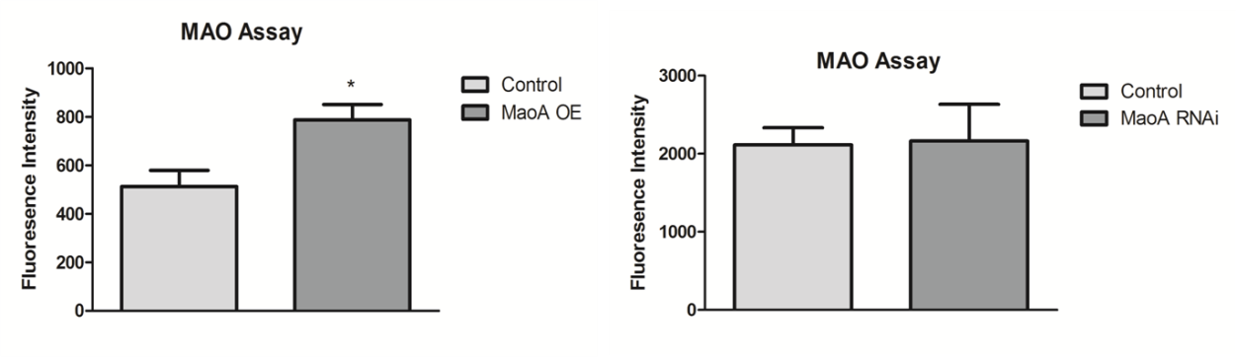
d

Fig. 1 MaoA expression during growth and development in Dictyostelium. MAO activity in Dictyostelium cell extracts
a, Expression profile of all four isoforms of Dictyostelium mao obtained from RNA sequencing data (https://dictyexpress.research.bcm.edu). b, Total RNA was isolated from Dictyostelium during vegetative growth and development using TRIzol method. To quantify maoA expression, qRT-PCR was carried out with rnlA as a control and the fold change was calculated accordingly. Time points are shown in hours (bottom). Error bars represent the mean and SEM (n = 3). c-d, The enzymatic assay for monoamine oxidase was performed in overexpression and knockdown cells of maoA with the corresponding control. Dictyostelium cell lysates were treated with equal volume of p-tyramine (substrate), HRP conjugate and the fluorescent dye reagent. The H₂O₂ released as a byproduct would react with HRP conjugate and the fluorescent dye. This results in an increase in the fluorescent emission and its intensity for the control and test were plotted. c, Increased MAO activity in maoA^{OE} cells compared to controls. Error bars represent the mean and SEM (n=2). *P< 0.05. d, MaoA knockdown cells have no change in their activity compared to control, an effect possibly due to other isoforms of MAO. Error bars represent the mean and SEM (n=3).
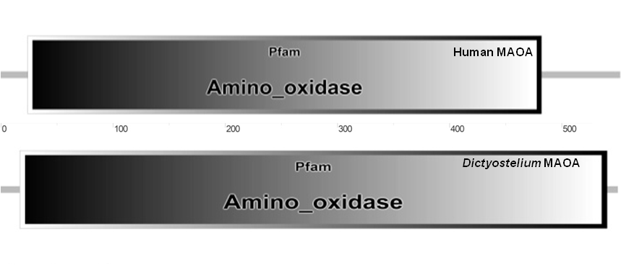
b
a
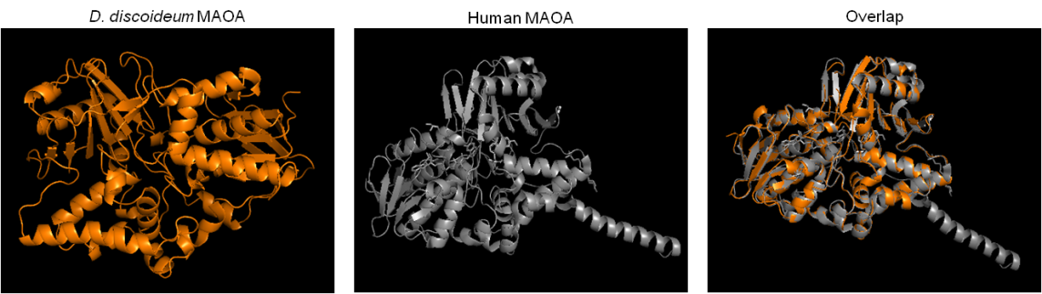

Fig. 2 Conserved amine oxidase domain of Dictyostelium MAOA.
a, Dictyostelium MAOA have the conserved amino oxidase domain as revealed by SMART analysis. b, MAOA of humans (template) (PDB ID - 2Z5X) and Dictyostelium have several structural similarities and align with a RMSD value of 0.44 Aº.

a
Cell extract
Serotonin
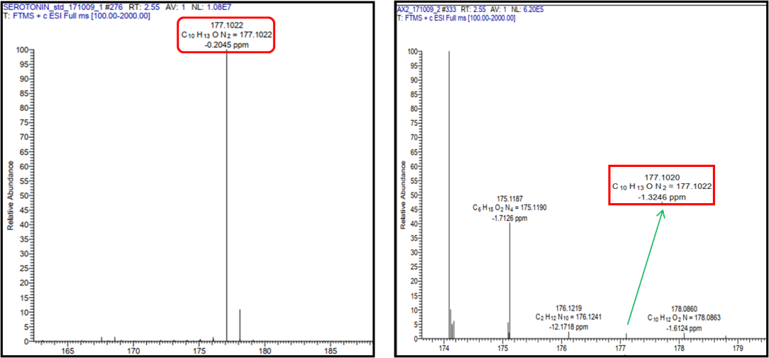
b
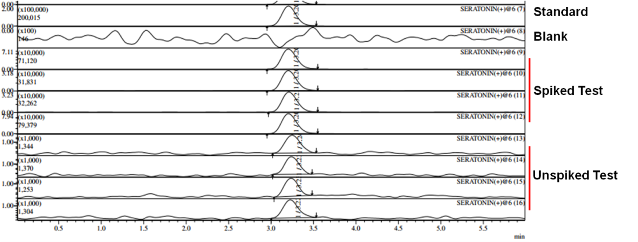
c
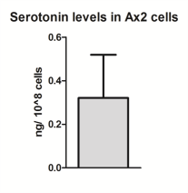

Fig. 3 LC-MS analysis showing the presence of serotonin in Dictyostelium.
a, Using High-Resolution Accurate Mass Spectrometry, the corresponding mass of serotonin (177.1022) was detected in Dictyostelium cell lysates. The mass value of serotonin standard matched with that of the test. Mass accuracy was determined by calculating the serotonin mass to that of the test sample and it was less than 1.5 ppm, well within the acceptable 5 ppm range (n=2). b, Presence of serotonin was confirmed by a triple quadrapole LC-MS instrument. To determine the accuracy of the analysis, the cell lysates were spiked with serotonin and a single but elevated peak with the same retention time was observed and this correlated with the unspiked test and standard, confirming the mass accuracy (n=4). c, Serotonin levels (0.321 ± 0.198) were quantified in Dictyostelium mounds using a triple quadrapole LC-MS instrument (n=3).
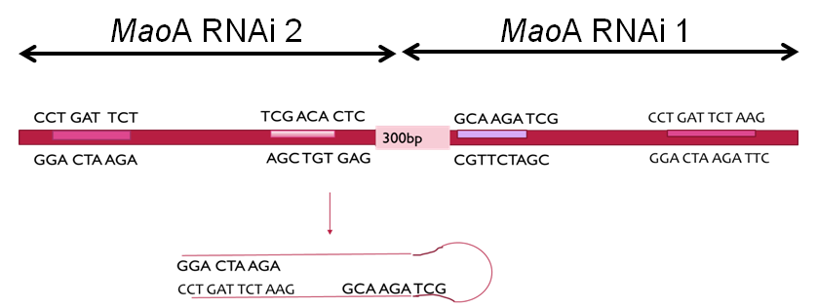
a
b
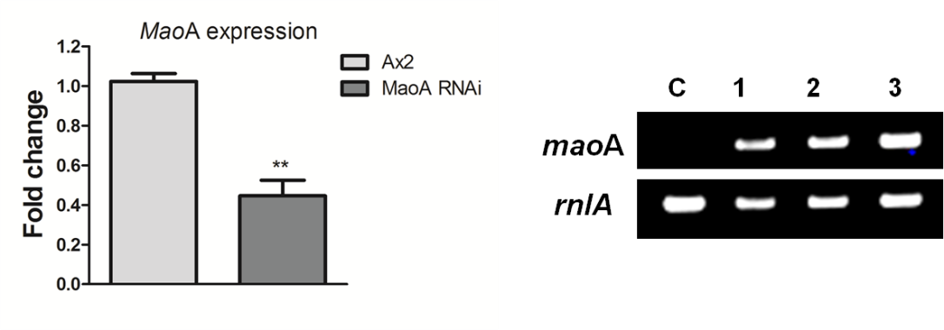
c

Fig. 4 Confirmation of RNAi and overexpression clones of maoA.
a, Schematic representation of the hairpin loop in maoA RNAi construct. b, qRT-PCR showing decreased maoA expression in [RNAi]maoA cells (n=3). **P< 0.01. c, MaoA overexpression was confirmed by semi-quantitative PCR.

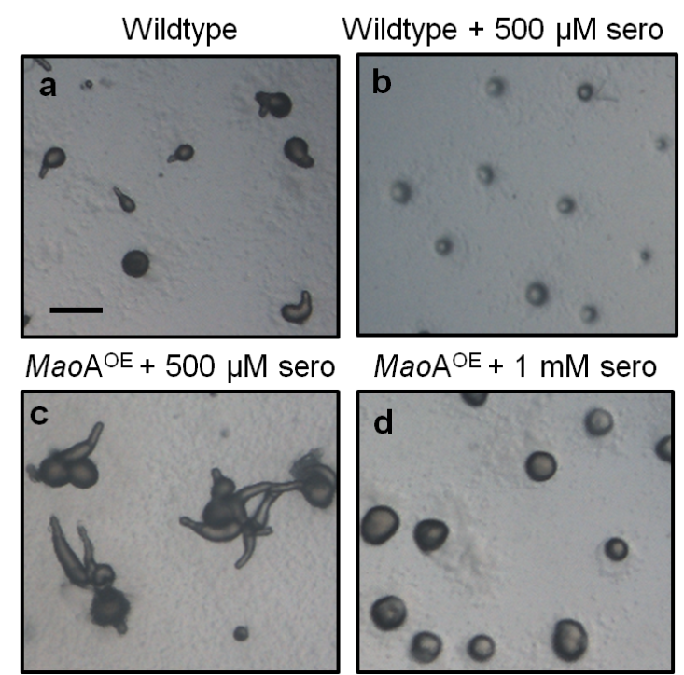
e
Docking serotonin with Dictyostelium maoA
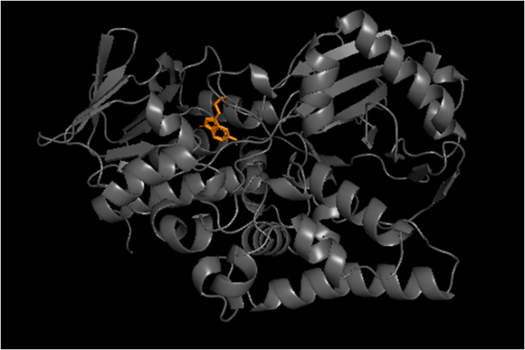

Fig. 5 Serotonin addition to wildtype phenocopies maoA RNAi mound arrest. Interaction of serotonin with MAOA.

a, Wildtype cells washed with KK2 buffer were plated on phosphate buffered agar and images were taken after 16h. b-c, Wildtype (b) and maoA^{OE} (c) cells were mixed with 500 µM of serotonin and plated for development and imaged after 16 h. d, MaoA^{OE} cells were treated with 1 mM of serotonin and observed at 16 h. Scale bar, 0.5 mm. e, Dictyostelium MAOA and serotonin interacted with a binding energy of -8.5 kcal/mol.

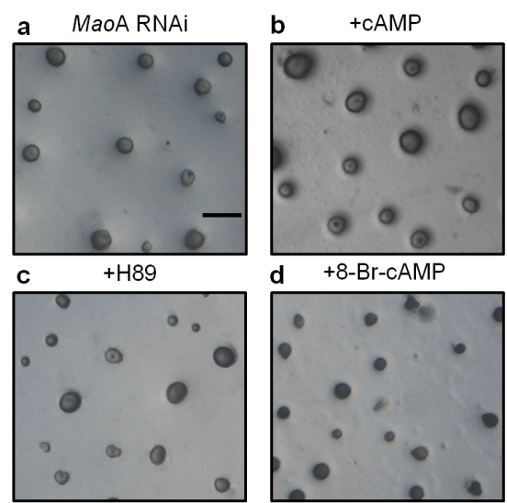

Fig. 6 Altering PKA activity failed to rescue [RNAi]maoA phenotype.
a, KK2 buffer added on top of RNAi mounds (control). b-d, Addition of 0.2 mM cAMP or (b), 50 µM H89 or (c) 5 mM 8-Br-cAMP (d). Images were taken 2-4 h post chemical treatment. Scale bar, 0.5 mm.

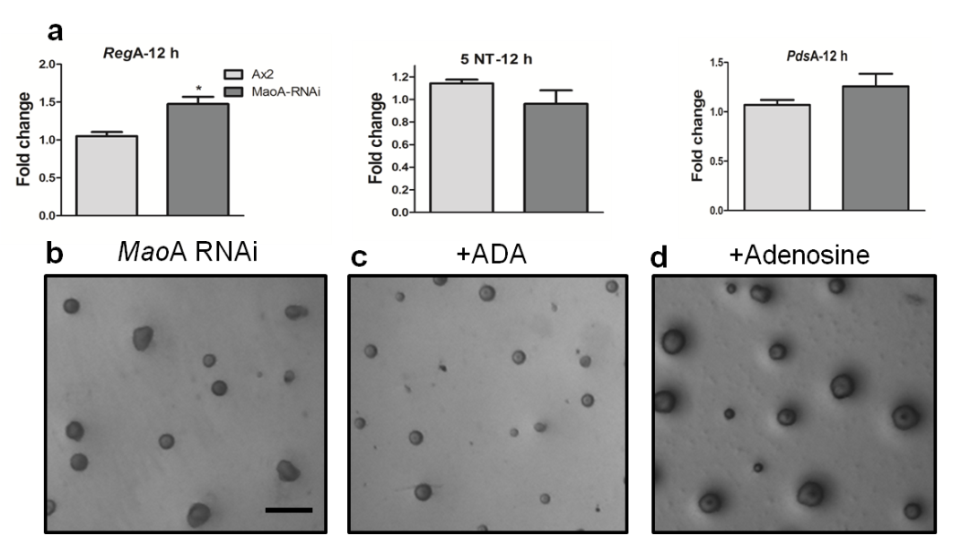

Fig. 7 Altering adenosine levels did not rescue maoA knockdown phenotype.
a, Expression profile of 5’ nucleotidase (5’ NT) and phosphodiesterases (regA, pdsA) involved in cAMP to adenosine conversion. Error bars represent the mean and SEM (n=3). b, [RNAi]maoA mounds. c-d, 5U of adenosine deaminase (c) and 2 mM adenosine (d) were added on top of [RNAi]maoA mounds. Images were taken 2-4 h post chemical treatment. Scale bar, 0.5 mm.

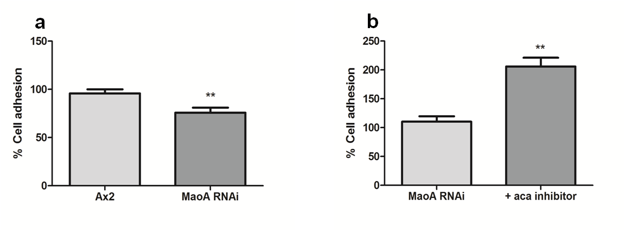
Cell-cell adhesion
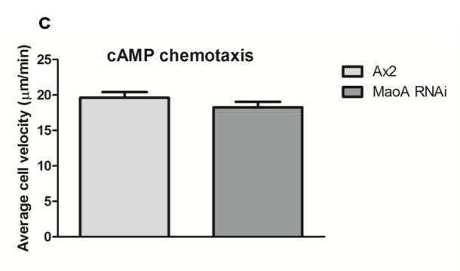

Fig. 8 Cell-cell adhesion and not cAMP chemotaxis is significantly impaired in [RNAi]maoA. a, Wildtype and maoA knockdown cells was developed on KK2 agar and after 16 h, the multicellular mounds/slugs were dissociated by vigorous vortexing in KK2 buffer. Individual cells were counted using a Neubauer chamber and resuspended in phosphate buffer. Non-adherent, single cells were counted 45 min post incubation. The percent cell-cell adhesion was plotted by normalising wildtype count as 100%. Error bars represent the mean and SEM (n=3) b, To ascertain the effect of cAMP on cell-cell adhesion in [RNAi]maoA, cells were treated with 2 mM aca inhibitor. Percentage of cell adhesion was plotted subsequent to normalising with untreated [RNAi]maoA cells (100% cell adhesion). Error bars represent the mean and SEM (n=2). **p<0.01. c, An under-agarose cAMP chemotaxis assay was performed and average cell velocity in response to 10 μM cAMP was recorded. The graph represents the mean and SEM (n=2).

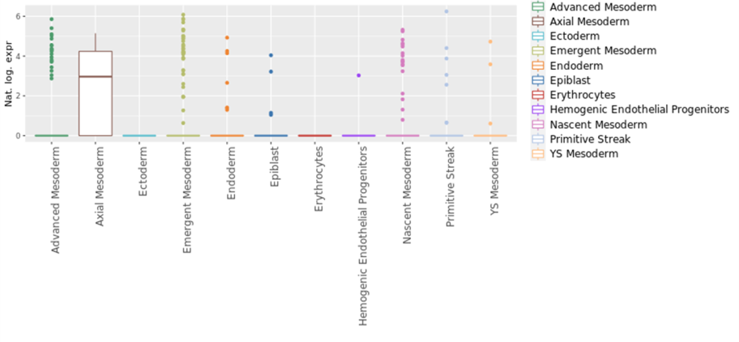
MaoA expression during early gastrulation in humans
MaoA expression during early gastrulation in mice
b
a

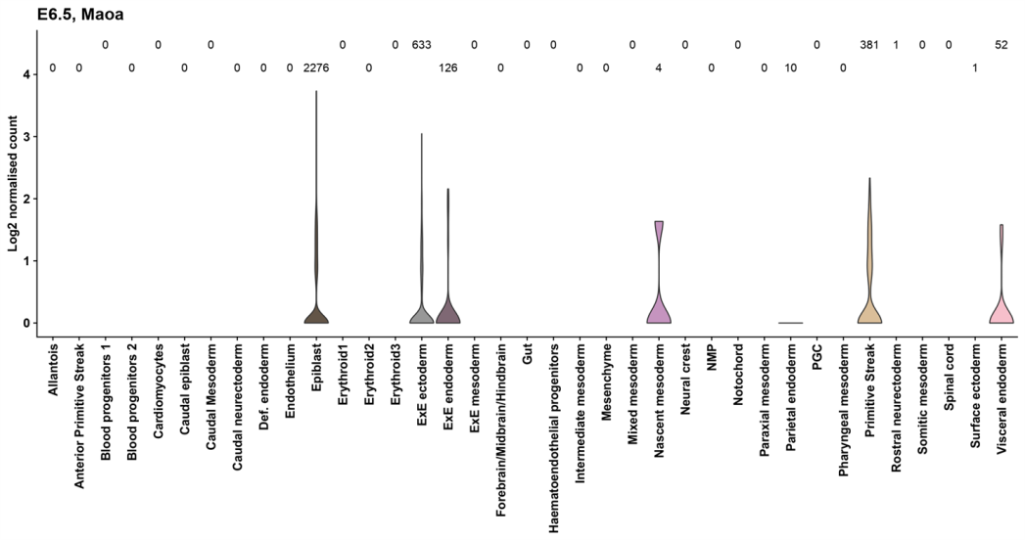
c
MaoA expression during early gastrulation in Xenopus

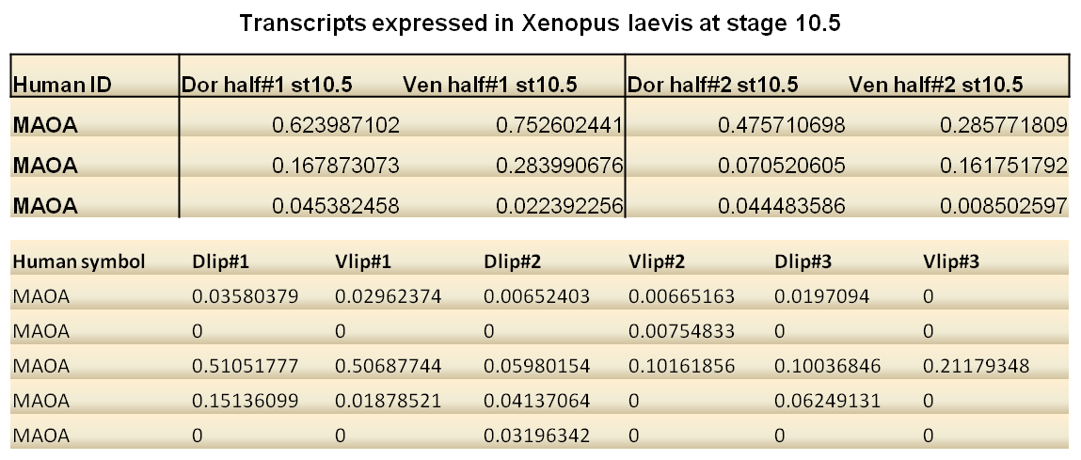

Fig. 9 Transcriptomic profile of maoA during gastrulation and pre-gastrulation stages of three different organisms.
a, Single cell RNA sequencing data of the human gastrulating embryo were obtained from the human-gastrula.net/ database. MaoA expression was observed in the primitive streak (vertebrate organizer). b, Single cell RNA sequencing data of mice (E6.5) were obtained from the marionilab.cruk.cam.ac.uk/MouseGastrulation2018/ database. MaoA expression in the primitive streak indicates its possible role in organizer formation. c, Microarray and RNA sequencing of the Xenopus laevis (stage 10.5) embryo showing maoA expression.
Phylogenetic tree of maoA
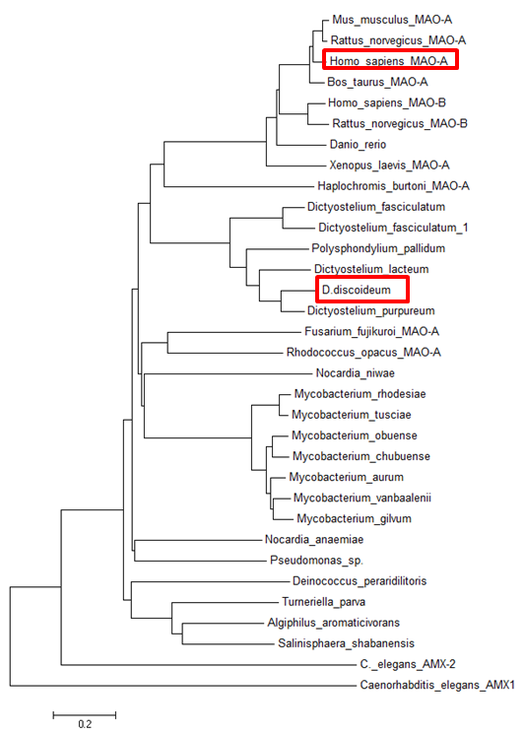

Fig. 10 Phylogenetic tree showing the relationship between MAOA of Dictyostelium with that of other organisms.
Phylogenetic tree of MAOA was constructed using MEGA5 (Molecular Evolutionary Genetic Analysis 5). The Neighbour-Joining Tree revealed that the maoAs across various organisms (bacteria, Dictyostelium and higher animals) share a common ancestor and are closely related with each other. The common clade between human and Dictyostelium suggest similarities between the respective proteins.

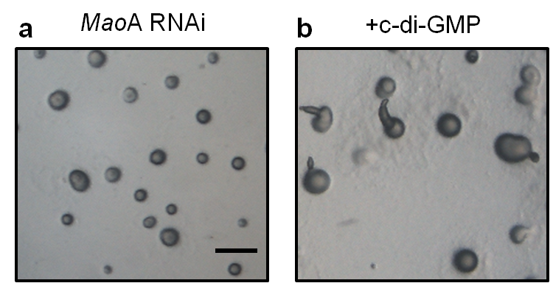

Fig. 11 Partial rescue of [RNAi]maoA phenotype with cyclic di-GMP.

a-b, [RNAi]maoA lines developed in the presence of 1 mM c-di-GMP. Images were taken after 14 h. Scale bar, 0.5 mm. c-di-GMP causes stalk cell induction in Dictyostelium and when added on [RNAi]maoA mounds, it led to stalk formation in a fraction of mounds (20.23 ± 6.86%).

