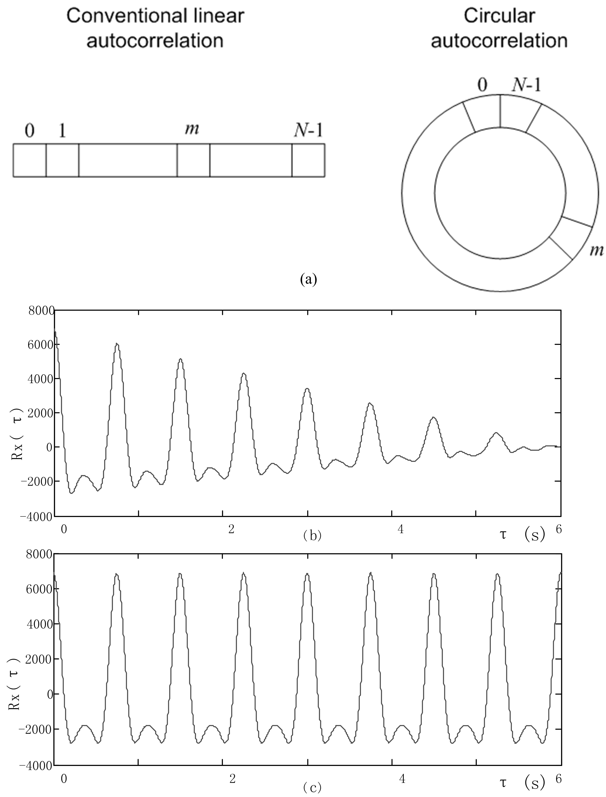
Supplementary fig. 1 (a) Memory management of conventional linear autocorrelation and circular autocorrelation computation. (b) Autocorrelation function of a typical PPG signal calculated by conventional linear autocorrelation. (c) Autocorrelation function calculated by circular autocorrelation

