Plant Foods for Human Nutrition
Lepidium meyenii Walp (red maca) supplementation prevents acrylamide-induced oxidative stress and liver toxicity in rats: Phytochemical composition by UHPLC–Q/Orbitrap/MS/MS
Roberto O. Ybañez-Julca^{1*}, Javier Palacios², Daniel Asunción-Alvarez¹, Iván Quispe-Diaz¹, Chukwuemeka R. Nwokocha³, Ricardo Diego de Albuquerque⁴.
¹ Laboratorio de Farmacología, Facultad de Farmacia y Bioquímica, Universidad Nacional de Trujillo. Trujillo, Perú.
² Laboratorio de Bioquímica Aplicada, Facultad de Ciencias de la Salud, Universidad Arturo Prat, 1110939 Iquique, Chile.
³ Department of Basic Medical Sciences, Faculty of Medical Sciences, The University of the West Indies, Kingston, Jamaica.
⁴ Laboratório de Tecnologia em productos Naturais, Universidade Federal Fluminense, Niterói, Brasil.

*Correspondence: Roberto O. Ybañez-Julca- E-mail address: rybanez@unitru.edu.pe

Supplementary material

Figure S1 (a-h): Full MSMS spectra and structures of peaks 1 (a), 5 (b), 6 (c), 7 (d), 9 (e), 10 (f), 12(g), 25 (h).

a) peak 1
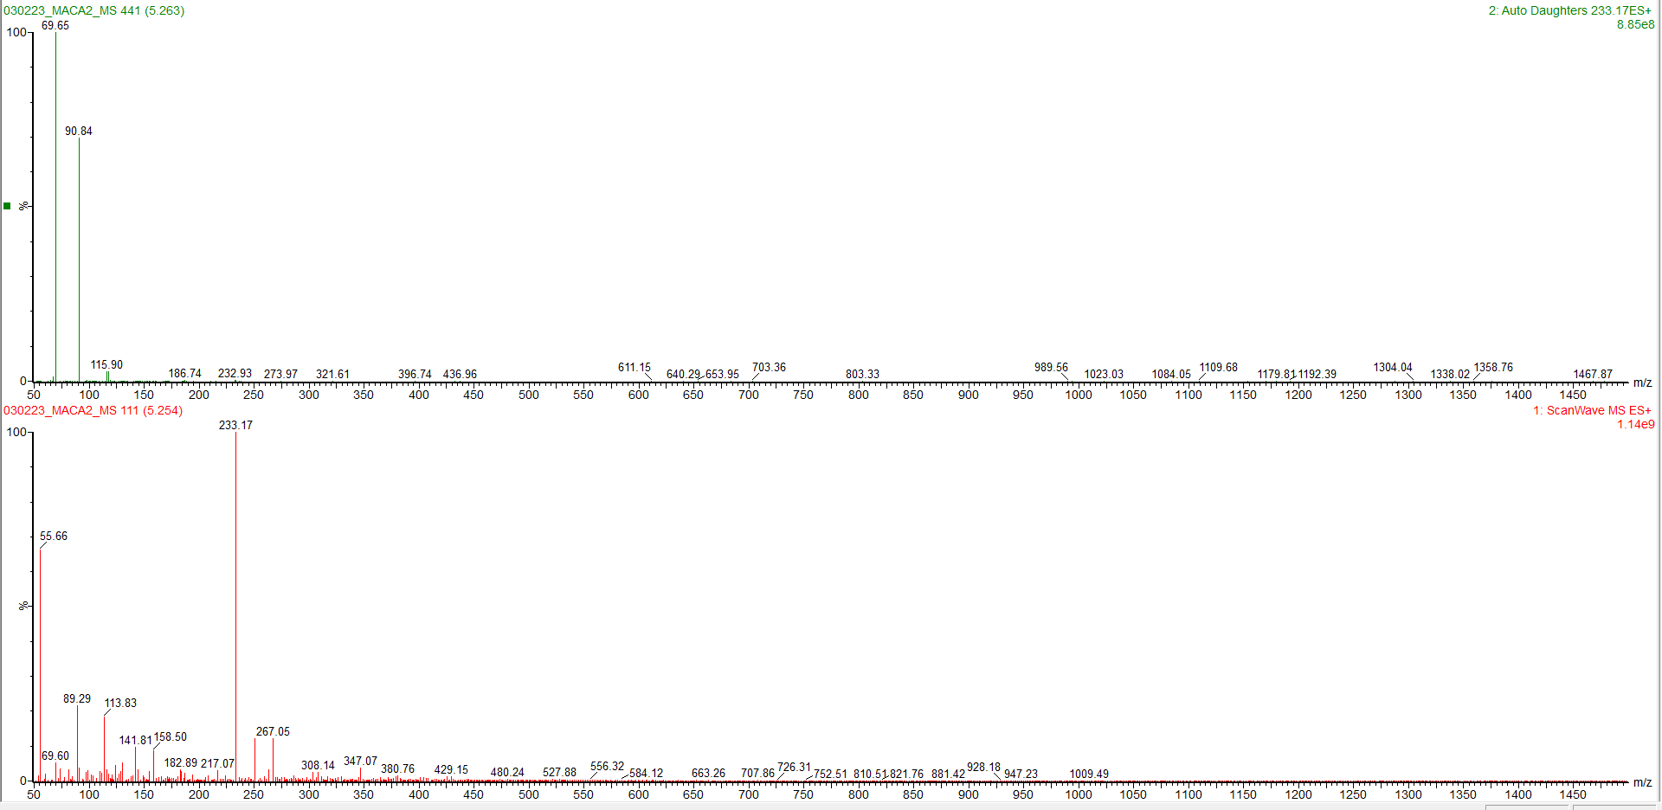

b) peak 5
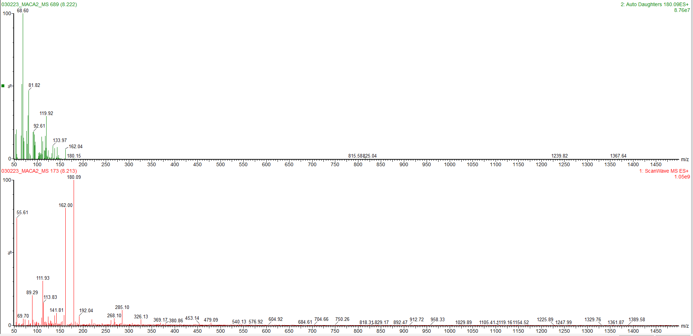

c) peak 6
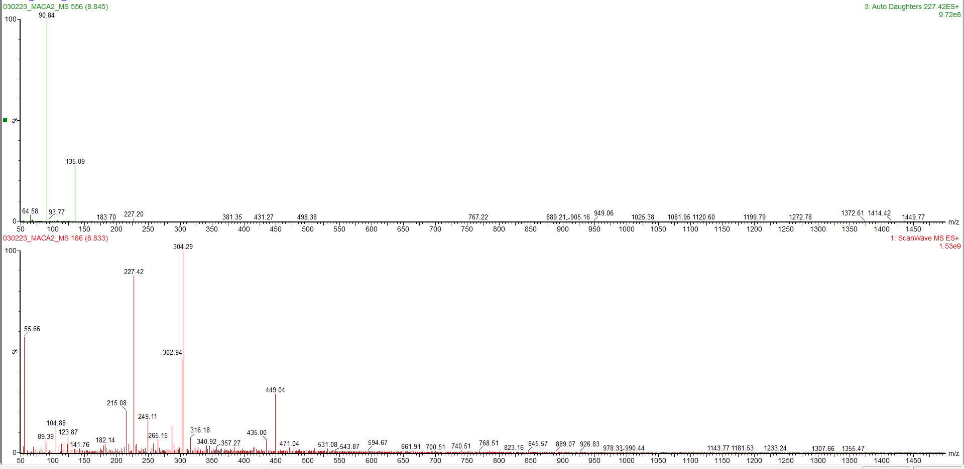

d) peak 7
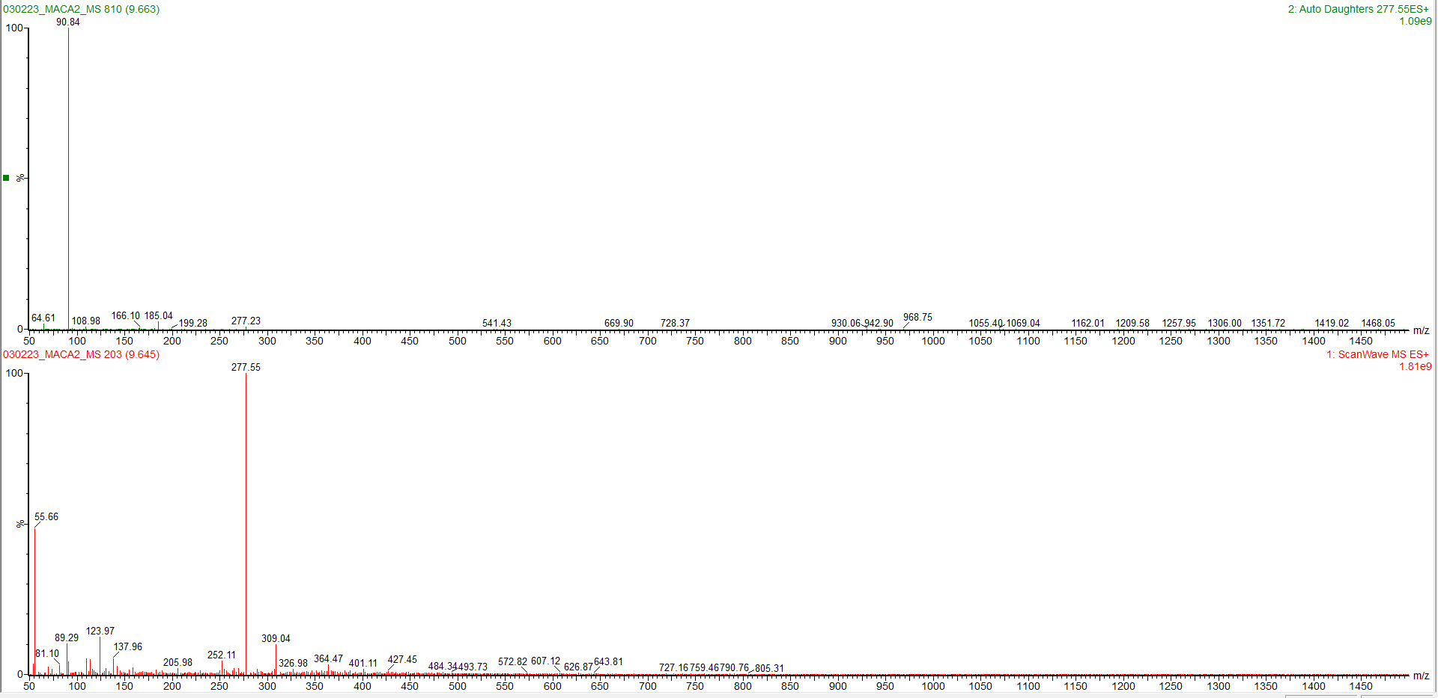

e) peak 9
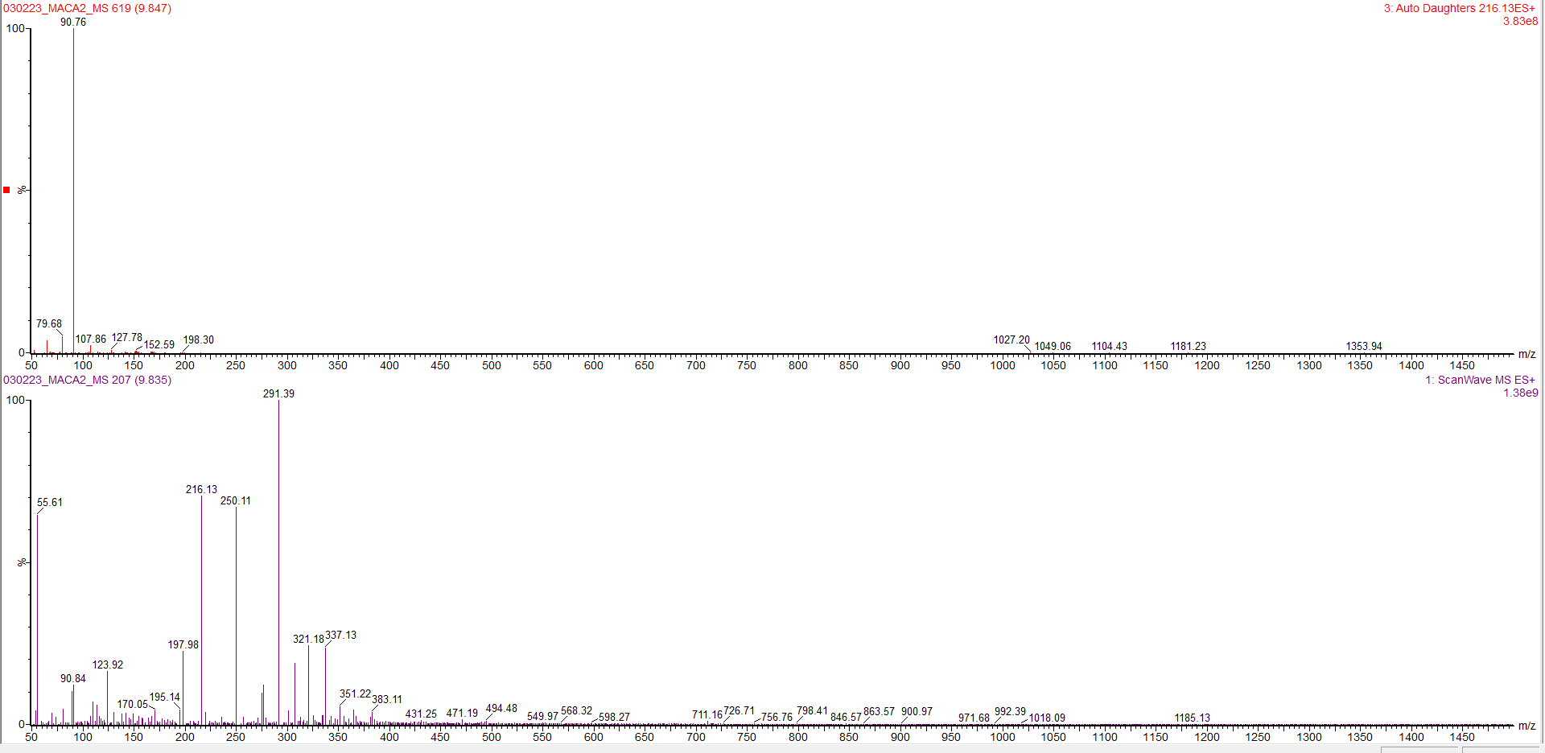

f) peak 10
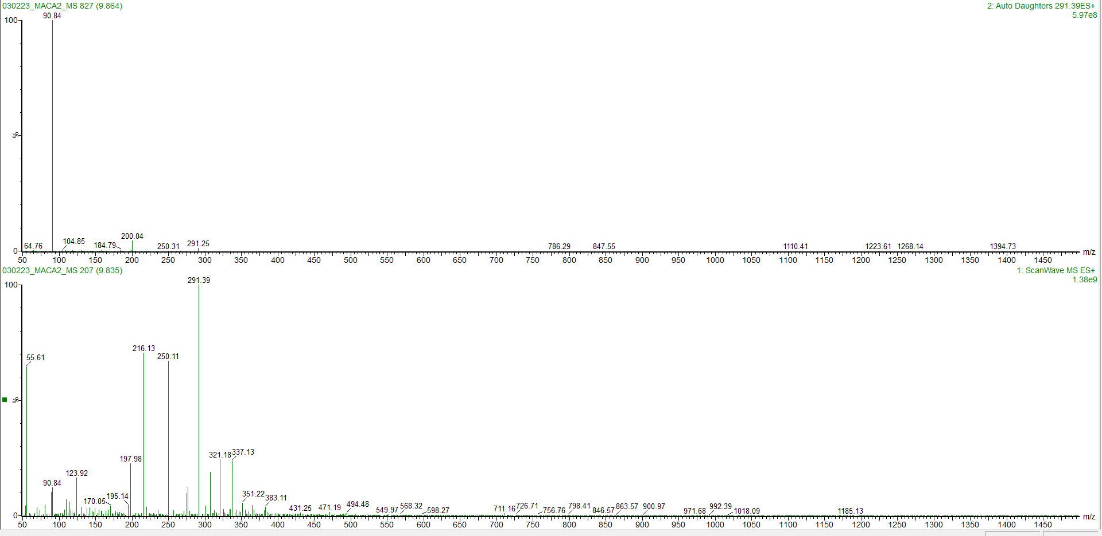

g) peak 12
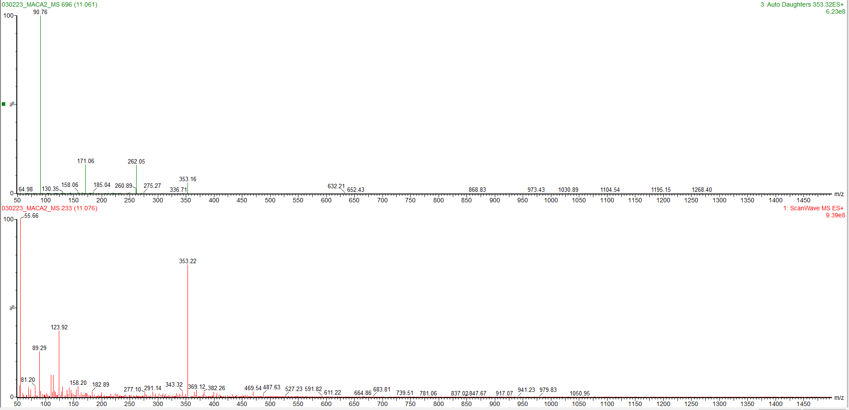

h) peak 25
