Supplementary data

Long-chain fatty dihydropyridines with antihypertensive and cardioprotective potential for damage caused by ischemia and reperfusion
Eduarda Santa-Helena^{1,2}, Joaquim de Paula Ribeiro², Diego da Costa Cabrera³,Carolina Rosa Gioda^{1,2}, Marcelo G. Montes D’Oca³, Luiz Eduardo Maia Nery^{1,2} and Carla Amorim Neves Gonçalves^{1,2}
    - Postgraduate Program in Physiological Sciences, Institute of Biological Sciences, Federal University of Rio Grande - FURG, Rio Grande, RS, Brazil
    - Institute of Biological Sciences, Federal University of Rio Grande - FURG, Rio Grande, RS, Brazil

    - Kolbe Organic Synthesis Laboratory, School of Chemistry and Food, FURG, Rio Grande, RS,
Brazil

Corresponding author: Luiz Eduardo Maia Nery. Instituto de Ciências Biológicas, Universidade Federal do Rio Grande - FURG, Av. Itália Km 8, CEP 96201-900, Rio Grande, RS - Brazil.
Phone/Fax: +55 53 32336848 or +55 53 32336854

Email address: famnery@terra.com.br

Instituto de Ciências Biológicas - Universidade Federal do Rio Grande – FURG, Rio Grande, RS, Brazil Zip Code: 96203-900 Rio Grande, RS, Brazil.

Contents
- Selected ¹H, ¹³C NMR and FT-IR spectra ……………………………………………………………S2-S6
- Reference …………………………………………………………………………………………………...S7

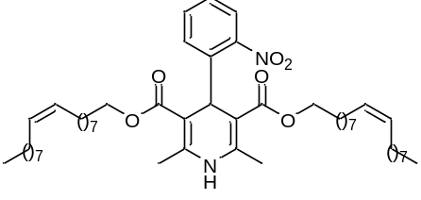
- ¹H NMR spectrum (CDCl₃, 400 MHz) of 2c

- ¹³C NMR spectrum (CDCl₃, 100 MHz) of 2c

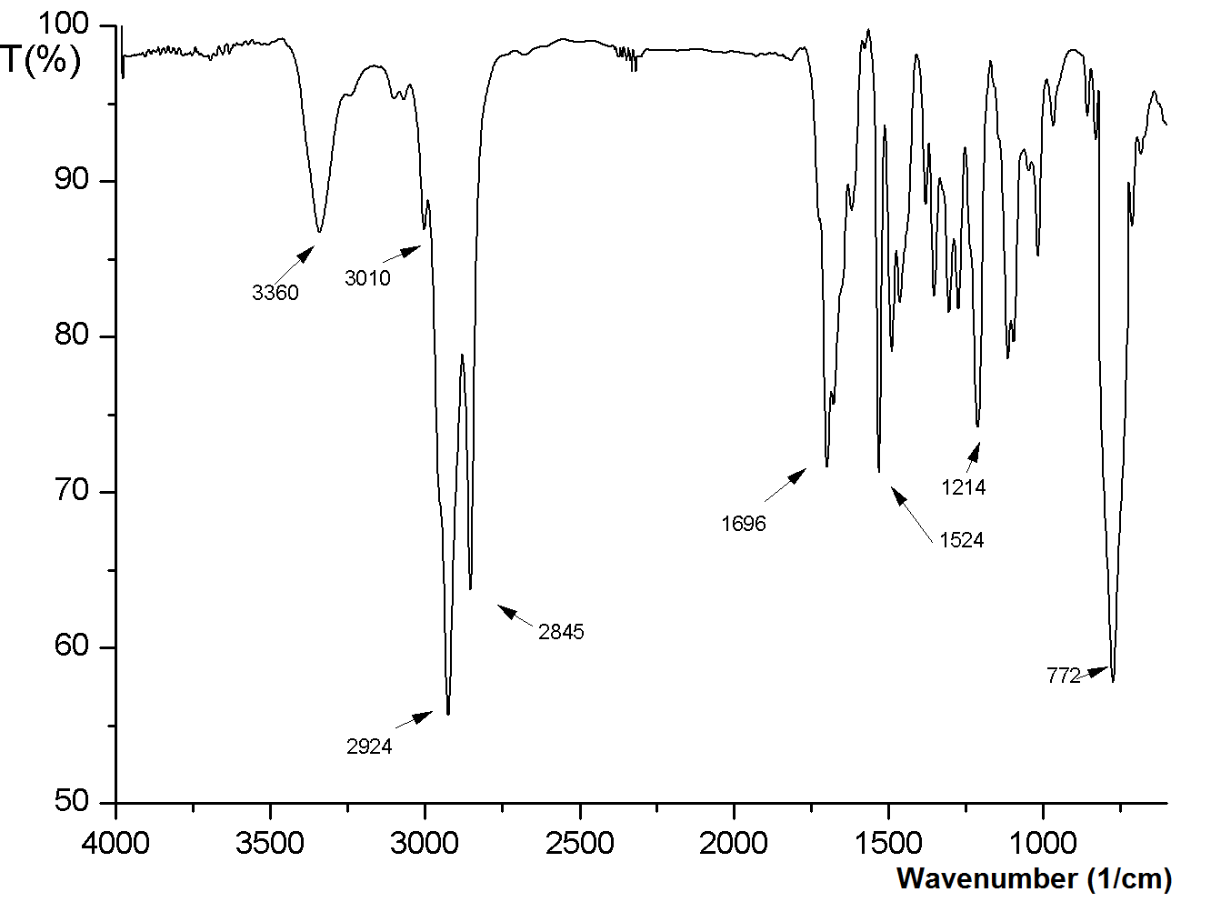
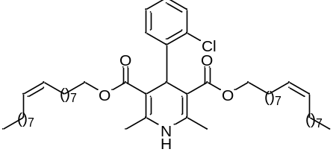
- FT-IR spectrum (KBr, ν_{max}cm⁻¹) of 2c

- ¹H NMR spectrum (CDCl₃, 400 MHz) of 8c
- ¹³C NMR spectrum (CDCl₃, 100 MHz) of 8c

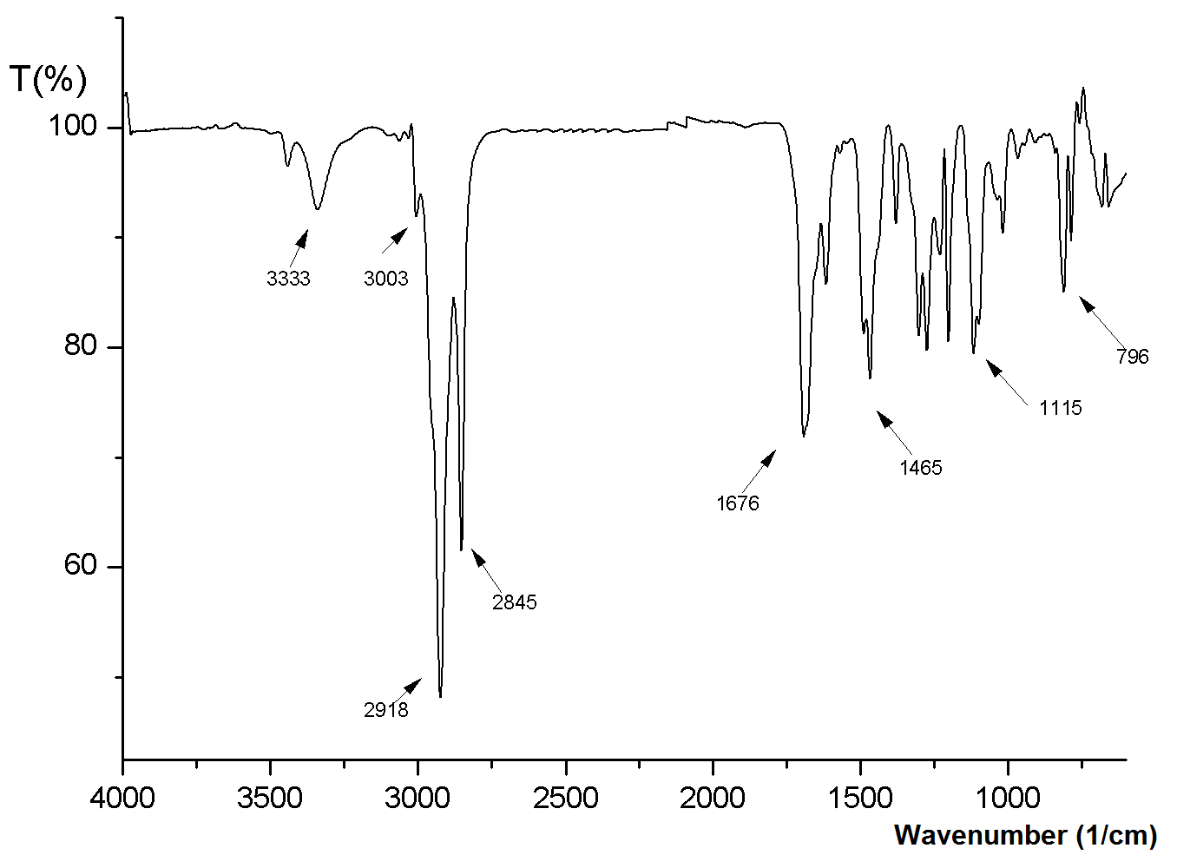
- IR-FT spectrum (film, ν_{max}cm⁻¹) of 8c

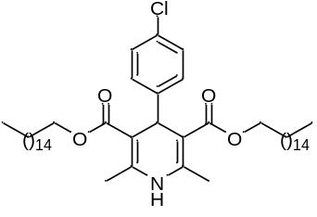

- ¹H NMR spectrum (CDCl₃, 400 MHz) of 9a

- ¹³C NMR spectrum (CDCl₃, 100 MHz) of 9a
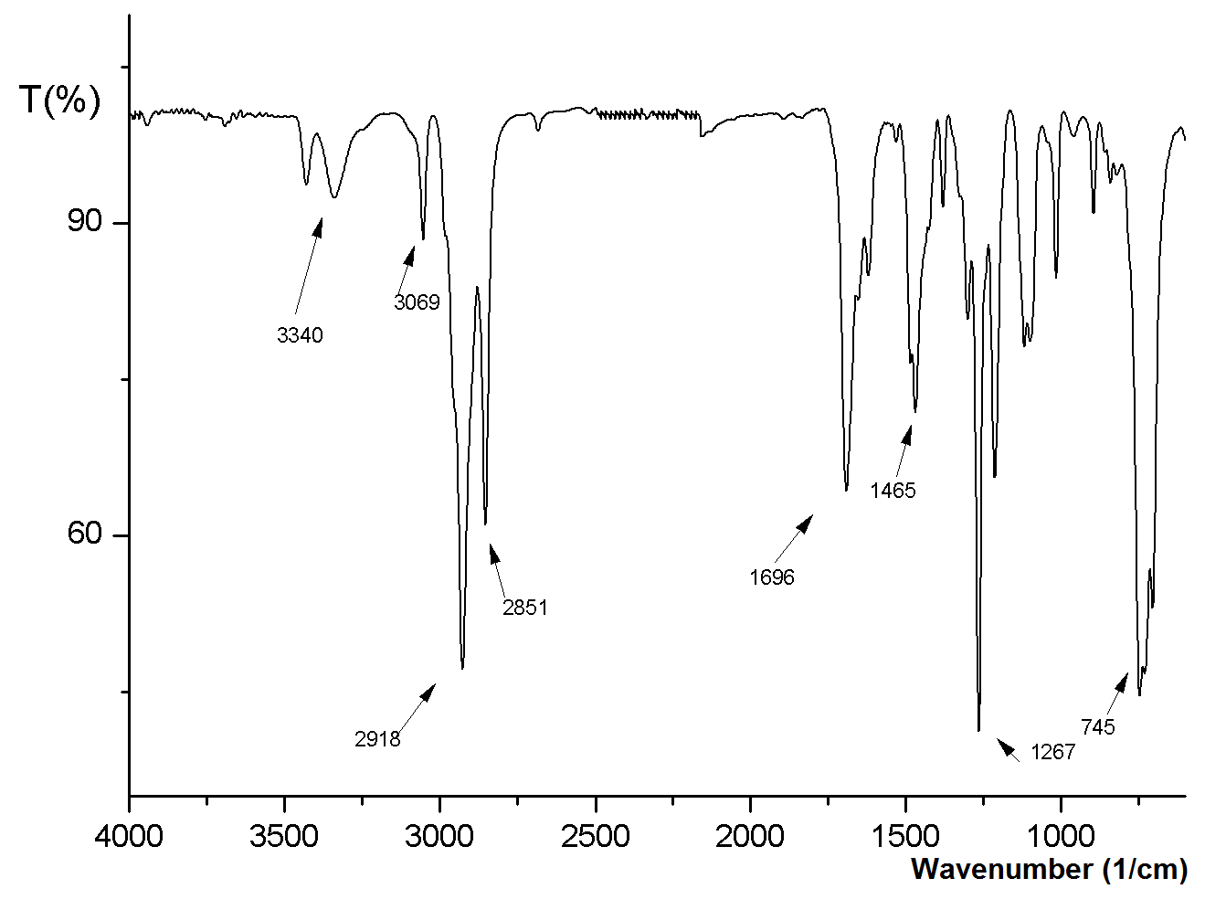

- FT-IR spectrum (film, ν_{max}cm⁻¹) of 9a

Reference

- Cabrera, D. C., Santa-Helena, E., Leal, H. P., de Moura, R. R., Nery, L. E. M., Gonçalves, C. A. N., Russowsky, D. and D'Oca, M. G. M. (2019). Synthesis and antioxidant activity of new lipophilic dihydropyridines. Bioorganic chemistry, 84, 1-16.

