Supplementary

Towards In Vivo Proof-of-Binding of ¹⁸F-labeled Inhibitor [¹⁸F]TRACK to Peripheral Tropomyosin Receptor Kinases

Melinda Wuest^{1*}, Justin J. Bailey¹, Jennifer Dufour¹, Darryl Glubrecht¹, Vanessa Omana², Tom H. Johnston³, Jonathan M. Brotchie³, Ralf Schirrmacher^{1*}

¹Department of Oncology and Cross Cancer Institute, University of Alberta, Edmonton, Alberta, Canada

²The Neuro - Montreal Neurological Institute-Hospital, McGill University, Montreal, Quebec, Canada

³Krembil Research Institute, University Health Network, Toronto, Ontario, Canada

⁴Atuka Inc., Toronto, Ontario, Canada.

[¹⁸F]TRACK
A)
B)
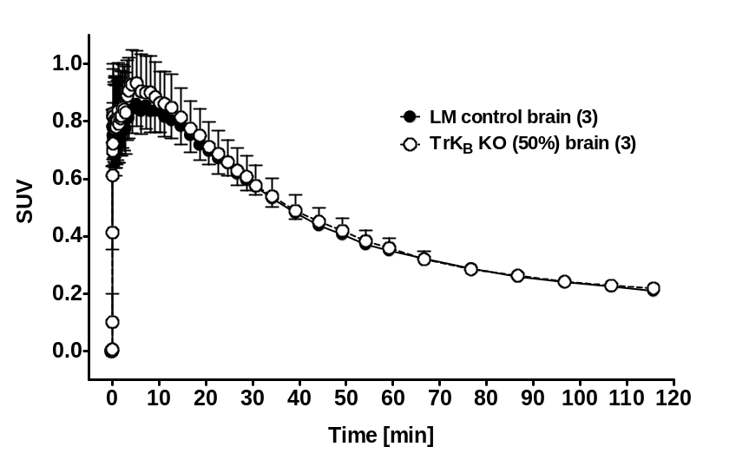

Figure S1: A) Representative PET images as maximum intensity projections (MIP) after injection of [¹⁸F]TRACK at 30 min post injection. Left: B6129SF2/J control mouse and Right: B6129S2-Ntrk2^{tm1Bbd}/J 50% TrkB knock out mouse. B) Time-activity curves for the radioactivity distribution in the whole brain over the time frame of 2 hours. Data are shown as SUV mean values from 3 experiments each.
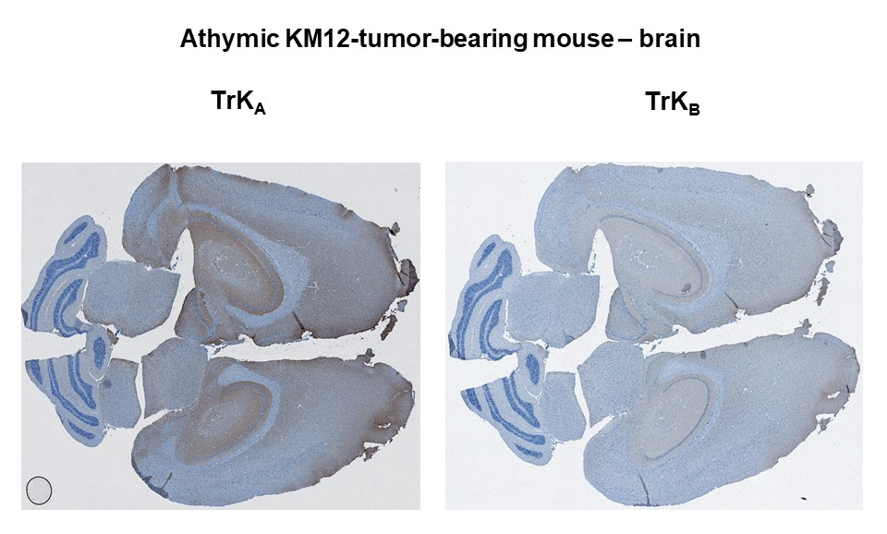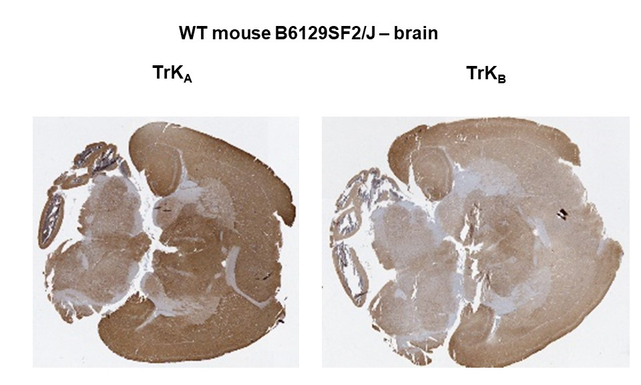

Figure S2: Immunohistochemical staining of TrkA and TrkB in the whole brain of an athymic KM12-tumor-bearing mouse (top) and a wild type (WT) control B6129SF2/J mouse (bottom). Pictures were taken using a 5x objective.

[¹⁸F]TRACK
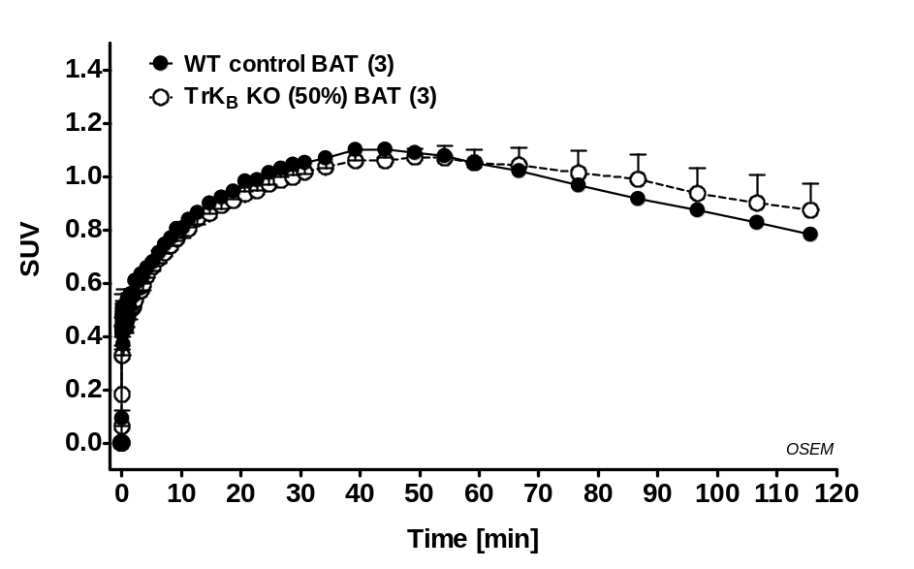

Figure S3: Time-activity curves for the radioactivity uptake into brown adipose tissue (BAT) of WT B6129SF2/J control mice and B6129S2-Ntrk2^{tm1Bbd}/J 50% TrkB knock out mice over the time frame of 2 hours. Data are shown as SUV mean values from 3 experiments each.

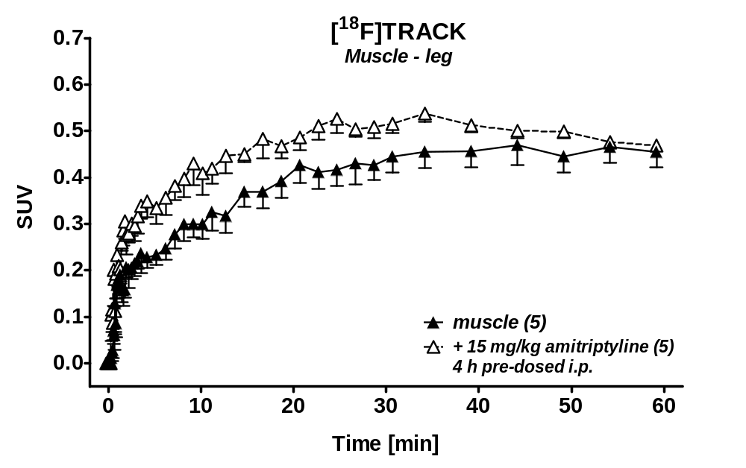

Figure S4: Time-activity curves for the radioactivity uptake profile in mouse muscle tissue of KM12-tumor bearing athymic nude mice over the time frame of 60 min after injection of [¹⁸F]TRACK. Data were collected in the absence and presence of 15 mg/kg amitriptyline (pre-dosed i.p. 4 hours before radiotracer injection) Data are shown as SUV mean values from 5 experiments each.

