The Mini Colon Model: a benchtop multi-bioreactor system to investigate the gut microbiome
Supplementary Information
Zijie Jin^{1,2}, Andy Ng^{1,2}, Corinne F. Maurice³, and David Juncker^{1,2}

¹McGill Genome Centre, McGill University, 740 Doctor Penfield Avenue, Montreal, QC, H3A 0G1 Canada ²Department of Biomedical Engineering, McGill University, Montreal, Quebec H3A 2B4, Canada ³Department of Microbiology and Immunology, McGill University, Montreal, QC H3A 2B4, Canada

Supplementary Table S1 PERMANOVA analysis between each pair of MiCoMo-grown communities from independent volunteers for Jaccard and Bray-Curtis indices
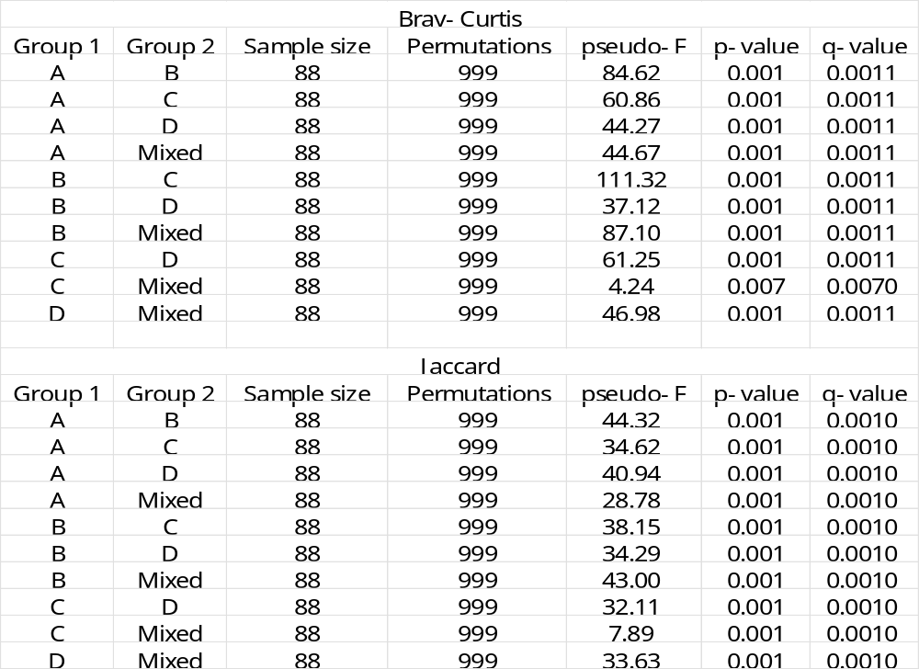

Supplementary Table S2 MiCoMo Component list
Category | Item name | Catalogue number | Supplier | # of items for 1 set of 3 reactors | Unit price (USD)
Water bath | Anova Sous vide | AN400-US00 | Amazon | 1 | $120
Water bath | plastic box |  | Dollarama | 1 | $2
Water bath | ping-pong balls |  | Dollarama | 1 | /
Pumps (fluidics) | 6-Channel Pump | RP-6R01S-3P6A-DC10VS | Takasago | 2 (1 could also work but adds uncertainty) | $234.92 (from 26180 JPY)
Pumps (pH) | RP-Q Series (0.2ml/min) | RP-Q1.2N-P20Z-DC3V pump | Takasago | 6 | $54.56 (from 6080 JPY)
Solenoid Valves (gas sparging) | Diaphragm Valve - KV series | KV-2-NCG | Takasago | 3 | $60.03 (from 6690 JPY)
Scaffold (Stand) | Clear Scratch- and UV-Resistant Cast Acrylic Sheet, 6" x 12" x 3/16" | 8560K163 | Mcmaster Carr | 6''X12'' | $6.76
Scaffold (base) | Clear Scratch- and UV-Resistant Cast Acrylic Sheet, 6" x 12" x 1/4" | 8560K163 | Mcmaster Carr | 6''X12'' | $12.35
Tubing (fluidic) | High-Temperature Abrasion-Resistant Soft Silicone Tubing  for Food, Beverage and Dairy, 1 mm ID, 2 mm OD | 3184K284 | Mcmaster Carr | ~10 ft for 1 assembly | $0.35
Tubing (pH) | Extreme-Temperature Teflon® PTFE Semi-Clear Tubing  for Chemicals, 1/32" ID, 1/16" OD | 5239K23 | Mcmaster Carr | ~5ft for 1 assembly | $1
Tubing (gas and feed bottle)  (also used in reactor assembly) | Clear Masterkleer Soft PVC Plastic Tubing  for Air and Water, 1/16" ID, 1/8" OD | 5233K51 | Mcmaster Carr | ~10ft for 1 assembly | $0.2
Tubing (connectors) | Plastic Quick-Turn Tube Coupling, Plugs, for 1/16" Barbed Tube ID, Polycarbonate | 51525K271 | Mcmaster Carr | ~20 | $0.52
Tubing (connectors)  (Included reactor connectors) | Plastic Quick-Turn Tube Coupling, Sockets, for 1/16" Barbed Tube ID, Polycarbonate | 51525K281 | Mcmaster Carr | ~20 | $0.46
Reactor (pH probe) | ASP200-2-1M-BNC pH Lab Electrode | 3550_0 | Phidget | 3 | $25
Reactor (body) | Corning 430639 cell culture flask, 25 cm2, canted neck, vented cap, sterile | UZ-01936-02 | Corning | 3 | $3
Reactor (gas needle) | Stainless Steel Dispensing Needle with Luer Lock Connection, 1-1/2" Needle Length, 16 Gauge | 75165A753 | Mcmaster Carr | 3 | $0.3
Reactor (seeding port) | PK100 BLUE CAP,9MM, BONDED PRE-SLIT | 29320-U | Superlco | 3 | $0.5
Electronics (Microcontroller) | ARD-MEGA Arduino Mega2560 Compatible Development Board | ARD-MEGA | Abra Electronics | 2 | $28
Electronics (pH module) | pH/ORP Adapter | 1130_0B | Phidget | 3 | $30
Electronics (jumper wires) | TUOFENG 22 awg Solid Wire-Solid Wire Kit-6 Different Colored 30 Feet/9M spools 22 Gauge Jumper Wire- Hook up Wire Kit | / | Amazon | 1 set is enough for like forever | $20
Electronics (transistors) | TIP120 Transistor Darlington Power NPN 5A 60V | TIP120 | Abra Electronics | 11 | $0.7
Electronics (terminal blocks) | 2492P Screw Terminal Block: 3-Pin, 0.1″ Pitch, Side Entry (3-Pack) | 2492P | Abra Electronics | 11 | $1.2
Others (glue) | Norland Optical Adhesive 81 | NOA81 | Norland Adhesives

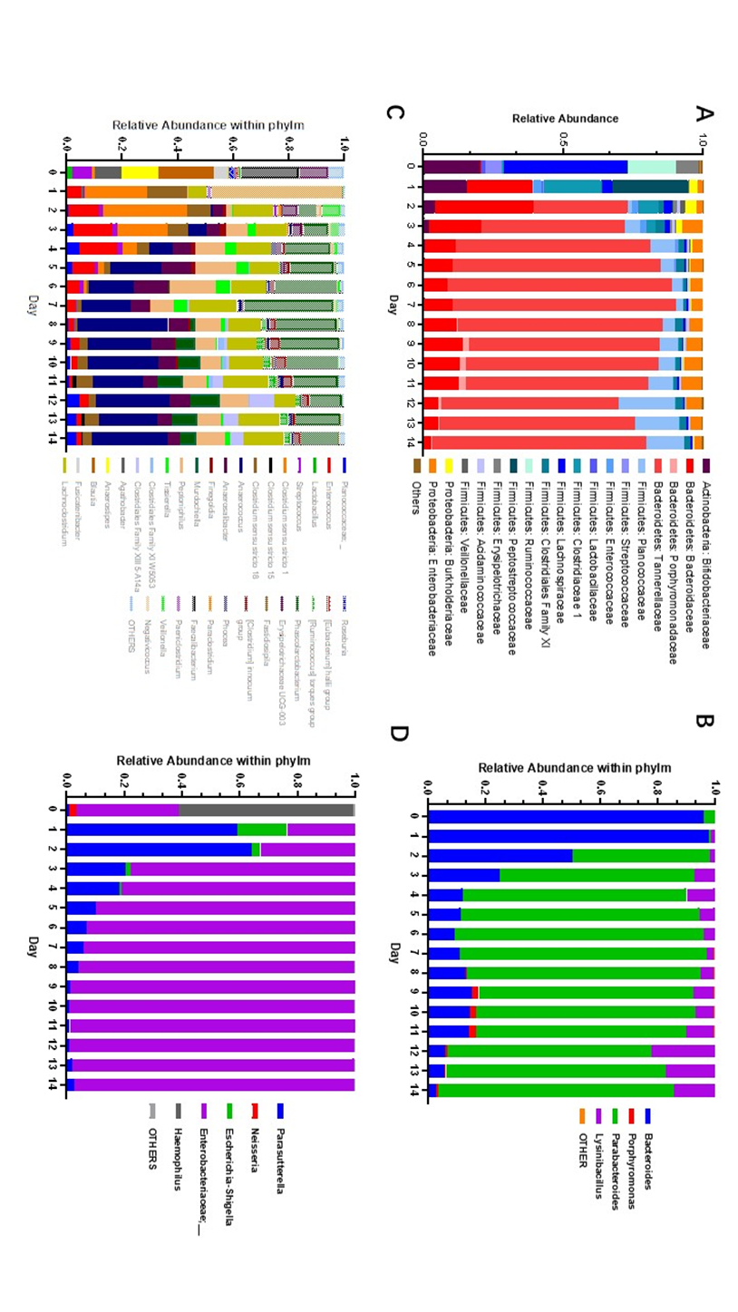
Figure S1: Dynamics of bacterial taxonomy in MiCoMo over 14 days culture for Individual B.
Day 0 indicates original fecal sample, Day 1 – 14 indicate cultured samples from MiCoMo, averaged over 3 technical replicates. ASVs that didn’t account for at least 1% of total abundance in any day were grouped in Others. A) Family-level taxonomy of the whole community B) Genus-level taxonomy within the Bacteroides phylum C) Genus-level taxonomy within the Firmicutes phylum D) Genus-level taxonomy within the Proteobacteria phylum

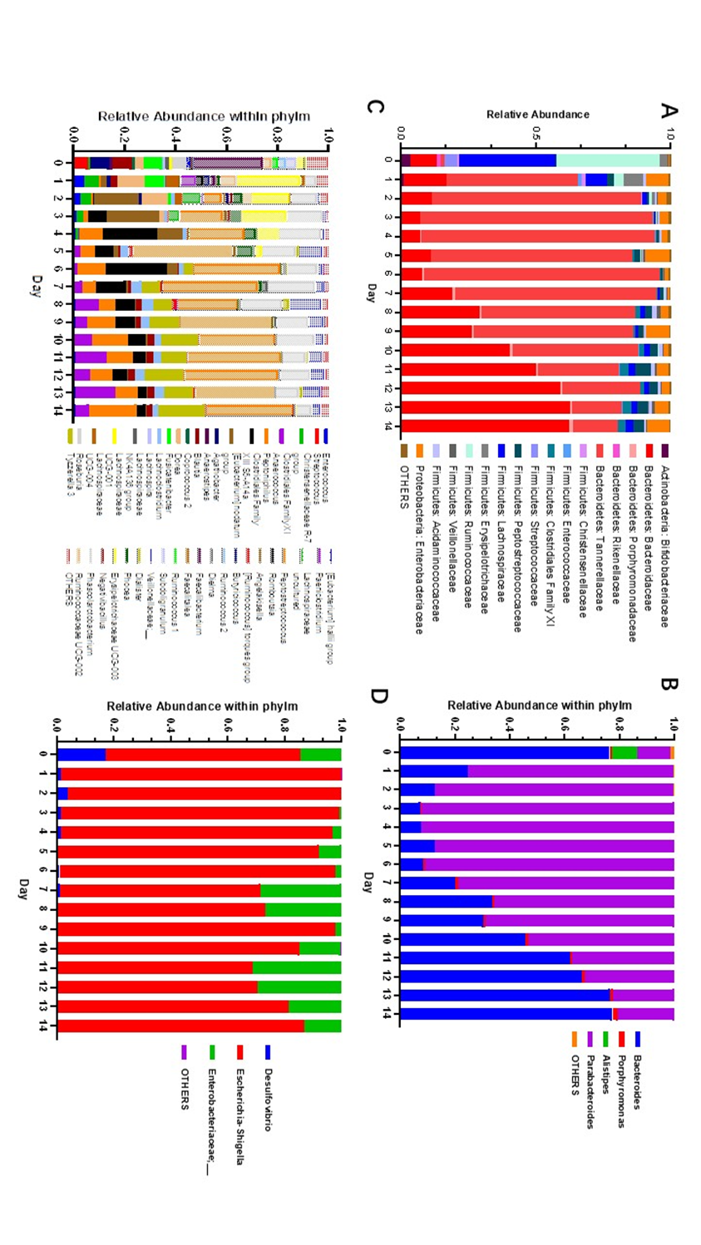

Figure S2: Dynamics of bacterial taxonomy in MiCoMo over 14 days culture for Individual C.
Day 0 indicates original fecal sample, Day 1 – 14 indicate cultured samples from MiCoMo, averaged over 3 technical replicates. ASVs that didn’t account for at least 1% of total abundance in any day were grouped in Others. A) Family-level taxonomy of the whole community B) Genus-level taxonomy within the Bacteroides phylum C) Genus-level taxonomy within the Firmicutes phylum D) Genus-level taxonomy within the Proteobacteria phylum

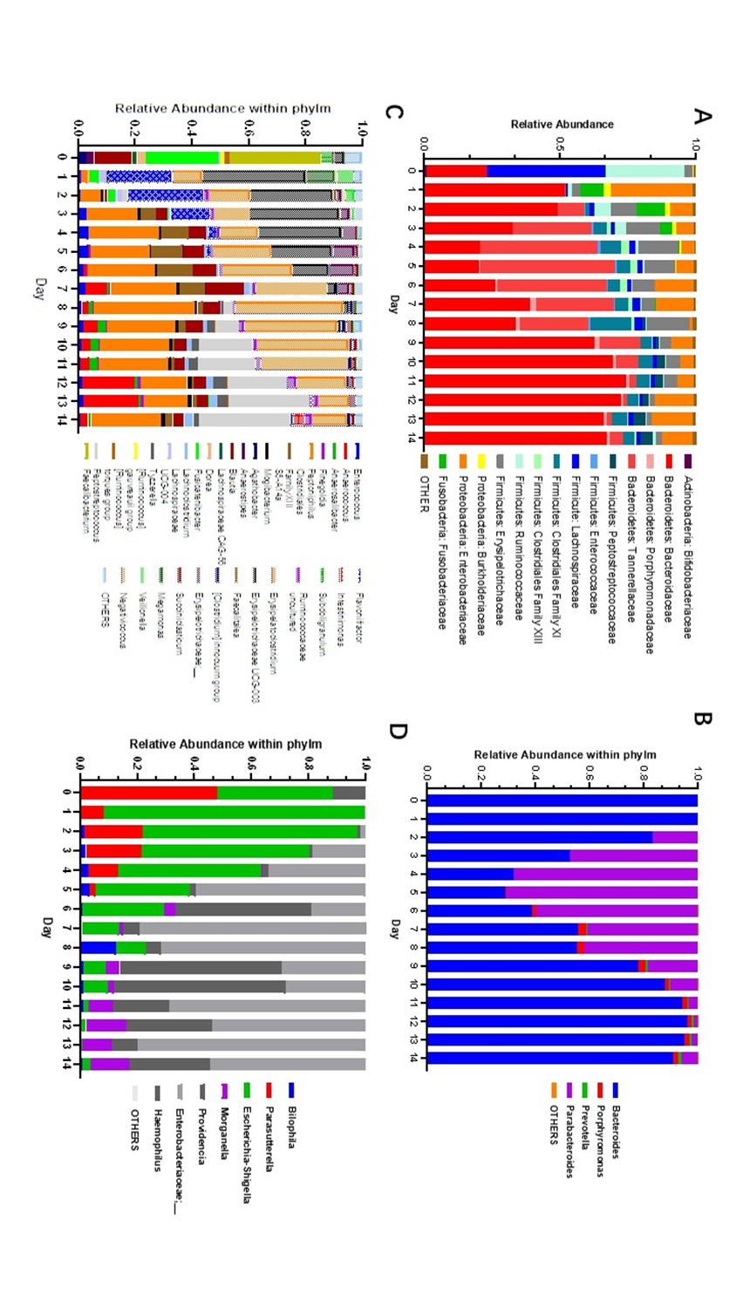
Figure S3: Dynamics of bacterial taxonomy in MiCoMo over 14 days culture for Individual D.
Day 0 indicates original fecal sample, Day 1 – 14 indicate cultured samples from MiCoMo, averaged over 3 technical replicates. ASVs that didn’t account for at least 1% of total abundance in any day were grouped in Others. A) Family-level taxonomy of the whole community B) Genus-level taxonomy within the Bacteroides phylum C) Genus-level taxonomy within the Firmicutes phylum D) Genus-level taxonomy within the Proteobacteria phylum

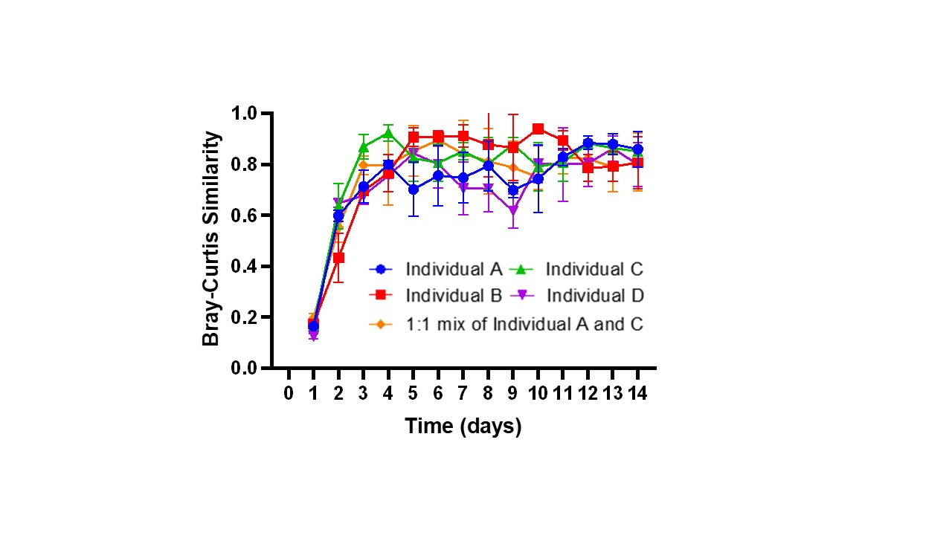
Figure S4: Bray-Curtis similarity between each daily reactor sample and the previous day.
Each line is average across 3 technical repeats of the same donor, error bars indicate standard deviations.

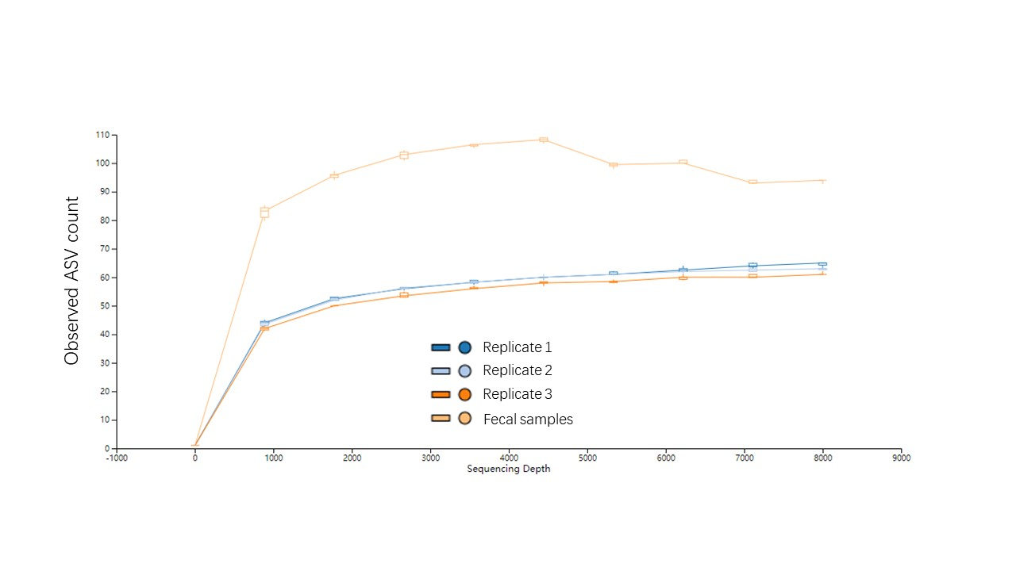
Figure S5: Alpha rarefaction curves for all replicates included in this work.
Each line is average of samples from one replicate reactor or from fecal sample, from all individuals

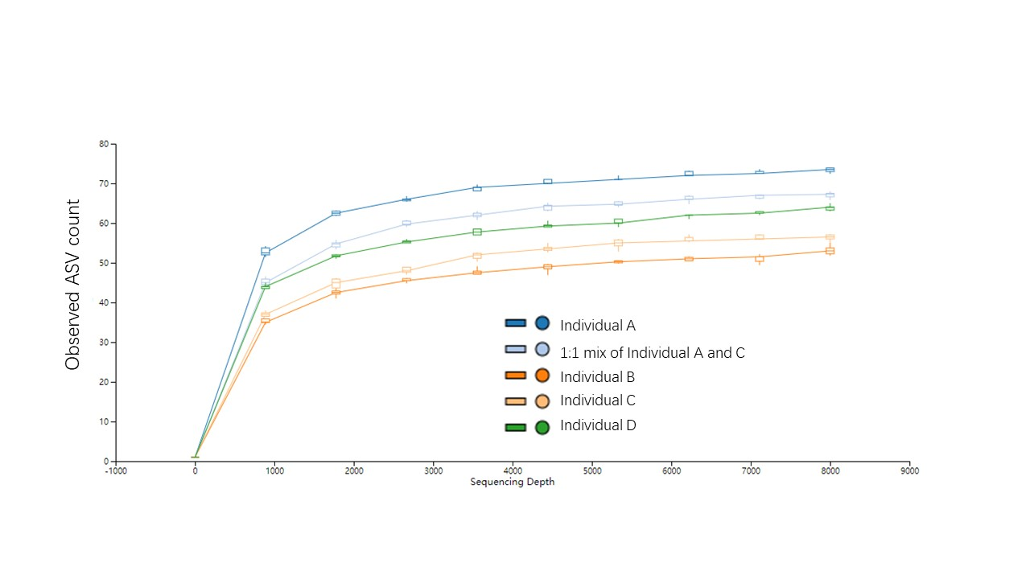
Figure S6: Alpha rarefaction curves for all individuals included in this work.
Each line is average of all replicate reactor samples and fecal sample from one individual

Protocols for MiCoMo assembly and operation
MiCoMo reactor fabrication:
- On a P25 cell culture flask:
  - For gas port:
    - Draw a dot about 1 - 1.5cm above the 30ml level line, at the same side as the neck of flask with a black sharpie, for gas line
    - Drill open with 5/64'' drill
    - Bend a 16G needle and try inserting it into the flask. Make sure the outlet just hover above the flask bottom
      - Ideally, the outlet points right at the serial number of flask (on bottom)
    - Reinsert the needle with an O-ring attached to the end. Push the needle all the way until O-ring claps onto flask wall
    - Mix 2-part epoxy glue and use a pipette tip to apply some glue at the O-ring/needle/flask conjunction. Keep adding glue until it forms a ~1cm diameter circle
    - Carefully flip the reactor back-and-forth, so the glue flows up and down and forms a cone around the needle/O-ring
    - After the glue hardens a bit more (~30 min or so), leave the reactor to dry overnight
      - Before leaving, check that the needle DOES NOT rotate/shake in the glue
  - For outlet and inlet connectors
    - Draw 2 dot above the previous dot, for inlet and outlet
    - Drill open one with 9/64'' drills for outlet, and one with 3/32'' drill for inlet
    - Cut a long piece of tubing (ensure it reaches the bottoms of flask, for outlet) and connect to luer lock
    - Insert the tubing into the hole and apply NOA adhesive to the luer lock. Push the luer lock against the hole and make sure that the glue forms a column
    - Glue a luer lock connector directly for inlet (no need for extra piece of tubing)
    - UV cure the glue for 2 min in the miicraft postcure chamber
  - For pH adjustment connectors, gas vent
    - Draw 3 dots on the upper layer of culture flask
    - Drill open with 3/32'' drills
    - Glue luer lock into each hole with NOA (no need for extra piece of tubing)
  - For seeding port
    - Draw a dot at the other side of other holes above 30ml line
    - Drill open with 3/32'' drill
    - Glue a rubber septum cap with NOA
- *For all NOA-glued connections, can apply some extra NOA and do a 2nd curing to ensure strength
- *For all luer-locks, check with a syringe after gluing to make sure the connection is still open
  - If not, use a needle/tweezers to poke open
For preparation of MiCoMo reactors:
The day before seeding:
- Assemble feed bottle with luer lock connector and tubing, wrap the tubing openings with aluminum foil then place in a big beaker
- Place other silicone tubings also in a big beaker and cover with aluminum foil
- Autoclave the beakers with prevac mode (30 min steam time)
- Bring scaffold of pumps into BSC and hook the wires
- Tape the multi-channel pump when confirmed functionality
- Confirm that all pumps work
- Check if pH probes need recalibrating/swapping
  - If needed, do it now
- Assemble the tubings into the pumps within BSC and run with 10% bleach for 10 minutes
- Pump out bleach and rinse (by pumping) with sterile milliQ water for 5 minutes

The day of seeding:
Media preparation:
- In BSC, prepare falcon tubes each with 27ml media + 200ul resazurin + ~500ul 20g/L L-cysteine (for final conc of 0.4g/L)
- Exchange overhead of these tubes with N2
- Heat up an 100 degrees water bath and water bath each tube of media for 30 min

Sterilization; the following process lasts for at least 30 minutes:
- Fill a big beaker with 10% bleach and place all luer lock connectors in it
- Unplug BNC connectors of the pH probes
- Cap all connectors for reactors and fill with ethanol; cap WITHOUT pH probes inserted
- Leave the vessels soaked in ethanol for 30 minutes.
- Soak pH probes in EtOH for 30 minutes

Connection and setup:
- Bring all reactors to BSC along with a big empty beaker
- Assemble the reactors in water bath basket on scaffold
- Dump ethanol out of reactor
- Connect tubing onto reactors
- Bring feed input luer-locks into EtOH and run multi-channel pump for 5 min
- Connect pH adjustment pumps with acid/base, and activate for 5min to ensure addition is proper/prefill the tubings
- Raise the feed input luer-locks above EtOH level
- Run the multi-channel pump until all ethanol is removed from reactors
- Run sterile milliQ water through pump and reactors for 5 min
- Pour reduced media into the vessels and cap with pH probes inserted
  - Make sure the probes are not pushing onto outlet tubings lest they stop the flow
- Plug the BNC connectors of pH probes
- Fill the water bath to level of holder and launch the sous-vide machine. Add some bleach to the water bath
- Fill a big beaker with active charcoal and place vent tubing and waste tubing in; secure the tubings with tape
- Start gas+transfer arduino and launch serial monitor, ensure that the time counter works properly
- Start pH arduino and launch serial monitor for pH arduino, ensure the sensors work properly
- Let the media be flushed with N2/adjust pH to setpoint for 30 minutes
- Ready to inoculate

Protocol for MiCoMo inoculation:
The following protocol is for seeding 3 reactors
- Prepare pre-reduced PBS
- Pre-reduce 3X 27ml of media in three falcon tubes and ready the reactor based on the protocol below
  - CHECK: At this stage, all tubing connections should have been properly secured, and electrical connections verified
  - Secure the pH probes with parafilm
- Add rPBS to fecal sample until 20% w/v and vortex for 10 min at max speed
- Centrifuge @201G for 3 minute to remove large debris
- Take three 5ml syringes and take 3ml of supernatant in each tube
- Seed each syringe of inoculum into 27 ml media at a final concentration of 2% w/v (0.6g/vessel for total 30ml per vessel, add 3 ml of fecal slurry in 27 ml media)
- Reinitiate the gas and transfer arduino code (to reset the timer of liquid transfer)
- Fill sterilized feed bottle with fresh media and connect the feed bottle to multi-channel pump inlet
- Add ping-pong balls to the water bath
At this point, reactor seeding is done
- Take the final 1 ml supernatant into a 1.5 ml tube
  - With PowerFecal kit, directly store this supernatant at -80 and extract with powerfecal when needed

