Table S1: Back-trajectories of air masses sampled in this study. Samples #2-5 are composited of several sampling days pooled together. Samples #6-10 represent a single sampling day each.
Dust 2 | Dust 3 | Dust 4 | Dust 5

Dust 6 | Dust 7 | Dust 8

Dust 9 | Dust 10

Table S2: AMOVA Fs values based on community composition of the different datasets (a) and sample types (b). All pair-wise comparisons resulted in significant q-values (under 0.05).
a | Clouds | Dust IL | Dust Red Sea | IL soils | Med Sea | Red Sea | Urban air
Beijing smog | 19.1 | 16.0 | 19.2 | 64.6 | 37.1 | 51.4 | 14.1
Clouds |  | 18.3 | 24.9 | 59.0 | 25.3 | 36.0 | 3.3
Dust IL |  |  | 3.7 | 17.0 | 17.7 | 24.4 | 10.6
Dust Red Sea |  |  |  | 15.8 | 18.8 | 23.6 | 14.1
IL soils |  |  |  |  | 28.0 | 35.4 | 32.2
Med Sea |  |  |  |  |  | 16.5 | 11.4
Red Sea |  |  |  |  |  |  | 21.0

b | Dust | Sea | Smog | Soil
Air | 21.2 | 21.5 | 12.4 | 33.9
Dust |  | 22.4 | 17.7 | 15.5
Sea |  |  | 31.1 | 18.2
Smog |  |  |  | 64.6

Table S3: AMOVA Fs values based on functional gene profile of the different datasets (a) and ssample types (b). All pair-wise comparisons resulted in significant q-values (under 0.05), except for Urban air and Clouds, marked with *.
a | Clouds | Dust IL | Dust Red Sea | IL soils | Med Sea | Red Sea | Urban air
Beijing smog | 17.5 | 8.8 | 11.9 | 33.8 | 12.6 | 23.4 | 9.6
Clouds |  | 15.1 | 22.7 | 49.1 | 16.6 | 33.3 | *3.1
Dust IL |  |  | 3.1 | 14.4 | 7.3 | 15.5 | 7.0
Dust Red Sea |  |  |  | 9.6 | 7.4 | 18.6 | 10.6
IL soils |  |  |  |  | 13.6 | 27.1 | 26.8
Med Sea |  |  |  |  |  | 5.4 | 7.7
Red Sea |  |  |  |  |  |  | 14.9

b | Dust | Sea | Smog | Soil
Air | 18.4 | 18.1 | 13.1 | 40.4
Dust |  | 14.3 | 10.9 | 13.0
Sea |  |  | 16.1 | 18.3
Smog |  |  |  | 33.8

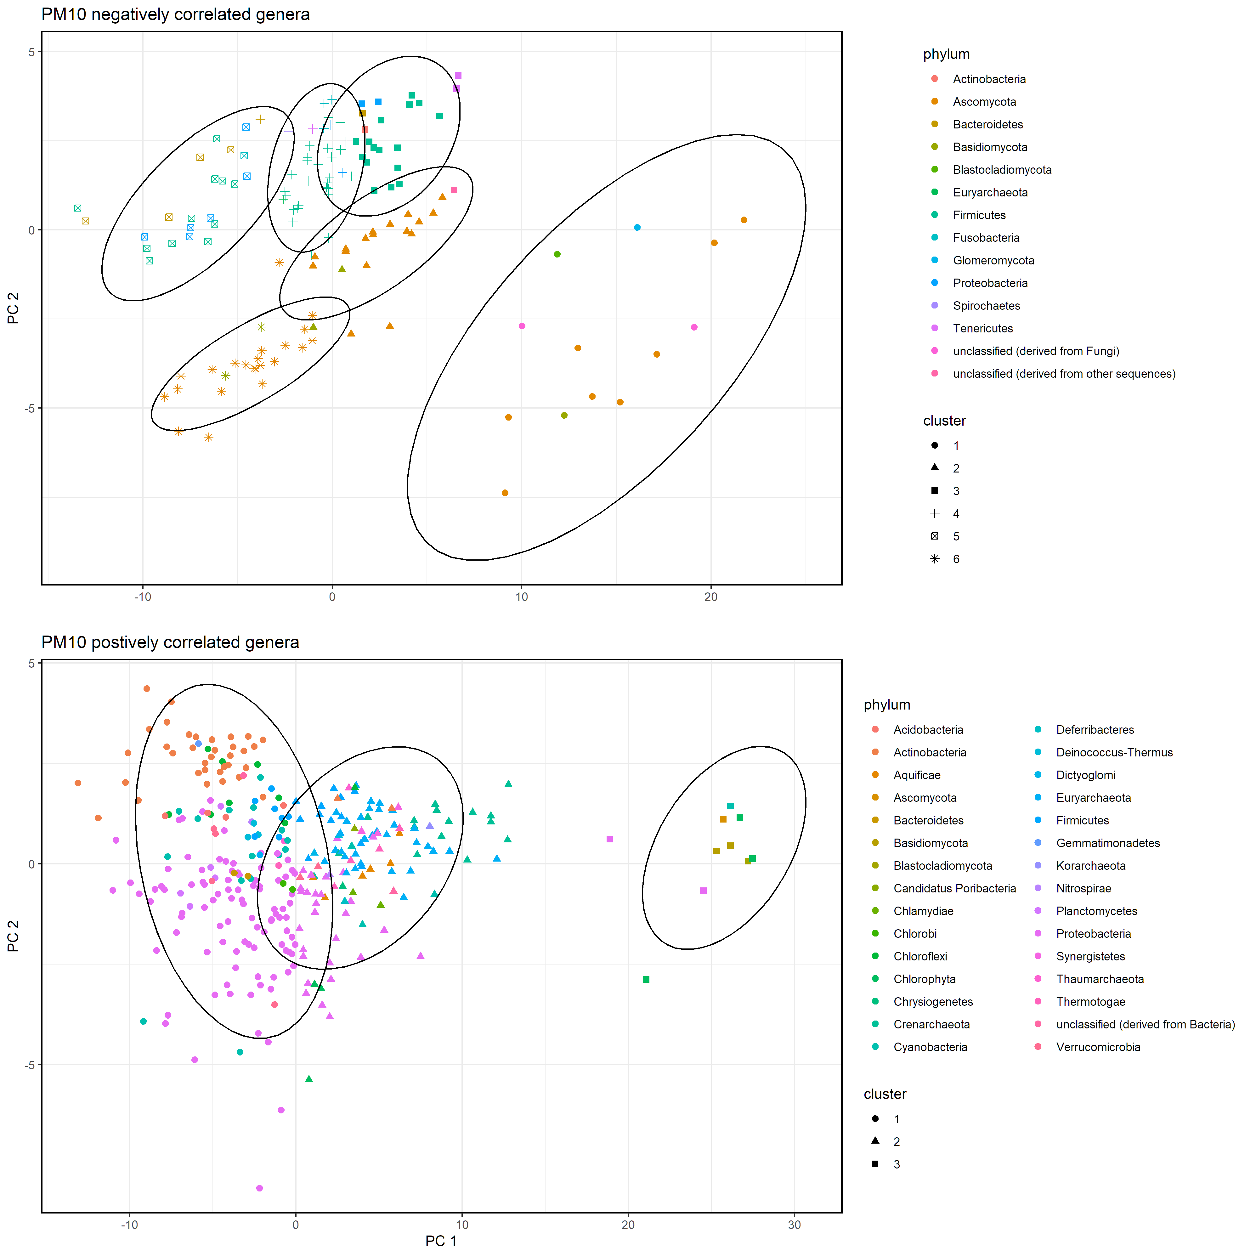
Figure S1: K-means clusters of genera that negatively or positively correlated PM₁₀ concentrations of Dust IL samples
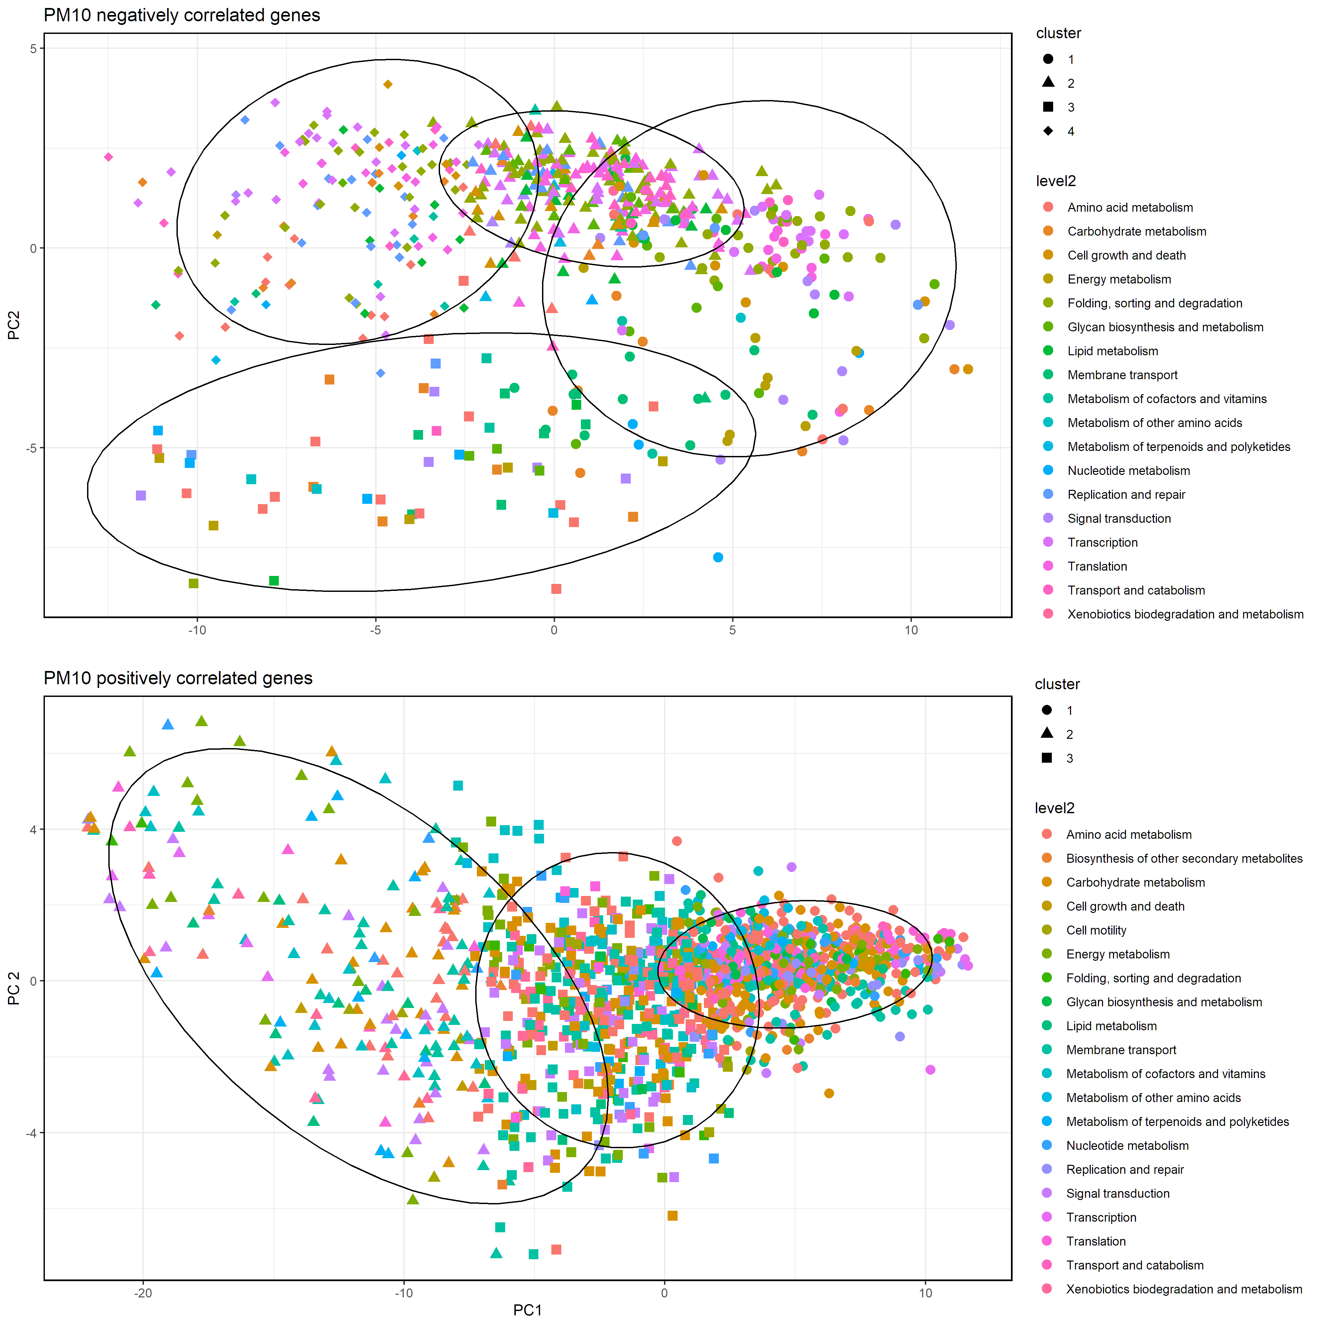
Figure S2: K-means clusters of genes that negatively or positively correlated PM₁₀ concentrations of Dust IL samples

