Supplementary Data

Anticancer Activity of Nano Uncaria gambir
Andika Pramudya Wardana^{1,2}, Nanik Siti Aminah^{2,3*}, Alfinda Novi Kristanti^{2,3}, Haninda Iffatuz Zahrah⁴, Mochamad Zakki Fahmi², Anita Yuliati⁴, Suhaili², and M. Iqbal Choudhary^{5,6}

¹Ph.D. Student of Mathematics and Natural Sciences, Faculty of Science and Technology, Universitas Airlangga, Komplek Kampus C UNAIR, Jl. Mulyorejo, 60115, Surabaya, Indonesia
²Department of Chemistry, Faculty of Science and Technology, Universitas Airlangga, Kampus C-UNAIR, Jl. Mulyorejo, Surabaya 60115, Surabaya, Indonesia
³Biotechnology of Tropical Medicinal Plants Research Group, Universitas Airlangga
⁴Faculty of Dental Medicine, Universitas Airlangga, Kampus A-UNAIR, Jl. Mayjen Prof. Dr. Moestopo 47, Surabaya 60131, Surabaya, Indonesia
⁵H. E. J. Research Institute of Chemistry, International Center for Chemical and Biological Sciences, University of Karachi, Karachi, 75270, Pakistan
⁶Adjunct Professor, Department of Chemistry, Faculty of Science and Technology, Universitas Airlangga, Komplek Kampus C UNAIR, Jl. Mulyorejo, Surabaya, Indonesia

*Correspondence: Nanik Siti Aminah
Department of Chemistry, Faculty of Science and Technology, Universitas Airlangga, Kampus C-UNAIR, Jl. Mulyorejo, Surabaya 60115, Surabaya, Indonesia
Tel +62-31-5936501
Fax +62-31-5936502
Email nanik-s-a@fst.unair.ac.id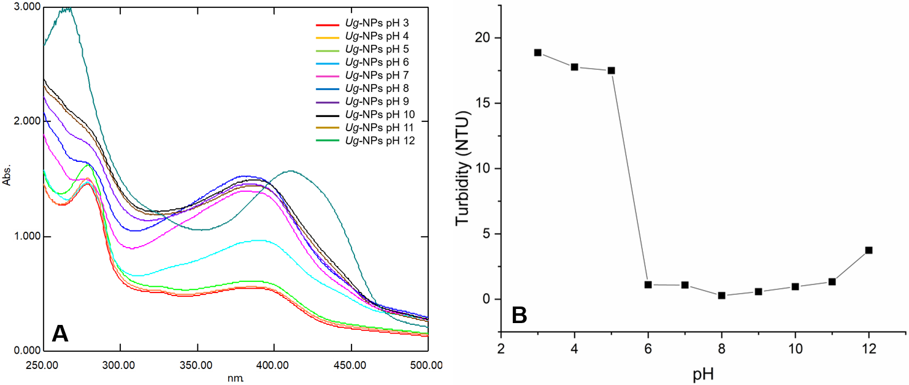
Supplementary Figure 1. Effect of pH on the stability of Ug-NPs A) UV-Vis Spectra, and B) Turbidity
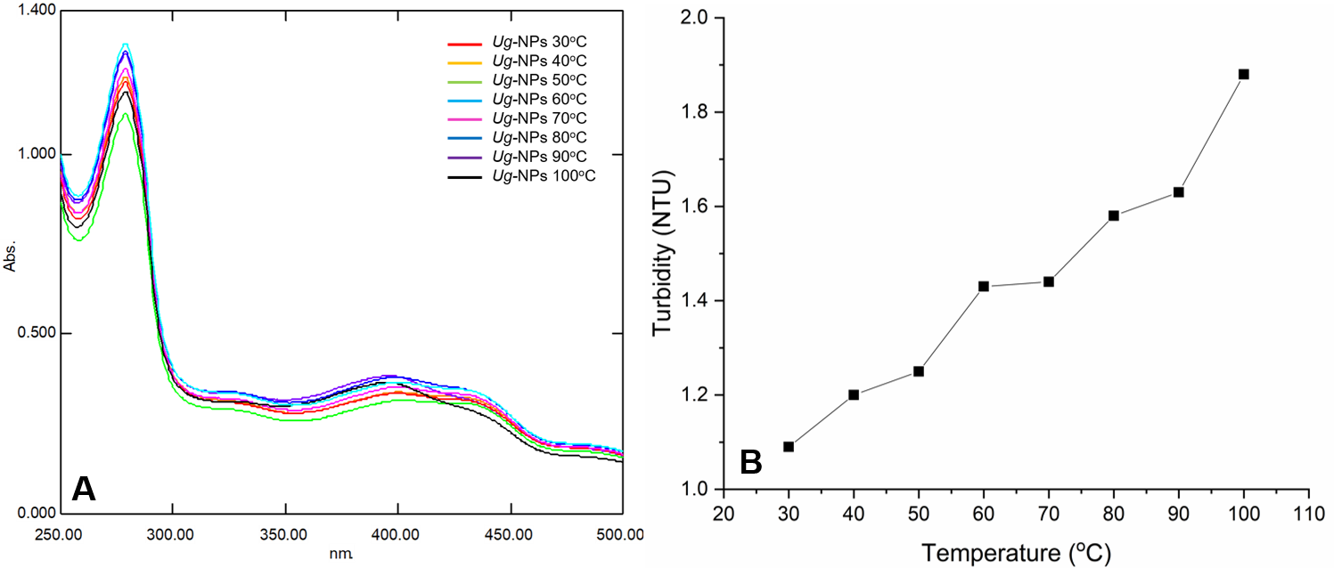
Supplementary Figure 2. Effect of temperature on the stability of Ug-NPs A) UV-Vis Spectra, and B) Turbidity

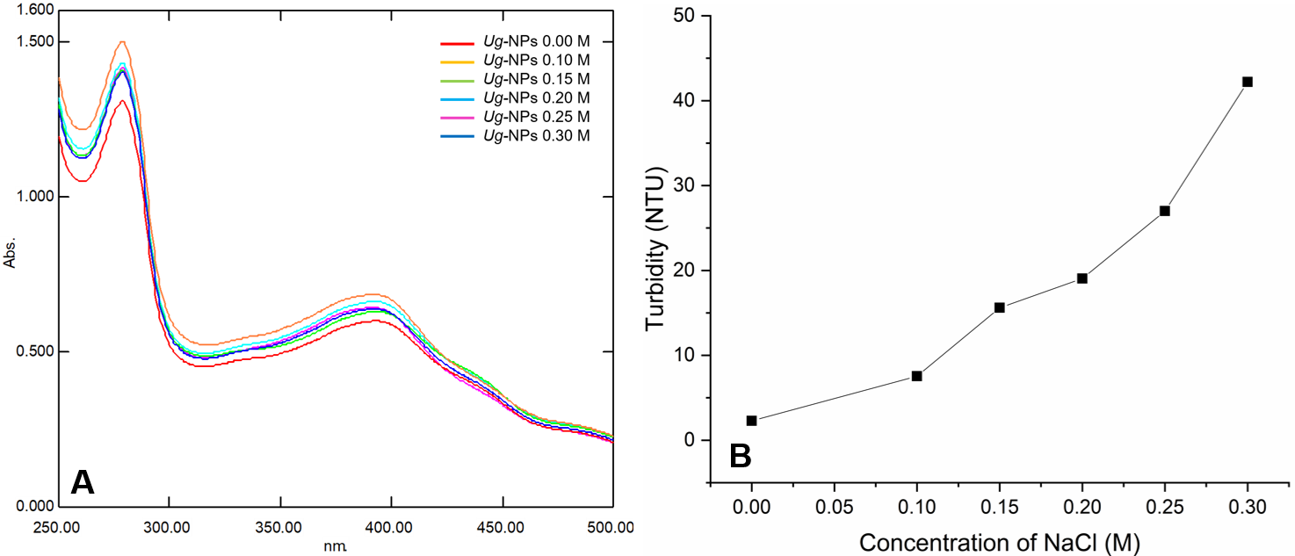
Supplementary Figure 3. Effect of NaCl on the stability of Ug-NPs A) UV-Vis Spectra, and B) Turbidity

