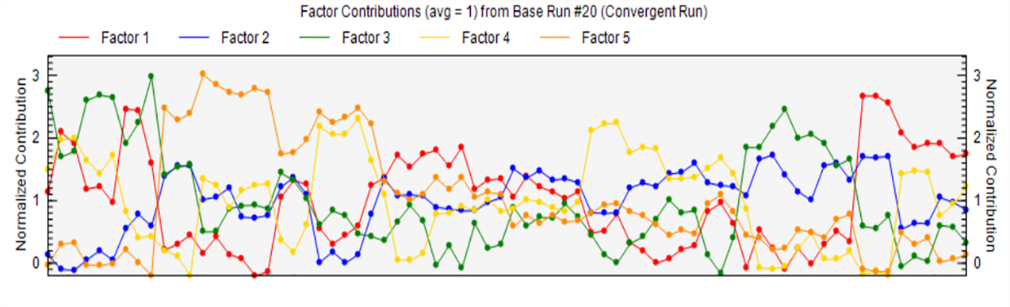Fig. S1 PMF model operation output results.

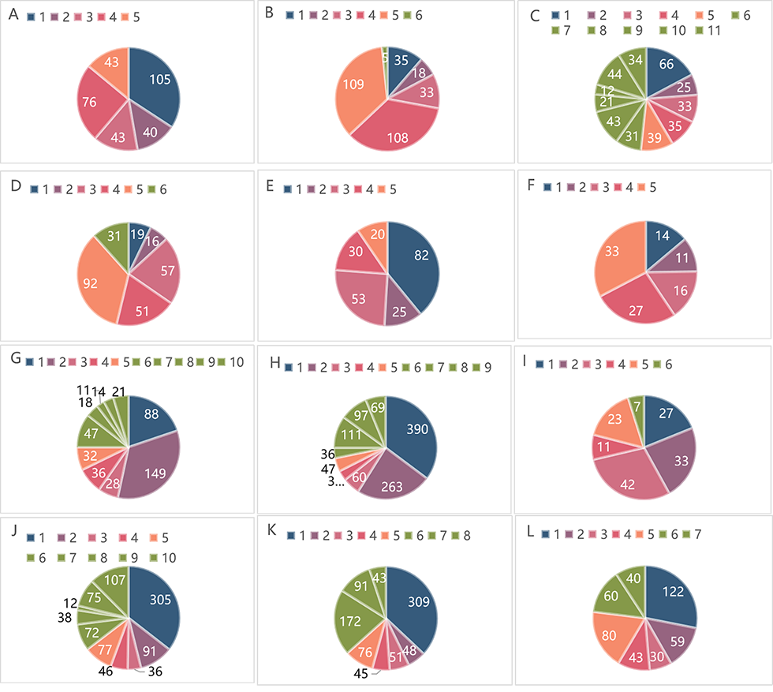
Fig. S2 Composition and abundance of community in four belt transects.
Note: A Zizania latifolia (Griseb. ) Stapf community-1/YD: 1 Zizania latifolia (Griseb.) Stapf 2 Setaria viridis (L.) Beauv. 3 Spodiopogon cotulifer (Thunberg) Hackel 4 Polygonumcrio politanum Hance 5 Pterocypsela elata (Hemsl.) Shih
B Broussonetia papyrifera community-2/YD1: 1 Broussonetia papyrifera 2 Morus alba L. 3 Setaria viridis (L.) Beauv. 4 Erigeron annuus (L.) Pers. 5 Monochoria vaginalis (Burm. F.) C.Presl 6 Pyrus betulifolia Bunge
C Spodiopogon cotulifer (Thunberg) Hackel community-3/YD1: 1 Spodiopogon cotulifer (Thunberg) Hackel 2 Veronica persica Poir. 3 Pterocypsela elata (Hemsl.) Shih 4 Ranunculus polii Franch. ex Hemsl. 5 Kalimeris indica (L.) Sch. Bip. 6 calystegia sepium(L.)R .Br 7 Eleusine indica (L.) Gaertn. 8 Polygonumcrio politanum Hance 9 Erigeron annuus (L.) Pers. 10 Cerastium glomeratum 11Monochoria vaginalis (Burm. F.) C.Presl
D Pyrus betulifolia Bunge community-4/YD2: 1 Pyrus betulifolia Bunge 2 Melia azedarach L. 3 Polygonumcrio politanum Hance 4 Setaria viridis (L.) Beauv. 5 Monochoria vaginalis (Burm. F.) C.Presl 6 Cerastium glomeratum
E Zizania latifolia (Griseb. ) Stapf community-5/YD2: 1 Zizania latifolia (Griseb.) Stapf 2 Clematis cadmia Buch.-Ham. ex Wall. 3 Polygonumcrio politanum Hance 4 Erigeron annuus (L.) Pers. 5 Setaria viridis (L.) Beauv.
F Pyrus betulifolia Bunge community-6/YD2: 1 Pyrus betulifolia Bunge 2 Melia azedarach L. 3 Morus alba L. 4 Monochoria vaginalis (Burm. F.) C.Presl 5 Cerastium glomeratum
G Kalimeris indica (L.) Sch. Bip./ Cynodon dactylon (L.) Pers. Community-7/YD3: 1 Cynodon dactylon (L.) Pers. 2 Kalimeris indica (L.) Sch. Bip. 3 Alopecurus aequalis Sobol. 4 Polygonumcrio politanum Hance 5 Ranunculus polii Franch. ex Hemsl. 6 Eleusine indica (L.) Gaertn. 7 Pterocypsela elata (Hemsl.) Shih 8 Setaria viridis (L.) Beauv. 9 Clematis cadmia Buch.-Ham. ex Wall. 10 Erigeron annuus (L.) Pers.
H Cynodon dactylon (L.) Pers./ Setaria viridis (L.) Beauv. community-8/YD3: 1 Cynodon dactylon (L.) Pers. 2 Setaria viridis (L.) Beauv. 3 Pterocypsela elata (Hemsl.) Shih 4 Alopecurus aequalis Sobol. 5 Astragalus sinicus L.6 Spodiopogon cotulifer (Thunberg) Hackel 7 Erigeron annuus (L.) Pers. 8 Carex thunbergii 9 Veronica persica Poir.
I Broussonetia papyrifera community-9/YD3: 1 Broussonetia papyrifera 2 Setaria viridis (L.) Beauv. 3 Polygonum perfoliatum L. 4 Calystegia sepium(L.)R .Br 5 Monochoria vaginalis (Burm. F.) C.Presl 6 Pyrus betulifolia Bunge
J Spodiopogon cotulifer (Thunberg) Hackel community10/YD4: 1 Spodiopogon cotulifer (Thunberg) Hackel 2 Cynodon dactylon (L.) Pers. 3 Eleusine indica (L.) Gaertn. 4 Juncus effusus 5 Monochoria vaginalis (Burm. F.) C.Presl 6 Cerastium glomeratum 7 Polygonum perfoliatum L. 8 Calystegia sepium(L.)R .Br 9 Ranunculus polii Franch. ex Hemsl. 10 Astragalus sinicus L.
K Ranunculus polii Franch. ex Hemsl. community-11/YD4: 1 Ranunculus polii Franch. ex Hemsl. 2 Setaria viridis (L.) Beauv. 3 Astragalus sinicus L. 4 Polygonumcrio politanum Hance 5 Cynodon dactylon (L.) Pers. 6 Erigeron annuus (L.) Pers. 7 Monochoria vaginalis (Burm. F.) C.Presl 8 Cerastium glomeratum
L Astragalus sinicus L. community-12/YD4: 1 Astragalus sinicus L. 2 Cynodon dactylon (L.) Pers. 3 Pterocypsela elata (Hemsl.) Shih 4 Cerastium glomeratum 5 Artemisia annua L. 6 Ranunculus polii Franch. ex Hemsl. 7 Achyranthes bidentata Blume.

Table S1 The important value statistics of the investigated communities (%).
Community name | Community composition | Relative abundance average | Average value of relative coverage | Average value of relative frequency | Mean value of important value
Zizania latifolia (Griseb. ) Stapf community-1/YD | Zizania latifolia (Griseb.) Stapf | 34.18 | 36.04 | 6.25 | 25.49
Zizania latifolia (Griseb. ) Stapf community-1/YD | Setaria viridis (L.) Beauv. | 13.15 | 17.33 | 31.25 | 20.58
Zizania latifolia (Griseb. ) Stapf community-1/YD | Spodiopogon cotulifer (Thunberg) Hackel | 13.89 | 17.3 | 31.25 | 20.82
Zizania latifolia (Griseb. ) Stapf community-1/YD | Polygonumcrio politanum Hance | 24.75 | 16.11 | 12.5 | 17.79
Zizania latifolia (Griseb. ) Stapf community-1/YD | Pterocypsela elata (Hemsl.) Shih | 14.02 | 13.22 | 18.75 | 15.33
Zizania latifolia (Griseb. ) Stapf community-5/YD2 | Zizania latifolia (Griseb.) Stapf | 39.35 | 41.3 | 7.69 | 29.45
Zizania latifolia (Griseb. ) Stapf community-5/YD2 | Clematis cadmia Buch.-Ham. ex Wall. | 11.78 | 18 | 23.08 | 17.6
Zizania latifolia (Griseb. ) Stapf community-5/YD2 | Polygonumcrio politanum Hance | 25.12 | 17.3 | 23.08 | 21.82
Zizania latifolia (Griseb. ) Stapf community-5/YD2 | Erigeron annuus (L.) Pers. | 14.38 | 12.7 | 23.08 | 16.73
Zizania latifolia (Griseb. ) Stapf community-5/YD2 | Setaria viridis (L.) Beauv. | 9.37 | 10.7 | 23.08 | 14.4
Spodiopogon cotulifer (Thunberg) Hackel community10/YD4 | Spodiopogon cotulifer (Thunberg) Hackel | 35.55 | 15.13 | 16.67 | 22.45
Spodiopogon cotulifer (Thunberg) Hackel community10/YD4 | Cynodon dactylon (L.) Pers. | 10.59 | 8.92 | 10 | 9.84
Spodiopogon cotulifer (Thunberg) Hackel community10/YD4 | Eleusine indica (L.) Gaertn. | 4.23 | 9.85 | 3.33 | 5.8
Spodiopogon cotulifer (Thunberg) Hackel community10/YD4 | Juncus effusus | 5.35 | 11.19 | 6.67 | 7.74
Spodiopogon cotulifer (Thunberg) Hackel community10/YD4 | Monochoria vaginalis (Burm. F.) C.Presl | 9 | 10.45 | 16.67 | 12.04
Spodiopogon cotulifer (Thunberg) Hackel community10/YD4 | Cerastium glomeratum | 8.34 | 11.2 | 10 | 9.85
Spodiopogon cotulifer (Thunberg) Hackel community10/YD4 | Polygonum perfoliatum L. | 4.38 | 9.82 | 3.33 | 5.85
Spodiopogon cotulifer (Thunberg) Hackel community10/YD4 | calystegia sepium(L.)R .Br | 1.36 | 8.31 | 3.33 | 4.33
Spodiopogon cotulifer (Thunberg) Hackel community10/YD4 | Ranunculus polii Franch. ex Hemsl. | 8.73 | 7.57 | 16.67 | 10.99
Spodiopogon cotulifer (Thunberg) Hackel community10/YD4 | Astragalus sinicus L. | 12.46 | 7.57 | 13.33 | 11.12
Spodiopogon cotulifer (Thunberg) Hackel community-3/YD1 | Spodiopogon cotulifer (Thunberg) Hackel | 17.32 | 21.8 | 3.7 | 14.27
Spodiopogon cotulifer (Thunberg) Hackel community-3/YD1 | Veronica persica Poir. | 6.43 | 8 | 7.41 | 7.29
Spodiopogon cotulifer (Thunberg) Hackel community-3/YD1 | Pterocypsela elata (Hemsl.) Shih | 8.53 | 6.9 | 11.11 | 8.83
Spodiopogon cotulifer (Thunberg) Hackel community-3/YD1 | Ranunculus polii Franch. ex Hemsl. | 9.04 | 7.4 | 11.11 | 9.19
Spodiopogon cotulifer (Thunberg) Hackel community-3/YD1 | Kalimeris indica (L.) Sch. Bip. | 10.17 | 13.1 | 14.82 | 12.7
Spodiopogon cotulifer (Thunberg) Hackel community-3/YD1 | calystegia sepium(L.)R .Br | 8.08 | 5.1 | 7.41 | 6.86
Spodiopogon cotulifer (Thunberg) Hackel community-3/YD1 | Eleusine indica (L.) Gaertn. | 11.31 | 8 | 3.7 | 7.68
Spodiopogon cotulifer (Thunberg) Hackel community-3/YD1 | Polygonumcrio politanum Hance | 5.56 | 6.9 | 7.41 | 6.61
Spodiopogon cotulifer (Thunberg) Hackel community-3/YD1 | Erigeron annuus (L.) Pers. | 3.12 | 3.8 | 11.11 | 6.01
Spodiopogon cotulifer (Thunberg) Hackel community-3/YD1 | Cerastium glomeratum | 11.47 | 11.6 | 11.11 | 11.39
Spodiopogon cotulifer (Thunberg) Hackel community-3/YD1 | Monochoria vaginalis (Burm. F.) C.Presl | 8.96 | 7.5 | 11.11 | 9.18
Cynodon dactylon (L.) Pers./ Setaria viridis (L.) Beauv. community-8/YD3 | Cynodon dactylon (L.) Pers. | 35.25 | 15.36 | 11.54 | 20.71
 | Setaria viridis (L.) Beauv. | 23.75 | 14.23 | 19.23 | 19.07
 | Pterocypsela elata (Hemsl.) Shih | 5.39 | 10 | 11.54 | 8.98
 | Alopecurus aequalis Sobol. | 3.13 | 8.58 | 3.85 | 5.19
 | Astragalus sinicus L. | 4.22 | 13.14 | 15.38 | 10.91
 | Spodiopogon cotulifer (Thunberg) Hackel | 3.25 | 9.87 | 19.23 | 10.78
 | Erigeron annuus (L.) Pers. | 10.03 | 13.14 | 11.54 | 11.57
 | Carex thunbergii | 8.77 | 8.91 | 3.85 | 7.18
 | Veronica persica Poir. | 6.21 | 6.77 | 3.85 | 5.61
Kalimeris indica (L.) Sch. Bip./ Cynodon dactylon (L.) Pers. Community-7/YD3 | Cynodon dactylon (L.) Pers. | 19.82 | 22.5 | 11.54 | 17.95
 | Kalimeris indica (L.) Sch. Bip. | 33.48 | 23.1 | 15.38 | 23.98
 | Alopecurus aequalis Sobol. | 6.23 | 8.5 | 3.85 | 6.19
 | Polygonumcrio politanum Hance | 8.1 | 8.2 | 7.69 | 8
 | Ranunculus polii Franch. ex Hemsl. | 7.13 | 9.2 | 11.54 | 9.29
 | Eleusine indica (L.) Gaertn. | 10.58 | 8 | 3.85 | 7.49
 | Pterocypsela elata (Hemsl.) Shih | 4.06 | 4.7 | 11.54 | 6.78
 | Setaria viridis (L.) Beauv. | 2.55 | 4.7 | 15.38 | 7.56
 | Clematis cadmia Buch.-Ham. ex Wall. | 3.23 | 4.7 | 11.54 | 6.5
 | Erigeron annuus (L.) Pers. | 4.8 | 6.3 | 7.69 | 6.25
Astragalus sinicus L. community-12/YD4 | Astragalus sinicus L. | 28.13 | 28.49 | 19.05 | 25.23
Astragalus sinicus L. community-12/YD4 | Cynodon dactylon (L.) Pers. | 13.61 | 16.48 | 23.81 | 17.97
Astragalus sinicus L. community-12/YD4 | Pterocypsela elata (Hemsl.) Shih | 6.83 | 9.93 | 14.29 | 10.35
Astragalus sinicus L. community-12/YD4 | Cerastium glomeratum | 9.83 | 9.93 | 9.52 | 9.76
Astragalus sinicus L. community-12/YD4 | Artemisia annua L. | 18.37 | 15.49 | 4.76 | 12.87
Astragalus sinicus L. community-12/YD4 | Ranunculus polii Franch. ex Hemsl. | 13.91 | 9.74 | 23.81 | 15.82
Astragalus sinicus L. community-12/YD4 | Achyranthes bidentata Blume | 9.31 | 9.93 | 4.76 | 8
Ranunculus polii Franch. ex Hemsl. community-11/YD4 | Ranunculus polii Franch. ex Hemsl. | 36.92 | 26.3 | 15.15 | 26.12
Ranunculus polii Franch. ex Hemsl. community-11/YD4 | Setaria viridis (L.) Beauv. | 5.78 | 9.86 | 15.15 | 10.26
Ranunculus polii Franch. ex Hemsl. community-11/YD4 | Astragalus sinicus L. | 6.1 | 9.95 | 12.12 | 9.39
Ranunculus polii Franch. ex Hemsl. community-11/YD4 | Polygonumcrio politanum Hance | 5.42 | 13.74 | 15.15 | 11.44
Ranunculus polii Franch. ex Hemsl. community-11/YD4 | Cynodon dactylon (L.) Pers. | 9.13 | 8.39 | 9.09 | 8.87
Ranunculus polii Franch. ex Hemsl. community-11/YD4 | Erigeron annuus (L.) Pers. | 20.61 | 12.4 | 9.09 | 14.04
Ranunculus polii Franch. ex Hemsl. community-11/YD4 | Monochoria vaginalis (Burm. F.) C.Presl | 10.85 | 8.53 | 15.15 | 11.51
Ranunculus polii Franch. ex Hemsl. community-11/YD4 | Cerastium glomeratum | 5.18 | 10.84 | 9.09 | 8.37
Broussonetia papyrifera community-2/YD1 | Broussonetia papyrifera | 11.35 | 52.74 | 5.56 | 23.21
Broussonetia papyrifera community-2/YD1 | Morus alba L. | 5.94 | 6.35 | 5.56 | 5.95
Broussonetia papyrifera community-2/YD1 | Setaria viridis (L.) Beauv. | 10.8 | 9.96 | 27.78 | 16.18
Broussonetia papyrifera community-2/YD1 | Erigeron annuus (L.) Pers. | 34.98 | 10.25 | 16.67 | 20.63
Broussonetia papyrifera community-2/YD1 | Monochoria vaginalis (Burm. F.) C.Presl | 35.32 | 7.02 | 27.78 | 23.37
Broussonetia papyrifera community-2/YD1 | Pyrus betulifolia Bunge | 1.62 | 13.68 | 16.67 | 10.66
Broussonetia papyrifera community-9/YD3 | Broussonetia papyrifera | 18.86 | 47.8 | 13.33 | 26.66
Broussonetia papyrifera community-9/YD3 | Setaria viridis (L.) Beauv. | 22.88 | 10 | 20 | 17.62
Broussonetia papyrifera community-9/YD3 | Polygonum perfoliatum L. | 29.4 | 10.2 | 6.67 | 15.43
Broussonetia papyrifera community-9/YD3 | Calystegia sepium(L.)R .Br | 7.78 | 5.9 | 13.33 | 9.01
Broussonetia papyrifera community-9/YD3 | Monochoria vaginalis (Burm. F.) C.Presl | 16.19 | 7.2 | 20 | 14.48
Broussonetia papyrifera community-9/YD3 | Pyrus betulifolia Bunge | 4.89 | 18.9 | 26.67 | 16.8
Pyrus betulifolia Bunge community-4/YD2 | Pyrus betulifolia Bunge | 7.15 | 50.73 | 15.79 | 24.56
Pyrus betulifolia Bunge community-4/YD2 | Melia azedarach L. | 6.02 | 12.79 | 5.26 | 8.02
Pyrus betulifolia Bunge community-4/YD2 | Polygonumcrio politanum Hance | 21.39 | 8.19 | 10.53 | 13.37
Pyrus betulifolia Bunge community-4/YD2 | Setaria viridis (L.) Beauv. | 19.26 | 13.15 | 26.32 | 19.58
Pyrus betulifolia Bunge community-4/YD2 | Monochoria vaginalis (Burm. F.) C.Presl | 34.51 | 8.62 | 26.32 | 23.15
Pyrus betulifolia Bunge community-4/YD2 | Cerastium glomeratum | 11.68 | 6.52 | 15.79 | 11.33
Pyrus betulifolia Bunge community-6/YD2 | Pyrus betulifolia Bunge | 13.91 | 53.6 | 33.33 | 33.6
Pyrus betulifolia Bunge community-6/YD2 | Melia azedarach L. | 10.93 | 17.9 | 8.33 | 12.38
Pyrus betulifolia Bunge community-6/YD2 | Morus alba L. | 15.9 | 15.4 | 8.33 | 13.21
Pyrus betulifolia Bunge community-6/YD2 | Monochoria vaginalis (Burm. F.) C.Presl | 26.9 | 6.6 | 25 | 19.5
Pyrus betulifolia Bunge community-6/YD2 | Cerastium glomeratum | 32.36 | 6.6 | 25 | 21.32

Table S2 Determination results of soil pH and SOM content in four belt transects.
Belt transect | Parameters | SOM（%） | pH
CK | Minimum value | 2.43 | 6.40
CK | Maximum value | 2.51 | 7.50
CK | Average value | 2.46 | 6.90
CK | Coefficient of variation | 0.018 | 0.08
YD1 | Minimum value | 1.09 | 5.00
YD1 | Maximum value | 1.55 | 5.70
YD1 | Average value | 1.34 | 5.37
YD1 | Coefficient of variation | 0.173 | 0.07
YD2 | Minimum value | 1.45 | 5.30
YD2 | Maximum value | 1.88 | 5.70
YD2 | Average value | 1.71 | 5.57
YD2 | Coefficient of variation | 0.134 | 0.04
YD3 | Minimum value | 1.22 | 5.50
YD3 | Maximum value | 1.58 | 5.60
YD3 | Average value | 1.39 | 5.57
YD3 | Coefficient of variation | 0.13 | 0.01
YD4 | Minimum value | 1.23 | 6.50
YD4 | Maximum value | 1.54 | 6.70
YD4 | Average value | 1.39 | 6.63
YD4 | Coefficient of variation | 0.112 | 0.02

