Supplementary Information

A Simple, Low-Cost and Reusable Microfluidic Gradient Strategy and its Application in Modeling Cancer Invasion
Mohamadmahdi Samandari^{a,b,1}, Laleh Rafiee^{a,1}, Fatemeh Alipanahª, Amir Sanati-Nezhad^{b,}*, Shaghayegh Haghjooy Javanmard^{a,}*

ª Department of Physiology, Applied Physiology Research Center, Cardiovascular Research Institute, Isfahan University of Medical Sciences, Isfahan 81746-73461, Iran
^{b} Center for Bioengineering Research and Education, and Department of Mechanical and Manufacturing Engineering, University of Calgary, Calgary, AB T2N 1N4, Canada
* Corresponding authors: sh_haghjoo@med.mui.ac.ir (S.H.-J.); amir.sanatinezhad@ucalgary.ca (A.S.-N.); Tel.: +98-31-3669-2836 (S.H.J.); +1-(403)-220-7708 (A.S.-N.)
¹ These authors contributed equally to this work

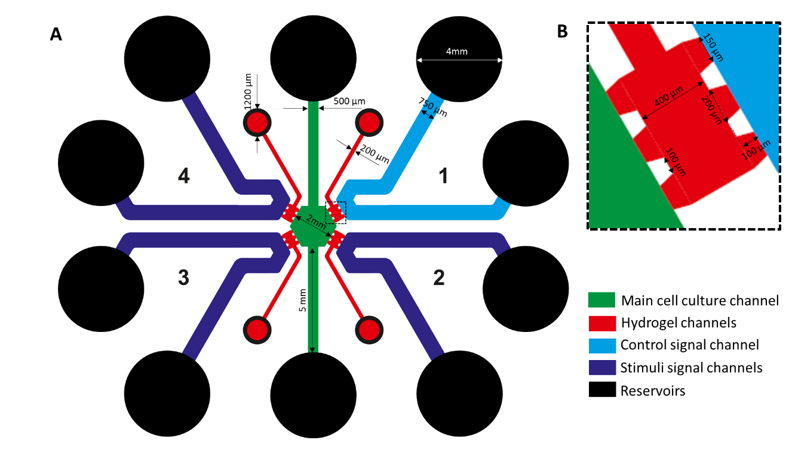
Figure S1. Schematic representation of the design of microfluidic network used in this study.

