Natural Hazards
Supporting Information for
Region-dependent meteorological conditions for the winter cold hazards with and without precipitation in China

Yueyue Yu^{1,2}, YANG Wenwen ZHANG Lingli^{1,4} GUAN Zhaoyong¹ Yang Qinlan³ Hu Muxin³ Qiu Wentian³ Wang Jingyi³

1Key Laboratory of Meteorological Disaster, Ministry of Education (KLME)/Joint International Research Laboratory of Climate and Environment Change (ILCEC)/Collaborative Innovation Center on Forecast and Evaluation of Meteorological Disasters (CIC–FEMD) /NUIST–UoR International Research Institute, Nanjing University of Information Science and Technology, Nanjing, China
2 LASG, Institute of Atmospheric Physics, CAS, Beijing, 100029, China
3Reading-NUIST Academy, Nanjing University of Information Science and Technology, Nanjing, 210044, China
4Jilin Changbaishan Meteorological Bureau, Changbaishan,133613, China

Corresponding author: Yueyue Yu (yuyy@nuist.edu.cn)

Contents of this file
Table A1
Figures A1 to A2

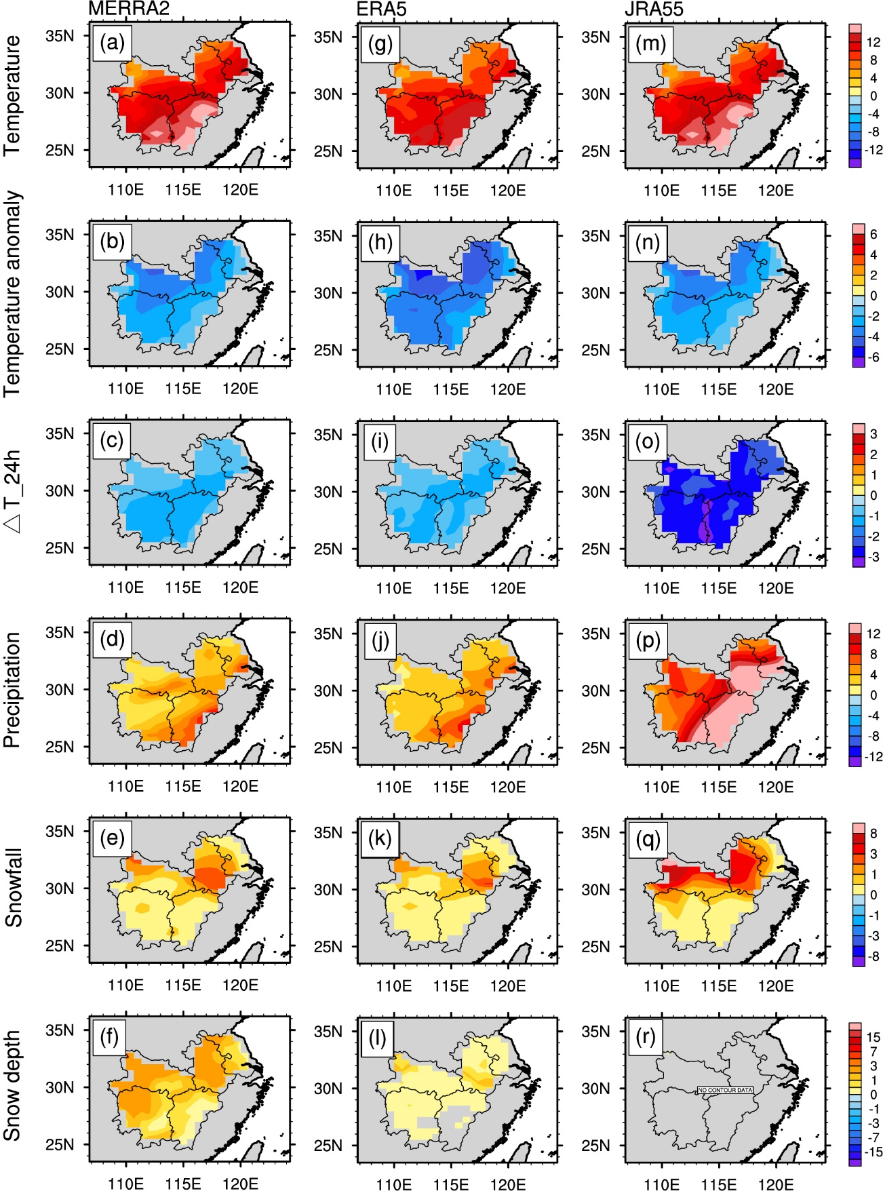
Figure A1. Spatial patterns of the event-mean-field of the six key variables of the Reanalysis dataset including (a-f) MERRA2, (g-l) ERA5, (m-r) JRA55 during DRY-C event in the middle and lower reaches of the Yangtze River region.
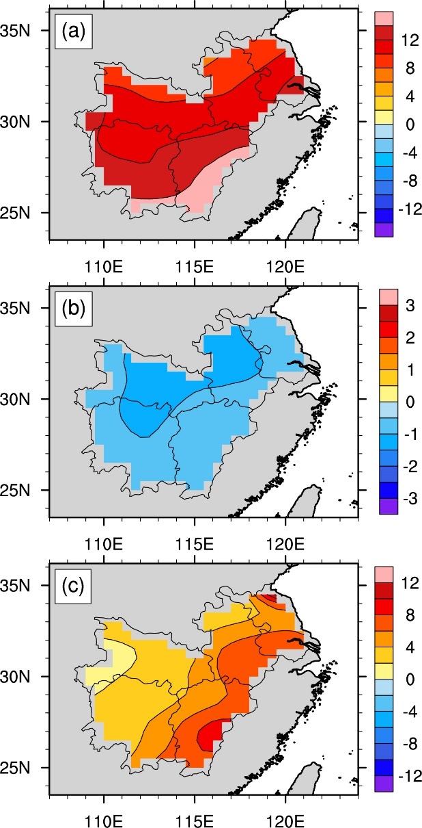
Figure A2. As in Fig. A1, but for the spatial patterns of the event-mean-field of (a) the daily mean temperature (units: °C), (b) 24-hour temperature change (units: °C d⁻¹), and (c) accumulated daily precipitation (units: mm d⁻¹) of the automatic weather stations.

Table A1. The daily cold hazards occurrence dataset in winters (November-March) from 1980 to 2020 in China.
Year | Time | Affected Province | Disaster
1980 | January 30-February 12 | Guangdong, Fujian | low temperature, sleet
1980 | February 13-23 | Fujian | low temperature, sleet
1980 | March 6-10 | Xinjiang | low temperature
1982 | February 4-17 | Hunan | sleet, freezing
1982 | December 20-30 | Yunnan, Guangdong, Guangxi, Hainan | low temperature, abrupt temperature drop
1983 | February 18-21 | Jiangsu | abrupt temperature drop
1983 | March 20-30 | Guangxi | abrupt temperature drop
1983 | December 26-30 | Yunnan, Sichuan, Guangxi, Fujian | snowstorm, low temperature
1984 | January 16-19 | Jiangsu, Anhui, Zhejiang, Hubei, Hunan, Jiangxi | snowstorm
1984 | February 6-8 | Jiangsu | low temperature
1985 | February 13-March 3 | Xinjiang | snowstorm
1985 | March 3-30 | Fujian, Guangxi | low temperature, sleet
1985 | March 4-23 | Sichuan, Xinjiang | snowstorm
1985 | March 24-31 | Sichuan | snowstorm
1985 | November 6-11 | Inner Mongolia | snowstorm
1986 | February 26-March 8 | In northern Guangxi, Yunnan, Sichuan, Guizhou, Fujian, Guangdong, Hainan | low temperature, sleet
1986 | November 23-24 | Inner Mongolia | snowstorm
1986 | December 6-7 | The northern xinjiang | snowstorm
1986 | December 16-17 | Inner Mongolia | snowstorm
1987 | March 20 | Heilongjiang | snowstorm
1988 | January 1-27, February 1-10, 19-27, March 4-30 | Xinjiang | snowstorm
1988 | February 15-March 31 | Sichuan, Yunnan | low temperature, sleet
1988 | February 22-29 | Hubei province | sleet, abrupt temperature drop
1988 | March 1-3 | Sichuan | snowstorm
1989 | January 10-20 | Hubei, Hunan | low temperature, snowstorm
1989 | January 15-February 20 | Yunnan, Sichuan, Guangxi, Hainan | low temperature, sleet
1989 | January 23-30 | Tibet | snowstorm
1989 | February 15-23 | Tibet | snowstorm
1989 | February 20-23 | Gansu | snowstorm, low temperature
1989 | February 20-23 | Hubei, Henan, Jiangsu, Anhui | snowstorm
1989 | December 10, 1989-January 7, 1990, January 22-March 31, 1990 | Tibet, Qinghai, Sichuan | snowstorm
1990 | January 26-February 2 | Shanxi, Hebei, Henan, Tianjin, Jiangsu | low temperature, freezing, snowstorm
1990 | January 27-February 2 | Shanghai, Anhui, Hubei, Zhejiang, Jiangsu, Jiangxi, Hunan | snowstorm, freezing
1990 | February 13-25 | Hubei huanggang | low temperature
1990 | March 20-27 | Shanxi | low temperature, sleet, freezing
1991 | February 22-23 | Hebei, Shanxi, Jiangsu | low temperature
1991 | December 20-30 | Shaanxi, Gansu | abrupt temperature drop, low temperature
1991 | December 22-29 | Jiangxi, Hubei, Hunan, Jiangsu, Anhui, Zhejiang, Fujian, Shanghai | low temperature, snowstorm
1991 | December 26-30 | Fujian, Guangdong, Sichuan | low temperature
1992 | November 30-December 3 | Sichuan | snowstorm, low temperature
1993 | February 1 to March 30 | Xinjiang, Qinghai, Sichuan | snowstorm
1993 | November 16-20 | Jiangsu, Anhui, Hubei, Henan | abrupt temperature drop, sleet
1993 | November 16-20 | Shanxi, Hebei, Shandong, Henan | low temperature, snowstorm
1993 | December 1-31 | Xinjiang | snowstorm
1994 | January 17-18 | Sichuan | abrupt temperature drop, snowstorm
1994 | January to March | Qinghai, Xinjiang, Tibet | snowstorm
1994 | March 21-31 | Yunnan | snowstorm
1995 | January 1-3 | Sichuan | snowstorm
1995 | January 1-3 | Sichuan | snowstorm, abrupt temperature drop
1995 | January 1-3 | Sichuan, Hunan, Jiangxi, Zhejiang, Anhui | snowstorm
1995 | January 18 to February 15 | Qinghai | snowstorm
1995 | February 15-28 | Guangxi, Yunnan | abrupt temperature drop, low temperature, sleet
1995 | February 16-March | Tibet, Qinghai | snowstorm
1996 | February 17-28 | Hainan, Guangdong, Guangxi | low temperature, sleet, freezing
1996 | November 1995 to March 1996 | Qinghai, Tibet | snowstorm
1996 | December 20, 1996-January 15, 1997 | Xinjiang | snowstorm
1997 | February 10-20 | Zhejiang, Fujian, Hunan, Guizhou, Jiangxi, Guangxi, Guangdong, Hainan | low temperature, sleet
1997 | March 1-10, 21-30 | Tibet | snowstorm
1997 | March 11-20 | Sichuan, Tibet | snowstorm
1997 | March 15-30 | Yunnan, Sichuan, Chongqing, Zhejiang, Guizhou, Jiangxi, Fujian, Guangxi, Guangdong, Hainan | low temperature, sleet
1997 | November 8-December 14 | Qinghai | snowstorm
1997 | December 31, 1996 to January 4, 1997 | Beijing, Tianjin, Hebei, Shandong | snowstorm
1997 | December 31, 1996 to January 4, 1997 | Heilongjiang, Jilin, Liaoning | snowstorm
1998 | January 8-16 | Qinghai | snowstorm
1998 | January 22-23 | Anhui, Jiangsu, Jiangxi, Zhejiang, Hunan, Hubei | sleet, freezing
1998 | March 19-23 | Henan, Zhejiang, Jiangsu, Anhui, Hubei, Hunan, Sichuan, Guangxi | low temperature, freezing, snowstorm
1999 | January 9-14 | Guizhou, Yunnan, Henan, Hubei | abrupt temperature drop, snowstorm
1999 | November 21-24, December 1-3 and 7-9 | Inner Mongolia | snowstorm
2000 | January 1-10 | Inner Mongolia | snowstorm
2000 | December 30, 1999-January 10, 2000 | Xinjiang | snowstorm
2001 | January | Inner Mongolia, Xinjiang | low temperature
2001 | January 9-16, 25-29 | Fujian, Guangdong | low temperature
2001 | January 13-16, 22-28 | Jiangsu, Zhejiang, Anhui, Hubei | low temperature
2001 | December 1 | Beijing | freezing
2001 | December 10-14 | Inner Mongolia | snowstorm
2002 | January 3-7,10-14,19-20,28-31 | Inner Mongolia | snowstorm
2004 | January 21-26 | Guangdong | low temperature
2004 | January 31 to February 3 | Qinghai | snowstorm
2004 | February 9-10 | Guangxi | low temperature
2004 | November 13-15 | Qinghai | snowstorm
2004 | December 3-19 | Inner Mongolia | snowstorm
2004 | December 20-30 | Zhejiang, Jiangxi, Hunan | snowstorm
2005 | January 10-13 | Hunan, Jiangxi, Hubei, Guizhou, Fujian, Zhejiang | snowstorm
2005 | January 17-19, 29-31, February 15, 21-23 | Tibet | snowstorm
2005 | January 20-22 | Xinjiang | snowstorm
2005 | January 22-28 | Inner Mongolia, Xinjiang, Tibet | snowstorm
2005 | February 7-13 | Hunan, Hubei and Guizhou | freezing, snowstorm
2005 | February 13-18 | Xinjiang | snowstorm
2005 | March 2-7 | Yunnan | abrupt temperature drop, low temperature, sleet
2005 | November 27, November 30 and December 2 | Inner Mongolia | snowstorm
2005 | December 3-7, 11-17, 20-21 | Shandong | snowstorm
2006 | January 1-10 | Guizhou, Guangxi | freezing
2006 | February 17-18 | Jiangxi | abrupt temperature drop
2007 | January 15-17 | Guizhou | freezing
2007 | January 15-17 | Hunan, Hubei, Anhui | snowstorm
2007 | January 20-31 | Heilongjiang | snowstorm
2007 | January 31-February 8 | Guizhou | abrupt temperature drop, freezing
2007 | February 13-14 | Heilongjiang, Jilin | snowstorm
2007 | March 3-6 | Heilongjiang, Jilin | snowstorm
2008 | January 10-16, 25-29, 31-February 2 | Guizhou, Hunan, Hubei, Anhui, Jiangxi | low temperature, sleet, freezing
2008 | December 20-22 | Guizhou | abrupt temperature drop, freezing
2008 | December 20-22 | Hubei, Hunan | abrupt temperature drop, snowstorm
2008 | January 10-16, 25-29, 31-February 2 | Henan, Shaanxi, Gansu, Ningxia | low temperature
2008 | December 1-5 | Gansu, Shanxi, Shandong, | abrupt temperature drop, low temperature
2008 | December 20-22 | Tianjin, Hebei, Shandong | abrupt temperature drop, low temperature, snowstorm
2009 | January 15-17 | Xinjiang | snowstorm, abrupt temperature drop
2009 | February 12 | Jilin, Liaoning | snowstorm
2009 | October 31 to November 16 | Beijing, Tianjin, Hebei, Shanxi, Shaanxi, Shandong | abrupt temperature drop
2009 | October 31 to November 16 | Inner Mongolia | abrupt temperature drop
2009 | November 1-16 | Heilongjiang, Jilin, Liaoning | abrupt temperature drop
2009 | November 1-16 | Jiangsu, Anhui, Henan, Jiangxi, Hubei, Hunan | abrupt temperature drop, low temperature
2009 | December 22-26 | Heilongjiang | abrupt temperature drop, sleet
2010 | January 1-6, 17-23 | Jiangsu, Anhui, Hubei, Jiangxi, Hunan | abrupt temperature drop, snowstorm
2010 | January 1-6, 17-23 | Xinjiang, Inner Mongolia | low temperature, abrupt temperature drop, snowstorm
2010 | February 10-20 | Jiangsu, Anhui, Zhejiang, Fujian, Henan, Hubei, Hunan | low temperature, sleet
2010 | December 3-7, 9-16, 21-26, 28-31 | Guizhou, Yunnan, Guangxi, Guangdong | abrupt temperature drop, sleet
2010 | December 3-7, 9-16, 21-26, 28-31 | Heilongjiang, Jilin | low temperature, abrupt temperature drop, snowstorm
2010 | December 3-7, 9-16, 21-26, 28-31 | Jiangsu, Shanghai, Anhui, Zhejiang, Fujian, Jiangxi, Hunan, Hubei | abrupt temperature drop, sleet, freezing
2010 | December 3-7, 9-16, 21-26, 28-31 | Xinjiang | low temperature, snowstorm
2011 | January 1-6, 10-11, 16-21 and 26-28 | Guizhou, Yunnan, Jiangxi, Hunan, Chongqing, Sichuan, Fujian, Guangdong, Guangxi | low temperature, sleet, freezing
2011 | February 10-20 | Zhejiang, Fujian, Jiangxi, Guangdong, Guangxi | low temperature, sleet
2011 | February 14-18 | Tibet | snowstorm
2011 | December 1-26 | Guizhou, Sichuan, Yunnan, Tibet | low temperature, sleet
2011 | December 5-9, 14-16 | Inner Mongolia, Shandong, Hebei, Gansu, Xinjiang | low temperature, snowstorm
2011 | December 5-9, 14-16 | Inner Mongolia, Xinjiang | low temperature, snowstorm
2012 | January 3-March 20 | Hunan, Jiangxi, Zhejiang, Fujian, Guangdong, Guangxi, Yunnan, Guizhou, Shanghai | low temperature, sleet
2012 | January 20-February 5 | Heilongjiang, Jilin | low temperature, snowstorm
2012 | February 8-9 | Tibet | snowstorm
2012 | February 21-24 | Xinjiang | snowstorm
2012 | November 1-10, December 13-31 | Beijing, Tianjin, Hebei, Inner Mongolia | snowstorm
2012 | November 6-13, 15-18, December 1-4 | Heilongjiang, Liaoning, Jilin | snowstorm
2013 | January 1-11 | Zhejiang, Anhui, Fujian, Jiangxi, Hubei, Hunan | low temperature, sleet
2013 | January 1-14 | Zhejiang, Anhui, Fujian, Jiangxi, Hubei, Hunan, Guangxi, Chongqing, Sichuan, Guizhou, Yunnan | low temperature, sleet
2013 | January 5-13, 16, 20-29 | Inner Mongolia, Xinjiang | snowstorm
2013 | January 17-19 | Inner Mongolia, Xinjiang, Tibet | snowstorm
2013 | January 23-31 | Heilongjiang | snowstorm
2013 | February 4-7, 16-18, 23-25 | Tibet | snowstorm
2013 | February 18-19 | Anhui, Jiangsu, Hubei, Zhejiang | snowstorm
2013 | December 15-24 | Yunnan, Sichuan, Guizhou | abrupt temperature drop, low temperature, sleet, freezing
2013 | November 16-20, 24-27 | Heilongjiang, Jilin | snowstorm
2014 | January 15-24 | Yunnan, Sichuan | sleet, freezing
2014 | January 21-31 | Xinjiang | snowstorm
2014 | February 4-13 | Hunan, Hubei, Jiangxi, Anhui, Zhejiang, Jiangsu | low temperature, sleet, freezing
2014 | February 5-18 | Sichuan, Chongqing, Hunan, Hubei, Jiangxi, Guizhou, Guangxi, Guangdong, Anhui, Zhejiang | low temperature, sleet, freezing
2014 | November 30 to December 3 | Heilongjiang | snowstorm
2015 | January 27-31 | Jiangsu, Anhui, Henan, Hubei, Hunan, Jiangxi, Guizhou | snowstorm
2015 | January 27-31 | Shanxi, Henan | snowstorm
2015 | February 21-22 | Heilongjiang | snowstorm
2015 | February 25 | Liaoning | snowstorm
2015 | November 22, 26 | Shanxi | abrupt temperature drop
2015 | November 23-24 | Shandong | snowstorm
2015 | November 23-25 | Henan, Shanxi | abrupt temperature drop
2015 | December 1-3 | Heilongjiang | snowstorm
2015 | December 1-3 | Inner Mongolia | snowstorm
2015 | December 9-13 | Xinjiang | snowstorm
2016 | January 21-25 | Hubei, Anhui, Zhejiang | abrupt temperature drop, snowstorm
2016 | January 21-25 | Yunnan, Sichuan, Chongqing, Guizhou, Jiangxi, Guangxi, Fujian, Hainan, Guangdong | abrupt temperature drop, snowstorm
2016 | February 11-15 | Hebei, Shandong, Shanxi, Gansu | abrupt temperature drop, sleet
2016 | November 19-24 | Henan, Shaanxi, Shandong, Hubei | snowstorm
2016 | December 3-13, 17-25, 27-29 | The northern xinjiang | snowstorm
2016 | December 21-22 | Jilin | snowstorm
2017 | January 17-21 | Xinjiang | snowstorm, abrupt temperature drop
2017 | January 19-22 | Hebei, Shanxi | abrupt temperature drop
2017 | January 19-22 | Liaoning, Jilin | abrupt temperature drop
2017 | January 19-22 | Inner Mongolia, Xinjiang | abrupt temperature drop
2017 | February 6-10, 20-22 | Shanxi, Shaanxi, Henan | abrupt temperature drop, sleet
2018 | January 3-4 | Henan | sleet
2018 | January 3-7 | Anhui | low temperature, sleet, freezing
2018 | January 24-28 | Guizhou, Guangxi, Guangdong, Sichuan, Chongqing, Yunnan | low temperature, sleet
2018 | January 24-28 | Henan, Shaanxi, Shanxi | abrupt temperature drop
2018 | January 24-28 | Jiangsu, Zhejiang, Anhui, Hubei, Hunan | snowstorm
2018 | February 1-6 | Yunnan | low temperature, sleet
2018 | February 3-4, 10-12, 15-17, 21-22, 24-25 | Guizhou, Yunnan, Sichuan, Fujian, Guangdong, Guangxi, Zhejiang, Gansu | low temperature, freezing或snowstorm
2018 | February 3-4, 10-12, 15-17, 21-22, 24-25 | Heilongjiang, Jilin, Liaoning | abrupt temperature drop, sleet
2018 | December 5, 11 | Jiangsu, Anhui, Zhejiang, Hunan, Shandong, Henan | low temperature, sleet
2018 | December 5-11, 25-31 | Guizhou, Hunan | low temperature, sleet, freezing
2018 | December 5-11, 25-31 | Inner Mongolia, Heilongjiang | abrupt temperature drop, low temperature
2018 | December 5-11, 25-31 | Xinjiang, Gansu, Beijing | low temperature
2018 | December 6-10, 29-30 | Jiangsu, Anhui, Zhejiang, Hunan | low temperature, sleet
2018 | December 25-28 | Jiangsu, Anhui, Zhejiang, Hunan | low temperature
2019 | January 1-15 | Qinghai | snowstorm
2019 | January 11-22 | Henan, Guangdong, Guangxi, Yunnan | low temperature, freezing, snowstorm
2019 | January 16-31 | Tibet, Qinghai | low temperature, snowstorm
2020 | January 4-10 | Guizhou, Yunnan, Hubei, Hunan, Anhui, Henan | low temperature, sleet, freezing
2020 | January 4-10 | Inner Mongolia | low temperature, sleet, freezing
2020 | January 4-10 | Inner Mongolia, Shaanxi, Shanxi, Hebei, Henan, Shandong | low temperature, sleet, freezing
2020 | February 13-16 | Jiangsu, Anhui, Zhejiang, Hubei, Hunan, Jiangxi, Chongqing, Guizhou, Fujian, Henan | abrupt temperature drop, sleet
2020 | February 13-16 | Jilin, Liaoning | abrupt temperature drop, low temperature, snowstorm
2020 | February 13-16 | Hebei, Shandong, Beijing, Tianjin | low temperature, abrupt temperature drop, freezing, snowstorm

