Appendix

Structural components of the selected GZH and LPC multi-residential buildings

Table 3: Structural components of the selected GZH and LPC multi-residential buildings (* frame ratio of all windows calculated by measuring the glazing and frame areas; g-value stands for energy transmittance of the glazing)
Component | LPC building | GZH building
Exterior walls | three-layer panel construction: 14 cm reinforced concrete, 6 cm polystyrene, 6 cm reinforced concrete with surface structure (U=0.56 W/(m²K)) | level 1 & 2: 51 cm brick walls (U=0.84 W/(m²K));  level 3 & 4: 38 cm brick walls (U=1.06 W/(m²K));  attic: 25 cm brick wall with 6 cm calcium silicate boards for interior insulation (U=0.43 W/(m²K))
Interior walls | 15 cm and 7 cm reinforced concrete | mainly 38 cm brick walls and some drywalls; in attic only drywalls
Basement ceiling | 14 cm prestressed concrete, 2.5 cm mineral wool, 5 cm anhydrite screed, 0.5 cm flooring (U = 1.17 W/(m²K)) | 14 cm prestressed concrete / 6 cm polystyrene insulation / 6 cm anhydrite screed / flooring (U=0.48 W/(m²K))
Ceilings | 14 cm prestressed concrete, 1 cm anhydrite screed, 0.5 cm flooring  (U = 3.8 W/(m²K)) | suspended wooden beam ceilings / 1 cm mineral wool / 2 cm dry screed / flooring (U=0.63 W/(m²K))
Top-floor ceiling | 14 cm prestressed concrete, 6 cm mineral wool (U = 1.0 W/(m²K)) | -
Roof | Flat roof of reinforced concrete, cassette panels (cold roof) | Saddle roof with 16 cm between-rafter mineral wool insulation and 2.5 cm plasterboard interior (U=0.21 W/(m²K))
Windows | double insulation glazing (U_{w} = 2.8 W/(m²K) and g = 0.75) | double insulation glazing (Uw = 1.8 W/(m²K) and g = 0.70) *

Initial and boundary conditions for ENVI-met and HIRVAC

Table 4: Initial and boundary conditions for ENVI-met simulations in the districts of Dresden and Erfurt.
Parameter/variable | Value
Soil type | loam
Soil temperature (0-50 cm depth) | 21 °C
Soil moisture (0-50 cm depth) | 20 % (related to field capacity)
Air temperature (2 m AGL) | 28 °C
Relative air humidity (2 m AGL) | 50 %
Horizontal wind speed in 10 m AGL | 4 m s⁻¹
Wind direction | 150 degrees (i.e., south-east wind)
Model (core) domain (number of grid points in x-y direction) | Erfurt: 948 m x 972 m (237x243)  Dresden: 972 m x 716 m (243x179)

Table 5: Initial and boundary conditions for HIRVAC simulations in the districts of Dresden and Erfurt.
Parameter/variable | Value
Soil type | loam
Soil temperature (50 cm depth) | 19 °C
Soil moisture (0-50 cm depth) | 30 % (related to field capacity)
Surface temperature (2 m AGL) | 19 °C
Horizontal wind speed in 2 km AGL | 6.6 m s⁻¹ (leads to similar initial wind speed in 10 m AGL as in ENVI-met)
Wind direction | 150 degrees (i.e., south-east wind)
Model (core) domain (number of layers in z-direction) | 120
Surface coverage | Sparse tree canopy: Leaf Area Index: 2, crown cover: 50%, vegetation height 8 m
Start Date | same as in the ENVI-met simulation

Boundary Conditions for Building Performance Simulation
- Location LPC building in Dresden Gorbitz and GZH building in Erfurt Oststadt (both Germany)
- Orientation of the buildings similar to reality
- Shading objects: shading of surrounding buildings and trees as well as by balconies was taken into account for the GZH building, for the LPC such shading objects were not present
- No sun protection system was applied (are not present in both buildings)
- Assumed thermal bridge loss coefficient related to all surfaces of the building envelope of 0.10 W/(m²K) was applied for both buildings (BMI 2020)
- Building air tightness related to all component surfaces (weighted by building envelope surface) defined by n₅₀ value (air exchange rate coefficient at 50 Pa pressure difference) of 4 h⁻¹ (EN_15242 2007)
- Assumed window ventilation for all rooms:
  - Windows tilted during night (from 10 pm to 7 am) and fully opened in the morning (7 am to 8 am) and in the evening (8 pm to 10 pm) when the room temperature is higher than 23 °C and the outdoor air temperature is cooler. This window opening behaviour is based on the window ventilation profiles derived from surveys (Schiela et al. 2021 (submitted))
  - During the day, the windows remain closed (from 8 am to 8 pm)
  - Realistic window opening profile was considered in the BPS
  - Room doors remain closed all the time
  - Both BPS tools consider wind and temperature gradient driven air exchange through windows by simplified pressure coefficients (more details see elsewhere (Schünemann et al. 2021))
- Internal heat gain profiles by occupants, lighting and electric devices derived by DIN EN 16798-1 (DIN-EN-16798-1 2021)
  - No differentiation of the days of the week and the usage of the rooms
  - Staircase and basement contain no internal heat gains
  - Internal heat gains related to the floor area:
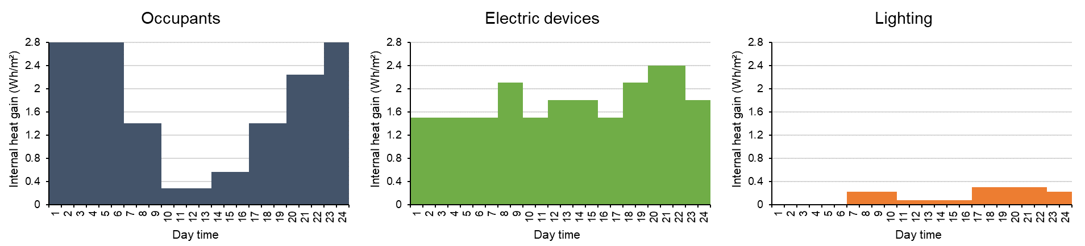
  - The assumed occupants are not senior citizens
  - Sum of the daily internal heat gains is 87 Wh/m²d

Statistical evaluation of daily temperature range for summer periods
Figure 8 illustrates the statistical distribution of daily temperature range for “hot summers” and “very hot summer months” in the climate reference period 1991-2020 for the climate station Dresden Klotzsche. The category “hot summer” was applied for all summers with a climatological heat sum (cumulative sum of all days with a mean temperature above 20 °C in the summer half year at which 20 °C is subtracted) over the 75 percentile threshold of the related distribution for the last reference period. Following this definition eight summers were detected as “hot summers” in the last reference period from 1991-2020. The category “very hot summer months” summarizes all months with a mean that is higher as the 95% percentile of the statistical distribution of this month in the reference period. A comparable result with a slight shift of +0.5 K was found for the distribution of daily temperature range in hot summers at the climate station Erfurt-Weimar. For it, the same simulation period for both investigation areas can be used as input for the model chain.
Figure 11 (left side) shows that the average and median of daily temperature range are around 11 K for hot summers and 12 K for hot summer months that is comparable with the result from the HIRVAC-beech simulation. The statistical expectancy range (from 25 to 75 percentile) is between 8 and 14 K (hot summers) and 9 and 14 K (hot summer months) which is comparable with the temperature amplitude of the measurements for the chosen heat wave in summer 2018 (Figure 8).
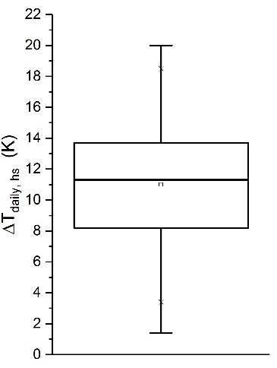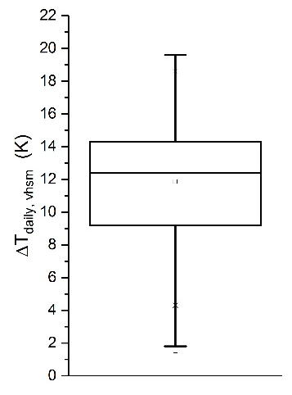
Figure 11: Boxplots (including mean, median, 1, 5, 25, 75, 95 and 99 percentiles) of the daily temperature amplitude for hot summers (left) and very hot summer months (right) of the last climate period 1991-2020 for the climate station Dresden Klotzsche.

