Supplementary Information
Sources and Biogeochemical Processing of Dissolved Organic Matter in the Middle Reach of the Yangtze River: Insights from Optical Properties and Nitrate Dual-Isotopes
J. Liao , Q. H. Huang , G. N. Liu , N. T. Wang , Z. P. Qiu , C. Y. Hu , R. G. M. Spencer
J. Liao · G. N. Liu · N. T. Wang
Wuhan Center, China Geological Survey, Wuhan 430205, China
Q. H. Huang
Key Laboratory of Yangtze River Water Environment of the Ministry of Education, College of Environmental Science and Engineering, Tongji University, Shanghai 200092, China
Z. P. Qiu · C. Y. Hu
School of Geography and Information Engineering, China University of Geosciences, Wuhan 430074, China
R. G. M. Spencer
Department of Earth, Ocean, and Atmospheric Science, Florida State University, Tallahassee, FL, USA
Correspondence author: J. Liao, Wuhan Center, China Geological Survey, Wuhan 430205, China. Email: liaojin_earth@163.com

Table S1 Definition and significance of fluorescence optical indices
DOM quality index | Formula or Description | Significance | References
HIX | $\frac{\sum{I_{435-480}}}{\sum{I_{300-345}}}$ at Ex 254 nm | Used to characterize humification status of DOM and increases with increasing degree of humification | Zsolnay et al. 1999; Ohno 2002
BIX | $\frac{I_{380}}{I_{430}}$ at Ex 310nm | Used to indicate the relative contribution of fresh DOM to recalcitrant DOM and increases with increasing autochthonous component | Huguet et al. 2009
α₂₅₄ | $$2.303 × A_{λ}÷Ɩ$$ | Used to represent the CDOM concentration | Wang et al. 2019
S₂₇₅₋₂₉₅ | $$\frac{\ln^{α_{λ}}-\ln^{α_{λ_{0}}}}{λ_{0}-λ}$$ | Used to trace degradation of DOM and increases with increasing degree of photodegradation | Yamashita et al. 2013
S_{R} | $$\frac{S_{275-295}}{S_{350-400}}$$ | Used to characterize molecular weight of DOM and increases with decreasing molecular size | Helms et al. 2008
Note: Ɩ is the path length in meters, $A_{λ}$ is the absorbance at wavelength λ, and Ⅰ is the integrated area of the defined wavelength range.

Table S2 Optical concentration (UV-abs, EEMs) and nitrate isotopic compositions in the middle Yangtze River.
Sample | Distance to Estuary（km） | ∑Flu (R.U.) | C4  (R.U.) | C5  (R.U.) | α₂₅₄ | HIX | BIX | S_{R} | C5  /$\sum{Flu}$ | $${NO}_{3}^{-}-N$$  （mg/L） | $δ^{18}O_{{NO}_{3}}$ (‰) | $δ^{15}N_{{NO}_{3}}$ (‰)
Rainy Season
M01 | 2030 | 0.94 | 0.12 | 0.09 | 10.72 | 7.19 | 0.86 | 0.82 | 0.10 | 1.24
M02 | 1977 | 1.05 | 0.13 | 0.09 | 12.83 | 8.16 | 0.81 | 0.84 | 0.09 | 1.56 | 2.01 | 5.77
M03 | 1975 | 1.04 | 0.12 | 0.08 | 11.84 | 8.33 | 0.82 | 0.77 | 0.08 | 1.57 | 2.15 | 5.61
M04 | 1940 | 1.04 | 0.13 | 0.10 | 15.23 | 7.96 | 0.81 | 0.93 | 0.10 | 1.49 | 0.66 | 5.49
M05 | 1928 | 1.01 | 0.12 | 0.10 | 14.27 | 7.46 | 0.82 | 0.91 | 0.10 | 1.59 | 1.20 | 5.37
M06 | 1905 | 0.99 | 0.13 | 0.13 | 12.42 | 6.44 | 0.82 | 0.79 | 0.13 | 1.60 | 1.49 | 5.73
M07 | 1893 | 0.92 | 0.11 | 0.11 | 13.65 | 6.60 | 0.85 | 0.92 | 0.12 | 1.54 | 1.23 | 5.75
M08 | 1880 | 1.02 | 0.13 | 0.13 | 12.72 | 6.39 | 0.83 | 0.82 | 0.12 | 1.53 | 1.05 | 5.60
M09 | 1861 | 1.04 | 0.13 | 0.12 | 14.89 | 6.96 | 0.82 | 0.91 | 0.11 | 1.53
M10 | 1847 | 1.04 | 0.14 | 0.12 | 14.94 | 6.95 | 0.82 | 0.92 | 0.11 | 1.47 | 0.77 | 5.53
M11 | 1840 | 1.01 | 0.11 | 0.11 | 14.75 | 6.86 | 0.82 | 0.94 | 0.11 | 1.45
M12 | 1816 | 1.00 | 0.13 | 0.10 | 13.21 | 7.51 | 0.83 | 0.82 | 0.10 | 1.37 | -0.55 | 4.75
M13 | 1796 | 0.98 | 0.14 | 0.14 | 13.66 | 5.98 | 0.83 | 0.88 | 0.14 | 1.46 | 0.62 | 5.45
T01 | 1793 | 1.18 | 0.17 | 0.20 | 13.70 | 4.77 | 0.95 | 0.98 | 0.17 | 2.50
M14 | 1784 | 0.95 | 0.12 | 0.11 | 12.29 | 6.92 | 0.86 | 0.84 | 0.11 | 1.28 | 0.60 | 6.15
M15 | 1766 | 0.95 | 0.13 | 0.13 | 12.52 | 5.53 | 0.84 | 0.87 | 0.14 | 1.37 | -0.16 | 5.28
M16 | 1734 | 0.95 | 0.12 | 0.12 | 14.51 | 6.39 | 0.83 | 0.97 | 0.12 | 1.20 | -0.39 | 5.70
M17 | 1680 | 0.79 | 0.10 | 0.09 | 11.93 | 5.90 | 0.90 | 0.99 | 0.12 | 1.52 | 0.12 | 5.70
M18 | 1671 | 0.79 | 0.10 | 0.11 | 10.16 | 5.50 | 0.90 | 0.85 | 0.14 | 1.56 | 0.96 | 6.28
M19 | 1615 | 0.74 | 0.10 | 0.09 | 9.68 | 5.96 | 0.86 | 0.81 | 0.12 | 1.38
M20 | 1569 | 0.72 | 0.10 | 0.10 | 11.68 | 5.72 | 0.88 | 1.05 | 0.14 | 1.21 | -0.42 | 5.63
M21 | 1502 | 0.73 | 0.15 | 0.10 | 9.60 | 5.72 | 0.88 | 0.84 | 0.14 | 1.27
L02 | 1432 | 0.79 | 0.11 | 0.13 | 10.55 | 5.14 | 0.86 | 0.94 | 0.17 | 0.73
L01 | 1420 | 0.80 | 0.11 | 0.11 | 10.87 | 5.73 | 0.87 | 0.94 | 0.14 | 0.92
M22 | 1407 | 0.78 | 0.11 | 0.11 | 10.26 | 5.87 | 0.86 | 0.89 | 0.14 | 0.95 | -0.15 | 5.43
M23 | 1349 | 0.72 | 0.12 | 0.12 | 9.65 | 5.30 | 0.89 | 0.90 | 0.17 | 1.11 | -0.38 | 5.58
M24 | 1261 | 0.75 | 0.28 | 0.12 | 9.91 | 6.87 | 0.84 | 0.94 | 0.16 | 1.04 | 0.26 | 5.90
T02 | 1227 | 0.70 | 0.11 | 0.17 | 11.59 | 3.49 | 1.01 | 1.11 | 0.25 | 0.85
M25 | 1138 | 0.84 | 0.31 | 0.13 | 13.23 | 7.22 | 0.82 | 1.13 | 0.15 | 1.06 | 3.09 | 8.93
M26 | 1078 | 0.91 | 0.67 | 0.15 | 11.37 | 9.00 | 0.77 | 0.94 | 0.17 | 1.09 | 0.53 | 5.07
M27 | 1047 | 0.91 | 0.82 | 0.14 | 13.62 | 11.05 | 0.76 | 1.22 | 0.16 | 1.10 | -0.08 | 5.12
M28 | 951 | 0.91 | 0.15 | 0.16 | 11.49 | 4.78 | 0.87 | 0.95 | 0.18 | 0.99 | 1.94 | 6.52
L03 | 938 | 0.74 | 0.11 | 0.14 | 12.47 | 4.38 | 0.89 | 1.14 | 0.19 | 0.60
L04 | 938 | 0.78 | 0.12 | 0.18 | 12.99 | 3.71 | 0.87 | 1.12 | 0.24 | 0.57
M29 | 924 | 0.75 | 0.11 | 0.17 | 10.65 | 4.01 | 0.85 | 1.05 | 0.23 | 0.59
M30 | 923 | 0.74 | 0.10 | 0.11 | 9.66 | 5.20 | 0.86 | 0.94 | 0.15 | 0.68
Dry Season
M02 | 1977 | 0.57 | 0.08 | 0.07 | 7.86 | 5.91 | 0.90 | 0.61 | 0.13 | 1.33
M04 | 1940 | 0.57 | 0.08 | 0.11 | 8.37 | 4.77 | 0.91 | 0.67 | 0.20 | 1.56 | -0.59 | 6.15
M05 | 1928 | 0.57 | 0.08 | 0.09 | 8.04 | 5.40 | 0.92 | 0.61 | 0.15 | 1.36
M06 | 1905 | 0.57 | 0.09 | 0.09 | 8.38 | 5.43 | 0.90 | 0.73 | 0.15 | 1.59 | -0.55 | 6.30
M07 | 1893 | 0.61 | 0.09 | 0.19 | 10.66 | 3.70 | 1.04 | 0.91 | 0.32 | 1.30 | -0.32 | 5.86
M08 | 1880 | 0.59 | 0.08 | 0.11 | 8.60 | 5.03 | 0.91 | 0.71 | 0.18 | 1.30 | -0.07 | 6.22
M10 | 1847 | 0.60 | 0.09 | 0.09 | 8.43 | 5.68 | 0.92 | 0.70 | 0.15 | 1.18 | 0.46 | 6.28
M11 | 1840 | 0.60 | 0.09 | 0.09 | 8.42 | 5.87 | 0.93 | 0.72 | 0.15 | 1.25
M13 | 1796 | 0.60 | 0.09 | 0.09 | 8.47 | 5.93 | 0.90 | 0.79 | 0.15 | 1.18 | -0.89 | 6.13
M15 | 1766 | 0.60 | 0.08 | 0.10 | 10.45 | 4.92 | 0.90 | 0.87 | 0.17 | 1.26
M16 | 1734 | 0.63 | 0.09 | 0.13 | 9.67 | 4.65 | 0.93 | 0.97 | 0.20 | 1.28 | 0.19 | 6.35
M18 | 1671 | 0.61 | 0.09 | 0.12 | 9.15 | 4.73 | 0.92 | 0.89 | 0.20 | 1.30 | -0.41 | 6.40
M19 | 1615 | 0.60 | 0.10 | 0.19 | 11.92 | 3.50 | 0.91 | 1.15 | 0.31 | 1.22
M21 | 1502 | 0.60 | 0.10 | 0.10 | 10.90 | 5.24 | 0.92 | 1.18 | 0.17 | 1.53 | 0.05 | 6.40
L02 | 1432 | 0.62 | 0.07 | 0.31 | 11.55 | 1.83 | 1.06 | 1.47 | 0.50 | 1.14
L01 | 1420 | 0.61 | 0.07 | 0.15 | 10.03 | 3.59 | 1.04 | 1.06 | 0.25 | 1.11
M24 | 1261 | 0.65 | 0.19 | 0.16 | 9.25 | 4.69 | 0.90 | 0.85 | 0.24 | 1.43
T02 | 1227 | 0.91 | 0.16 | 0.45 | 18.12 | 2.28 | 0.96 | 1.33 | 0.50 | 1.09
M25 | 1138 | 0.75 | 0.92 | 0.16 | 9.77 | 10.77 | 0.77 | 0.85 | 0.21 | 1.31 | 0.84 | 6.69
M26 | 1078 | 0.72 | 0.55 | 0.21 | 9.98 | 6.30 | 0.87 | 0.90 | 0.29 | 1.25 | 0.79 | 6.67
M27 | 1047 | 0.91 | 1.37 | 0.19 | 12.09 | 11.91 | 0.77 | 0.97 | 0.20 | 1.16 | -0.08 | 6.42
M28 | 951 | 0.85 | 0.28 | 0.33 | 12.05 | 3.71 | 0.94 | 1.24 | 0.39 | 1.27 | -2.31 | 5.90
L03 | 938 | 0.59 | 0.10 | 0.38 | 8.56 | 1.78 | 1.10 | 1.24 | 0.64 | 0.99
M29 | 924 | 0.80 | 1.08 | 0.33 | 13.69 | 6.18 | 0.81 | 1.38 | 0.41 | 1.19
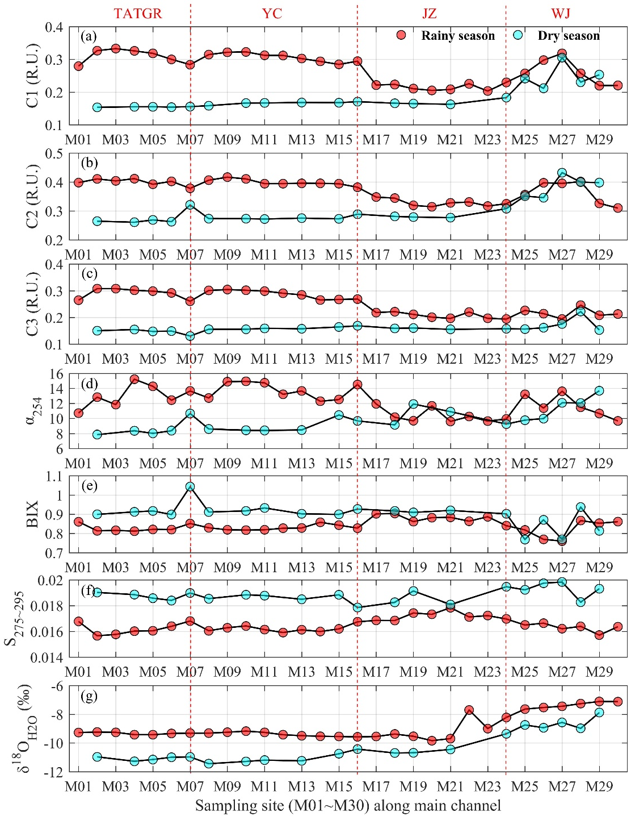
Fig.S1 Longitudinal distribution of different parameters in the surface running water from two different seasons along the Middle Reach of the Yangtze River. (a) C1 component; (b) C2 component; (c) C3 component; (d) α₂₅₄; (e) autochthonous index (BIX); (f) S_{275~295}; (f) $δ^{18}O_{H_{2}O}$. The red dashed lines represent the boundaries of four segments including TATGR, Yichang (YC), Jinzhou (JZ), Wuhan-Jiujiang (WJ) along the river.
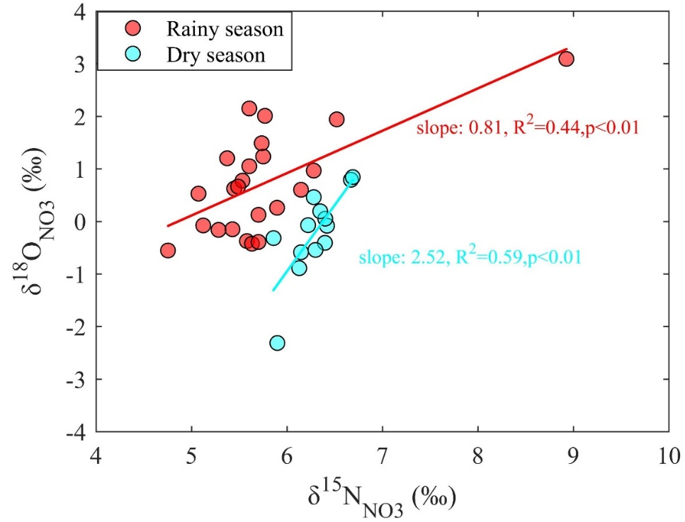
Fig.S2 $δ^{18}O_{{NO}_{3}}$ versus $δ^{15}N_{{NO}_{3}}$ in water samples of two different seasons.

