Supplementary

Preparation of carboxymethyl cellulose (CMC) derived from palm fiber waste: Effect of ozone pretreatment on CMC properties

Agustu Sholeh Pujokaroni^{1,2}, Hideaki Ichiura^{3,*}
¹ The United Graduate School of Agricultural Sciences, Ehime University, 3-5-7 Tarumi, Matsuyama, Ehime 790-8566, Japan
² Faculty of Agriculture, Mulawarman University, Jl. Kuaro, Gn. Kelua, Kec. Samarinda Ulu, Kota Samarinda, Kalimantan Timur 75119, Indonesia
³ Faculty of Agriculture and Marine Science, Kochi University, 200 Monobe-Otsu, Nankoku, Kochi 783-8502, Japan

Table S1 DP and carboxylate content of cellulose extracted from palm fiber treated with ozone
Ozone treatment time for extracted cellulose (h) | DP | Carboxylate contents (mmol/g)
0 | 1012 | 0.45
1 | 294 | 1.38
3 | 207 | 1.82
5 | 185 | 2.05

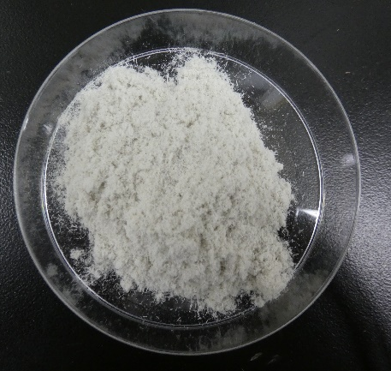
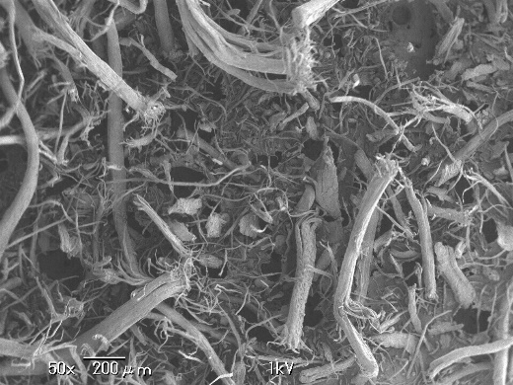
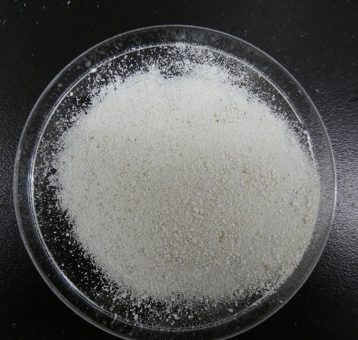
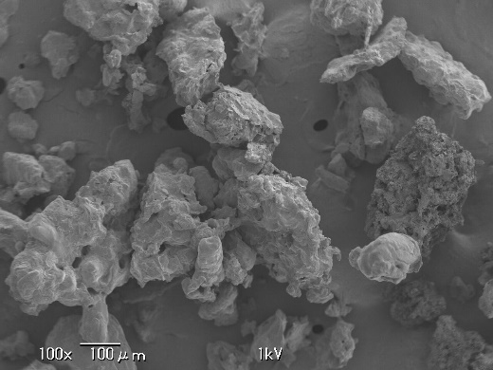
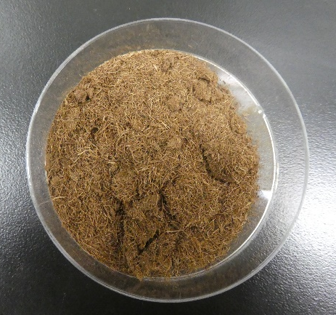
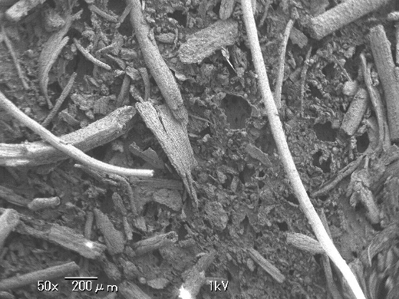
(c)
(d)
(g)
(h)
(a)
(b)
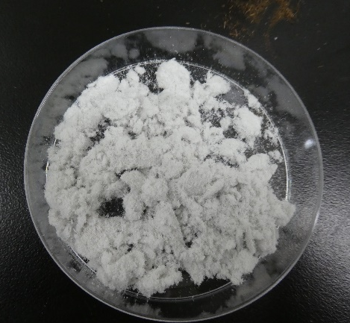
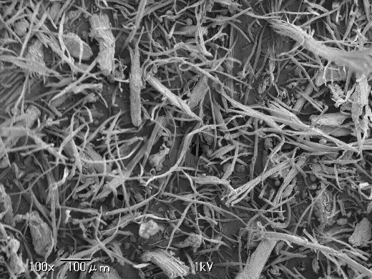
Figure S1 Images and SEM Images of palm fiber [(a) and (b)], extracted cellulose [(c) and (d), oxidized cellulose [(e) and (f)] and CMC-10-(3) [(g) and (h)].
(f)
(e)
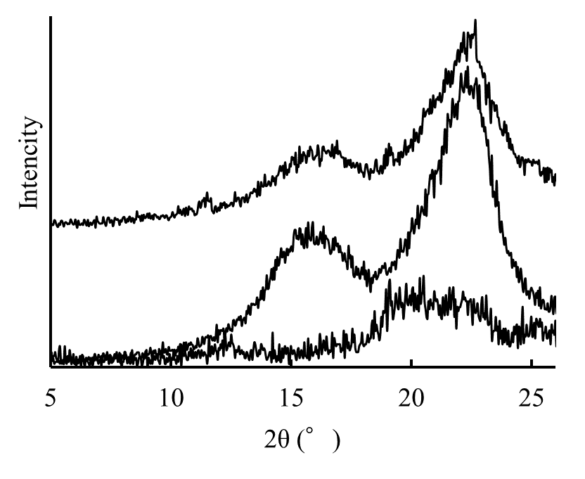
Figure S2 XRD of (a) extracted cellulose, (b) oxidized cellulose and (c) CMC-10-(3).
(a)
(b)
(c)

