High-harmonic generation with ultra-low threshold and extraordinary photon flux in CdTe
Supplementary Information
Hang Yang¹, Zhe Long¹, Kan Tian¹, Linzhen He¹, Rui Qin², Zi-Yu Chen³*, and Houkun Liang¹*
¹School of Electronics and Information Engineering, Sichuan University, Chengdu, Sichuan 610064, China
²National Key Laboratory of Shock Wave and Detonation Physics, Institute of Fluid Physics, China Academy of Engineering Physics, Mianyang 621999, China
³Key Laboratory of High Energy Density Physics and Technology (MoE), College of Physics, Sichuan University, Chengdu 610064, China

- Numerical simulation

To roughly guide our search for potential materials for efficient high-harmonic generation (HHG), we calculate the high harmonic response in CdTe driving by a 1600 nm laser pulse at an intensity of 2×10¹¹ W/cm² by using ab initio simulations based on the framework of real-time time-dependent density functional theory (TDDFT). Long-wavelength driving laser, as the 7.1 μm laser used in the experiments, is too long to simulate by using the TDDFT method. Supplementary Figure 1(a) shows the simulated high harmonic spectra in the nonperturbative regime. The harmonic spectral intensity in CdTe is generally comparable to that in phosphorene except for higher orders. This simulation result demonstrates that we are on track in searching for promising candidate materials. Both odd and even harmonics are present in the spectrum of CdTe, reflecting the broken inversion symmetry in the CdTe crystal. Supplementary Figure 1(b) shows the time-frequency spectrogram of the HHG process using wavelet analysis. Clear structures of recombination trajectories as well as discrete bursts in phase with laser fields can be observed, revealing the coupled interband and intraband dynamics contributed to the HHG mechanism in CdTe.

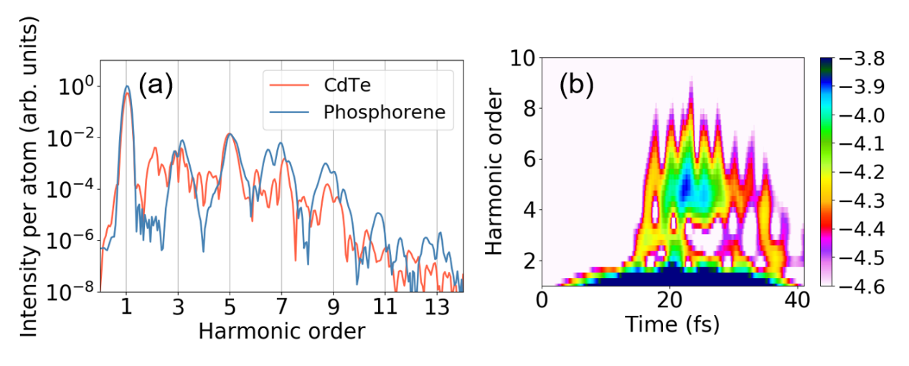
Supplementary Figure 1: high-harmonic generation in a CdTe (111) crystal and phosphorene obtained from first-principles calculations. (a) The comparison of high-harmonic spectra in CdTe (orange) and phosphorene (blue) using ab initio time-dependent DFT (TDDFT) simulations. The calculated high harmonic response is driven by a 1600 nm laser pulse at intensity of 2×10¹¹ W/cm². (b) Time–frequency analysis of the HHG process in bulk CdTe obtained through TDDFT simulations.

- Experimental description
The experimental schematics are shown in Supplementary Figure 2. It includes the mid-infrared optical parametric amplifier, the harmonics generation in CdTe, the characterization of the mid-infrared beam profile and the temporal profile, the harmonics spectral detection in several spectrometers, and the harmonics power measurement in a fiber-coupled power meter.
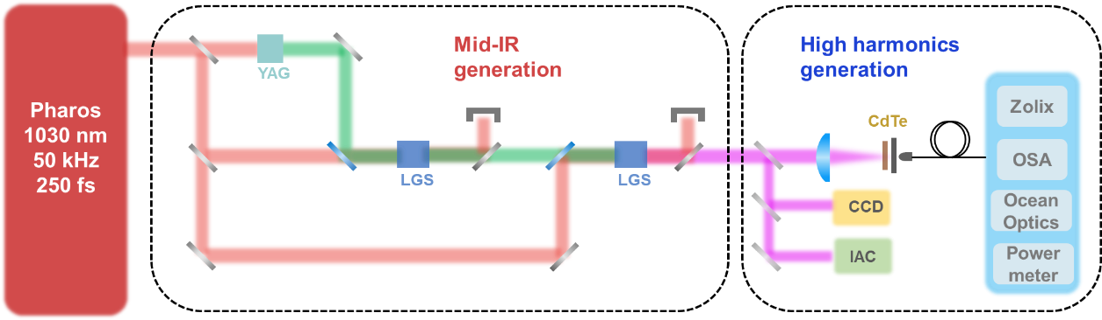
Supplementary Figure 2: The experimental schematic of the HHG in CdTe pumped by the mid-infrared femtosecond pulses. It starts with the two-stage mid-infrared optical parametric amplifiers (OPA). The commercial pump source (Pharos, Light Conversion) delivers 20 W, 250 fs pulses at 1030 nm wavelength and 50 kHz repetition rate. The near-infrared seed pulses are obtained by white light continuum generation in a 10-mm-thick YAG crystal. A 2 W fraction of the pump power is used to drive the first OPA stage, which employs an 8-mm-thick LiGaS₂ crystal cut for Type I phase matching ($θ={51}^{°}$) and produces 200 mW signal pulses centered at a wavelength of 1205 nm. The signal pulses are subsequently injected into the second OPA stage, which ultimately produces up to 210 mW 7.1 μm mid-infrared output in another 8-mm-thick LiGaS₂ crystal with Type I phase matching ($θ={51}^{°}$) under 10 W pump power. The LiGaS₂ crystals are replaced by KTA crystals to produce the OPA output centered at 3 μm. The mid-infrared power is measured by OPHIR powermeter (StarLite). An infrared camera (Dataray, WinCamD-IR-BB-7.5 system) is employed to measure the mid-infrared beam profile and estimate the focused beam size as shown in Figure S4. The temporal duration of the mid-infrared pulse is measured by a home-built interferometric autocorrelator (IAC). More details of the IAC measurement are shown in Figure S4 (b) and (c). The mid-infrared laser is focused by a zinc selenide (ZnSe) lens with the focal lengths of 50, 100 and 200 mm to generate an intensity varying from 30 GW/cm² to 4.48 TW/cm². The HHG spectra spanning in the mid-infrared, near-infrared, visible and ultraviolet region are measured by a scanning-grating monochromator with a liquid-nitrogen-cooled MCT detector, optical spectrum analyzer (YOKOGAWA, AQ6370D) and two different Ocean Optics spectrometers (USB 2000+ and Maya 2000 Pro). The output power of the 5th to 8th harmonics is measured by coupling the emission into a powermeter (JoinwiT, JW2323C). The harmonics with perpendicular and horizontal polarizations are separated by using a FLP20-VIS polarizer. All the measurements are performed at room temperature.

- Spectral, temporal and beam profile characterization of the mid-infrared OPA
The spectrum, the measured and retrieved IAC traces, the retrieved temporal profile and the measured beam profile of the mid-infrared OPA are shown in Supplementary Figure 3.
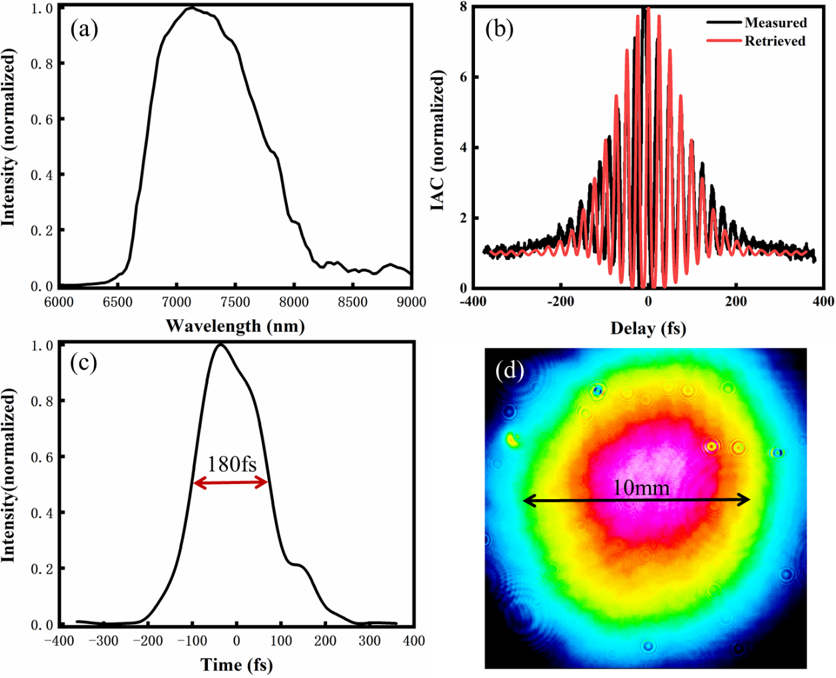

Supplementary Figure 3 (a) The spectrum of the mid-IR OPA with 7.1 μm central wavelength. (b) The measured (black) and retrieved (red) interferometric autocorrelation (IAC) traces of the mid-infrared OPA output. The IAC trace is reconstructed through a genetic algorithm based on so-called “evolutionary phase retrieval from IAC (EPRIAC)” algorithm¹⁷. In the Taylor expansion of the reconstructed spectral phase, dispersion terms up to 7th order are considered. (c) The retrieved temporal profile of the mid-infrared OPA based on the IAC measurement, revealing a 180 fs pulse width. (d) The measured beam profile of the mid-infrared OPA before the ZnSe focusing lens. A beam diameter of 10 mm is recorded.

- Comparison of materials for HHG in solids
The experimentally reported key parameters of HHG such as the pump wavelength, the maximal pump intensity and pump threshold intensity of some commonly used materials of HHG in solids are summarized and compared with those of CdTe in our experiment, as shown in Supplementary Table 1.
Supplementary Table 1. Comparison of HHG in CdTe with other commonly used materials of HHG in solids.
Materials | Pump wavelength  (μm) | Maximal pump intensity (TW/cm²) | Threshold pump intensity  (TW/cm²) | Reference
Graphene | 4.77 | 1.7 | 5th-0.8 | 1
MoS₂ | 4.13 | 2.2 | 7th-0.8 | 2
β-WP₂ | 1.9 | 1.2 | 9th-0.23 | 3
Si | 3.5 |  | 17th-0.26 | 4
Sapphire | 0.8 | 1.31 | 7th-0.366 | 5
ZnO | 3.25 | 4.5 | 15th-0.5 | 6
GaSe | 5 | 3 | 11th-0.27 | 7
Nanostructured ZnO | 2~2.3 | 1 | 5th-0.030 | 8
GaP meta | 3.7-4 | 0.6 | 5th-0.2 | 9
Silicon meta | 2.2-2.3 | 0.3 | 5th-0.05 | 10
Silicon plasmonics | 2.1 | 0.2 | 5th-0.01 | 11
Sapphire meta | 0.8 | 0.42 | 7th-0.23 | 12
Perovskite | 3.5 | 1 | 7th-0.12 | 13
Si-sapphire interface | 2.2 | 5.6 | 7th-1.1 | 14
WSe₂ nanosheet | THz | 0.767 | 6th-0.01 | 15
CdO | 2.08 | 0.014 | 5th-0.001 | 16
CdTe | 7.1 | 4.5 | 12th-0.03 | This work

The reported pump threshold intensity and the maximal pump intensity of the commonly used materials of HHG in solids are summarized in Supplementary Figure 4. Four categories of materials such as bulk, thin films, 2D materials and materials with meta-structures are included. It is revealed that CdTe exhibits a threshold intensity of 30 GW/cm² which is 1-to-2 orders of magnitude lower than that of traditional bulk materials such as ZnO, Si and sapphire etc. In the meantime, CdTe can be pumped at a high intensity of 4.5 TW/cm² without obvious damage, which is 5-time to 1-order of magnitude higher than that of meta-structures and nano-films.
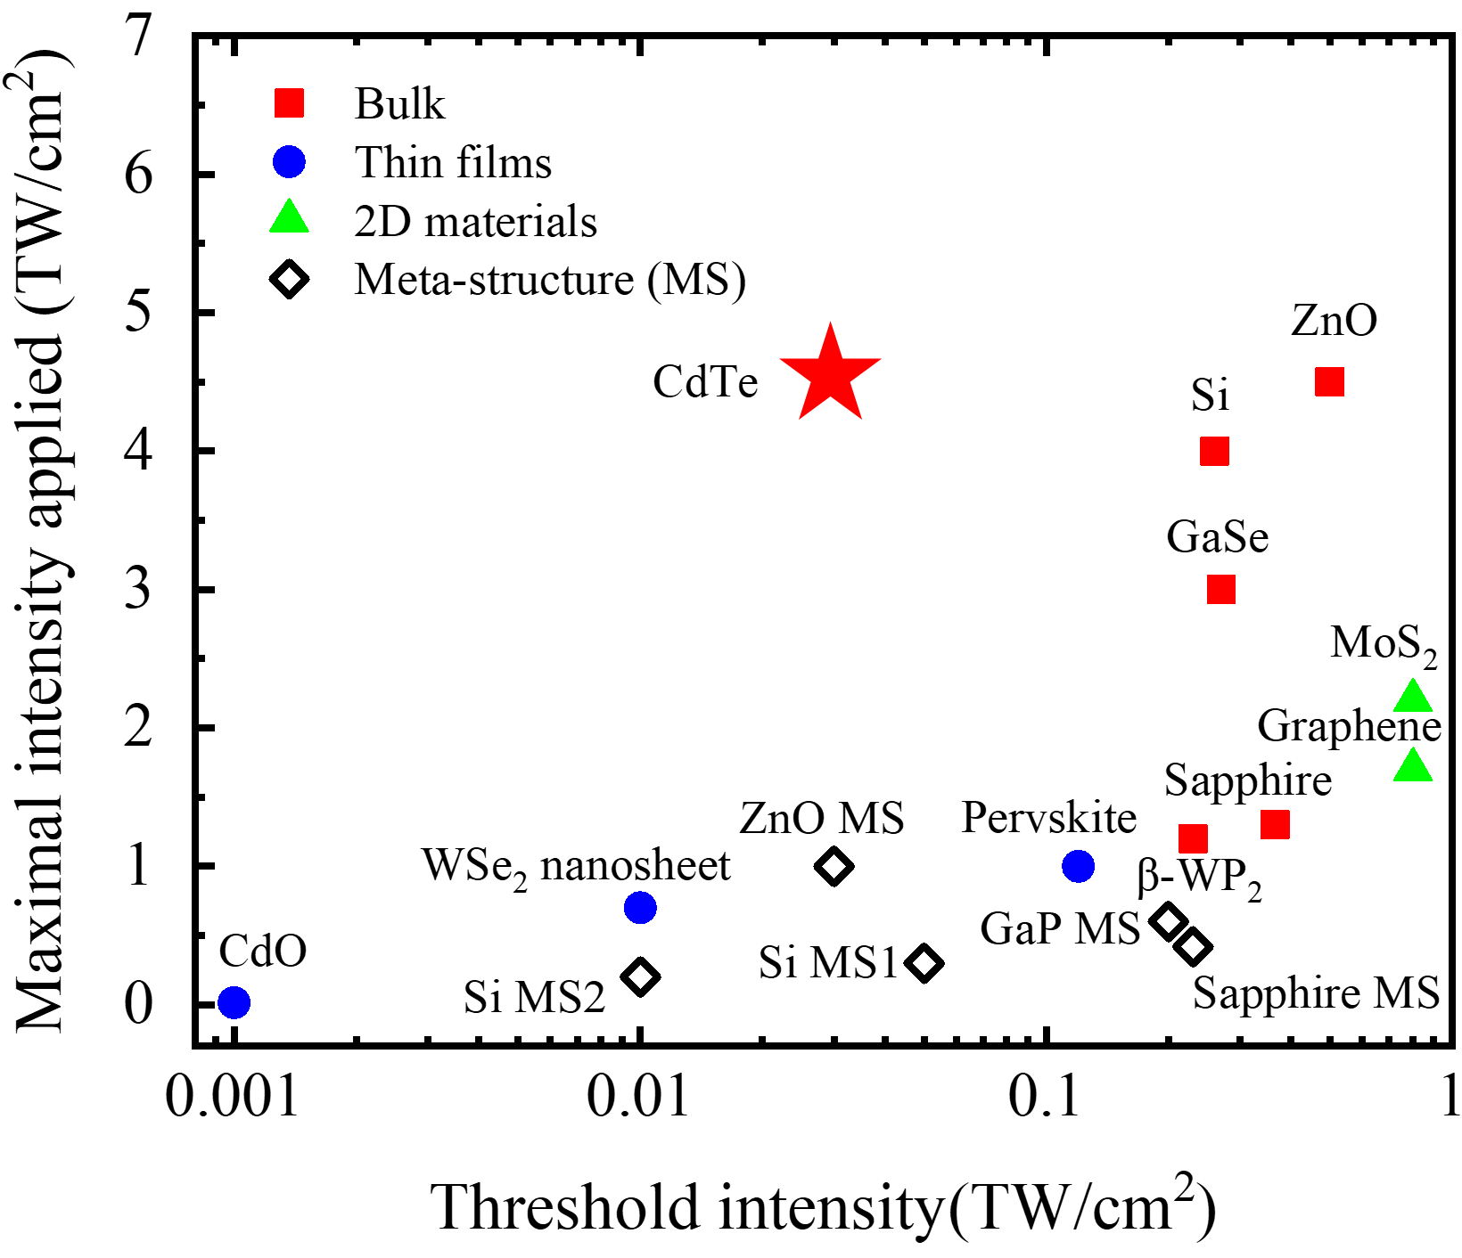
Supplementary Figure 4: Comparison of the threshold pump intensity and the maximal pump intensity applied in the commonly used materials of HHG in solids with those in CdTe.

Supplementary References
- Yoshikawa, N., Tamaya, T. & Tanaka, K. High-harmonic generation in graphene enhanced by elliptically polarized light excitation. Science 356, 736–738 (2017).
- Liu, H. et al. High-harmonic generation from an atomically thin semiconductor. Nat. Phys. 13, 262–265 (2017).
- Lv, Y. Y. et al. High-harmonic generation in Weyl semimetal β-WP₂ crystals. Nat. Commun. 12, 1-8 (2021).
- Vampa, G. et al. Generation of high harmonics from silicon. Preprint at http://arXiv.org/abs/1605.06345 (2016).
- Kim, H., Han, S., Kim, Y. W., Kim, S. & Kim, S. W. Generation of coherent extreme-ultraviolet radiation from bulk sapphire crystal. ACS Photon. 4, 1627–1632 (2017).
- Ghimire, S. et al. Observation of high-order harmonic generation in a bulk crystal. Nat. Phys. 7, 138–141 (2011).
- Kaneshima, K. et al. Polarization-resolved study of high harmonics from bulk semiconductors. Phys. Rev. Lett. 120, 243903 (2018).
- Sivis, M. et al. Tailored semiconductors for high-harmonic optoelectronics. Science 357, 303–306 (2017).
- Shcherbakov, M. R. et al. Generation of even and odd high harmonics in resonant metasurfaces using single and multiple ultra-intense laser pulses. Nat. Commun. 12, 1-6 (2021).
- Liu, H. et al. Enhanced high-harmonic generation from an all-dielectric metasurface. Nat. Phys. 14, 1006-1010 (2018).
- Vampa, G. et al. Plasmon-enhanced high-harmonic generation from silicon. Nat. Phys. 13, 659–662 (2017).
- Han, S. et al. High-harmonic generation by field enhanced femtosecond pulses in metal–sapphire nanostructure. Nat. Commun. 7, 13105 (2016).
- Hirori, H. et al. High-order harmonic generation from hybrid organic-inorganic perovskite thin films. APL Mater. 7, 041107 (2019).
- Vampa, G., Liu, H., Heinz, T. F. & Reis, D. A. Disentangling interface and bulk contributions to high-harmonic emission from solids. Optica 6, 553-556 (2019).
- Langer, F. et al. Lightwave-driven quasiparticle collisions on a subcycle timescale. Nature 533, 225–229 (2016).
- Yang, Y. et al. High-harmonic generation from an epsilon-near-zero material. Nat. Phys. 15, 1022–1026 (2019).
- Hong, K. H., Lee, Y. S. & Nam, C. H. Electric-field reconstruction of femtosecond laser pulses from interferometric autocorrelation using an evolutionary algorithm. Opt. Commun. 271, 169–177 (2007).

