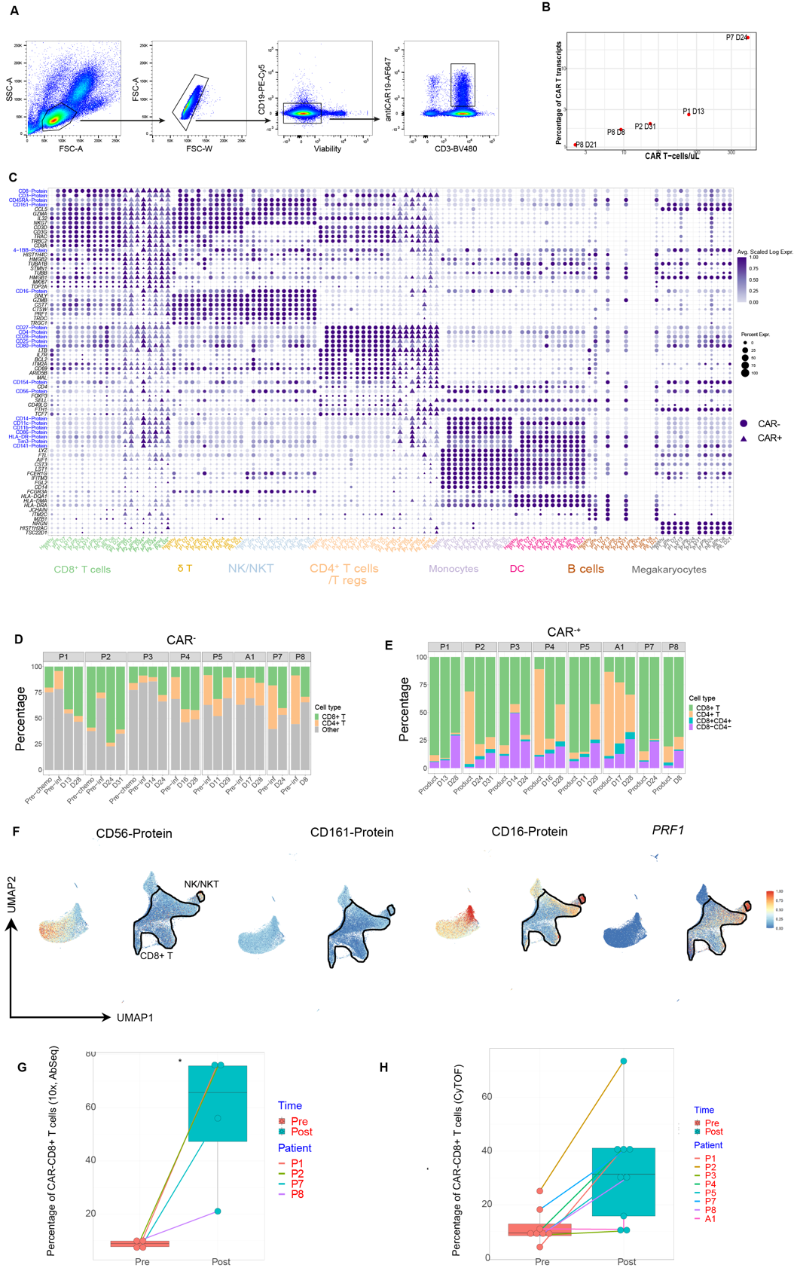
Extended Data Fig. 1. Single cell gene and protein expressions reveal endogenous (PBMC) and CAR T immune cell subsets. (A) Gating strategy to identify CAR⁺ T cells from total PBMC using flow cytometry cell sorting. (B) Scatter plot showing percentage of cells with detectable CAR T transcripts versus the number of CAR T cell counts in the blood via DNA quantification. (C) Dot plot of selected genes (scRNA-seq) and proteins (AbSeq) for each sample analysed via single cell multi-omics. The size of each point represents the percentage of cells with non-zero expression. The colour represents the scaled log expression (see Methods). CAR⁻ T cells are represented by filled circles, CAR⁺ T cells by filled triangles. (D) Stacked bar plot of the CD8⁺ T and CD4⁺ CAR⁺ T cells in each sample analysed by mass cytometry. (E) Stacked bar plot of the CD4⁺ and CD8⁺ subsets in each CAR⁻ sample analysed by mass cytometry. (F) UMAP with selected marker genes and proteins, identifying NK-like CD8+ and unconventional NK and NKT cells. (G-H) Proportion of CAR⁺CD8⁺ T cells identified with Abseq (N=4 patients. G) and Mass-cytometry data (N=8 patients, H).
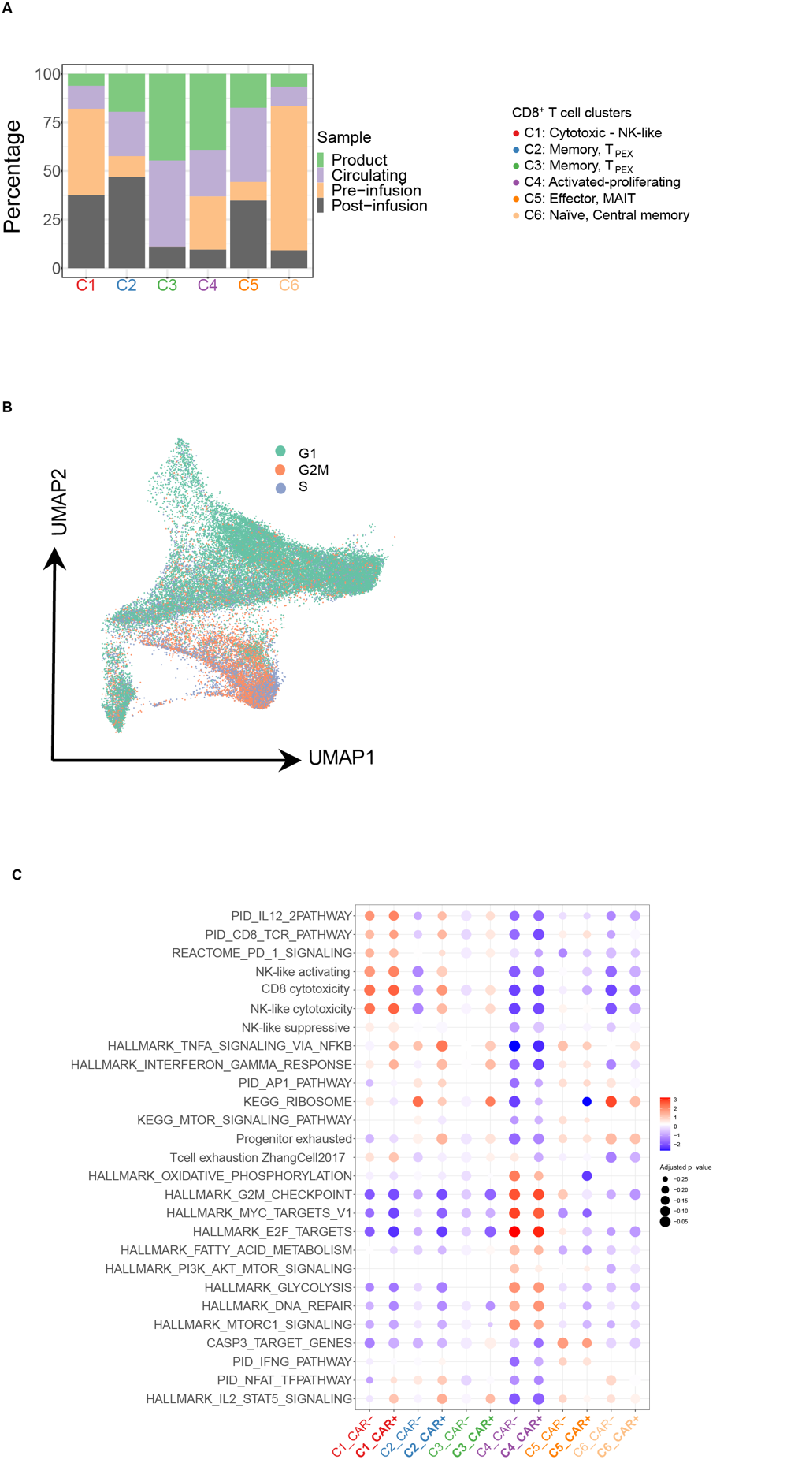
Extended Data Fig. 2. Characterization of CAR⁺ and CAR⁻ CD8⁺ T cells in clusters identified using single-cell multi-omics. (A) Distribution of sample type composition at each CD8⁺ cluster for both CAR⁻ and CAR⁺ T cells. (B) Projection of predicted G1, G2M and S phase cells on UMAP. (C) Dot plot of NES values from GSEA performed utilising cluster genes. Shown are both CAR⁻ and CAR⁺ T cells. Only significant gene sets are shown (p-value<0.05). The size of each point represents the –log10(p-value). The colour represents the NES. Gene sets were either taken from the MsigDB database or manually curated (Table S3).

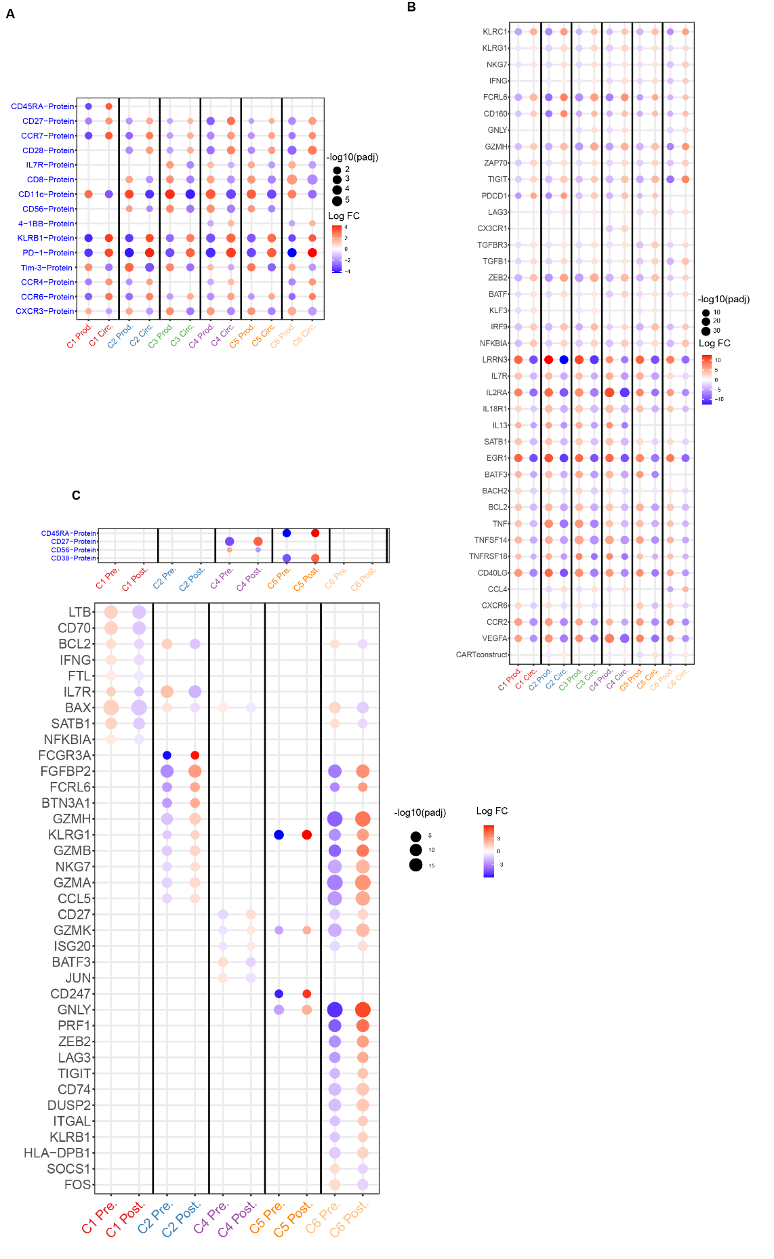
Extended Data Fig. 3. Differential gene and protein analysis between product vs circulating post-infusion and pre- vs post-infusion CD8⁺ T cells. (A-B) Dot plot of fold change values for gene (A) and protein (B) comparing product vs circulating CAR⁺ CD8⁺ T cells, calculated using edgeR with the patients as replicates. Shown are markers with significant p-value (<0.1 using edgeR). The size of each point represents –log10(adjusted p value). The colour represents the log fold change. (C) Dot plot of fold change values comparing pre vs post CAR⁻ CD8+ T cells, calculated using edgeR with the patients as replicates. Shown are markers with significant p-value (<0.1 using edgeR). The size of each point represents –log10(adjusted p value). The colour represents the log fold change.
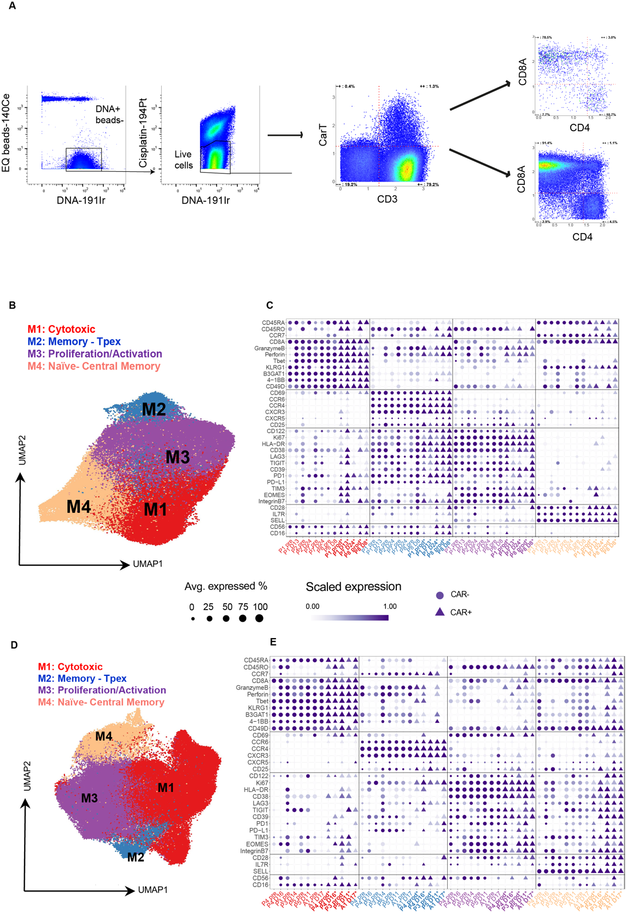
Extended Data Fig. 4. Characterization of CAR⁺ and CAR⁻ CD8⁺ T cells in clusters using mass cytometry. (A) Gating strategy to identify CAR⁺ T cells from total PBMC using mass cytometry. (B) UMAP of CD8⁺ T cells and for both CAR⁺ and CAR⁻ T cells using mass cytometry, revealing four clusters. This plot corresponds to samples obtained from the same patients with available single cell multi-omics data, i.e., P1, P2, P7, P8. (C) Dot plot of scaled expression values (Materials and methods) for mass cytometry markers for the same patients as (B), and for both CAR⁺ and CAR⁻ T cells. Shown are markers with significant p-value (<0.1 using Wilcoxon Rank Sum test). The size of each point represents the percentage of cells with non-zero expression. The colour represents the scaled log expression. Endogenous samples are represented by filled circles, CAR T samples by filled triangles. (D) UMAP of CD8⁺ T cells and for both CAR⁺ and CAR⁻ T cells, showing four clusters using data from patients P3, P4, P5, and A1. (E) Dot plot of scaled expression values (Materials and methods) for mass cytometry markers corresponding to the clusters identified in (D). Shown are markers with significant p-value (<0.1, Wilcoxon Rank Sum test). The size of each point represents the percentage of cells with non-zero expression. The colour represents the scaled log expression. `
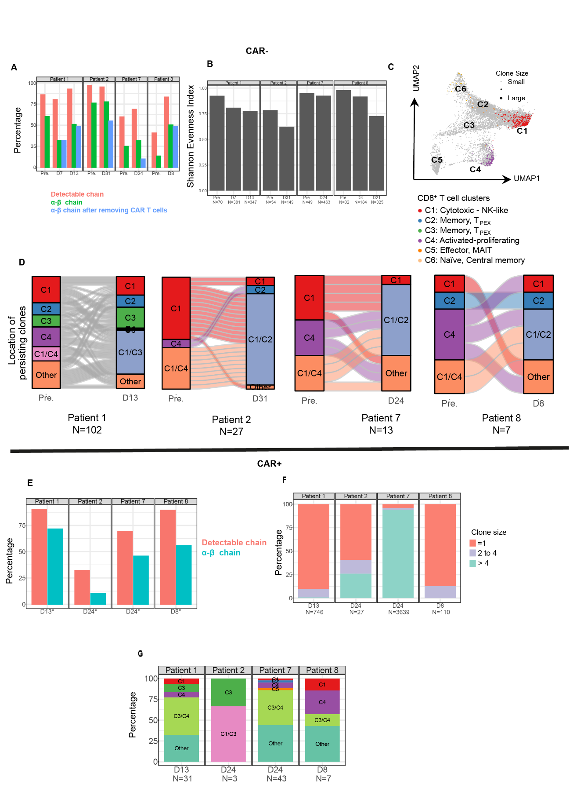
Extended Data Fig. 5. Clonal distribution of CAR⁻ and CAR⁺ CD8⁺ T cells. (A) Percentage of cells in the CAR⁻ CD8⁺ T cells with a detectable α-β chain. (B) Shannon evenness values calculated from the TCR repertoire of CAR⁻ CD8⁺ T cells in each sample. (C) Distribution of expanded clones with size >1 identified in the CAR⁻CD8⁺ T cells in pre-infusion samples mapped on the UMAP plot, identifying the distribution on the CD8⁺ clusters. (D) Alluvial plots revealing the distribution of clones identified in CAR⁻ CD8⁺ T cells in pre- and post-infusion samples, and their cluster distribution based on gene expression profiles (C1 to C6). “Other” denotes clones observed in multiple phenotypes. Number of clones indicated by N. (E) Percentage of cells in the CAR⁺ CD8⁺ T cells with a detectable α-β chain. (F) Distribution of clones identified in the CAR⁺CD8⁺ T cells in post-infusion samples. (G) Distribution of clones identified in the CAR⁺CD8⁺ T cells in each cluster identified from scRNA-seq. Shown are post-infusion samples.

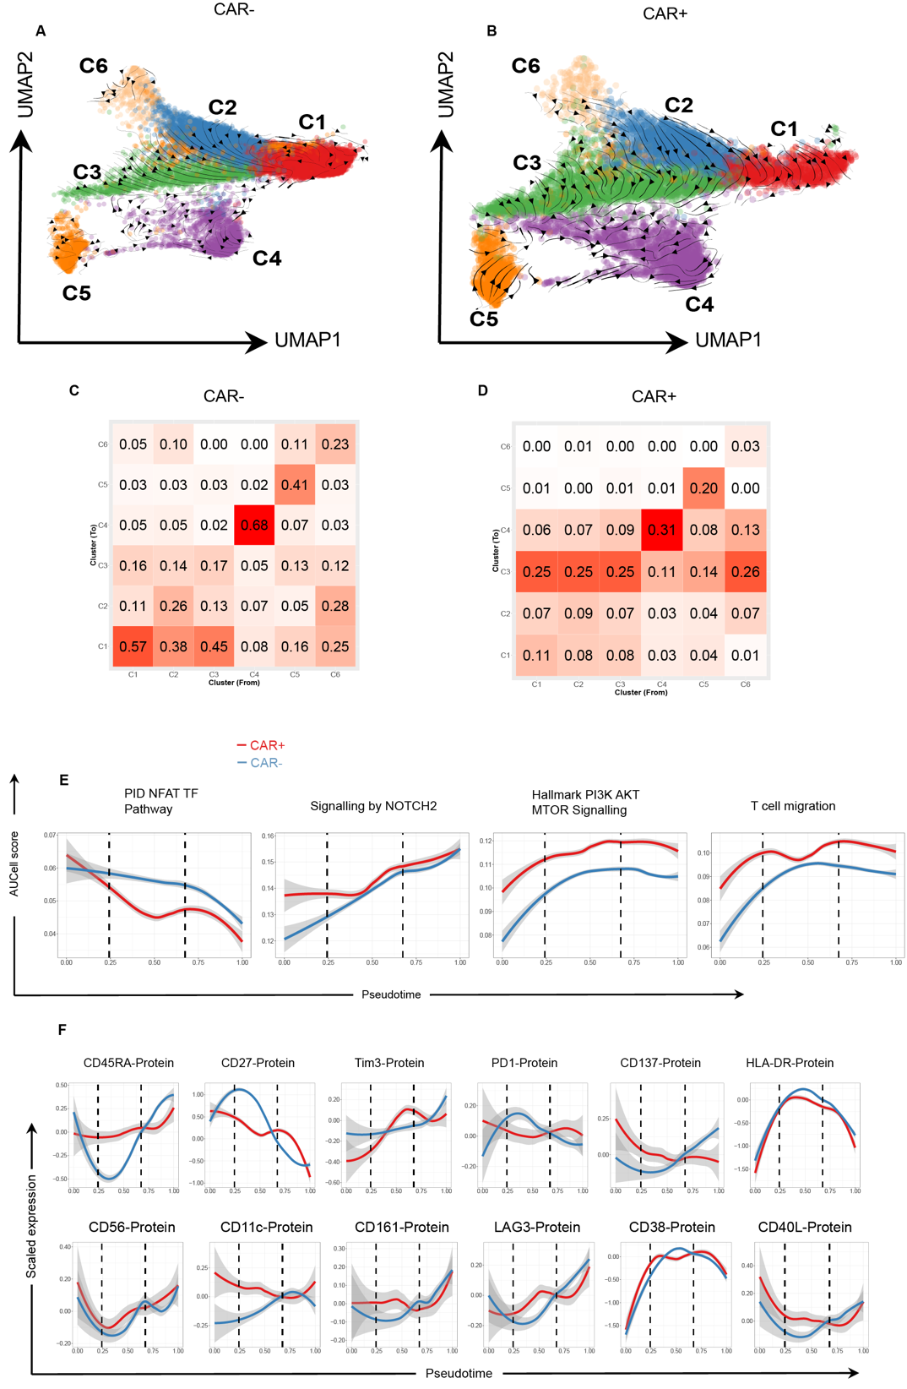
Extended Data Fig 6 RNA velocity and cluster transition probabilities confirming the inferred differentiation trajectories. A) UMAP showing extrapolated future states (arrows) estimated by RNA velocity, applied to CAR⁻ CD8⁺ cells. B) UMAP showing extrapolated future states (arrows) estimated by RNA velocity, applied to all CAR CD8⁺ single cells. C) Heatmap showing probability of directed cluster transitions calculated using CellRank, averaged over all CAR⁻CD8⁺ T cells. D) Heatmap showing probability of directed cluster transitions calculated using CellRank, averaged over all CAR⁺ CD8⁺ T samples. (E) Loess curves for gene signature along estimated pseudotime trajectories. Scores are calculated usilng AUCell. (F) Loess curves for protein expression along estimated pseudotime trajectories.

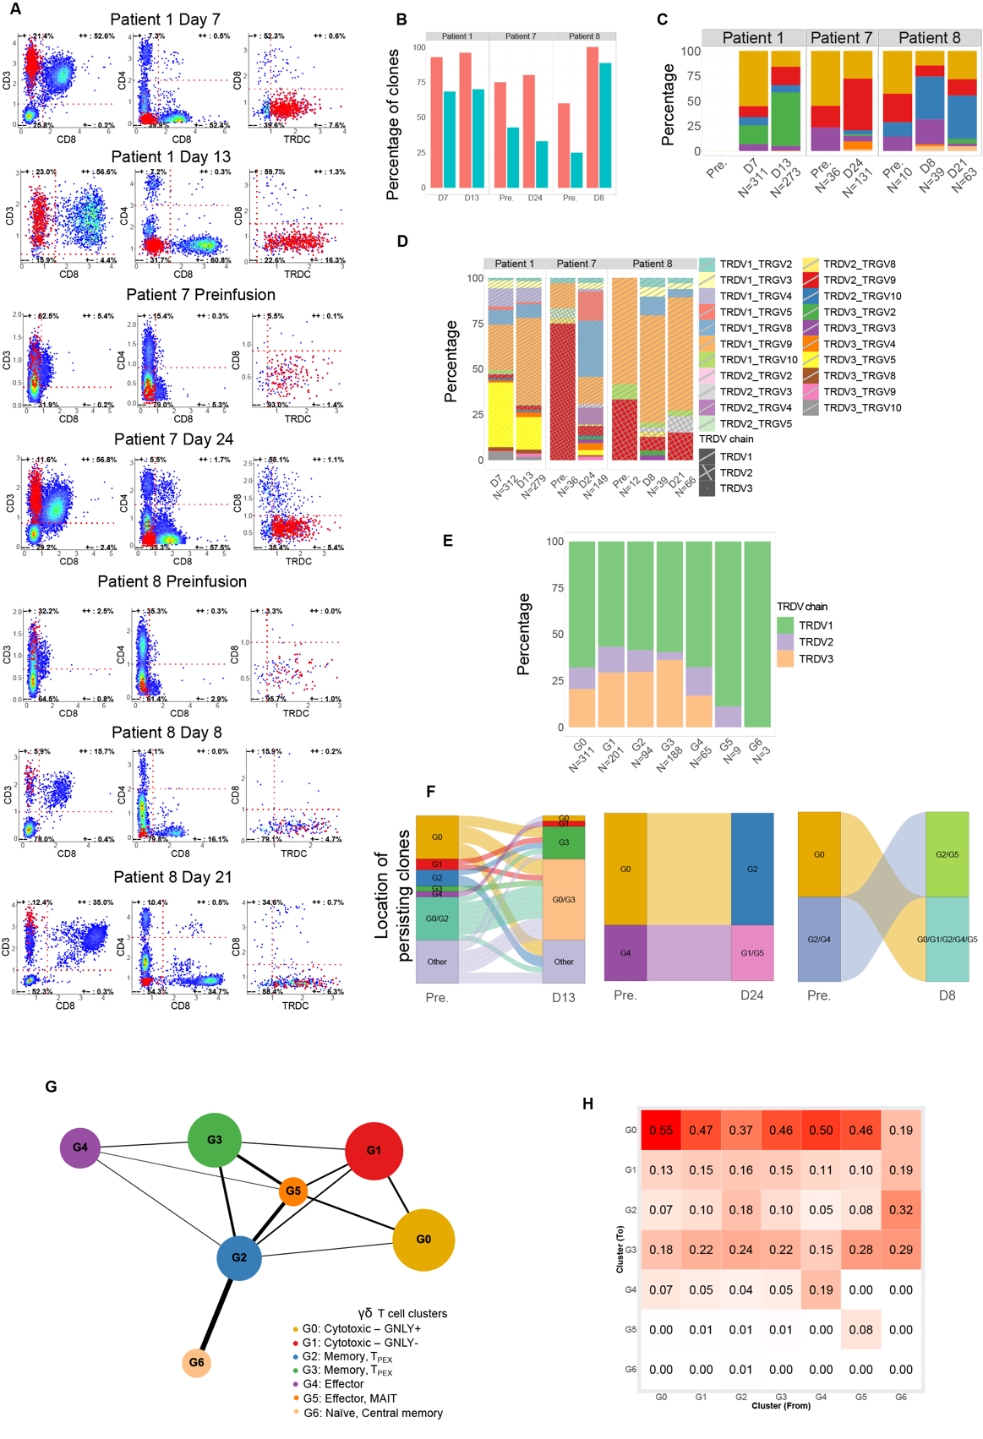
Extended Data Fig. 7. Identification of γδ T cells with clonal and differentiation trajectory analyses. (A) Scatter plots of markers used to define γδ T cells for each sample with γδ T cells. (B) Percentage of cells in the γδ T population with a detectable chain and detectable γ-δ chain. (C) Distribution of clones in each cluster. (D) Distribution of clones divided by gamma and delta chain, for each patient and sample time point. The number of clones is indicated by N. (E) Distribution of clones divided by delta chain gene usage, for each cluster. The number of clones is indicated by N. (F) Alluvial plots revealing the distribution of clones in pre- and post-infusion samples, and their cluster distribution based on gene expression profiles (G0 to C6). “Other” denotes clones observed in multiple phenotypes. Number of clones indicated by N. (G) PAGA graph revealing the cluster transitions weights (represented by line weights). (H) Heatmap showing probability of directed cluster transitions calculated using CellRank, averaged over all endogenous samples.

