Supporting Information
Composition tunability of semiconductor radiosensitizers for low-dose X-ray induced photodynamic therapy

Lei Chen¹, Jinghui Zhang^{1,2}, Luchao Zhu⁴, Lihua Xu¹, Jinpeng Jing¹, Yushuo Feng¹, Zongzhang Wang¹, Peifei Liu¹, Wenjing Sun*^{1,3}, Xiangmei Liu*², Yimin Li*^{4,5}, Hongmin Chen*^{1,2,4}

¹State Key Laboratory of Molecular Vaccinology and Molecular Diagnostics & Center for Molecular Imaging and Translational Medicine, School of Public Health, Xiamen University, Xiamen 361102, P. R. China
E-mail: hchen@xmu.edu.cn
²State Key Laboratory of Organic Electronics and Information Displays & Institute of Advanced Materials (IAM), Jiangsu Key Laboratory for Biosensors, Nanjing University of Posts & Telecommunications, Nanjing 210023, P. R. China
E-mail: iamxmliu@njupt.edu.cn
³Zhejiang University-Hangzhou Global Scientific and Technological Innovation Center (ZJU-HIC), Hangzhou 311200, P. R. China
E-mail: sunwj0102@zju.edu.cn
⁴Department of Radiation Oncology, Cancer Center, the First Affiliated Hospital of Xiamen University, Xiamen 361003, P. R. China
E-mail: lym05@xmu.edu.cn
⁵The Third Clinical Medical College, Fujian Medical University, P. R. China

Experimental Section:
Materials
Bismuth nitrate pentahydrate (Bi(NO₃)₃·5H₂O), tetrabutyl titanate (TBOT), 4-nitrophenyl chloroformate 3-(4,5-dimethylthiazol-2-yl)-2,5-diphenyltetrazolium bromide (MTT) and 2,7-dichlorodihydrofluorescein diacetate (DCFH-DA) were purchased from Sigma-Aldrich (MO, USA). Methylene blue (MB) was purchased from Alfa Aesar (China) Chemical Co. Ltd. Hoechst 33342 and BODIPY 581/591 C11 were purchased from Thermo Fisher Scientific (Waltham, MA). JC-1 was purchased from MedChemExpress (MCE). U87MG cells were obtained from Institute of Biochemistry and Cell Biology (Shanghai, China). Male nude mice were purchased from Shanghai SLAC Laboratory Animal Co. Ltd (Shanghai, China).
Characterization
TEM images were taken on a JEM-2100 transmission electron microscope (JEOL Ltd., Tokyo, Japan). HRTEM images and element mapping were taken on a Tecnai F30 transmission electron microscope. The crystalline phase was examined by X-ray diffraction (XRD) at 40 kV and 30 mA in the range of 20–60° (2θ) at a scanning rate of 5°/min. The hydrodynamic diameters and zeta potential of nanoparticles were measured on Malvern Zetasizer nano-ZS90. FTIR spectra were obtained using Bruker Vertex 70V spectrometer, scanning from 3500 to 500 cm⁻¹, and the samples were prepared by the KBr pellet method. XPS was performed using a PHI 5000 Versa Probe with Al Kα as the excitation source. The MTT assay of the TBR was measured by Enzyme-labelled meter: BioTek CO., Ltd (USA). The fluorescence images of cells were taken on a laser scanning confocal microscopy (Olympus FV1200, Japan). The whole-body fluorescence imaging of mice was conducted using an IVIS in vivo imaging system (Caliper IVIS, Lumina II).
Cell culture
U87MG (human glioblastoma) cell lines and 3T3 cell lines (mouse embryo fibroblasts) were cultured at 37 ºC within 5% CO₂.
Animal experiments
All the animal experimental procedures were in accord with the guidelines of the Regional Ethics Committee for Animal Experiments and the Care Regulations approved by the Institutional Animal Care and Use Committee of Xiamen University. Mice bearing U87MG tumors were constructed by subcutaneously injecting 2×10⁶ U87MG cells into the right hind leg of male BALB/c nude mice. When the tumor reached to 50-80 mm³ in volume, the BALB/c mice bearing U87MG tumors were applied. The mice bearing U87MG tumors were randomly divided into 6 groups (n=5), namely PBS, PBS+X, PBS+2X, TBR, TBR+X, and TBR+2X (X, X-ray irradiation) groups, and X-ray treatment was applied to the tumor region after intravenous injection of PBS or TBR (5 mg/kg). Group PBS+2X and TBR+2X repeated the therapeutic process on the third day.
In vivo imaging evaluation
Mice bearing U87MG tumors were intravenously injected with TBR-Cy5.5 (5 mg/kg). Fluorescence imaging was conducted at 0, 4, 8, 12, and 24 h post-injection.
Serum chemistry and hematological analysis
Mice were intravenously treated daily for 3 days with TBR (20 mg/kg). Blood samples were collected for serum chemistry analysis and complete blood analysis before treatment (day 0), and at day 3 and day 7 post-treatment. Aspartate aminotransferase (AST), alanine aminotransferase (ALT), urea nitrogen (UREA), and creatinine (CREA-S) in mice serum were measured using an Auto Biochemistry Analyzer (Mindray, BS-220). White blood cell (WBC), red blood cell (RBC), hemoglobin (HGB), hematocrit (HCT), mean corpuscular volume (MCV), mean corpuscular hemoglobin (MCH), mean corpuscular hemoglobin concentration (MCHC), RBC distribution width (RDW-SD), platelets (PLT), and mean platelet volume (MPV) in mice blood were measured using an Automatic Tri-classification Blood Cell Analyzer (Mindray, BC-2600).
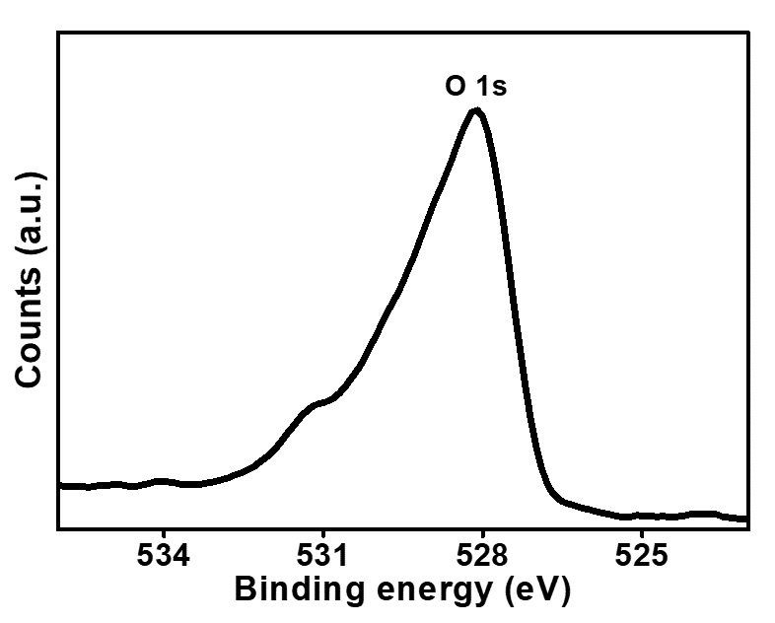
Figure S1. XPS spectrum of O 1s.
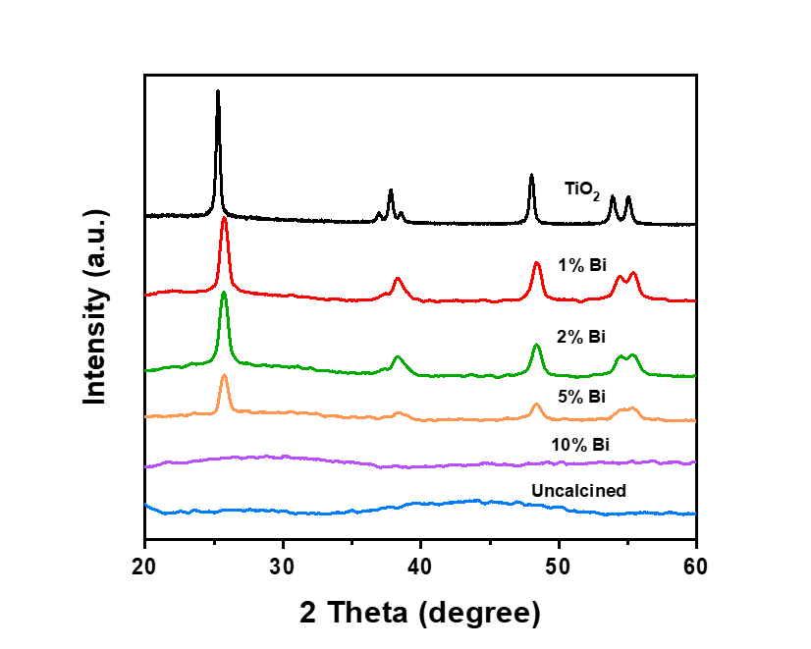
Figure S2. X-ray diffraction patterns of TiO₂:Bi (TB) with different contents of Bi dopant.
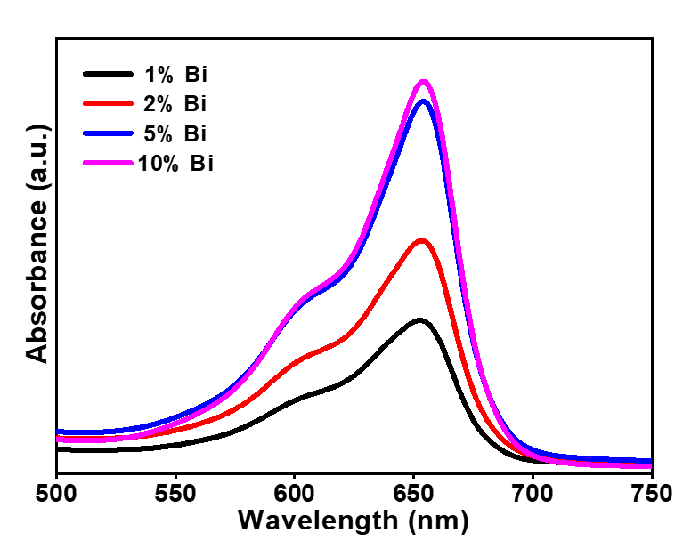
Figure S3. The absorption spectra of MB treated with TB (Bi doping amount: 1%, 2%, 5%, and 10%) under X-ray irradiation.
Figure S4. Confocal images of the U87MG cells after incubating with TBR-Cy5.5 for 24 h. Blue and red colors represented Hoechst 33342 and Cy5.5 fluorescence.
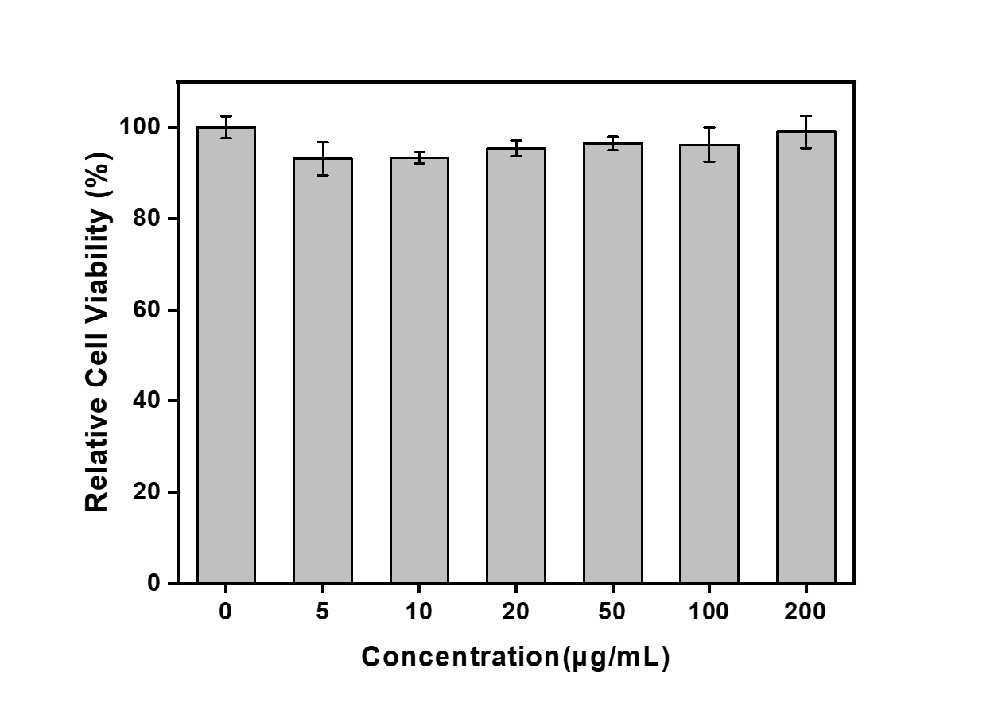
Figure S5. The viability of mouse fibroblasts treated with different concentrations of TBR.
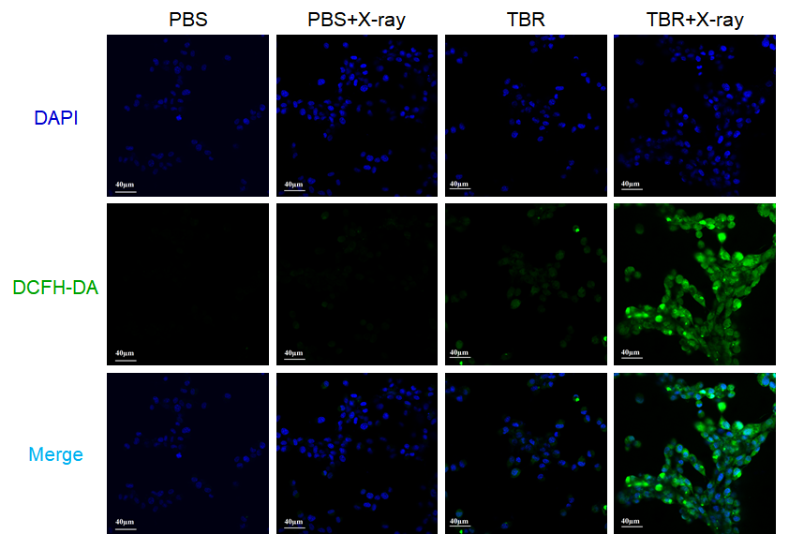
Figure S6. CLSM evaluation of U87MG cells stained by DCFH-DA after different treatments. Green fluorescence indicated the presence of OH.
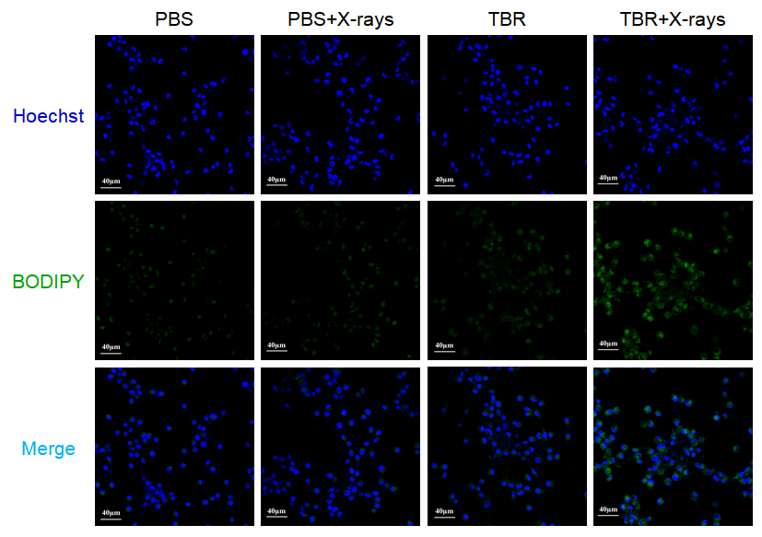
Figure S7. CLSM evaluation of U87MG cells in BODIPY-C11 staining assay.
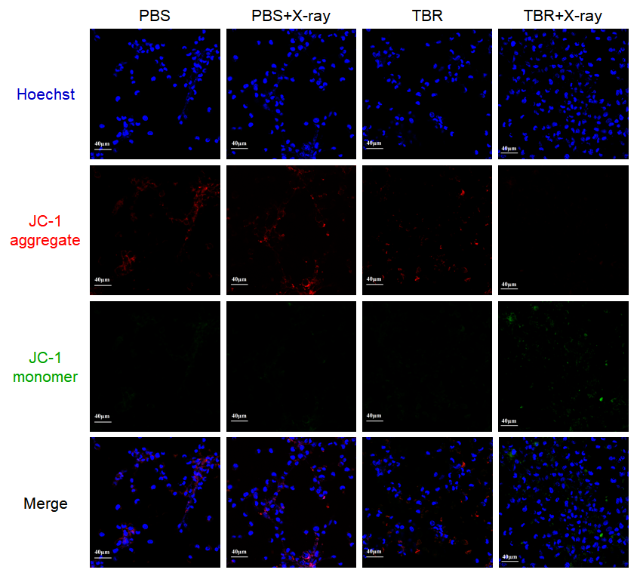
Figure S8. CLSM observation of U87MG cells in JC-1 staining assay. The red fluorescence indicates that the membrane potential is positive, and the green fluorescence indicates that the membrane potential decreases.
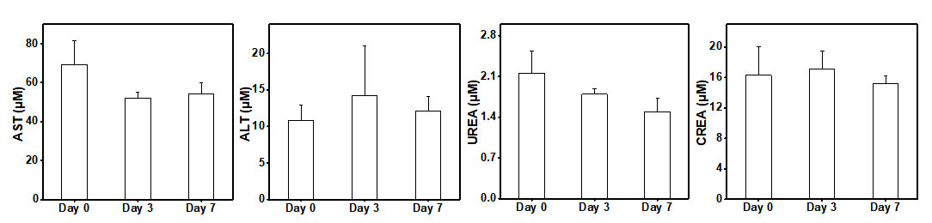
Figure S9. Mice were intravenously treated daily for 3 days with TBR (20 mg/kg). Blood samples were collected for serum chemistry analysis before treatment (day 0), and at day 3 and day 7 post- intravenous treatment. AST, aspartate transaminase; ALT, alanine transaminase; UREA, blood urea nitrogen; CREA, creatinine.
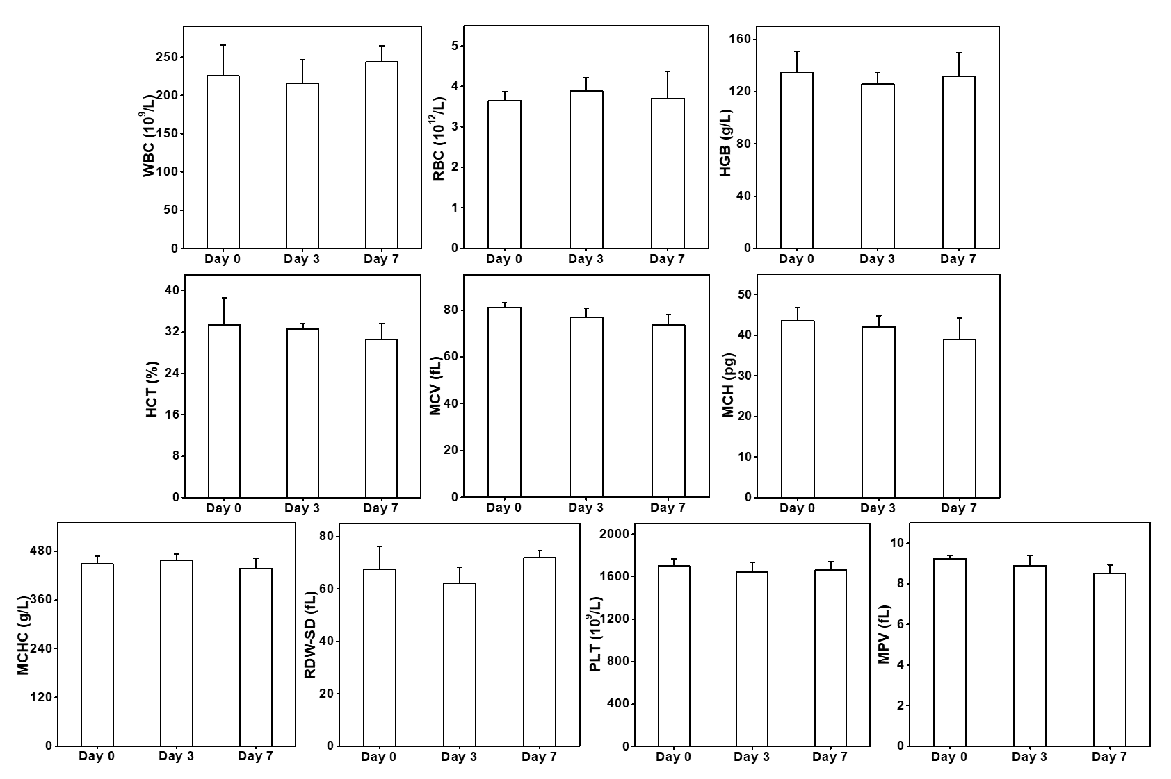
Figure S10. Mice were intravenously treated daily for 3 days with PBS or TBR (50 mg/kg). Blood samples were collected for complete blood analysis before treatment (day 0), and at day 3 and day 7 post- intravenous treatment. WBC, white blood cell; RBC, red blood cell; HGB, hemoglobin; HCT, hematocrit; MCV, mean corpuscular volume; MCH, mean corpuscular hemoglobin; MCHC, mean corpuscular hemoglobin concentration; RDW-SD, RBC distribution width; PLT, platelets; MPV, mean platelet volume.
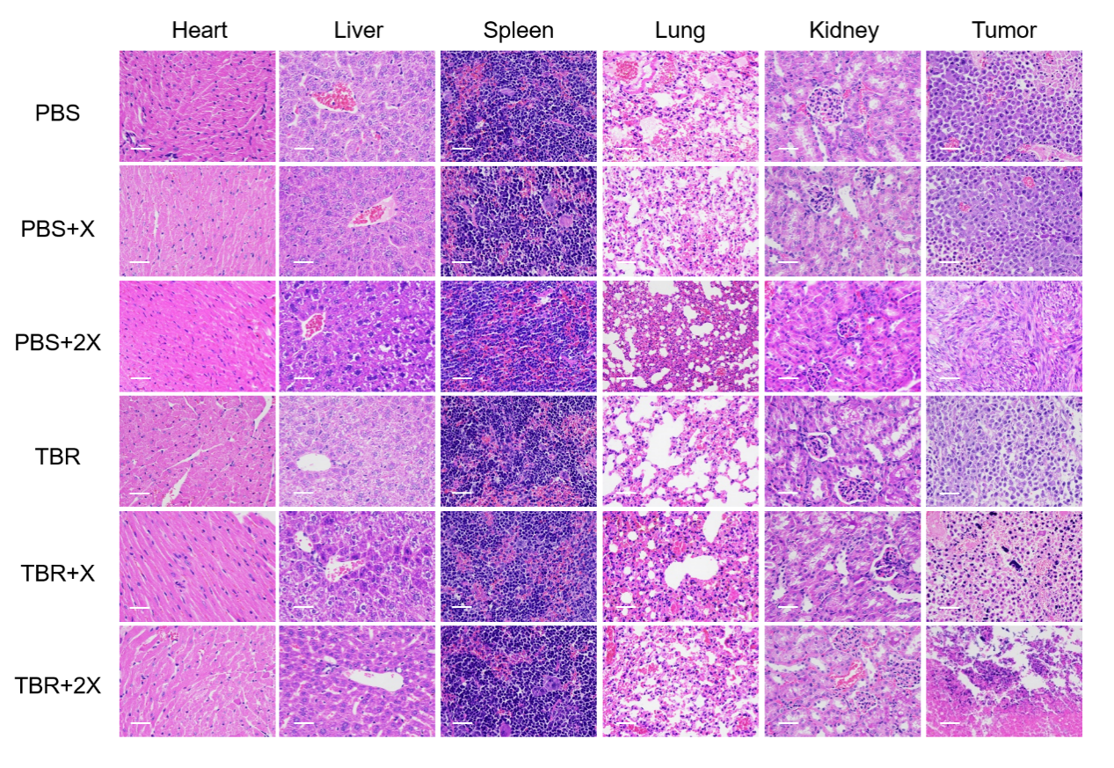
Figure S11. H&E staining of main organs of mice after different treatments. (Scale bar: 100 µm)

