Supplementary Information for

One-pot solution growth of 2D/3D perovskite crystalline lateral heterostructures

Tiebin Yang¹, Feng Li^{1,}*, Chun-Ho Lin², Xinwei Guan², Yin Yao³, Xudong Yang⁴, Tom Wu², Rongkun Zheng^{1,}*

- School of Physics, The University of Sydney, Sydney, NSW 2006, Australia
- School of Materials Science and Engineering, UNSW Sydney, NSW 2052, Australia.
- Electron Microscope Unit, UNSW Sydney, NSW 2052, Australia.
- State Key Laboratory of Metal Matrix Composites, Shanghai Jiao Tong University, Shanghai 200240, China.

*E-mails: feng.li2@sydney.edu.au; rongkun.zheng@sydney.edu.au

This supplementary information file includes:
Materials and Methods
Supplementary Figs. 1-13
Supplementary Note

Materials and Methods.
Materials. PbBr₂ (>98 %), PbI₂ (>98%) are purchased from Sigma-Aldrich. MABr (>99%), MAI (>99%), (PEA)₂Br (>99%), (PEA)₂I (>99%), and (BA)₂Br (>99%) are purchased from Greatcell Solar.
Growth of the 2D/3D perovskite lateral heterostructures. Typically, 1 mmol of (PEA)₂Br, 1.5 mmol of MABr, and 2 mmol of PbBr₂ powders were dissolved into 2-mL dimethylformamide (DMF) solvent and then stirred for 3 hrs. After purification by a 0.22-μm filter, the obtained filtrate was transferred to a new vial and was preheated to 60 °C. A 5-μL filtrate was then dipped onto the glass or SiO₂ substrate, immediately followed by covering a piece of glass. Then, the whole set was further heated to 90 °C at the rate of 10 °C/h and then was kept at 90 °C for 10 hrs. The same procedure and raw material ratio were applied for the growth of (BA)₂MAPb₂Br₇/MAPbBr₃ heterostructure. As for (PEA)₂MAPb₂I₇/MAPbI₃ heterostructure, 1 mmol of (PEA)₂I, 1.5 mmol of MAI, and 2 mmol of PbI₂ powders were dissolved into a 1.5-mL propylene carbonate (PC) solvent and then stirred for 3 hrs. Then, the set was kept at 60 °C for 10 hrs for the growth of I-based heterostructure.
Optical property measurements. Fluorescence optical images were taken by Nikon NiE widefield microscope. The MAPbBr₃ part was excited by a 470-nm LED light illumination with a green bandpass filter. The 2D (PEA)₂MAPb₂Br₇ and (BA)₂MAPb₂Br₇ crystal parts were excited upon a 385-nm LED light illumination with a blue bandpass filter. The (BA)₂MAPb₂I₇ crystal part was excited by a 565-nm LED light illumination with an orange bandpass filter. PL spectra of (BA)₂MAPb₂Br₇ and (PEA)₂MAPb₂Br₇ thin crystals were measured by Hiroba micro PL set up. PL mapping measurements were conducted by the WITec Alpha 300 series confocal Raman spectroscopy.
Heterostructure characterizations. Bright-field optical images were taken by Leica DMi8M optical microscope. XRD ω–2θ scanning measurements were performed with a Stoe Stadi P diffractometer using a Mo Kα (0.7093 Å) source. The AFM and KPFM images were taken by Burker Icon with Pt/Ir tip. TEM samples were prepared by a standard lift-out procedure with a Thermo-fisher G4 Hydra plasma FIB-SEM. TEM images were taken by Thermo-fisher Themis-Z double abbreviation corrected TEM.
Device performance measurements. A simple metal-semiconductor-metal structure was constructed for characterizing the optoelectronic property of our 2D/3D perovskite lateral heterostructure. 5-nm Ti/40-nm Au electrodes were thermally deposited by AJA ATC-1800-E via a stainless-steel shadow mask on the top of the 2D/3D lateral heterostructures. The effective cross-section area of our 2D/3D lateral heterostructure for the photodiode was measured as $160×2 {μm}^{2}$. Electronic properties of the mixed-dimensional lateral heterostructures were measured by a Keithley 4200 Parameter analyzer integrated with a 4-arm probe station. As for the related photodiode characterizations, the laser source was supplied by Super K EVO with a tunable wavelength filter part Libra. Laser intensity was measured via a common Thorlabs power meter.

Supplementary Figures
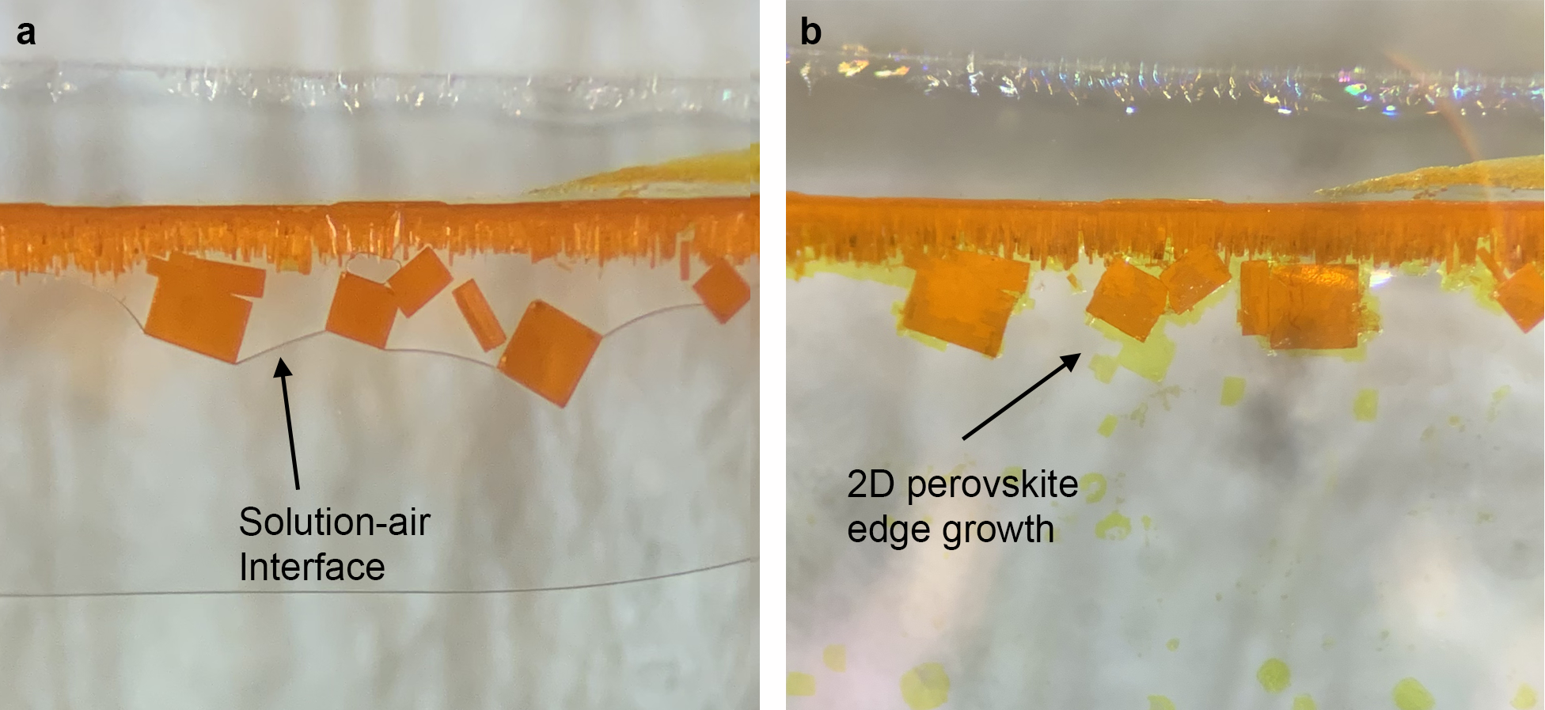
Supplementary Fig. 1. (a) Optical image of 2D/3D MAPbBr₃/(PEA)₂MAPb₂Br₇ perovskite lateral heterostructures at the 3-h moment during the growth process. (b) Optical image of the 2D/3D perovskite lateral heterostructures after 1 day during the growth process.

Supplementary Fig. 2. XRD data of MAPbBr₃ thin single crystals grown on the glass substrate without the 2D perovskite component addition. From the figure, the (110) set of peaks can be clearly seen besides the (100) main peaks.

Supplementary Fig. 3. (a) Optical images of MAPbI₃/(PEA)₂MAPb₂I₇ lateral heterostructures grown on the glass substrate, where the inner 3D perovskite crystal parts are with rectangle shapes. (b) Optical image of stand-alone MAPbI₃ thin single crystals grown on the glass substrate, which shows the irregular shapes.

Supplementary Fig. 4. (a) Typical atomic force microscopy (AFM) topographic image of 3D/2D MAPbBr₃/(BA)₂MAPb₂Br₇ perovskite lateral heterostructure. (b) Contact potential difference (CPD) distribution image of MAPbBr₃/(BA)₂MAPb₂Br₇ lateral heterostructure corresponding to (a). (c) Typical AFM topographic image of MAPbI₃/(BA)₂MAPb₂I₇ perovskite lateral heterostructure. (d) CPD distribution image of MAPbI₃/(BA)₂MAPb₂I₇ lateral heterostructure corresponding to (c).

Supplementary Fig. 5. Low magnification high-angle annular dark-field scanning (HAADF) transmission electron microscopy (STEM) image of (PEA)₂MAPb₂Br₇/MAPbBr₃ lateral heterostructure at the interface region.

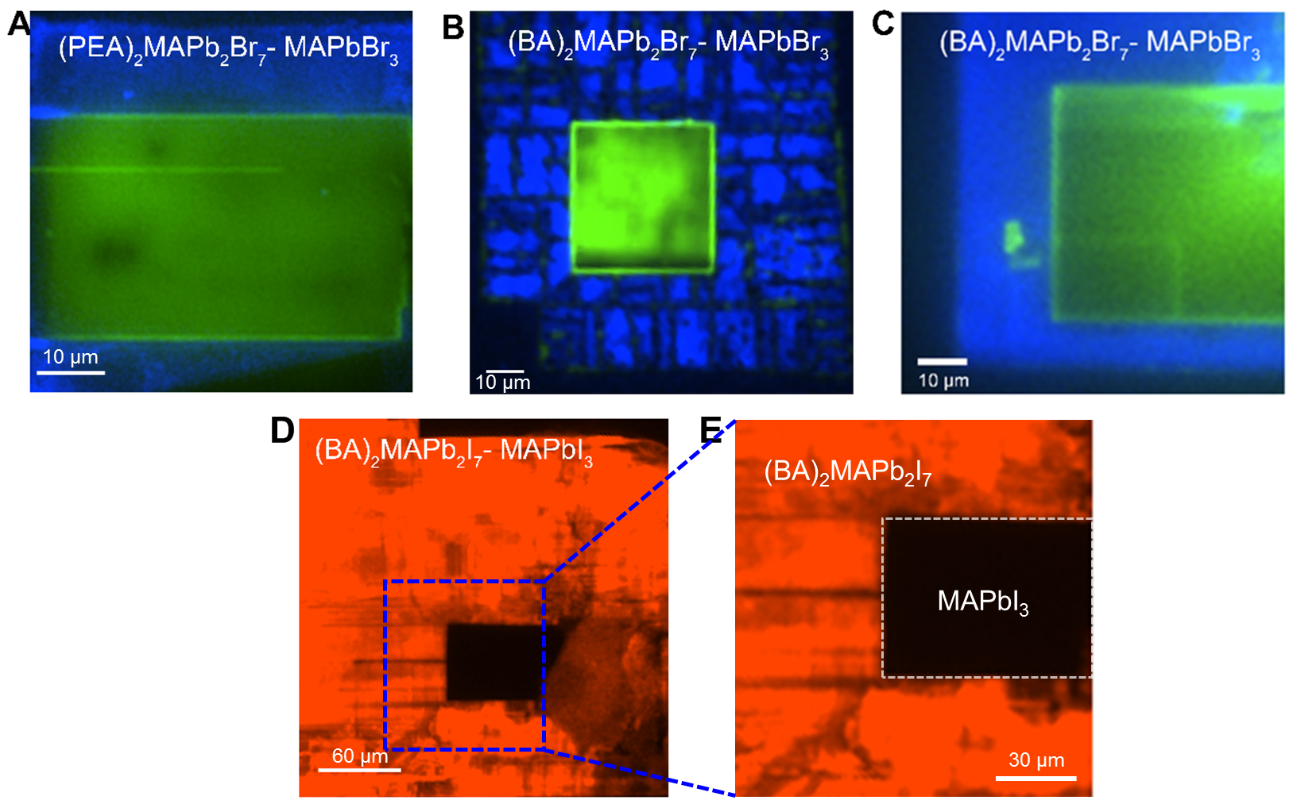
Supplementary Fig. 6. Fluorescence microscope images of the obtained 3D/2D crystalline halide perovskite lateral heterostructures, including (a) MAPbBr₃/(PEA)₂MAPb₂Br₇, (b, c) MAPbBr₃/(BA)₂MAPb₂Br₇, and (d, e) MAPbI₃/(BA)₂MAPb₂I₇, respectively.

Supplementary Fig. 7. Steady photoluminescence (PL) measurement at different regions of our 2D/3D perovskite MAPbBr₃/(PEA)₂MAPb₂Br₇ lateral heterostructure. The heterostructure interface domain shows a much larger PL intensity than that of the individual thin single crystal. Inset: PL mapping image of the heterostructure interface region.

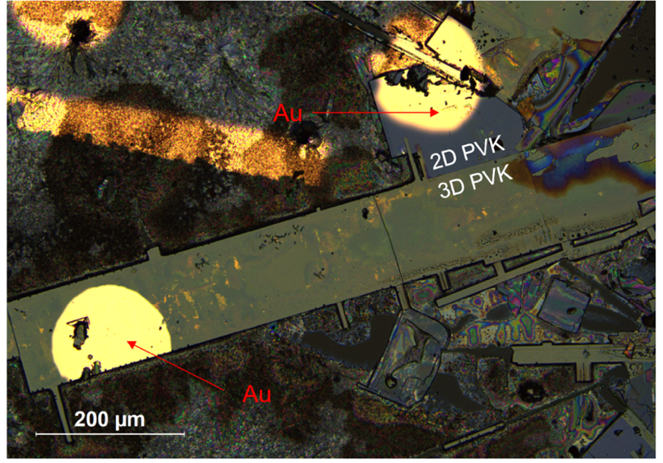
Supplementary Fig. 8. Optical image showing the structure of the fabricated photodetector based on MAPbBr₃/(PEA)₂MAPb₂Br₇ perovskite lateral heterostructure.

Supplementary Fig. 9. I-V curves of the photodetectors based on MAPbBr₃/(PEA)₂MAPb₂Br₇ lateral heterostructure (blue), 3D MAPbBr₃ perovskite thin single crystal (red) and 2D (PEA)₂MAPb₂Br₇ (green) perovskite thin single crystal, respectively, tested under the dark condition.

Supplementary Fig. 10. I-V characteristics of the photodetectors based on the 2D/3D mixed-dimensional perovskite lateral heterostructures under light illumination with different wavelengths (and with different power densities): (a) 410 nm laser, (b) 420 nm laser, (c) 430 nm laser, and (d) 440 nm laser, respectively.

Supplementary Fig. 11. I-V characteristics of the photodetectors based on 2D perovskite (PEA)₂MAPb₂Br₇ thin single crystal under different power-density light illumination with the laser wavelengths of (a) 410 nm, (b) 420 nm, (c) 430 nm, and (d) 440 nm.

Supplementary Fig. 12. (a) Photoresponsivity (R) and (b) detectivity (D*) values, respectively, of the photodetector based on 3D/2D perovskite MAPbBr₃/(PEA)₂MAPb₂Br₇ lateral heterostructure under different-wavelength light illumination with different laser power densities. (c) R and (d) D* values, respectively, of the device based on 2D perovskite (PEA)₂MAPb₂Br₇ thin single crystal under the same condition. (e) R and (f) D* values, respectively, of the device based on 3D perovskite MAPbBr₃ thin single crystal under the same condition.

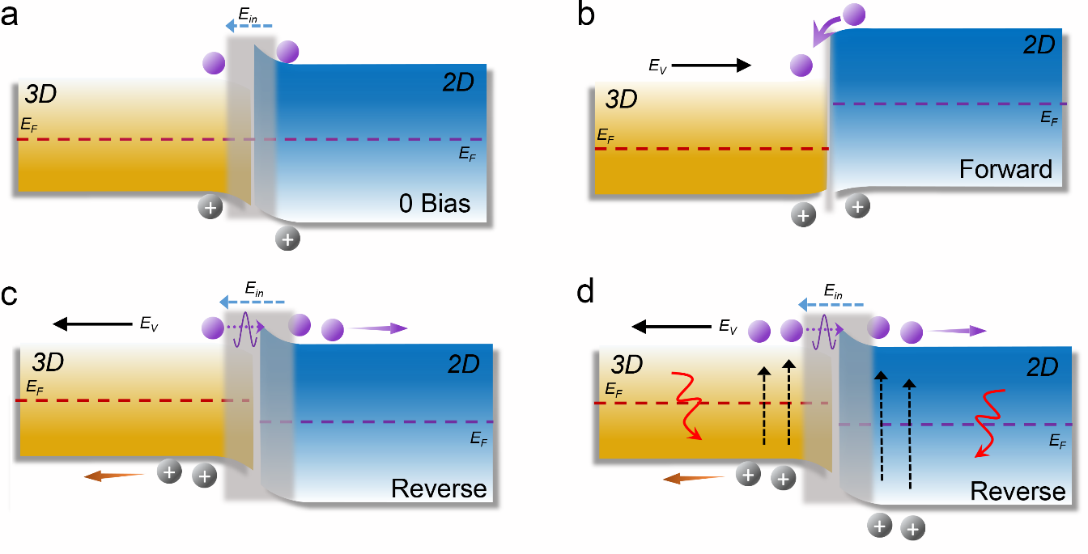
Supplementary Fig. 13. Schematic band alignments of 3D/2D perovskite lateral heterostructure under different working conditions: (a) fresh state with a 0-V bias, (b) applying a forward bias, and (c) applying a reverse bias. (d) Band alignment of the 3D/2D perovskite lateral heterostructure under a 410-nm light illumination with an applied reverse bias, generating electron-hole pairs efficiently. E_{F}, E_{v,} and E_{in} are the Fermi level, applied electric field, and built-in electric field, respectively.

Supplementary Note
In this note, we tried to analyze the working mechanism for the photodetectors based on 2D/3D perovskite lateral heterostructures through the band alignment evolution at the interface region upon light illumination. Supplementary Fig. 13a depicts the band alignment of the 3D/2D lateral heterostructure at a fresh state without an external bias, where the electrons can diffuse from 2D perovskite crystal into the 3D perovskite part due to the higher Fermi level (F_{E}) of 2D perovskite and thus leading to the formation of depletion layer with the built-in electric field (E_{in}). When applied a forward bias (E_{v}) onto the heterojunction (Supplementary Fig. 13b), the narrowing depletion layer and the lower F_{E} of the 3D perovskite part facilitate the transfer of electrons and holes, resulting in the fast-increasing current. Under the reverse bias conditions, the electrons have to overcome the wider depletion region, as well as the related contact potential barrier, to transfer from the 3D perovskite crystal to the 2D perovskite part, which causes a small reverse current (Supplementary Fig. 13c). When applied UV light illumination as an additional tunning parameter, both 2D and 3D perovskite crystal blocks in the mixed-dimensional lateral heterostructures can be excited, where more photo-induced electrons and holes are generated. However, the contact potential barrier still exists when the heterostructure is operated under a reverse bias, which leads to a stably increased photocurrent as the light intensity increases, unless the voltage bias is large enough to drive electrons to pass through the barrier (Supplementary Fig. 13d).

