Extended Data
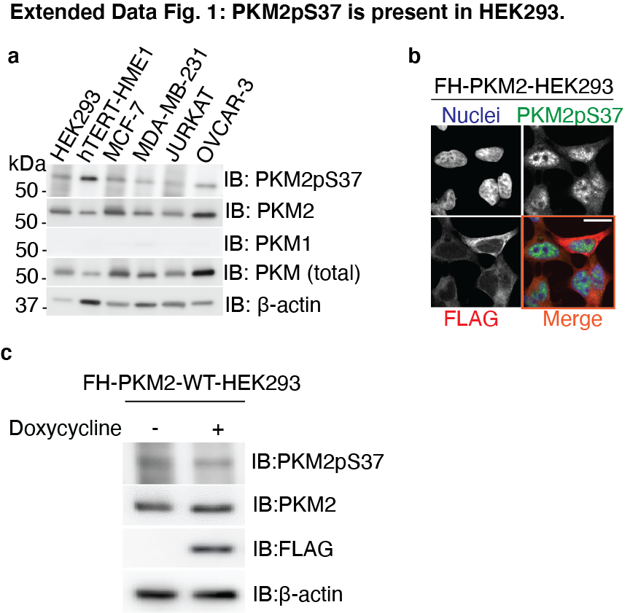
a, Immunoblot analysis probing PKM2 proteins in whole cell lysates of non-tumorigenic and cancer cell lines. b, Immunofluorescence images showing localization of FH-PKM2 in FH-PKM2-HEK293 cells; Nuclei, Hoechst 33342 (blue); PKM2pS37, Alexa Fluor 488 (green); FLAG-PKM2, Alexa Fluor 594 (red); Scale bar, 15 μm. c, Immunoblot analysis showing expression of the wild-type Flag-HA-tagged PKM2 (FH-PKM2-WT) upon doxycycline induction and PKM2pS37 status in stable 293 T-Rex Flp-In cells.
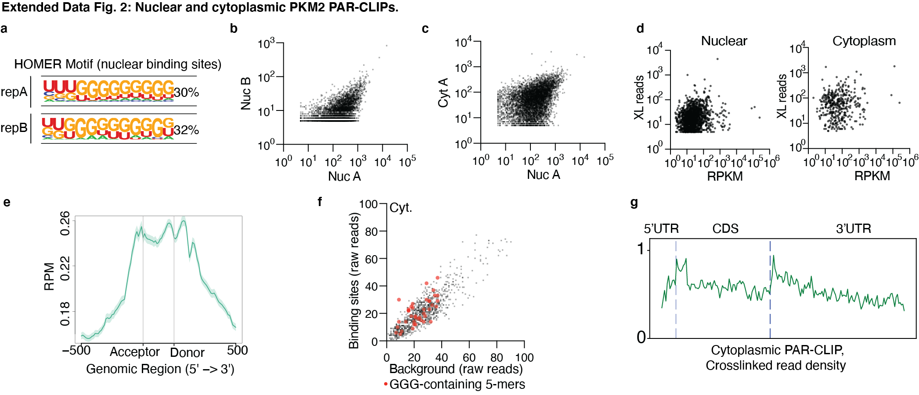
a, Homer motif analysis of two nuclear PAR-CLIP replicates. b, Scatter plot showing correlation of crosslinked reads per gene of nuclear replicates. c, Scatter plot showing correlation of crosslinked reads per gene of nuclear versus cytoplasmic PAR-CLIPs or cytoplasmic PAR-CLIP replicates. d, Scatter plot showing no correlation between crosslinked reads and RPKM per gene for both nuclear and cytoplasmic PKM2 PAR-CLIPs. e, Distribution of crosslinked HNRNPF footprints across splicing sites. f, Scatter plot of the frequency of all possible 5-mers in Cytoplasmic PKM2 PAR-CLIP binding sites versus matched background sequences g, Distribution of cytoplasmic PKM2 crosslinked reads along mature mRNA transcripts.

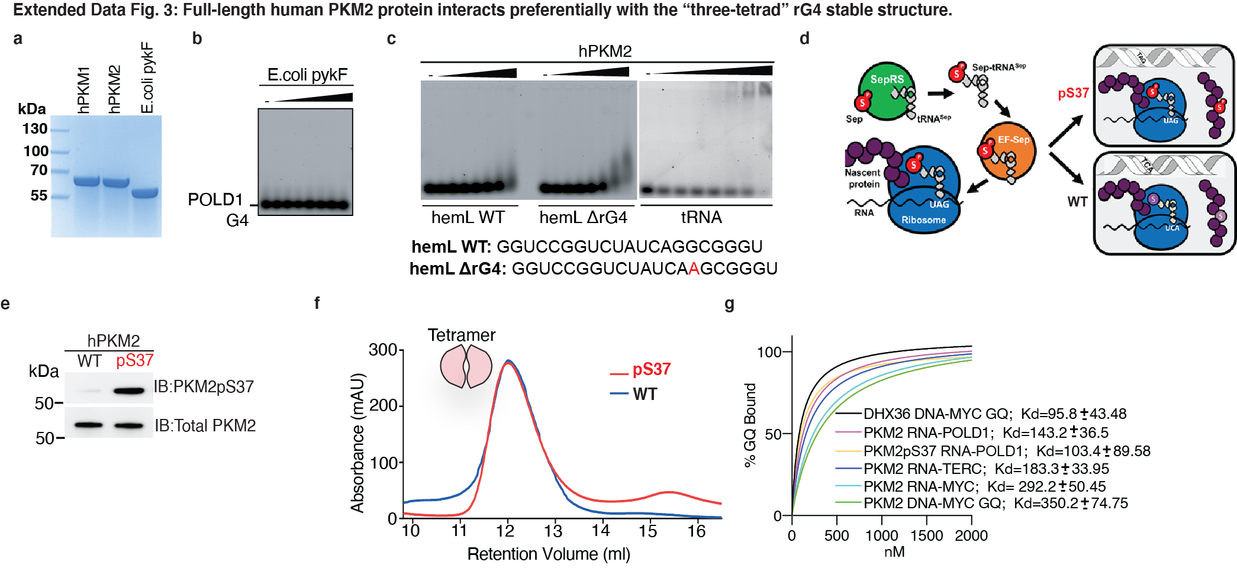
a, Coomassie stained SDS-PAGE showing the purity of recombinantly expressed human PKM1/PKM2 proteins (6xHis tagged) and their 43% identical E. coli homolog pykF (6xHis tagged). b, EMSA using 31.25-2,000 nM recombinant, His-tagged 6xHis- pykF with 5 nM of the POLD1 RNA G4 (nuclear PAR-CLIP target). c, EMSA with 31.25-2,000 nM PKM2 and sequence forming a 2-tetrad G4 and a non G40 forming mutant. d, Expression of PKM2 proteins authentically phosphorylated at serine 37 (pS37) or non-phosphorylated (WT) using our novel biotechnology platform to produce full length human proteins in an engineered bacterial system as described before ^{64,65}. e, The pS37 epitope of the authentically phosphorylated human PKM2 protein is specifically recognized by our custom-made phospho-specific antibody. f, Representative SEC analysis of WT and pS37 proteins showing the majority of both proteins is in the tetrameric form (apparent MW ~280kDa). g, EMSA binding curves of different combinations of protein-G4 molecules.

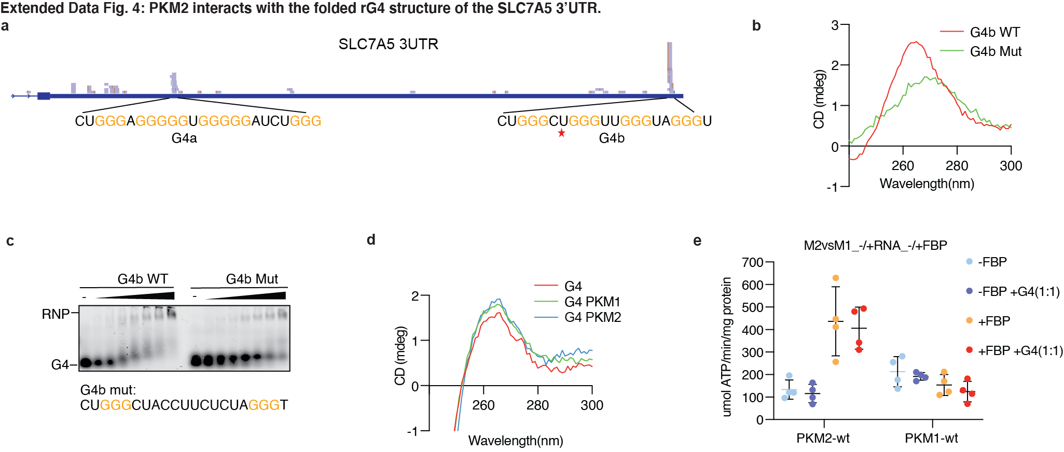
a, Alignment of nuclear FH-PKM2 PAR-CLIP reads with the SLC7A5 3UTR showing binding on two potential G4 structures b, Circular dichroism spectrum of SLC7A5 3’UTR G4b and a mutant with preserved two out of the three guanine triplets. c, 31.25-2,000 nM recombinant, His-tagged PKM2 with 7.5 nM rG4 sequence derived from SLC7A5 3UTR G4. d, Circular dichroism spectrum of SLC7A5 3’UTR G4b in the presence of PKM1 or PKM2. e, Activity of recombinant PKM2 and PKM1 proteins or their complexes with SLC7A5 3’UTR G4 (1 : 1 indicates protein:RNA ratio) at various fixed concentration of PEP (0.6 mM)in the presence or absence of 70 uM F1,6BP.
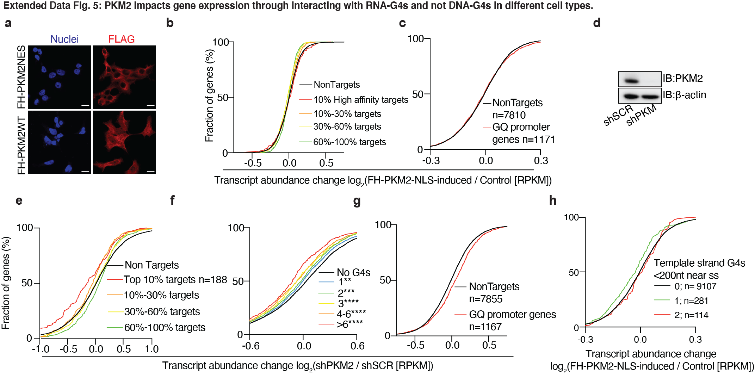
a, Immunofluorescence showing localization of FH-PKM2-NES and FH-PKM2; Nuclei, Hoechst 33342 (blue); FLAG, Alexa Fluor 594 (red). b, mRNA expression changes upon depletion of PKM2 after doxycycline-dependent expression of FH-PKM2-NLS in HEK293 cells. The empirical cumulative distribution function (CDF) of nuclear PKM2 targets binned by normalized crosslinked reads (colored lines) compared to expressed non-targets (black line). c, Same as in (b), however, genes were binned according to whether they contained predicted G4 (DNA G4 structures) in their promoter region. d, Immunoblot analysis showing expression of the endogenous PKM2 and PKM2pS37 in MCF-7 control (shSCR) and PKM2-KD (shPKM2) cells. e, Same as in (b), only for MCF7 control versus PKM2-KD cells. f, Same as in (e), however, transcripts were binned according to the number of canonical rG4 motifs (GGG(N1-7)3-GGG) in their exons or in their introns within 200 nt of the splicing sites. g, Same as in (c), however, with MCF7 control versus PKM2-KD cells. f, Same as in (b), however, transcripts were binned according to the number of canonical single stranded DNA G4 motifs (GGG(N1-7)3-GGG) in template strand of their exons or in their introns within 200 nt of the splicing sites. (*P ≤ 0.05, **P ≤ 0.01, ***P ≤ 0.001, ****P ≤ 0.0001)
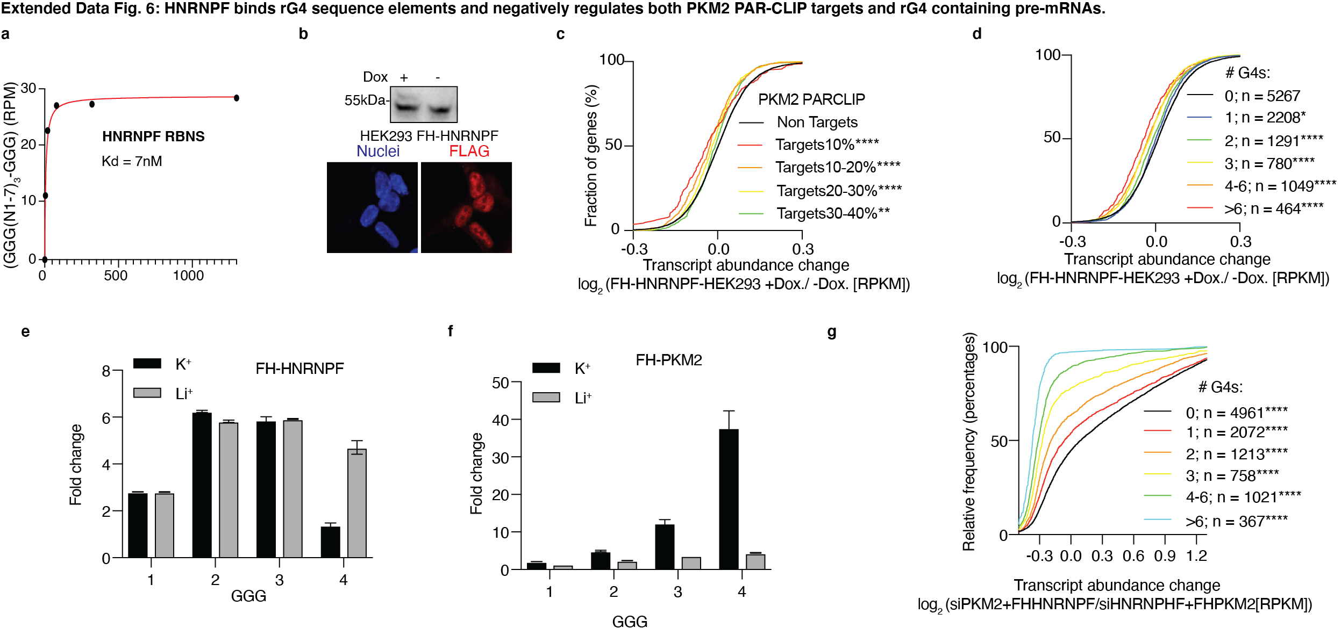
a, Reanalysis of RBNS showing binding of HNRNPF on rG4 forming sequences b, HEK293-FH-HNRNPF cells after doxycycline induction(upper panel) and Immunofluorescence showing localization of FH-HNRNPF; Nuclei, Hoechst 33342 (blue); FLAG, Alexa Fluor 594 (red). c, mRNA expression changes upon expression of FH-HNRNPF in HEK293. The empirical cumulative distribution function (CDF) of nuclear PKM2 targets binned by normalized crosslinked reads (colored lines) compared to expressed non-targets (black line). d, CDF of transcripts binned according to the number of canonical rG4 motifs (GGG(N1-7)3-GGG) in their exons or in their introns within 200 nt of the splicing sites. e,f, Fold change bar graph (Bound/Input) of sequences possessing 1-4 G-triplets in FH-HNRNPF or FH-PKM2 RBNS performed in the presence of K⁺ or Li⁺ . g, CDF of transcripts binned according to the number of canonical rG4 motifs (GGG(N1-7)3-GGG) in their exons or in their introns within 200 nt of the splicing sites after compined silencing of PKM2 and addition of FH-HNRNPF versus silencing of HNRNPF and addition of FHPKM2. *P ≤ 0.05, **P ≤ 0.01, ***P ≤ 0.001, ****P ≤ 0.0001.

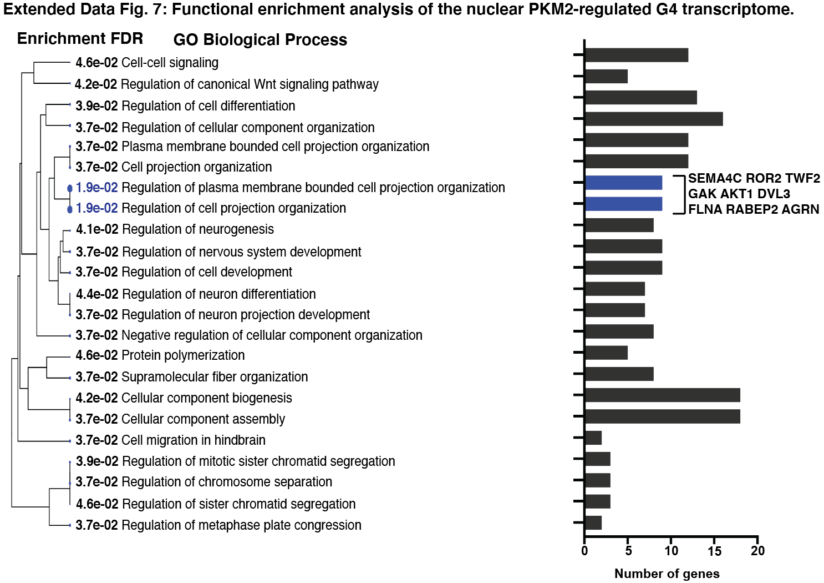
Gene ontology (GO) biological process enrichment analysis of significantly upregulated genes in nuclear PKM2 expressing cells, and downregulated in nuclear PKM2 depleted cells, containing more than three G4s in their transcript’s region. The specific genes indicated in the enrichment bar graph are significantly enriched in cell projection processes that characterize migratory cells.

