ADDITIONAL FILES
Aucubin alleviates oxidative stress and inflammation via Nrf2-mediated signaling activity in experimental traumatic brain injury
Han Wang^{1, 2†}, Xiao-Ming Zhou^{3†}, Ling-Yun Wu^{1†}, Guang-Jie Liu¹, WeiDong Xu², Xiang-Sheng Zhang¹, Yong-Yue Gao¹, Tao Tao¹, Yan Zhou¹, Yue Lu¹, Juan Wang¹, ChuLei Deng², Zong Zhuang¹, ChunHua Hang^{1*} and Wei Li^{1*}
- Department of Neurosurgery, Nanjing Drum Tower Hospital, The Affiliated Hospital of Nanjing University Medical School, Nanjing, China
- Department of Neurosurgery, Jinling Hospital, the first School of Clinical Medicine, Southern Medical University, Nanjing, China
- Department of Emergency, Jinling Hospital, Nanjing, China
†Han Wang, Xiao-Ming Zhou and Ling-Yun Wu contributed equally to this work.
*Corresponding author:
Wei Li, lwxzlw@126.com, Tel./fax: +86 25 83106666-11901;
Chun-Hua Hang, hang_neurosurgery@163.com, Tel./fax: +86 25 83106666-11902.

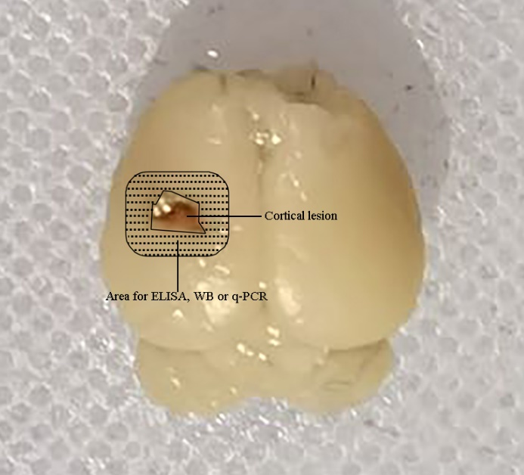
Supplemental Figure 1: Representative image of the cortical lesion caused by a weight-drop system. Shaded areas illustrate the perilesional cortex that was harvested for WB, ELISA and q-PCR analysis.

Supplemental Figure 2: Modified Neurological Severity Score points. 1 score is awarded for the inability to perform the test or for the lack of a tested reflex (normal score, 0; maximal score, 18).

Supplemental Figure 3: Au alleviated the neural apoptosis and neuronal loss in hippocampus. (a, c) Representative photomicrographs and quantification of Nissl staining in the CA1 region of hippocampus (scale bars = 20 μm). (b, d) Representative photomicrographs and quantification of TUNEL staining in the CA1 region of hippocampus. Red, TUNEL; blue, DAPI (scale bars = 50 μm). (e) Diagram of mouse brain section showing the location of lesion cavity (red) and photograph region (red square). Bars represent the mean ± SD. (n=6 for each group, one-way ANOVA, *P < 0.05 versus indicated groups)

Supplemental Figure 4: Quantification of Nrf2 fluorescent intensity (one-way ANOVA, *P < 0.05 versus indicated groups).

