Characterization and comparison of intestinal bacterial microbiomes of Euschistus heros and Piezodorus guildinii collected in Brazil and the United States
Matheus S. Moro^{1,2,Ψ}, Wing Xu^{3,Ψ}, Wei Wei³, Lucas W. Mendes⁴, K. Clint Allen⁵, J. Baldin Pinheiro⁶, Steven J. Clough^{3,7*}, Maria I. Zucchi^{2,8*}

Supplementary material

Table 1. Collected samples.
Species | Location | Latitude | Longitude
Euschistus heros | Anhembi/SP - BR | -22.789 | -48.128
Euschistus heros | Canarana/MT - BR | -13.539 | -52.164
Euschistus heros | Palmeirante/TO - BR | -7.8615 | -47.927
Euschistus heros | Piracicaba/SP - BR | -22.725 | -47.648
Euschistus heros | Ponta Grossa/PR - BR | -25.095 | -50.163
Euschistus heros | Rio Verde/GO - BR | -17.797 | -50.900
Euschistus heros | Sinop/MG - BR | -11.873 | -55.498
Euschistus heros | Sorriso/MG - BR | -12.559 | -55.714
Euschistus heros | Teresina/PI - BR | -5.0892 | -42.802
Euschistus heros | Uberlândia/MG - BR | -18.911 | -48.262
Piezodorus guildinii | Anhembi/SP - BR | -22.789 | -48.128
Piezodorus guildinii | Leland/MS - USA | 33.404 | -90.891
Piezodorus guildinii | Leopoldo Bulhões/GO - BR | -16.615 | -48.740
Piezodorus guildinii | Rolling Fork/MS - USA | 32.907 | -90.877
Piezodorus guildinii | Uberlandia/MG - BR | -18.911 | -48.262
Piezodorus guildinii | Vicksburg/MS - USA | 32.317 | -90.887
Piezodorus guildinii | Washinton C./MS - USA | 38.277 | -89.350
Piezodorus guildinii | Woodville/MS - USA | 31.069 | -91.308

Table 2. Quality control of reads and samples.
Species | Location | Sample number before filtering | Samples number after filtering | Mean number of raw reads | Mean number of reads after filtering | Mean percentage after filtering
Euschistus heros | Anhembi/SP - BR | 10 | 6 | 39,695 | 28,848 | 70%
Euschistus heros | Canarana/MT - BR | 10 | 9 | 27,976 | 18,604 | 69%
Euschistus heros | Palmeirante/TO - BR | 10 | 8 | 8,858 | 4,659 | 49%
Euschistus heros | Piracicaba/SP - BR | 21 | 12 | 48,362 | 38,416 | 59%
Euschistus heros | Ponta Grossa/PR - BR | 10 | 6 | 7,973 | 4,406 | 34%
Euschistus heros | Rio Verde/GO - BR | 7 | 4 | 5,725 | 2,763 | 49%
Euschistus heros | Sinop/MG - BR | 10 | 9 | 7,302 | 3,301 | 37%
Euschistus heros | Sorriso/MG - BR | 10 | 9 | 14,740 | 9,587 | 52%
Euschistus heros | Teresina/PI - BR | 10 | 8 | 53,929 | 40,878 | 72%
Euschistus heros | Uberlândia/MG - BR | 9 | 7 | 31,136 | 22,111 | 73%
Piezodorus guildinii | Anhembi/SP - BR | 29 | 20 | 33,507 | 24,751 | 66%
Piezodorus guildinii | Leland/MS - USA | 17 | 17 | 13,727 | 10,139 | 59%
Piezodorus guildinii | Leopoldo Bulhões/GO - BR | 14 | 12 | 21,221 | 14,279 | 55%
Piezodorus guildinii | Rolling Fork/MS - USA | 37 | 33 | 19,117 | 15,708 | 60%
Piezodorus guildinii | Uberlandia/MG - BR | 6 | 2 | 8,611 | 4,181 | 34%
Piezodorus guildinii | Vicksburg/MS - USA | 4 | 0 | 3,456 | 1,481 | 33%
Piezodorus guildinii | Washinton C./MS - USA | 61 | 38 | 36,963 | 33,413 | 60%
Piezodorus guildinii | Woodville/MS - USA | 11 | 11 | 7,347 | 4,365 | 43%
 | Total | 286 | 192 | 7,551,148 | 4,157,241

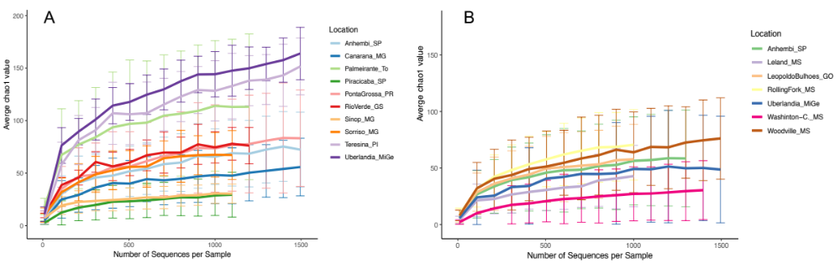
Figure 1. Rarefaction analyses using chao1 index of alpha diversity for E. heros (A) and P. guildinii (B).

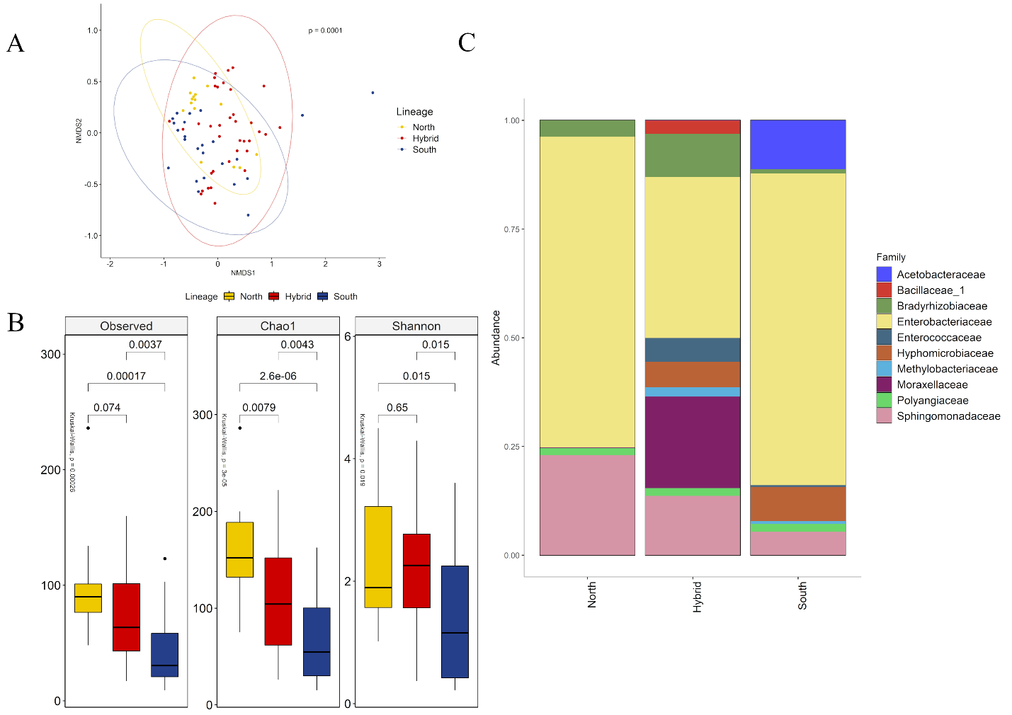
Figure 2. (A) NMDS of Bray-Curtis similarity matrix among 75 samples from the intestinal microbiome of E. heros, for the different lineages. The ellipses are showing clustering between lineages. Permutational multivariate analysis of variance (PERMANOVA) is indicated in the upper right. (B) Alpha diversity levels based on Observed OTU, Chao1 index and Shannon index for the different lineages. The nonparametric test (Kruskal Wallis) is indicated in the upper left of each graph. Pairwise comparison (Wilcoxon) is indicated between lineages (C) Analysis of the ten most abundant bacteria families in the intestinal microbiome of E. heros collected in Brazil, classified by lineages.
Figure 3. Abundance analysis of each bacteria families in the intestinal microbiome of E. heros collected in Brazil, classified by lineages. Pairwise comparison (Wilcoxon) is indicated between lineages.

Figure 4. Abundance analysis of each bacteria families in the intestinal microbiome of P. guildinii collected in Brazil and the United States, classified by country. Pairwise comparison (Wilcoxon) is indicated between country.
Figure 5. Abundance analysis of each bacteria families in the intestinal microbiome of E. heros and P. guildinii collected in Brazil, classified by ecoregion. Pairwise comparison (Wilcoxon) is indicated between ecoregions.
Figure 6. Abundance analysis of each bacteria families in the intestinal microbiome of E. heros and P. guildinii collected in Brazil, classified by species. Pairwise comparison (Wilcoxon) is indicated between species.s

