Table S1 – Inclusion and exclusion criteria based on PICOS model.
Parameter | Inclusion criteria | Exclusion criteria
Patients | Patients affected by CLL treatment-naïve. | Patients wil CLL with p53 or 17q del; already treated patients.
Interventions | Systemic chemotherapy, immunotherapy, chemoimmunotherapy, Bruton Kinase inhibitor, BH-3 mimetic.
Comparator | Not applicabile. | Not applicabile.
Outcomes | OS, PFS, ORR, Toxicity. | QoL as only outcome.
Study design | Phase II-III RTCs. | Not randomized trials, retrospective comparator, trials without information about IgVh mutation and karyotype stratification, not English papers.

Figure S1 – Risk of BIAS summary
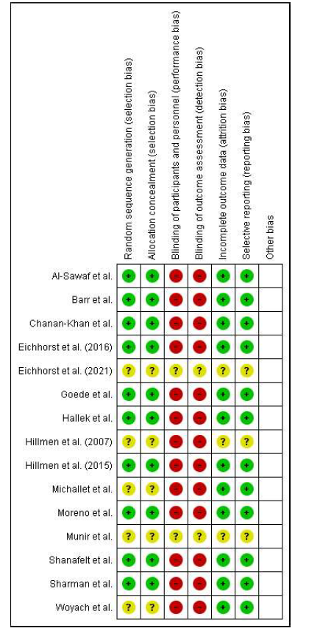

Figure S2 – Risk of BIAS graph
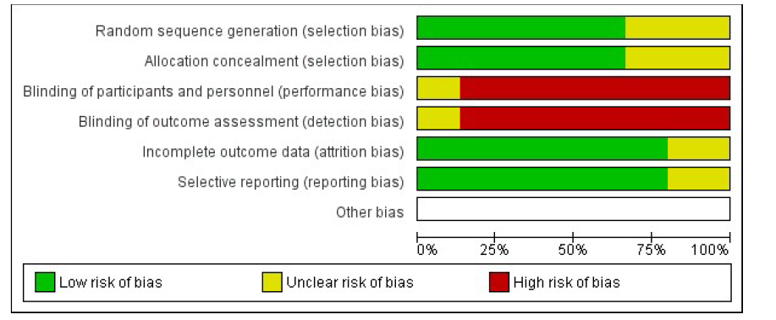

Figure S3 – SUCRAs for unselected PFS

Treatments from the best to the worst. For each treatment, in the horizontal axis is reported the position in the network, whereas in the vertical axis is reported the SUCRA.

Figure S4 – Netleague for unselected PFS
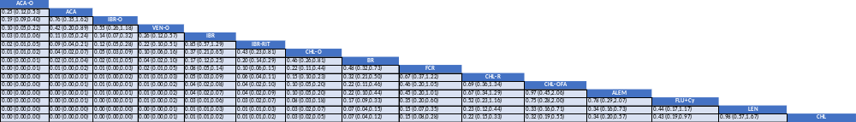

Netleague of PFS for unmutated and mutated IgVh patiens. The table shows the pair-wise comparisons for each treatment, with the hazard ratio and the credible interval (95%) for each comparison. Treatments are sorted from the best to the worst.

Figure S5 – SUCRAs fon PFS in unmutated IgVh patients

Treatments from the best to the worst. For each treatment, in the horizontal axis is reported the position in the network, whereas in the vertical axis is reported the SUCRA

Figure S6– Netleague for PFS in ummutated IgVh patients
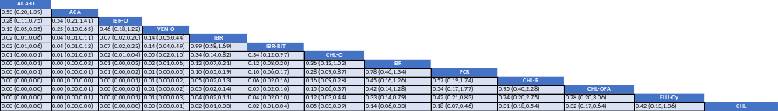
The table shows the pair-wise comparisons for each treatment, with the hazard ratio and the credible interval (95%) for each comparison. Treatments are sorted from the best to the worst

Figure S7 – SUCRAs for PFS in mutated IgVh patients

Treatments from the best to the worst. For each treatment, in the horizontal axis is reported the position in the network, whereas in the vertical axis is reported the SUCRA

Figure S8 – Netleague for PFS in muted IgVh patients
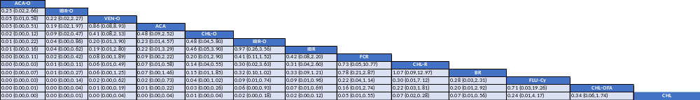
The table shows the pair-wise comparisons for each treatment, with the hazard ratio and the credible interval (95%) for each comparison. Treatments are sorted from the best to the worst

Figure S9 – network plot for tolerability
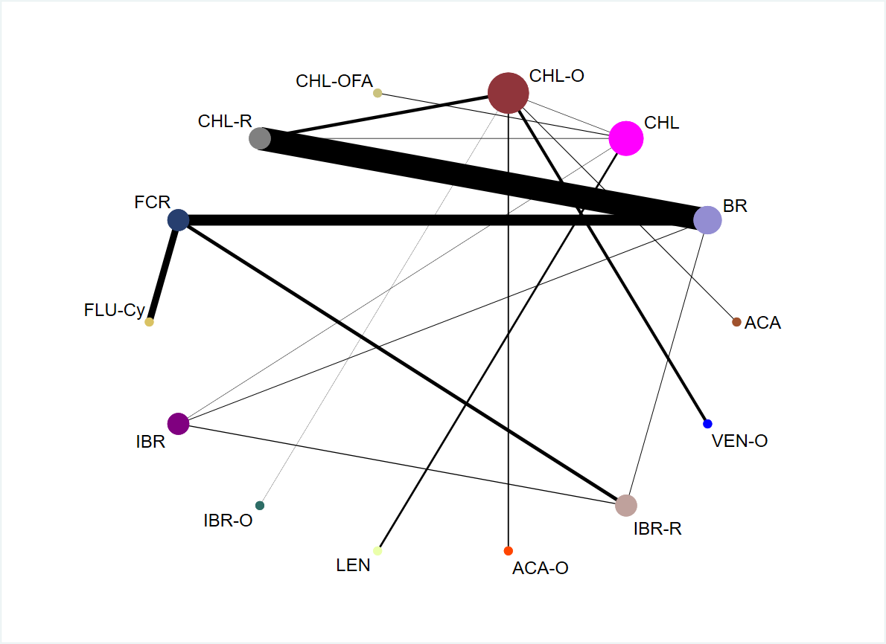
Figure S10 – SUCRAs for tolerability

Treatments from the best to the worst. For each treatment, in the horizontal axis is reported the position in the network, whereas in the vertical axis is reported the SUCRA

Figure S11 – Netleague for tolerability
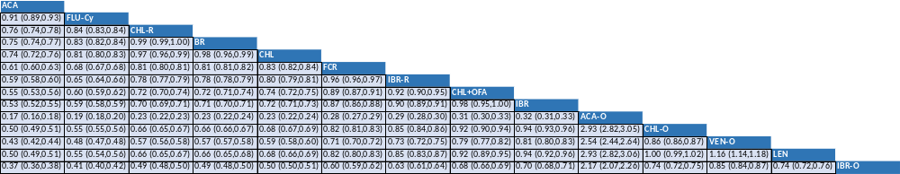
The table shows the pair-wise comparisons for each treatment, with the risk ratio and the credible interval (95%) for each comparison. Treatments are sorted from the best to the worst

Figure S12 – SUCRAs for ORR

Treatments from the best to the worst. For each treatment, in the horizontal axis is reported the position in the network, whereas in the vertical axis is reported the SUCRA

Figure S13 – Netleague for ORR
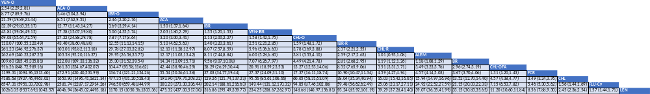
The table shows the pair-wise comparisons for each treatment, with the Odds Ratio and the credible interval (95%) for each comparison. Treatments are sorted from the best to the worst
Figure S14 – Networkplot of MRD
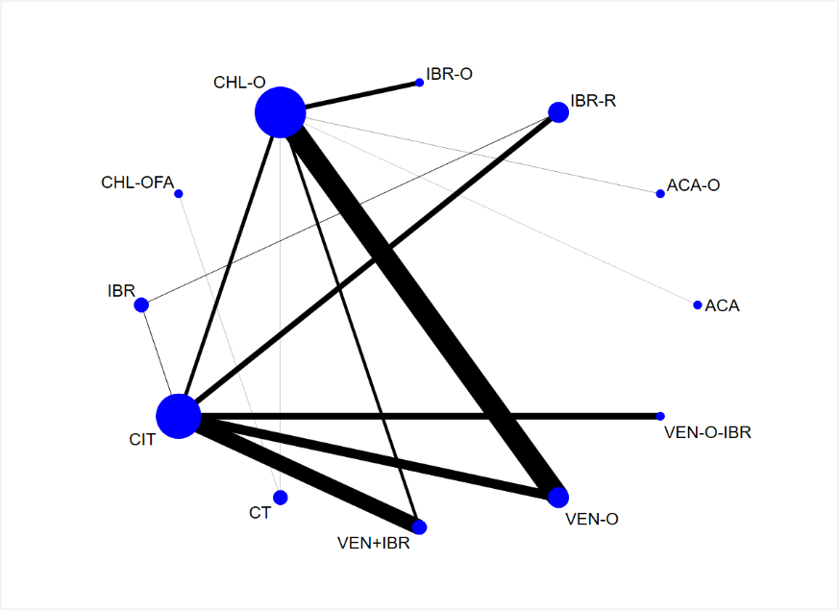
Figure S15 - SUCRAs for MRD
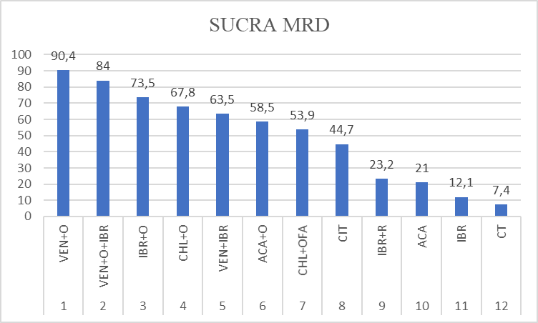
Treatments from the best to the worst. For each treatment, in the horizontal axis is reported the position in the network, whereas in the vertical axis is reported the SUCRA

Figure S16 – Netleague of MRD
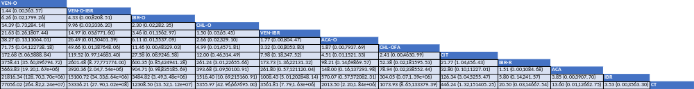
The table shows the pair-wise comparisons for each treatment, with the Odds Ratio and the credible interval (95%) for each comparison. Treatments are sorted from the best to the worst

