SUPPLEMENTARY MATERIAL
eFigure 1. Estimated cumulative incidence, mortality and number of hospital admissions between January 15th, 2021 and July 1st, 2021 associated with the absence of vaccination (A), and with the vaccination of the non-immunized full adult population (B), adults under 65 years (C), adults over 45 years (D), adults over 55 years with mandatory vaccination of those over 65 years (E), adults under 35 years and over 65 years (F), adults over 65 years (G), and adults at risk of severe COVID (i.e. aged over 65 years or with medical conditions) (H).

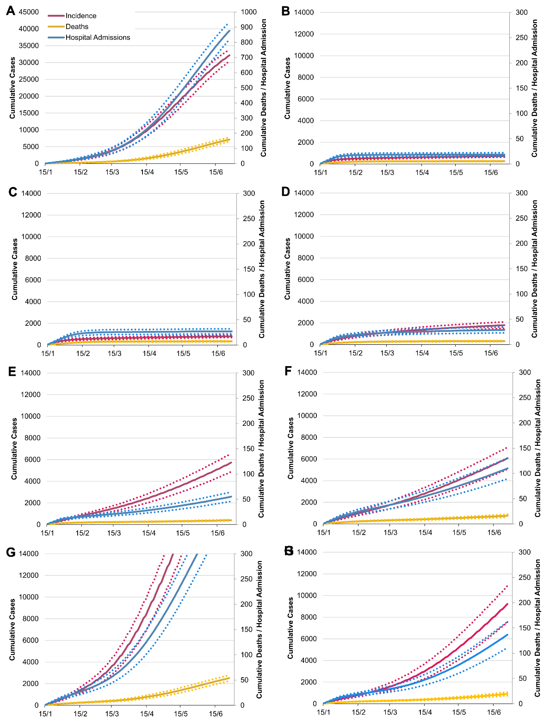
Note: Numbers are absolute values for the French population. The dotted lines represent the uncertainty range (95% prediction interval) stemming from the uncertainty in the parameter values.

eFigure2. Model-predicted daily incidence in France in the scenario considering that NPIs present on December 15th would be maintained until April 15th and then discontinued after that date. The dotted lines represent the uncertainty range (95% prediction interval) stemming from the uncertainty in the parameter values.
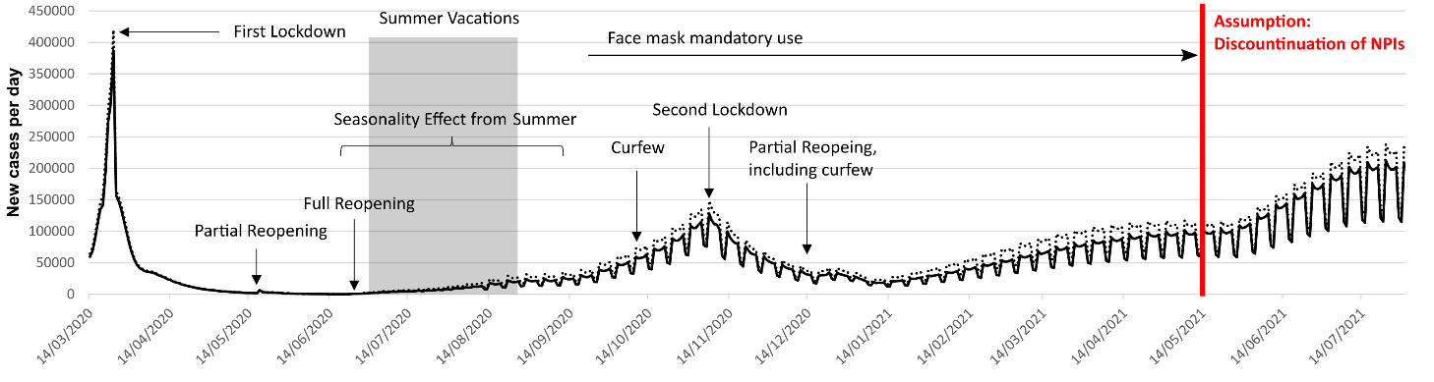

eTable 1. Summary of main model parameters.
Parameters | Value | Source
Individuals’ characteristics
Family structure (%) |  | Insee, 2020¹
Singles | 37%
Couples with children | 27%
Couples without children | 27%
Singles with children | 9%
Age structure (categorized by 5-year age groups) |  | Insee, 2020¹
Prevalence of conditions associated with increased risk of death from Covid-19 (i.e., obesity, diabetes, chronic cardiac diseases, and chronic respiratory diseases) | Estimates per 10-year age groups and sex | ^{2–7}
Social contacts
School class size (average) | 30 | Assumption
Proportion of small companies (<10 employees) | 18.40% | INSEE, 2018 ⁸
Number of colleagues in small companies (average) | 2 | Assumption
Number of colleagues in bigger companies (average) | 10 | Assumption
Employment rate (for people aged 20 to 65 years) | 92% | INSEE, 2020 ⁸
Shopping density (per 100,000 inhabitants) | 29.3 | APUR, 2018 ⁹
Number of shopping trips (average per week) | 1.2 | Assumption
Number of people met per shopping trip (average) | 5 | Assumption
Social network distance | 22 | ¹⁰
Frequency of meeting friends (average per week) | 1 | Assumption
Event participations, i.e., museum, cinema, music and sport events (average per year) | 5.4 | French Ministry of Culture, 2015 ¹¹
Close encounters per event participation (average) | 5 | Assumption
Round trips with public transport (average per week) for workers | 5 | Assumption
Round trips with public transport (average per week) for non-workers | 1.7 | Assumption
Close encounters in public transport | 3 to 5 | Assumption, with work-related trips assumed to happen at peak times with more encounters
International contamination (average, per week) | 1.8 | Based on imported cases observed in France initially (Santé Publique France) ⁷
SARS-CoV-2 infection characteristics
Contamination risk (per min/m²) | 0.025 | Estimated through model calibration, and based on seroprevalence in May 2020 in France ¹²
Proportion of the population infected with SARS-COV-2 in May 2020 | 4.5%
Proportion of asymptomatic people | 25% | London Imperial College, 2020 ¹³
Hospitalization rates | [0.1%-31.4%] | Institut Pasteur ¹⁴
ICU rates (if hospitalized) | [3.4%-36.4%] | Institut Pasteur ¹⁴
Mortality rates (if hospitalized) | [0.0%-42.0%] | Institut Pasteur ¹⁴
Impact of comorbidities on outcomes (Hospitalization, ICU, Mortality) | Hazard ratio estimates adjusted for sex and age and other comorbidities | ¹⁵
% of Reduction of contamination risk (per min/m²) during the summer (seasonality assumption) | 23% | Kissler, 2020 ¹⁶
Delays (days)
Incubation time (average, standard deviation) | 6.4 (2.3) | ¹⁷
Infection onset to diagnosis (average, standard deviation) | 2.1 (2.6) | ¹⁸
Infection onset to hospital admission (average, standard deviation) | 5.8 (4.2) | Institut Pasteur ¹⁴
Hospital admission to recovery or transfer to rehabilitation care (average, standard deviation) (no oxygen or low-flow oxygen) | 8.0 (1.0) | DRESS ¹⁹
Hospital admission to death (average, standard deviation) (no ICU admissions) | 4.0 (1.0) | DRESS ¹⁹
Rehabilitation care to Recovery (average, standard deviation) (no oxygen or low-flow oxygen) | 33.0 (3.3) | DRESS ¹⁹
Hospital admission to ICU (average, standard deviation) (initially low-flow oxygen) | 4.0 (1.0) | DRESS ¹⁹
ICU admission to ICU discharge or death (average, standard deviation) (short stay) | 16.0 (1.6) | DRESS ¹⁹
ICU admission to ICU discharge or death (average, standard deviation) (long stay) | 35.0 (3.5) | DRESS ¹⁹
ICU discharge to recovery or rehabilitation care (average, standard deviation) | 4.0 (1.0) | DRESS ¹⁹
Infection onset to recovery (average, standard deviation) (no hospitalization) | 20.5 (6.7) | London Imperial College ¹³
Proportion of hospitalized patients with mild or moderate disease with low-flow oxygen | 78.2% | Assumption
Proportion of hospitalized patients with mild or moderate disease requiring rehabilitation care | 12.4% | DRESS ¹⁹
Proportion of hospitalized patients with severe disease admitted directly to the ICU | 63.0% | DRESS ¹⁹
Proportion of hospitalized patients admitted to the ICU with a long stay | 15.0% | DRESS ¹⁹

Supplementary material references
1. Insee. Population totale par sexe et âge au 1er janvier 2020, France métropolitaine. https://www.insee.fr/fr/statistiques/fichier/1892088/pop-totale-france-metro.xls.
2. Bonaldi, C. et al. A first national prevalence estimate of diagnosed and undiagnosed diabetes in France in 18-to 74-year-old individuals: the French Nutrition and Health Survey 2006/2007. Diabetic medicine 28, 583–589 (2011).
3. Ferré, A. et al. Chronic bronchitis in the general population: influence of age, gender and socio-economic conditions. Respiratory medicine 106, 467–471 (2012).
4. Pasquereau, A. et al. La consommation de tabac en France: premiers résultats du baromètre santé 2017. Bull épidémiol hebd 14, 265–273 (2018).
5. Perrine, A., Lecoffre, C., Blacher, J. & Olié, V. L’hypertension artérielle en France: prévalence, traitement et contrôle en 2015 et évolution depuis 2006. Revue de Biologie Médicale/N 347, (2019).
6. Herva, E. et al. The effect of polyvalent pneumococcal polysaccharide vaccine on nasopharyngeal and nasal carriage of Streptococcus pneumoniae. Scandinavian journal of infectious diseases 12, 97–100 (1980).
7. Santé Publique France. COVID-19. Point épidémiologique hebdomadaire du 24 mars 2020. https://www.santepubliquefrance.fr/maladies-et-traumatismes/maladies-et-infections-respiratoires/infection-a-coronavirus/documents/bulletin-national/covid-19-point-epidemiologique-du-24-mars-2020.
8. Insee. Tableaux de l’économie française. (2018).
9. APUR. Évolution des commerces à Paris. Inventaire 2017 et évolutions 2014- 2017. https://www.apur.org/fr/nos-travaux/evolution-commerces-paris-inventaire-commerces-2017-evolutions-2014-2017 (2018).
10. Gilbert, E., Karahalios, K. & Sandvig, C. The network in the garden: Designing social media for rural life. American Behavioral Scientist 53, 1367–1388 (2010).
11. Ministère de la Culture. Chiffres clés. (2018).
12. INSERM. EpiCov. https://www.epicov.fr/ (2020).
13. MCfGIDA. Imperial College London. COVID-19—report 3: transmissibility of 2019-nCoV. https://www.imperial.ac.uk/mrc-global-infectious-disease-analysis/news-wuhan-coronavirus/ (2010).
14. Salje, H. et al. Estimating the burden of SARS-CoV-2 in France. Science 369, 208–211 (2020).
15. Williamson, E. et al. OpenSAFELY: factors associated with COVID-19-related hospital death in the linked electronic health records of 17 million adult NHS patients. MedRxiv (2020) doi:https://doi.org/10.1101/2020.05.06.20092999.
16. Kissler, S. M., Tedijanto, C., Goldstein, E., Grad, Y. H. & Lipsitch, M. Projecting the transmission dynamics of SARS-CoV-2 through the postpandemic period. Science 368, 860–868 (2020).
17. Backer, J. A., Klinkenberg, D. & Wallinga, J. Incubation period of 2019 novel coronavirus (2019-nCoV) infections among travellers from Wuhan, China, 20–28 January 2020. Eurosurveillance 25, 2000062 (2020).
18. Kucharski, A. J. et al. Early dynamics of transmission and control of COVID-19: a mathematical modelling study. The lancet infectious diseases (2020).
19. Courtejoie, N. & Dubost, C.-L. Parcours hospitalier des patients atteints de la Covid-19 lors de la première vague de l’épidémie. (2020).

