Supplementary Information

A microfluidic diagnostic device with air plug-in valves for the simultaneous genetic detection of various food allergens

Daigo Natsuhara^{1,*}, Sae Misawa², Ryogo Saito¹, Koki Shirai¹, Shunya Okamoto¹, Moeto Nagai¹, Masashi Kitamura² & Takayuki Shibata^{1,*}

¹ Department of Mechanical Engineering, Toyohashi University of Technology, Toyohashi, Aichi 441-8580, Japan.
² Faculty of Pharmacy and Pharmaceutical Sciences, Josai University, Sakado, Saitama 350-0295, Japan.
*Corresponding authors:
Daigo Natsuhara (d-natsuhara@mems.me.tut.ac.jp), Takayuki Shibata (shibata@me.tut.ac.jp)

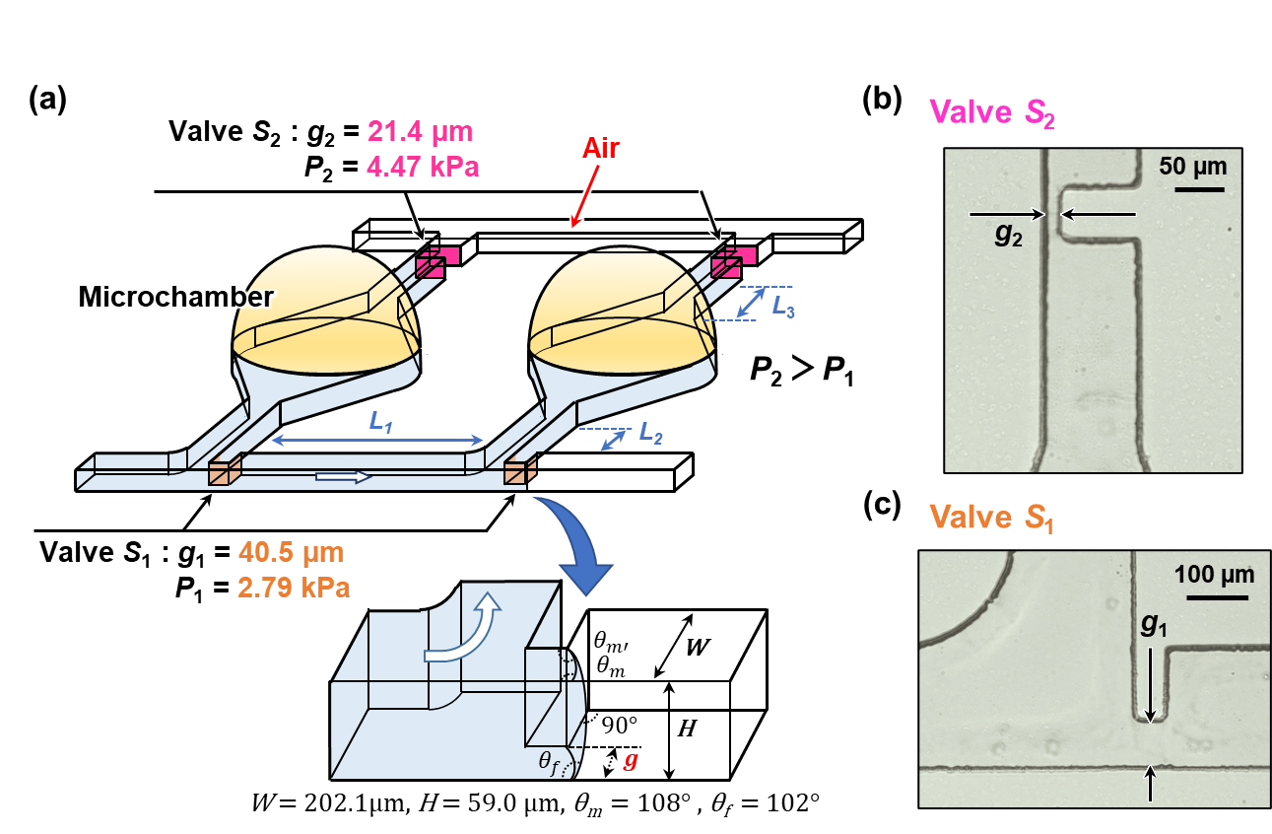
Figure S1. Schematic representation of a method of sequential liquid dispensing into multiple reaction microchambers. (a) Detailed design of microchambers with a pair of single-faced stop valves with different burst pressures. (b) Optical microscopy image of a permanent stop valve S₂. (c) Optical microscopy image of a temporary stop valve S₁.

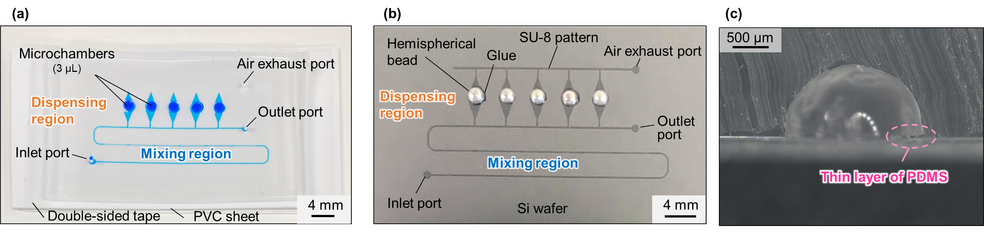
Figure S2. Schematic representation of the microfluidic diagnostic device fabricated through a modified soft lithography process using hemispherical polymer beads to create deep localized microchamber structures. (a) A fabricated PDMS microfluidic device consisting of an array of five reaction microchambers (∼3 µL each) was filled with blue-colored water. (b) Hemispherical polymer beads were glued manually in the center on the top surface of each SU-8 chamber pattern to create a master mold for the replication of the PDMS microfluidic devices. (c) Cross-section of a PDMS microchamber fabricated from a hemispherical bead. An unexpected thin layer of PDMS was overhanging into the microchamber area because of poor controllability of the uniformity of the adhesive layer thickness.

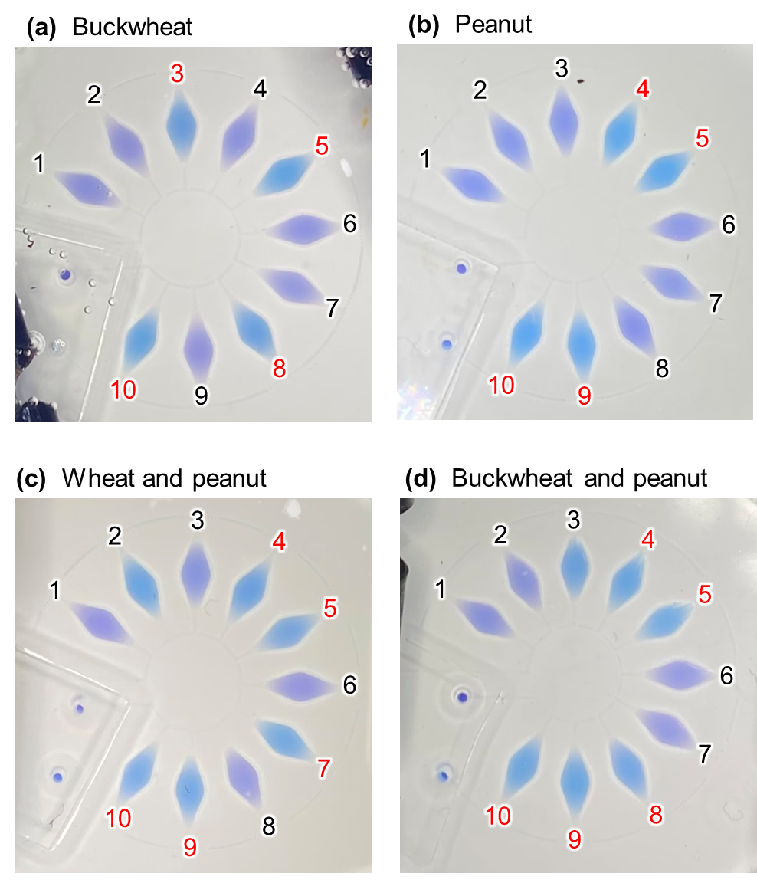
Figure S3. Photographs taken with a smartphone camera showing the colorimetric detection of (a) buckwheat DNA (Nos. 3 and 8), (b) peanut DNA (Nos. 4 and 9), (c) a mixture of wheat (Nos. 2 and 7) and peanut DNA, and (d) a mixture of buckwheat and peanut DNA by LAMP assays run at 60 °C for 60 min. Universal primer sets to identify all plant species were pre-spotted in chamber Nos. 5 and 10 as a positive control, whereas no primers were pre-spotted in chamber Nos.1 and 6 as a negative control.

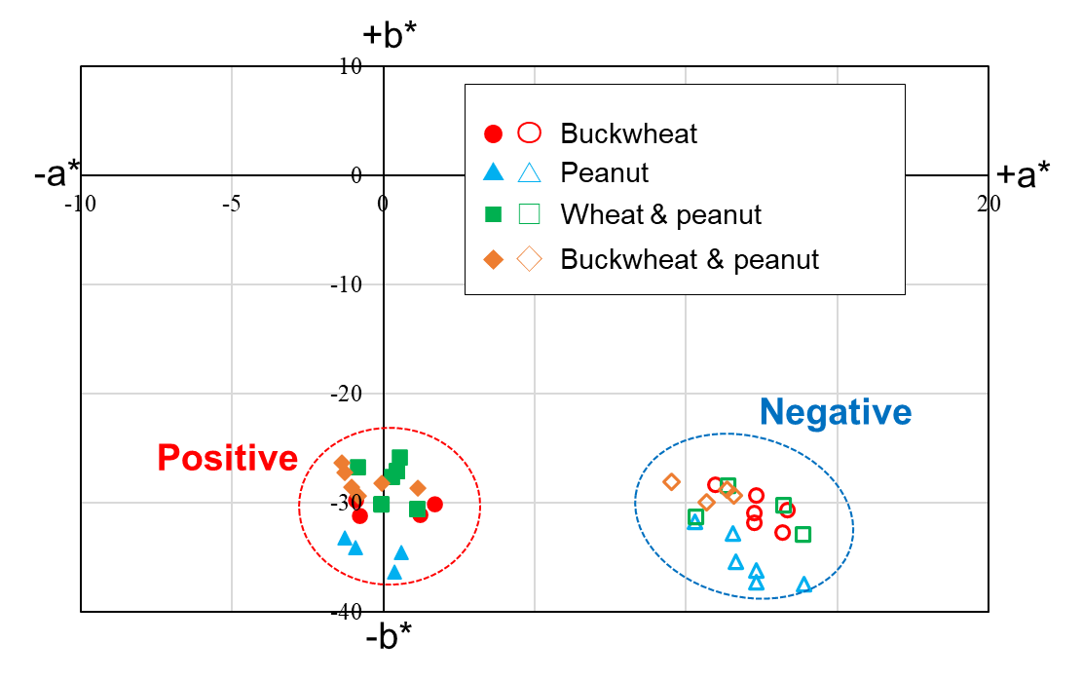
Figure S4. Color distributions for positive (sky blue) and negative (violet) LAMP reactions (shown in Fig. S3) run for the detection of three food allergens (wheat, buckwheat, and peanut) and tea plant as a negative control, plotted in the a*-b* chromatic plane of the CIELAB color space. LAMP reactions were run at 60 °C for 60 min.

