Supplementary Materials

Tracing sources of PM₁₀ in central Taiwan by using chemical characteristics and Pb isotope ratios:
Local versus long-range transport

Po-Chao Wu¹²³ and Kuo-Fang Huang^{2,*}

¹Earth System Science Program, Taiwan International Graduate Program (TIGP), Academia Sinica, Taipei, Taiwan.
²Institute of Earth Sciences, Academia Sinica, Taipei, Taiwan.
³College of Earth Science, National Central University, Taoyuan, Taiwan.

*Corresponding author:
Dr. Kuo-Fang Huang
Institute of Earth Sciences, Academia Sinica
128, Section 2, Academia Road, Nangang, Taipei 11529, Taiwan
Tel: +886-2-2783-9910 ext. 1616
Fax: +886-2-2783-9871
E-mail: kfhuang@earth.sinica.edu.tw
Table S1 Concentrations of mass (μg/m³), major ions (ng/m³) and metals (ng/m³) of PM₁₀ collected during each event.
Sampling Date | 11/13-15 (2018) | 11/25 (2018) | 12/7 (2018) | 10/4-5 (2019) |  | 10/30-31 (2019) | 10/31-11/1 (2019)
Sites | #1 – #6 | #1, #3– #6 | #1 – #6 | #1 – #6 | Cape Fugui | #5 | #5
PM₁₀ | 46.5 – 116 | 48.4 – 74.0 | 42.2 – 121 | 66.0 – 92.2 | 17.9 | 78.1 | 59.0
SO₄²⁻ | 4,569 – 11,496 | 4,794 – 9,019 | 2,661 – 4,885 | 16,445 – 23,725 | 3,942 | 7,336 | 6,343
NO₃⁻ | 3,671 – 11,097 | 8,277 – 16,062 | 2,563 – 3,127 | 10,665 – 24,430 | 1,176 | 8,825 | 7,918
NH₄⁺ | 1,096 – 4,791 | 4,258 – 8,354 | 482 – 1,091 | 9,754 – 15,472 | 1,102 | 2,688 | 1,994
Cl⁻ | 1,789 – 7,057 | 861 – 2,872 | 2,377 – 6,666 | 60.0 –751 | 1,061 | 3,709 | 5,044
Na | 1,385 – 4,243 | 790 – 1,370 | 1,510 – 4,061 | 508 – 723 | 1,301 | 3,613 | 4,854
Mg | 194 – 394 | 81.4 – 167 | 130 – 740 | 126 – 162 | 171 | 1,023 | 854
Al | 368 – 1,707 | 155 – 351 | 390 – 3,656 | 526 – 1,055 | 111 | 2,324 | 1,454
K | 458 – 1,115 | 844 – 1,293 | 534 – 2,030 | 512 – 674 | 149 | 1,125 | 851
Ca | 486 – 2,210 | 194 – 466 | 507 – 2,001 | 352 – 486 | 128 | 1,599 | 872
Ti | 47.0 – 209 | 14.0 – 46.7 | 54.5 – 378 | 29.1 – 61.5 | 7.00 | 140 | 88.7
V | 4.15 – 11.1 | 5.53 –12.9 | 3.30 – 11.4 | 17.8 – 27.0 | 4.35 | 8.09 | 5.88
Cr | 3.37 – 8.62 | 4.18 – 9.77 | 2.90 – 9.48 | 4.91 – 7.40 | 2.11 | 5.92 | 4.26
Mn | 15.9 – 52.3 | 13.0 – 19.5 | 17.2 – 72.7 | 16.8 – 24.9 | 3.48 | 44.7 | 28.6
Fe | 634 – 2,233 | 200 – 570 | 706 – 3,789 | 414 – 614 | 96.8 | 1,648 | 1,023
Ni | 2.52 – 6.84 | 3.37 – 5.88 | 2.07 – 5.25 | 7.74 – 11.3 | 1.83 | 4.01 | 3.06
Cu | 22.3 – 46.5 | 35.5 – 105 | 14.5 – 59.8 | 16.5 – 94.2 | 20.0 | 19.0 | 23.1
Zn | 41.4 – 187 | 53.9 – 97.9 | 35.1 – 153 | 90.7 – 156 | 21.0 | 99.1 | 104
As | 1.00 – 2.30 | 1.91 – 2.73 | 1.13 – 1.82 | 7.41 – 9.23 | 0.98 | 2.73 | 1.72
Sr | 3.66 – 14.0 | 4.94 – 7.61 | 4.56 – 13.4 | 2.10 – 3.29 | 1.54 | 12.2 | 8.12
Mo | 0.84 – 3.44 | 1.31 – 7.88 | 0.49 – 2.78 | 1.33 – 6.01 | 0.74 | 1.61 | 1.72
Cd | 0.14 – 0.59 | 0.43 – 0.80 | 0.09 – 0.38 | 1.31 – 1.55 | 0.18 | 0.54 | 0.38
Sb | 1.05 – 4.36 | 1.03 – 2.81 | 0.63 – 2.70 | 3.18 – 18.3 | 0.70 | 1.73 | 1.24
Ba | 7.74 – 17.6 | 13.2 – 18.4 | 6.76 – 35.3 | 10.4 – 53.4 | 4.50 | 21.8 | 14.8
La | 0.40 – 0.82 | 0.03 – 0.23 | 0.33 – 1.62 | 0.42 – 0.71 | 0.10 | 1.16 | 0.82
Ce | 0.74 – 1.70 | 0.16 – 0.41 | 0.70 – 3.30 | 0.75 – 1.21 | 0.15 | 2.30 | 1.53
Nd | 0.30 – 0.75 | 0.06 – 0.17 | 0.29 – 1.37 | 0.30 – 0.47 | 0.06 | 0.93 | 0.65
Pb | 5.63 –22.9 | 11.3 – 30.5 | 5.45 – 18.2 | 23.3 – 30.3 | 4.91 | 17.3 | 12.4

Table S2 Relative contribution of each endmember to PM₁₀ collected during the local events.
 |  | Oil combustion/Oil refineries |  |  | Coal combustion |  |  | River sand/soil
 | Site | Mean (%) | 2.5% | 97.5% | Mean (%) | 2.5% | 97.5% | Mean (%) | 2.5% | 97.5%
Moderate-wind-speed | #1 | 76.9 | 58.8 | 93.1 | 10.0 | 0.4 | 25.8 | 13.1 | 0.5 | 36.0
Moderate-wind-speed | #2 | 73.6 | 53.8 | 91.9 | 11.0 | 0.6 | 27.4 | 15.4 | 0.6 | 40.4
Moderate-wind-speed | #3 | 78.5 | 61.0 | 94.2 | 9.3 | 0.4 | 24.1 | 12.2 | 0.4 | 33.8
Moderate-wind-speed | #4 | 70.6 | 50.5 | 88.9 | 12.0 | 0.5 | 28.9 | 17.4 | 0.8 | 44.5
Moderate-wind-speed | #5 | 75.4 | 56.9 | 92.7 | 10.5 | 0.5 | 26.6 | 14.1 | 0.6 | 38.5
Moderate-wind-speed | #6 | 73.5 | 54.6 | 91.2 | 11.4 | 0.5 | 28.5 | 15.1 | 0.7 | 40.0
Low-wind-speed | #1 | 77.8 | 59.0 | 94.0 | 9.4 | 0.5 | 24.2 | 12.8 | 0.5 | 35.9
Low-wind-speed | #2 | 78.6 | 59.9 | 94.5 | 8.6 | 0.4 | 23.4 | 12.7 | 0.6 | 35.2
Low-wind-speed | #3 | 80.3 | 61.8 | 95.3 | 8.0 | 0.3 | 21.9 | 11.7 | 0.3 | 33.3
Low-wind-speed | #4 | 75.3 | 57.3 | 92.6 | 10.6 | 0.5 | 26.7 | 14.0 | 0.6 | 37.4
Low-wind-speed | #5 | 88.4 | 73.2 | 98.0 | 4.7 | 0.2 | 14.3 | 6.9 | 0.3 | 21.7
Low-wind-speed | #6 | 71.3 | 51.3 | 90.0 | 12.7 | 0.5 | 30.1 | 16.0 | 0.6 | 43.0
High-wind-speed | #1 | 76.9 | 58.3 | 93.1 | 9.7 | 0.4 | 25.0 | 13.4 | 0.4 | 36.4
High-wind-speed | #2 | 68.2 | 47.6 | 87.2 | 13.8 | 0.7 | 31.5 | 18.0 | 0.8 | 46.8
High-wind-speed | #3 | 74.5 | 55.0 | 91.8 | 11.2 | 0.5 | 27.4 | 14.3 | 0.6 | 39.7
High-wind-speed | #4 | 62.0 | 40.5 | 81.8 | 16.0 | 1.0 | 36.0 | 22.0 | 1.0 | 53.6
High-wind-speed | #5 | 48.2 | 21.5 | 68.7 | 20.7 | 1.2 | 43.2 | 31.1 | 2.1 | 71.2
High-wind-speed | #6 | 72.2 | 52.1 | 90.2 | 12.0 | 0.6 | 29.1 | 15.8 | 0.7 | 41.8
Table S3 Method detection limits for elements determined by field blank measurements (N = 7) in this study.
Elements | MDLs (ng/m³) | Elements | MDLs (ng/m³)
Na | 5.66 | Zn | 1.26
Mg | 0.68 | As | 0.006
Al | 6.18 | Sr | 0.02
K | 2.67 | Mo | 0.007
Ca | 19.0 | Cd | 0.008
Ti | 0.78 | Sb | 0.06
V | 0.03 | Ba | 0.23
Cr | 0.90 | La | 0.005
Mn | 0.25 | Ce | 0.014
Fe | 2.86 | Nd | 0.006
Ni | 0.24 | Pb | 0.067
Cu | 0.76

Table S4 Analytical results for the urban particulate matter certified reference material, NIST SRM 1648a (in μg/g, N = 3).
Element | Certified value | Measured value | Recovery (%)
Na | 4,240 ± 60 | 4,596 ± 143 | 108.4
Mg | 8,130 ± 120 | 7,740 ± 582 | 95.2
Al | 34,300 ± 1300 | 34,066 ± 2459 | 99.3
K | 10,560 ± 490 | 10,415 ± 643 | 98.6
Ca | 58,400 ± 1900 | 57,704 ± 3449 | 98.8
Ti | 4,021 ± 86 | 3,889 ± 225 | 96.7
V | 127 ± 11 | 124 ± 7 | 98.0
Cr | 402 ± 13 | 351 ± 15 | 87.4
Mn | 790 ± 44 | 793 ± 21 | 100.4
Fe | 39,200 ± 2100 | 37,209 ± 769 | 94.9
Co | 17.93 ± 0.68 | 16.66 ± 1.0 | 92.9
Ni | 81.1 ± 6.8 | 73.1 ± 3.7 | 90.1
Cu | 610 ± 70 | 580 ± 44 | 95.1
Zn | 4,800 ± 270 | 4,519 ± 283 | 94.1
As | 115.5 ± 3.9 | 110 ± 12 | 95.4
Sr | 215 ± 17 | 210 ± 10 | 97.9
Cd | 73.7 ± 2.3 | 70.7 ± 4.7 | 96.4
Sb | 45.4 ± 1.4 | 43.0 ± 2.1 | 94.7
La | 39 ± 3* | 35 ± 1 | 90.2
Ce | 54.6 ± 2.2 | 49.4 ± 3.2 | 90.4
Pb | 6,550 ± 330 | 6,254 ± 388 | 95.5
* Reference value (reported by NIST)
Table S5 Analytical results for Gobi Kosa dust certified reference material, NIES No. 30 (in μg/g, N = 3).
Element | Certified value | Measured value | Recovery (%)
Na | 9,390 ± 710 | 9,312 ± 667 | 99.2
Mg | 15,100 ± 1300 | 14,382 ± 997 | 95.2
Al | 75,800 ± 4200 | 74,101 ± 3403 | 97.8
K | 21,300 ± 1100 | 20,708 ± 1253 | 97.2
Ca | 42,500 ± 3500 | 39,482 ± 1700 | 92.9
Ti | 4,260 ± 400 | 4,155 ± 158 | 97.5
Cr | 57.4* | 59.2 ± 0.3 | 103.2
Mn | 768 ± 83 | 702 ± 17 | 91.4
Fe | 38,400 ± 3500 | 34,061 ± 914 | 88.7
Co | 13.7* | 12.2 ± 0.4 | 88.8
Ni | 29.1* | 26.7 ± 0.6 | 91.9
Cu | 34.1* | 31.5 ± 2.3 | 92.5
Zn | 93.1 ± 8.5 | 84.1 ± 2.4 | 90.3
Sr | 250 ± 20 | 224 ± 8 | 89.6
Ba | 535 ± 31 | 505 ± 10 | 94.4
La | 40.4* | 38.8 ± 1.5 | 96.0
Pb | 22.4 * | 22.0 ± 0.8 | 98.4
* Reference values (reported by NIES¹).
Table S6 Long-term precision and accuracy of MC-ICP-MS measurements for Pb isotope ratios at AS-IES.
Reference Material  Pb isotope ratio | Recommended Value (2SD) | Measured  Value (2SD) | N
NIST SRM 981
(²⁰⁶Pb/²⁰⁷Pb) | 1.0934 (0.0005)ª | 1.0932 (0.0002) | 69
(²⁰⁸Pb/²⁰⁷Pb) | 2.3691 (0.0011)ª | 2.3693 (0.0003) | 69
NIST SRM 1648a
(²⁰⁶Pb/²⁰⁷Pb) | 1.2394^{b} | 1.2394 (0.0007) | 12
(²⁰⁸Pb/²⁰⁷Pb) | 2.4735^{b} | 2.4720 (0.009) | 12
ªPb isotope ratios compiled from measurements on TIMS and MC-ICP-MS².
^{b}Pb isotope ratios reported by Kumar et al.³
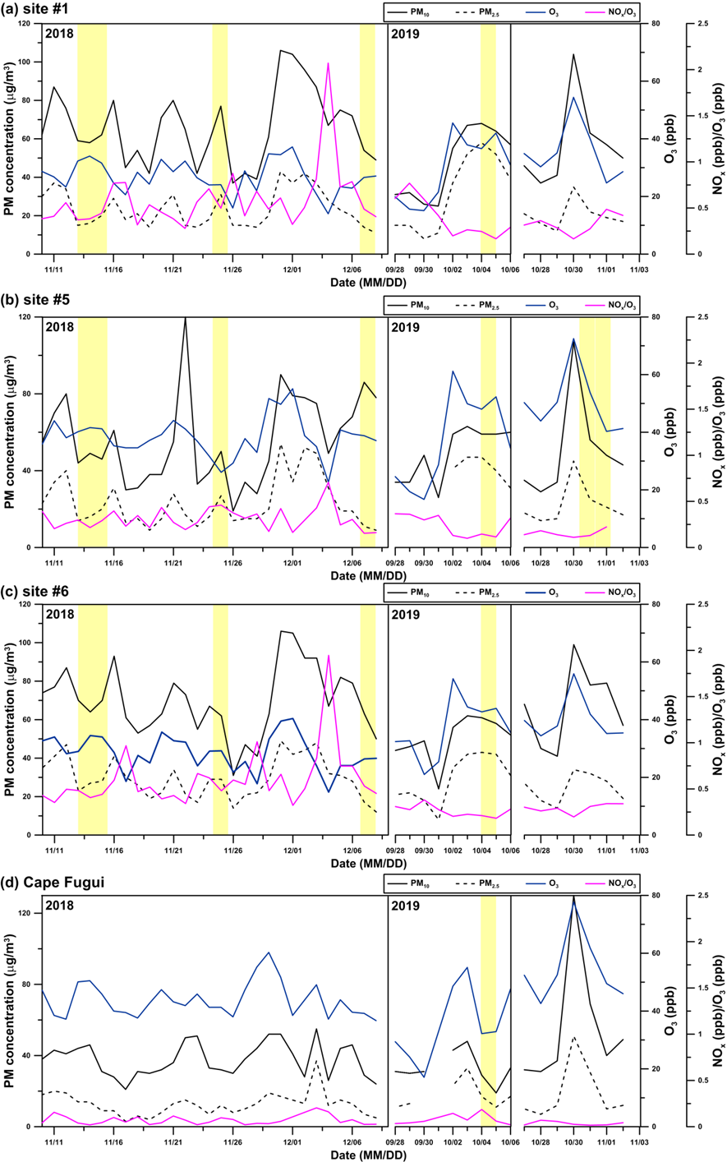
Figure S1. Daily record (Local time) of PM₁₀, PM_{2.5}, O₃, and the ratio of NO_{x}/O₃ at (a) site #1, (b) site #5, (c) site #6, and (d) Cape Fugui (available from the EPA environment resource database). Yellow areas represent PM₁₀ sampling periods conducted in this study.
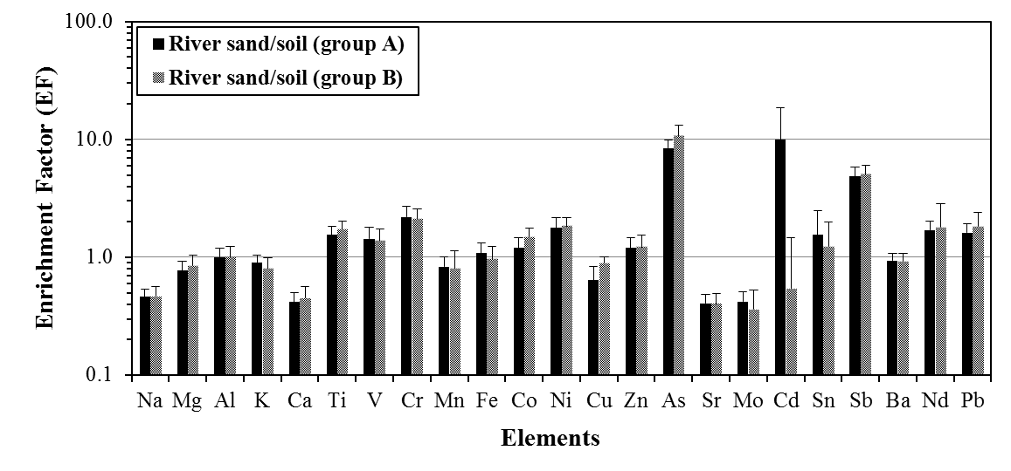
Figure S2. Enrichment factors of elements in river sand/soil collected in the downstream (group A, N = 10) and upstream (group B, N = 3) of the Choshui River catchment in central Taiwan.
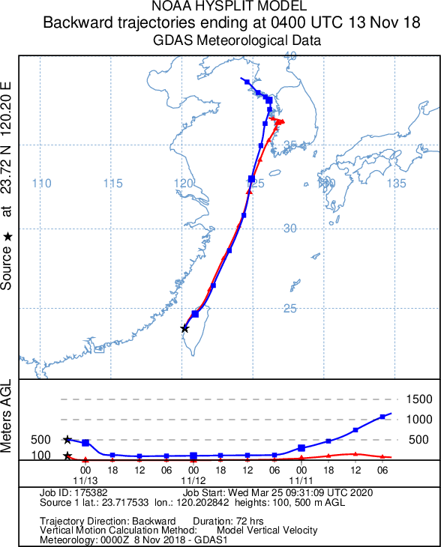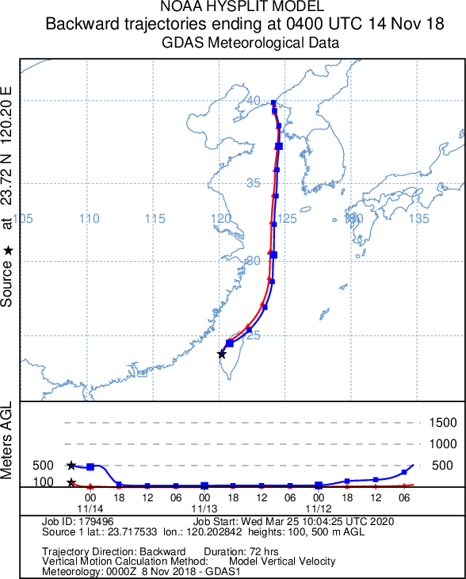
(a) Nov. 13-15, 2018

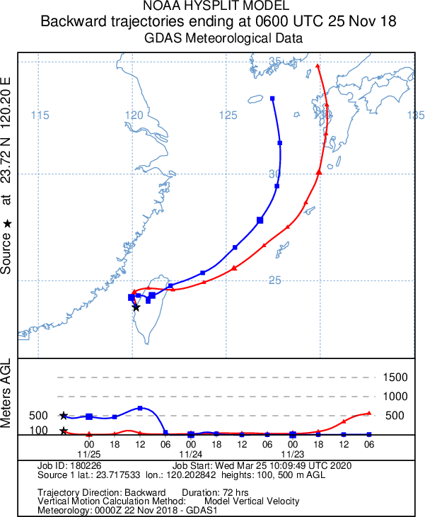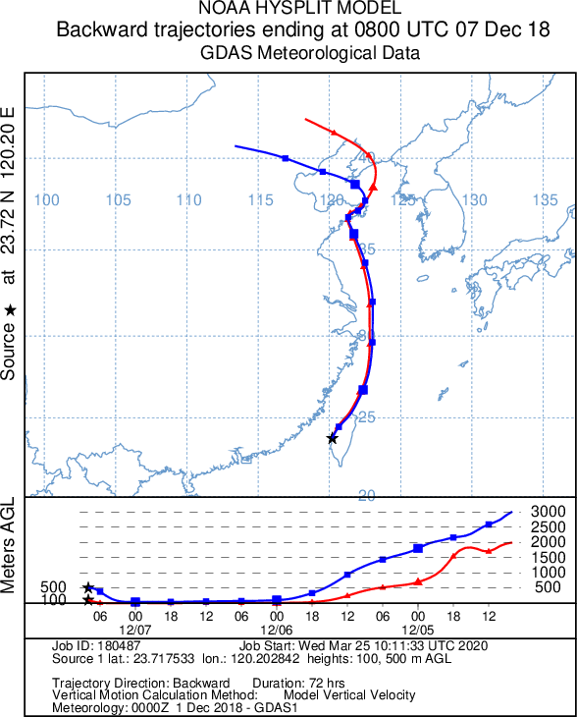
(b) Nov. 25, 2018 (c) Dec. 7, 2018

Figure S3. 72-hour back trajectories of air masses for (a) the moderate-wind-speed local event, (b) the low-wind-speed local event, and (c) the high-wind-speed local event in the study region in central Taiwan. Trajectories were calculated using the hybrid single-particle Lagrangian trajectory (HYSPLIT) model (NOAA Air Resources Laboratory; https://www.ready.noaa.gov/HYSPLIT.php).
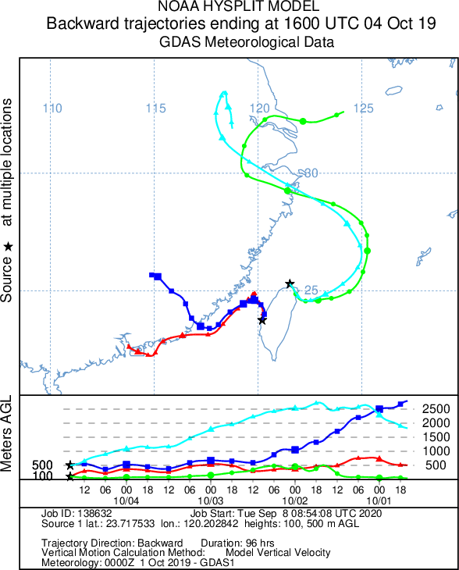
(a) Oct. 4-5, 2019

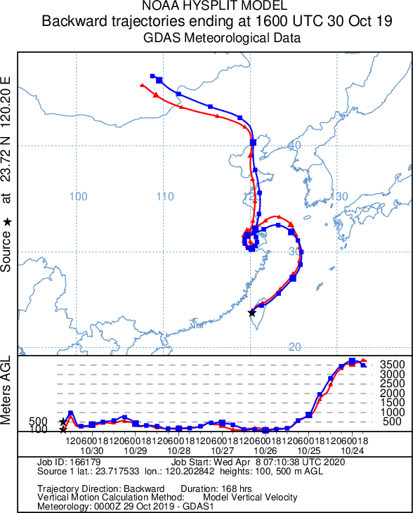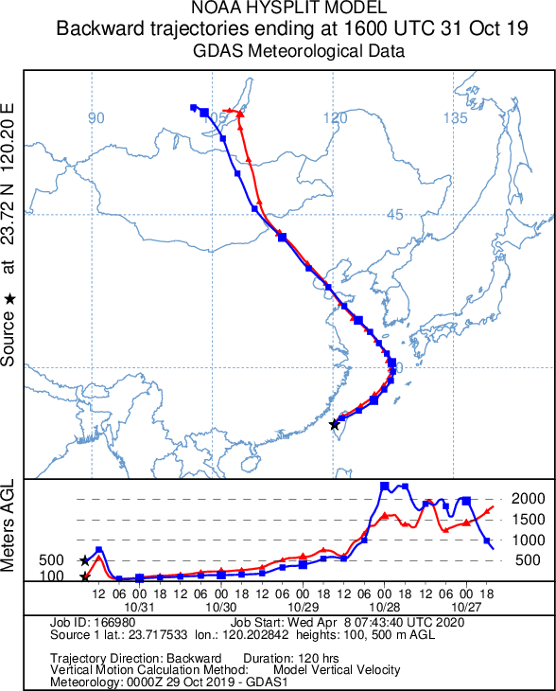
(b) Oct. 30-31, 2019 (c) Oct. 31–Nov. 1, 2019

Figure S4. (a) 96-hour back trajectories of air masses at central Taiwan and Cape Fugui during the long-range transport event. (b) 168-hour back trajectories of air masses at central Taiwan during dust storm event and (c) 144-hour back trajectories of air masses at central Taiwan during transition. Trajectories were calculated using the hybrid single-particle Lagrangian trajectory (HYSPLIT) model (NOAA Air Resources Laboratory; https://www.ready.noaa.gov/HYSPLIT.php).
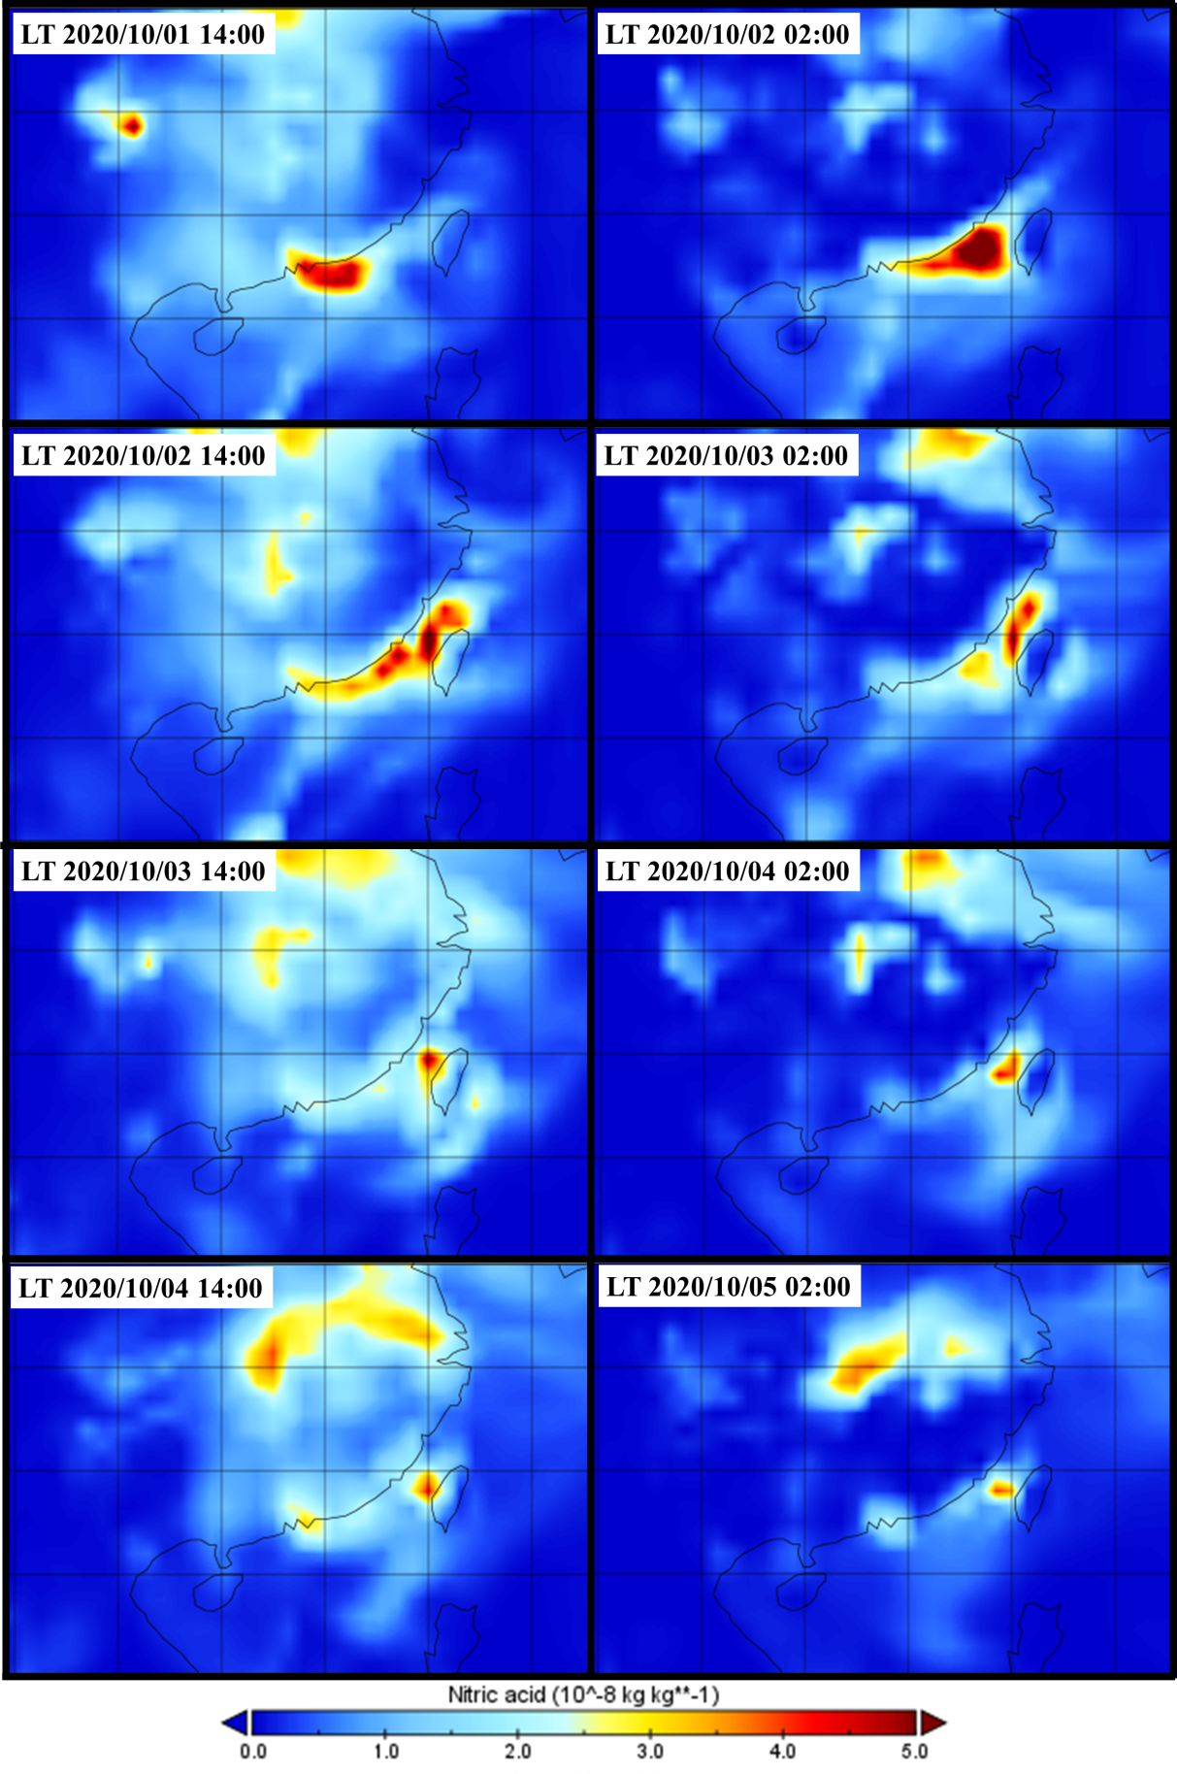
Figure S5. Nitric acid mixing ratio at the surface layer (1000 hPa) at local time (LT) during the long-range transport event in central Taiwan in 2019. Data was obtained from CAMS global reanalysis dataset (EAC4) in ECMWF (https://www.ecmwf.int/en/forecasts/dataset/cams-global-reanalysis).
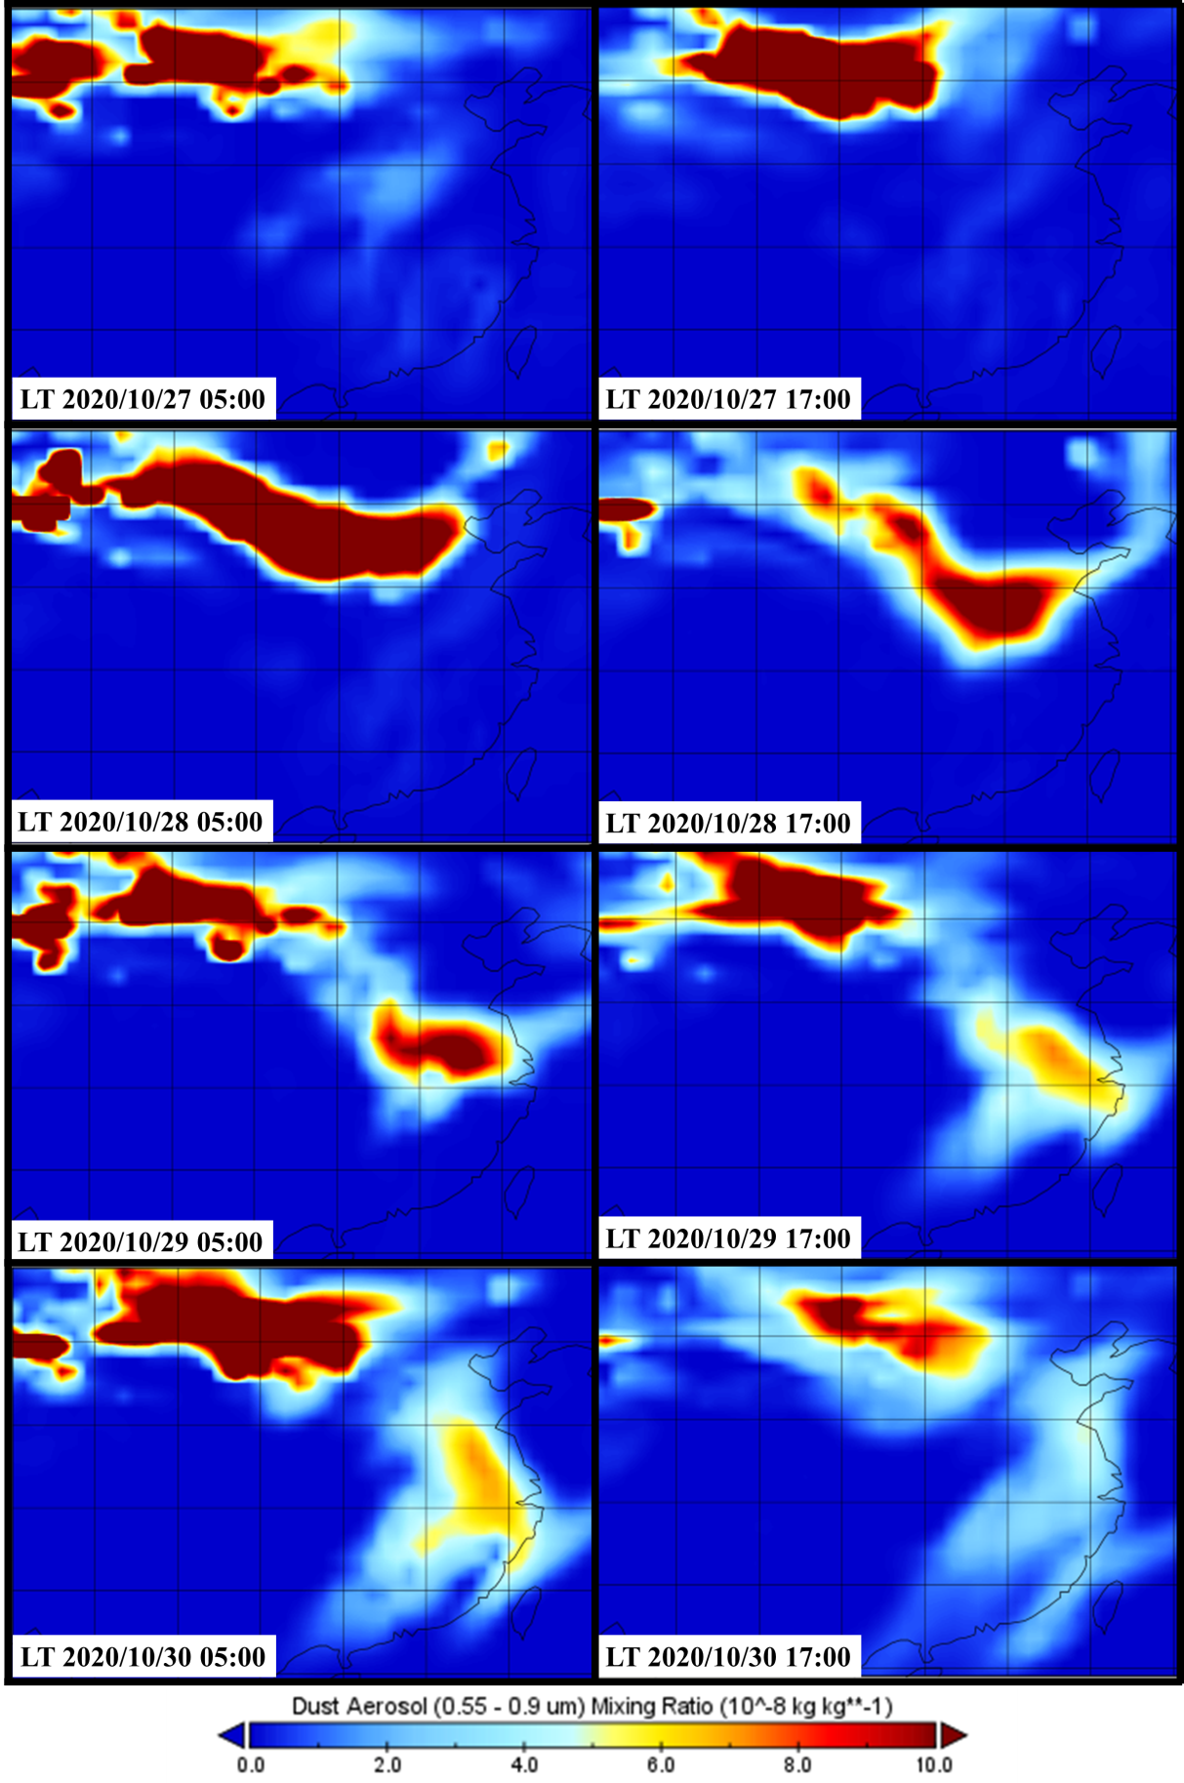
Figure S6. Dust aerosol (0.55 – 0.9 μm) mixing ratio at the surface layer (950 hPa) at local time (LT) during the dust storm event in central Taiwan in 2019. Data was obtained from CAMS global reanalysis dataset (EAC4) in ECMWF (https://www.ecmwf.int/en/forecasts/dataset/cams-global-reanalysis).

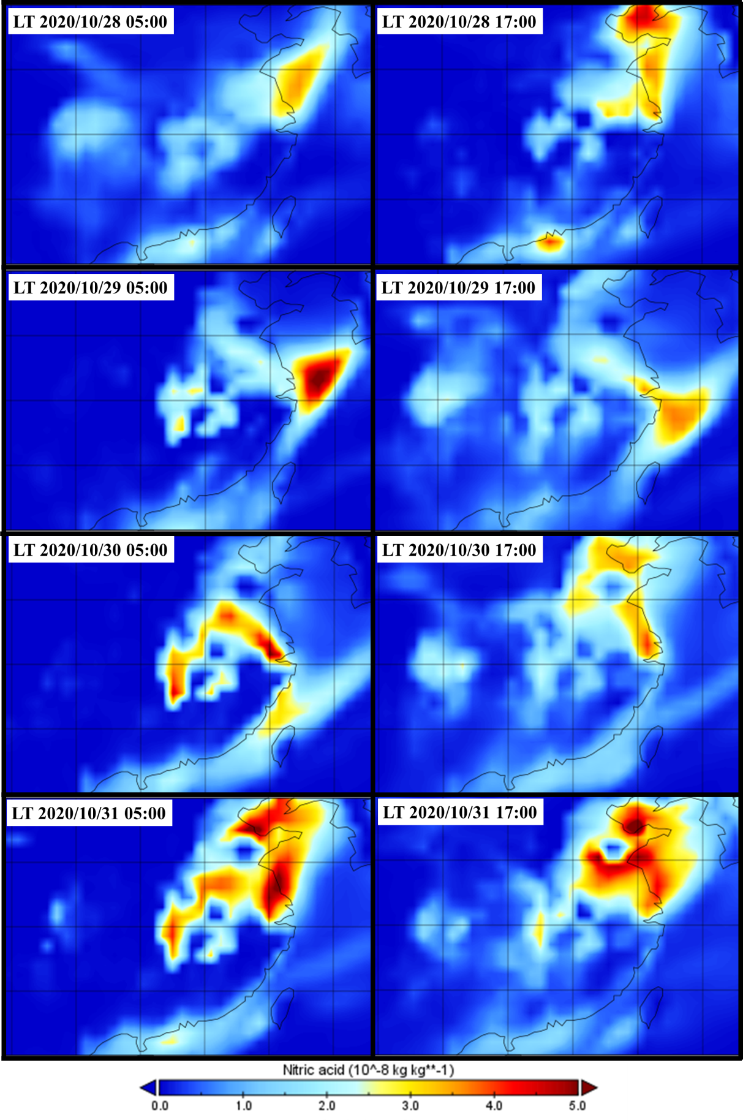
Figure S7. Nitric acid mixing ratio at the surface layer (1000 hPa) at local time (LT) during the dust storm event in central Taiwan in 2019. Data was obtained from CAMS global reanalysis dataset (EAC4) in ECMWF (https://www.ecmwf.int/en/forecasts/dataset/cams-global-reanalysis).
References:
1 Nishikawa, M. et al. Preparation and chemical characterisation of an Asian mineral dust certified reference material. Analytical Methods 5, 4088-4095 (2013).
2 Weiss, D. J. et al. Accurate and precise Pb isotope ratio measurements in environmental samples by MC-ICP-MS. International Journal of Mass Spectrometry 232, 205-215, https://doi.org/10.1016/j.ijms.2004.01.005 (2004).
3 Kumar, S. et al. Understanding the Influence of Open-waste Burning on Urban Aerosols using Metal Tracers and Lead Isotopic Composition. Aerosol and Air Quality Research 18, 2433-2446 (2018).

