Medicinal plant Iris japonica as Histidine Kinase Inhibitor Candidate can Enhance Antibiotic Susceptibility of Escherichia coli resistant to β-lactam antibiotics
Zhangkai Xu¹, Yinhuan Wang²，Jiang Chen¹，Nan Huang¹，Dongqing Cheng^{1*}
¹College Of Medical Technology, Zhejiang Chinese Medical University, Hangzhou, China
²Zhejiang Institute for Food and Drug Control, Hangzhou, China
* Correspondence:
Dongqing Cheng
chengdq@zcmu.edu.cn
Supplementary Material
Qualitative and quantitative analysis of tectoridin in Iris japonica extract: The standard tectoridin as a control, Iris japonica aqueous extracts and ethanol extract under UV light color reaction were: gray under visible light, brown and fluorescent spots under UV light. Ammonia reaction were: ammonia smoked yellow or brownish yellow fluorescent spots. Aluminium trichloride colorimetric determination phenomena were: Yellowish green fluorescent spots under UV light. Hydrochloric acid - magnesium reaction was: foam was purple. The reaction results were positive, indicating that Iris japonica aqueous extracts and ethanol extract contains flavonoids.
The tectoridin standard solution was taken and scanned in the wavelength range of 200-400 nm on a UV-visible spectrophotometer. As a result, the tectoridin standard had a maximum absorption peak at (266.5±0.2) nm (Figure 1).
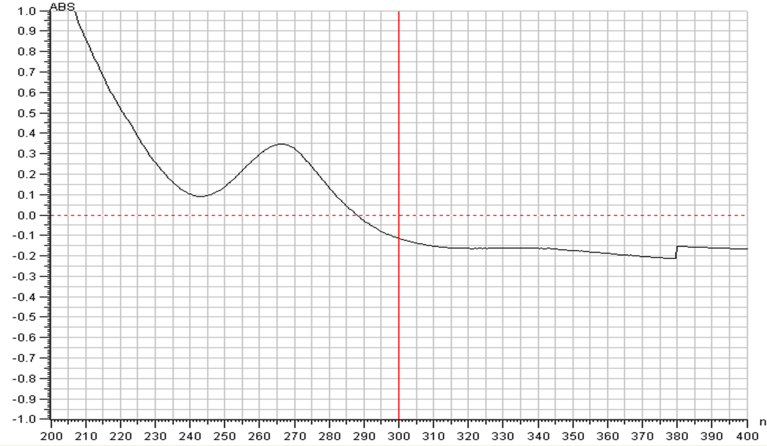
FIGURE1 The 200～400 nm wavelength scanning diagram of tectoridin

We chose to measure the absorbance value of different concentration tectoridin standards at 266.5nm (Table 2). We took the concentration of the tectoridin standard concentration as the abscissa and the absorbance as the ordinate to draw the standard curve (Figure 2). The results showed that the concentration of tectoridin in the range of 2.00 ~ 10.00 μg / mL were in line with the Beer's law, the linear regression equation was: y=92.043x+0.0603, R²=0.9991。

TABLE1 The absorbance of tectoridin standard
Iris standard（µg/mL） | OD（‾χ ±s ）
0 | 0.053±0.003
2.00 | 0.238±0.008
4.00 | 0.442±0.007
6.00 | 0.621±0.005
8.00 | 0.801±0.002
10.00 | 0.968±0.003

In the same way, the OD values of Iris japonica aqueous extracts and ethanol extracts were tested 0.318±0.003 and 0.906±0.007. According to the standard curve equation, the concentrations of Iris japonica aqueous extracts and ethanol extracts were determined to be 2.780 μg/mL and 9.190 μg/mL, respectively. According to the sample volume, the contents of tectoridin in Iris japonica aqueous extracts and ethanol extracts were 11.12% and 36.75%.

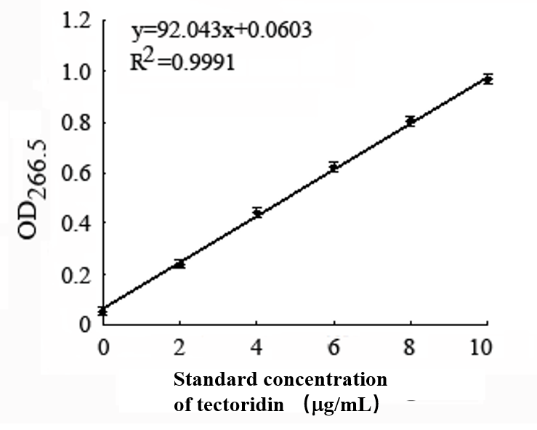
FIGURE2 Standard curve of tectoridin

