WB-Fig.6-1：The full, uncropped gel and blot images has lost because of computer malfunction.
WB-Fig.6-2
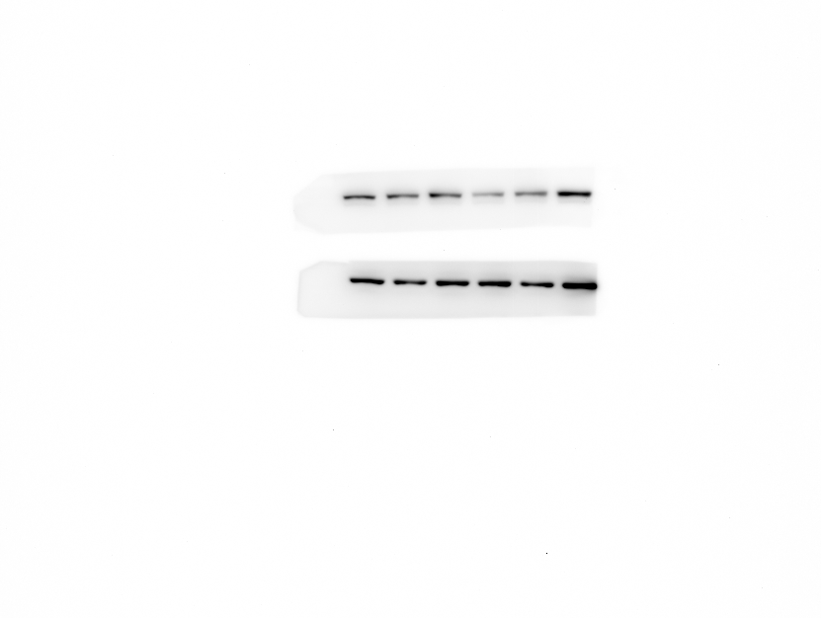

WB-Fig.7-1
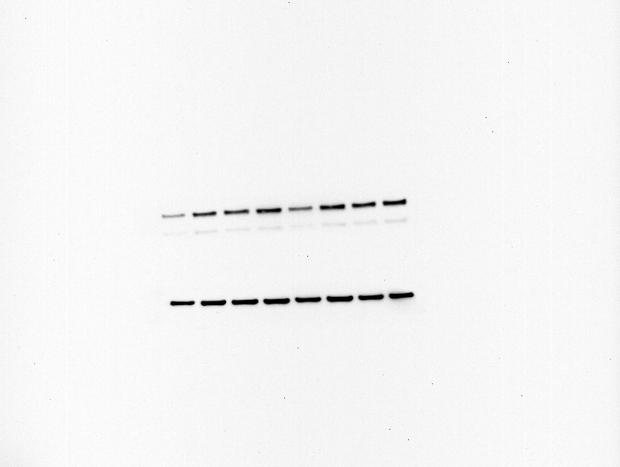
WB-Fig.7-2
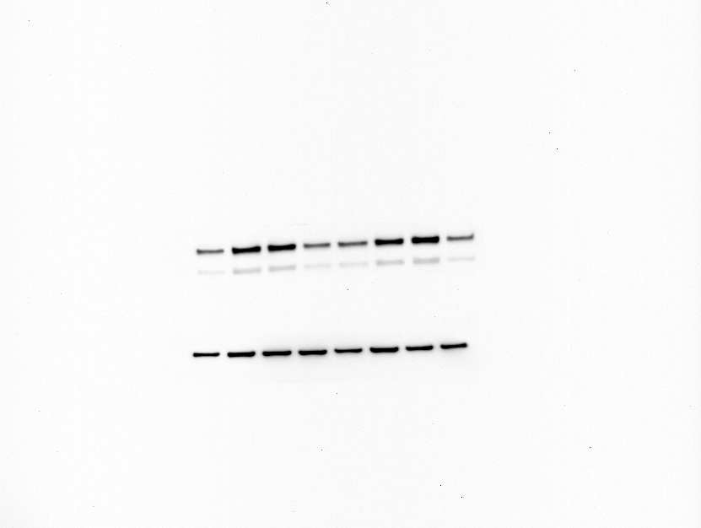

WB-Fig.8
