Additional file 2:
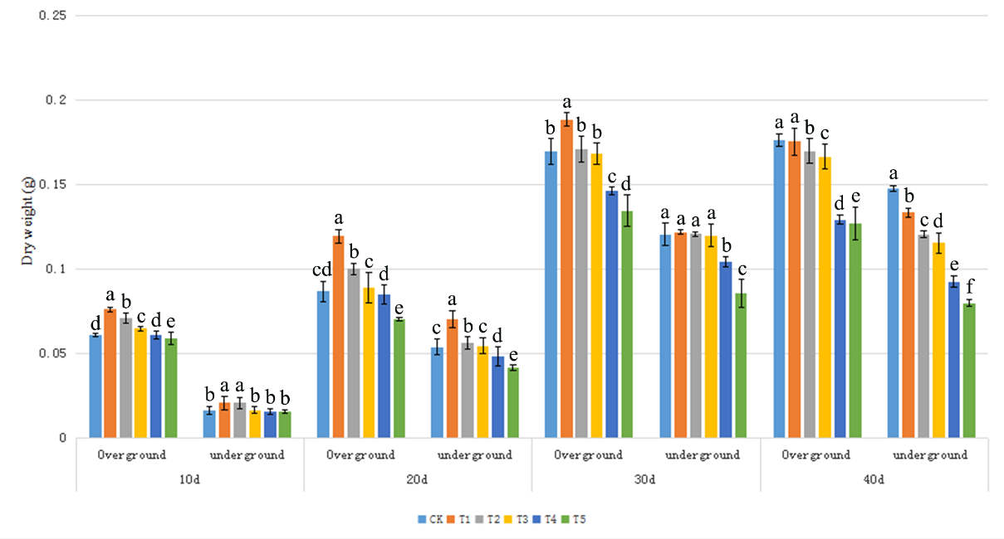
Figure S2 Changes of Verbena bonariensis biomass under Cd different concentration stress.

