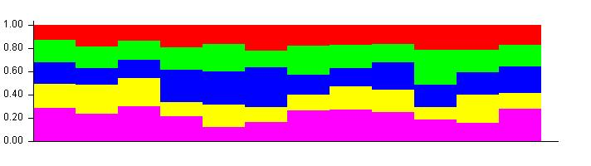
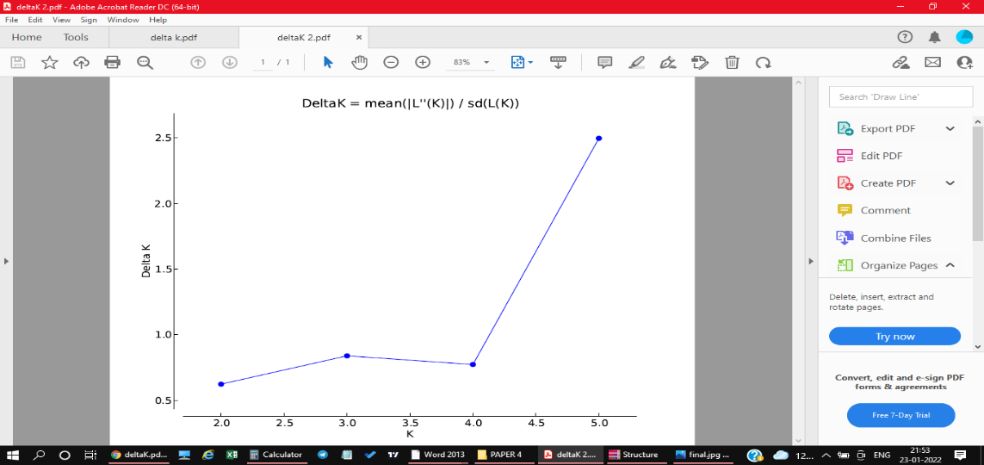

Fig S1. Structure analysis of 12 okra genotypes.

