Supplementary Figures To

Morphological physiological and transcriptional response to low nitrogen stress in Populus deltoides Marsh. clones with contrasting nitrogen use efficiency

Cun Chen ^{1, 2 ✝}, Yanguang Chu ^{1, 2 ✝}, Qinjun Huang ^{1, 2}, Weixi Zhang ^{1, 2}, Changjun Ding ^{1, 2}, Jing Zhang ^{1, 2}, Bo Li ^{1, 2}, Tengqian Zhang ^{1, 2}, Zhenghong Li ^{1, 2}, Xiaohua Su ^{1, 2, 3,*}

¹ State Key Laboratory of Tree Genetics and Breeding, Research Institute of Forestry, Chinese Academy of Forestry.
² Key Laboratory of Tree Breeding and Cultivation, State Forestry and Grassland Administration, Beijing, China.
³ Co-Innovation Center for Sustainable Forestry in Southern China, Nanjing Forestry University, Nanjing, Jiangsu Province, China.

✝ These authors contributed equally to this work.

* Correspondence: suxh@caf.ac.cn; Tel.: 86-10-6288-9627

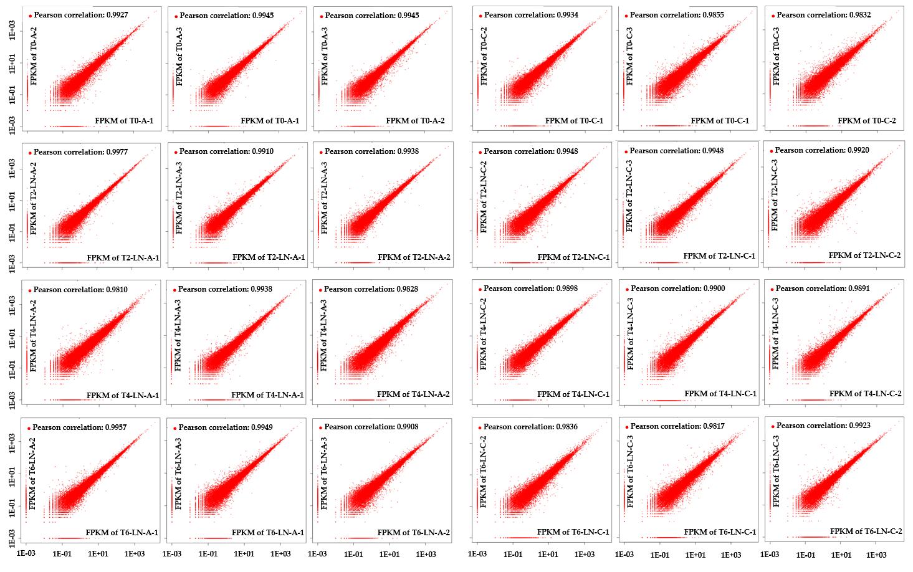
Figure S1. Transcriptome relationships among three biological replicates. A: N-efficient genotypes; C: N-inefficient genotypes. T0, T2, T4, and T6 represent 0, 5, 20, and 40 days of N treatment, respectively. LN: low N treatment.

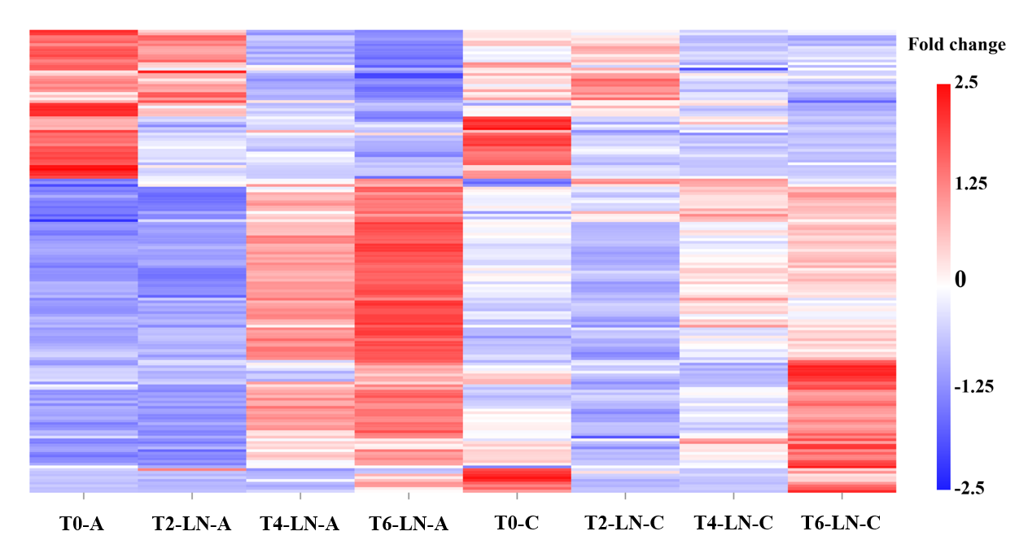
Figure S2. Expression pattern analysis of genes in the ‘magenta’ module. Red: upregulated; blue: downregulated. A: N-efficient genotypes; C: N-inefficient genotypes. T0, T2, T4, and T6 represent 0, 5, 20, and 40 days of N treatment, respectively. LN: low N treatment.
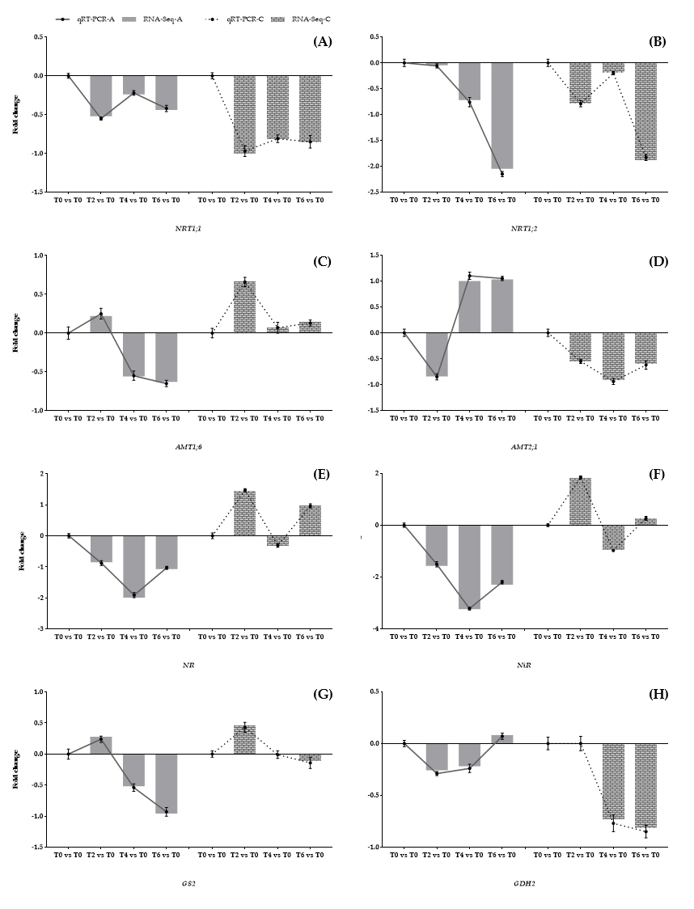
Figure S3. Expression of key genes in nitrogen metabolism in the leaves of genotypes A and C. (A), (B), (C), (D), (E), (F), (G) and (H) represent the expression trends of NRT1;1, NRT1;2, AMT1;6, AMT2;1, NR, NiR, GS2, and GDH2, respectively. The columns represent the results of RNA sequencing, and the lines show the analysis results of qRT-PCR. Vertical bars indicate SDs (n = 3) in qRT-PCR analysis. A: N-efficient genotypes; C: N-inefficient genotypes.

