Supplementary Methods
This document contains information on methods used to collect data on sleep measures and cognitive function from UK Biobank participants.
Sleep characteristics
Measures of sleep characteristics were obtained in three instances: baseline, first follow-up, imaging visit 1 (i.e., second follow-up).

Sleep measures are self-reported and include sleep duration, chronotype, difficulty getting up in the morning, napping, daytime dozing, snoring, and insomnia.

Sleep duration: was collected with the question “About how many hours of sleep do you get in every 24 hours? (Please, include naps)”.

Chronotype: Morning/evening person or chronotype was collected with the question “Do you consider yourself to be?”. The answers were reported in 4 factors: 1) more of a morning person, 2) more of a morning than evening person, 3) more of an evening person and 4) more of an evening than morning person.

Difficulty getting up in the morning: was determined with the question “On an average day, how easy do you find getting up in the morning?”. The answers were reported in three factors: 1) not at all easy, 2) not very easy, 3) fairly easy, and 4) very easy.

Nap: Frequency of nap during the day was collected with the question “Do you have a nap during the day?”. The answers were reported in three factors: 1) never/rarely, 2) sometimes and 3) usually.

Insomnia: was assessed with the question “Do you have trouble falling asleep at night or do you wake up in the middle of the night?”. The answers were reported in three factors: 1) never/rarely, 2) sometimes and 3) usually.

Snoring: was assessed with the question “Does your partner or a close relative or friend complain about your snoring?”. The answers were reported in two factors: 1) yes and 2) no.
Dozing: was assessed with the question “How likely are you to doze off or fall asleep during the daytime when you don’t mean to? (e.g. when working, reading or driving)”. The answers were reported in three factors: 1) never/rarely, 2) sometimes and 3) usually.
Cognitive function
Cognitive function including visual memory, reaction time, numeric memory, and fluid intelligence was assessed using touchscreen.
Visual memory
The visual memory was assessed with 2 rounds of Pairs card game as shown in Picture 1. The participants are shown 3 pairs of cards that are then turned face-down. The participants are asked to match as many cards as possible by simply touching the cards and turning them face-up. This is repeated with 6 pairs of cards. The number of correct matches represented the visual memory performance.
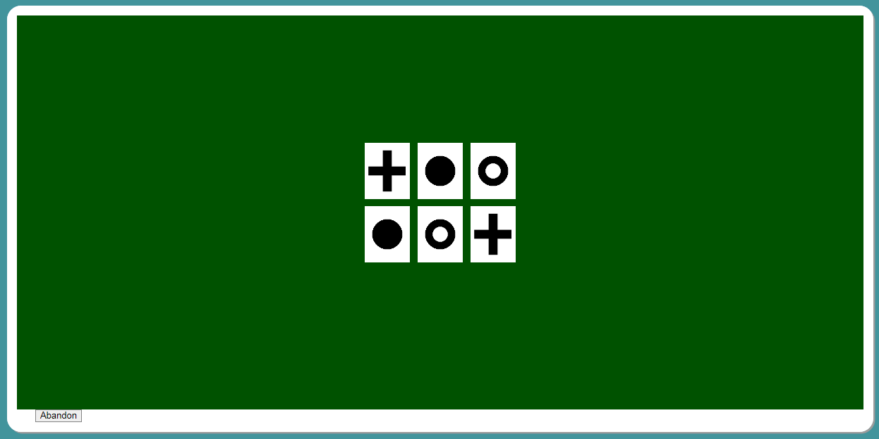
Picture 1. Visual memory assessment- Pairs card game. 3 pairs of cards are shown for a period and turned face-down. Participants are asked to correctly match the pairs.
Reaction time
The reaction time was assessed through 12 rounds of card-game called Snap as shown in Picture 2. Two cards are shown to the participant at a time. If both cards are the same, the participant is supposed to press the button as quickly as possible. The mean time to correctly identify the cards presented the reaction time.
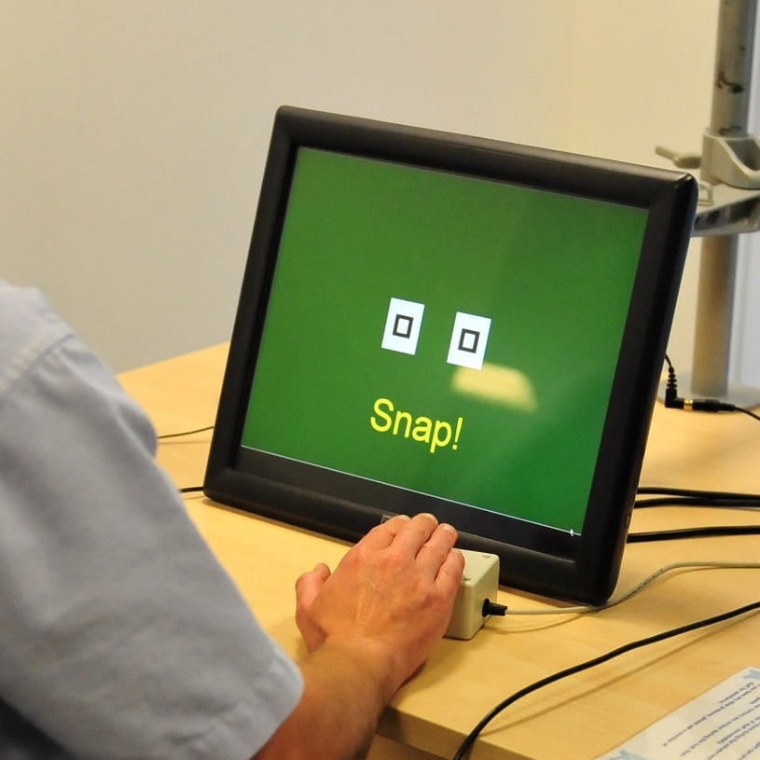
Picture 2. Reaction time assessment- Snap game. A participant playing a snap game used to assess reaction time.

Numeric memory
The numeric memory was assessed through memorization of 2-digit number which is displayed for 2000 ms as pictured in Picture 3. Then the numbers disappear for 3000 ms. The participant is asked to remember and enter the number. The test starts with 2-digit number and each time the participant entered correct number the digit increased by 1 (up to maximum 12 digits). If the number is 2-digit, after 5 incorrect attempts the test ends. If the number is 3-digit or higher the test ends after 2 successive incorrect answers. The maximum digits remembered correctly represented the numeric memory performance.
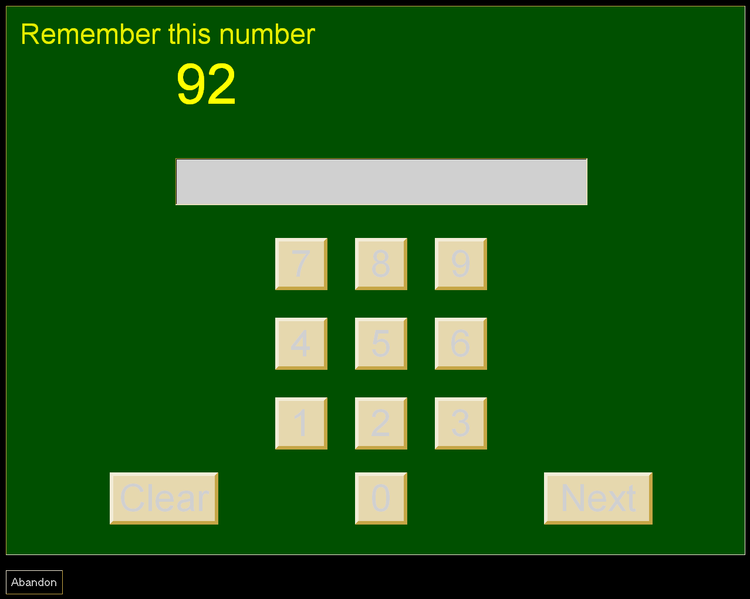
Picture 3. Numeric memory assessment- Number memorization. 2-digit number is displayed and disappears for a period which then is asked to be remembered and entered correctly.

Fluid intelligence
Fluid intelligence was assessed through 13 questions designed to assess the capacity to solve problems that require logic and reasoning ability, independent of acquired knowledge. If the participant agrees to answer the questions a timer is started, and questions are displayed until 2 minutes have reached. The unweighted sum of 13 questions represented the fluid intelligence performance.

Supplementary results
Sleep duration, sex, fat mass and other sleep variables
Associations among sleep and demographic measures are presented in Supplementary Table 3. For sleep, every 1-year increase in age above 55 was associated with 0.24 minutes (0.05%) shorter sleep duration at baseline and 0.18 minutes (0.04%) longer sleep duration at follow up. Males slept 5.22 minutes (1.2%) and 4.5 minutes (1.1%) less than females at baseline and follow up. Additionally, every additional year in age above 55 was associated with 1.26 minutes (0.3%) longer sleep in males compared to females. Those overweight or obese had 1.9 minutes (0.4%), 5.6 minutes (1.3%) less sleep at baseline than those with normal BMI. At the follow up, those with obesity had 0.66 minutes (0.16%) less sleep than those with normal BMI.

Association between sleep duration and other sleep variables (daytime dozing, chronotype, insomnia, napping, difficulty getting up in the morning and snoring) are presented in Supplementary Table 4. Reporting napping, snoring, or difficulty getting up in the morning was associated with longer sleep duration while insomnia, daytime dozing and being an evening person was associated with significantly shorter sleep duration.

Supplementary Tables
This document contains supplementary tables 1- 7 containing information on study population characteristics, sleep and other covariates’ interaction, association between sleep duration and other sleep characteristics and mediation analysis.
Supplementary table 1.

Supplementary table 1. Characteristics of selected and not selected participants
 | Overall | Selected | Not selected | p-value
n | 502506 | 29545 | 472961
Demographics
Age at baseline (years)  mean (SD) | 56.53 (8.10) | 54.65 (7.44) | 56.65 (8.12) | <0.001
Age at imaging (years)  Mean (SD) | 63.37 (7.55) | 62.98 (7.49) | 64.10 (7.62) | <0.001
Sex (%)  Male | 229122 (45.6) | 13765 (46.6) | 215357 (45.5) | <0.001
Education (%)  Higher | 161634 (39.5) | 13776 (49.1) | 147858 (38.8) | <0.001
BMI at baseline (kg/m²)  mean (SD) | 27.43 (4.80) | 26.53 (4.20) | 27.49 (4.83) | <0.001
BMI at imaging (kg/m²)  mean (SD) | 26.65 (4.51) | 26.50 (4.39) | 26.94 (4.72) | <0.001
Smoking (%)  Never | 273550 (54.7) | 17943 (60.8) | 255607 (54.4) | <0.001
Alcohol (%)  Never | 101773 (20.3) | 6661 (22.5) | 95112 (20.2) | <0.001
Diabetes (%)  Yes | 26425 (5.3) | 738 (2.5) | 25687 (5.5) | <0.001
Sleep measures
Sleep duration at baseline (hours/day)  mean (SD) | 7.10 (1.30) | 7.16 (0.99) | 7.09 (1.32) | <0.001
Sleep duration at imaging (hours/day)  mean (SD) | 7.13 (1.13) | 7.14 (1.08) | 7.11 (1.21) | 0.01
Snoring at baseline (%)  Yes | 173360 (37.2) | 10760 (36.4) | 162600 (37.3) | 0.002
Snoring at imaging (%)  Yes | 16385 (36.3) | 10821 (36.6) | 5564 (35.8) | 0.078
Insomnia at baseline (%)  Yes | 380226 (75.9) | 21331 (72.2) | 358895 (76.1) | <0.001
Insomnia ta imaging (%)  Yes | 37953 (78.1) | 22950 (77.7) | 15003 (78.7) | 0.007
Daytime dozing at baseline (%)  Yes | 120021 (24.1) | 5977 (20.2) | 114044 (24.3) | <0.001
Daytime dozing at follow (%)  Yes | 11537 (23.8) | 6781 (23.0) | 4756 (25.0) | <0.001
Brain measures
Grey matter volume (ml)  mean (SD) | 665.23 (59.55) | 665.08 (59.53) | 665.62 (59.62) | 0.428
White matter volume (ml)  mean (SD) | 477.99 (40.48) | 478.01 (40.47) | 477.96 (40.53) | 0.926
Intracranial volume (ml)  mean (SD) | 1548.36 (152.21) | 1547.24 (152.01) | 1551.50 (152.76) | 0.014
Left hippocampus volume (ml)  mean (SD) | 3.95  (0.41) | 3.96  (0.41) | 3.94  (0.41) | <0.001
Right hippocampus volume (ml)  mean (SD) | 4.12  (0.43) | 4.13  (0.43) | 4.12  (0.42) | 0.007
Cognitive measures
Visual memory imaging  mean (SD) | 3.61  (2.91) | 3.57  (2.85) | 3.71  (3.01) | <0.001
Reaction time imaging  mean (SD) | 592.79 (109.00) | 590.65 (107.78) | 596.87 (111.19) | <0.001
Numeric memory imaging  mean (SD) | 6.70  (1.48) | 6.72  (1.46) | 6.67  (1.52) | 0.01
Fluid intelligence imaging  mean (SD) | 6.65  (2.07) | 6.67  (2.05) | 6.60  (2.10) | 0.002

Supplementary table 2.

Supplementary table 2. Demographics and health characteristics of participants (n=29545)
 | Total | Female | Male | p-value
n | 29545 | 15780 | 13765
Demographics
Age at baseline (years)  mean (SD) | 54.65 (7.44) | 53.98 (7.28) | 55.42 (7.55) | <0.001
Age at imaging (years)  Mean (SD) | 63.0 (7.48) | 62.3 (7.32) | 63.8 (7.59) | <0.001
Time until imaging visit (years)  Mean (SD) | 8.34 (1.63) | 8.35 (1.63) | 8.34 (1.64) | 0.73
Education (%)  Higher | 6205 (21.0) | 3830 (24.3) | 2375 (17.3) | <0.001
BMI at baseline (kg/m²)  mean (SD) | 26.50 (4.08) | 25.97 (4.37) | 27.11 (3.62) | <0.001
BMI at imaging (kg/m²)  mean (SD) | 26.43 (4.25) | 25.97 (4.54) | 26.96 (3.82) | <0.001
Smoking (%)  Never | 9793 (33.1) | 4846 (30.7) | 4947 (35.9) | <0.001
Alcohol (%)  Never | 6661 (22.5) | 2883 (18.3) | 3778 (27.4) | <0.001
Total MET minutes of physical activity (mins/week)  mean (SD) | 3.22 (0.44) | 3.22 (0.43) | 3.23 (0.45) | 0.029
Hypertension  Yes (%) | 973 (3.3) | 972 (6.2) | 1 (0.0) | <0.001
Diabetes  Yes (%) | 738 (2.5) | 267 (1.7) | 471 (3.4) | <0.001
Sleep measures
Sleep duration at baseline (hours/day)  mean (SD) | 7.20 (0.93) | 7.24 (0.95) | 7.15 (0.91) | <0.001
Sleep duration at imaging (hours/day)  mean (SD) | 7.16 (1.02) | 7.12 (1.03) | 7.20 (1.00) | <0.001
Snoring at baseline (%)  Yes | 10760 (36.4) | 4194 (26.6) | 6566 (47.7) | <0.001
Snoring at imaging (%)  Yes | 10821 (36.6) | 4581 (29.0) | 6240 (45.3) | <0.001
Insomnia at baseline (%)  Yes | 21331 (72.2) | 12226 (77.5) | 9105 (66.1) | <0.001
Insomnia at imaging (%)  Yes | 22950 (77.7) | 13187 (83.6) | 9763 (70.9) | <0.001
Daytime dozing at baseline (%)  Yes | 5977 (20.2) | 2912 (18.5) | 3065 (22.3) | <0.001
Daytime dozing at imaging (%)  Yes | 6781 (23.0) | 3178 (20.1) | 3603 (26.2) | NaN
Brain measures
Grey matter volume (ml)  mean (SD) | 665.07 (59.35) | 634.65 (46.68) | 699.94 (52.78) | <0.001
White matter volume (ml)  mean (SD) | 478.12 (57.20) | 450.91 (46.03) | 509.30 (52.65) | <0.001
Intracranial volume (ml)  mean (SD) | 1547.62 (151.21) | 1466.30 (116.64) | 1640.84 (131.19) | <0.001
Left hippocampus volume (ml)  mean (SD) | 3.96 (0.41) | 3.84 (0.36) | 4.10 (0.41) | <0.001
Right hippocampus volume (ml)  mean (SD) | 4.13 (0.43) | 4.01 (0.38) | 4.27 (0.44) | <0.001
Cognitive measures
Visual memory round 1 at imaging  mean (SD) | 0.62 (2.37) | 0.65 (2.37) | 0.59 (2.38) | 0.053
Visual memory round 2 at imaging mean (SD) | 3.56 (2.83) | 3.50 (2.72) | 3.63 (2.94) | 0.001
Reaction time at imaging  mean (SD) | 589.37 (101.92) | 596.67 (101.21) | 581.13 (102.10) | <0.001
Numeric memory  mean (SD) | 6.85 (1.27) | 6.76 (1.25) | 6.94 (1.29) | <0.001
Fluid intelligence score  mean (SD) | 6.68 (2.05) | 6.55 (2.01) | 6.82 (2.10) | <0.001

Supplementary table 3.

Supplementary table 3. Age, sex BMI, and sleep duration association
 | Dependent variable:
 | Sleep duration at baseline (hours/day) | Sleep duration at imaging (hours/day)
Age at baseline  (Years, Estimate, SE) | -0.004***  (0.001)
Age at imaging  (Years, Estimate, SE) |  | 0.003***  (0.001)
Sex (male)  (Estimate, SE) | -0.087***  (0.011) | -0.075***  (0.017)
Age at baseline: Sex  (Estimate, SE) | 0.021***  (0.001)
Age at imaging: Sex  (Estimate, SE) |  | 0.018***  (0.002)
Adjusted R² | 0.011 | 0.013
BMI- Underweight at baseline  (kg/m², Estimate, SE) | -0.267  (0.139)
BMI- Overweight at baseline  (kg/m², Estimate, SE) | -0.031**  (0.012)
BMI- Obese at baseline  (kg/m², Estimate, SE) | -0.091***  (0.016)
BMI- Underweight at baseline: Sex  (kg/m², Estimate, SE) | 0.072  (0.439)
BMI- Overweight at baseline: Sex  (kg/m², Estimate, SE) | -0.020  (0.025)
BMI- Obese at baseline: Sex  (kg/m², Estimate, SE) | -0.034  (0.032)
BMI- Underweight at imaging  (kg/m², Estimate, SE) |  | 0.064  (0.097)
BMI- Overweight at imaging  (kg/m², Estimate, SE) |  | 0.019  (0.018)
BMI- Obese at imaging  (kg/m², Estimate, SE) |  | 0.011**  (0.001)
BMI- Underweight at imaging: Sex  (Estimate, SE) |  | -0.047  (0.297)
BMI- Overweight at imaging: Sex  (Estimate, SE) |  | -0.058**  (0.027)
BMI- Obese at imaging: Sex  (Estimate, SE) |  | -0.093***  (0.034)
Adjusted R² | 0.005 | 0.009
SE, standard error; BMI, Body mass index
**p<0.05; ***p<0.01

Supplementary table 4.

Supplementary table 4. Sleep duration, nap, getting up in the morning, daytime dozing, snoring, insomnia and chronotype association
 | Dependent variable:
 | Sleep duration at baseline | Sleep duration at imaging
Nap (Estimate, SE)
Nap sometimes at baseline | 0.167**  (0.012)
Nap usually at baseline | 0.592***  (0.030)
Nap sometimes at imaging |  | 0.105***  (0.019)
Nap usually at imaging |  | 0.586***  (0.047)
R2 adjusted | 0.023 | 0.021
Difficulty getting up in the morning (Estimate, SE)
Getting up- Fairly easy at baseline | 0.058***  (0.018)
Getting up - Not very easy at baseline | 0.066***  (0.023)
Getting up - Not at all easy at baseline | 0.109***  (0.037)
Getting up- Fairly easy at imaging |  | 0.121***  (0.018)
Getting up- Not very easy at imaging |  | 0.128***  (0.027)
Getting up- Not at all easy at imaging |  | 0.141***  (0.045)
R2 adjusted | 0.006 | 0.011
Daytime dozing (Yes/No; Estimate, SE)
Daytime dozing at baseline | -0.119***  (0.014)
Daytime dozing at imaging |  | -0.185***  (0.022)
Adjusted R2 | 0.008 | 0.012
Snoring (Yes/No; Estimate, SE)
Snoring at baseline | 0.057***  (0.021)
Snoring at imaging |  | 0.082***  (0.021)
Adjusted R2 | 0.006 | 0.010
Insomnia (Yes/No; Estimate, SE)
Insomnia at baseline | -0.232***  (0.027)
Insomnia at imaging |  | -0.363***  (0.031)
Adjusted R2 | 0.022 | 0.031
Chronotype (Estimate, SE)
Chronotype- Evening at baseline | 0.111***  (0.020)
Chronotype- More morning at baseline | 0.083***  (0.020)
Chronotype- More evening at baseline | 0.015  (0.021)
Chronotype- Evening at imaging |  | 0.083***  (0.022)
Chronotype- More morning at imaging |  | 0.031  (0.021)
Chronotype- More evening at imaging |  | -0.102***  (0.022)
Adjusted R2 | 0.007 | 0.014
SE, standard error
**p<0.05; ***p<0.01

Supplementary table 5.

Supplementary table 5. Interaction between sleep duration, age, sex and brain volumes
 | Dependent variable:
 | GM (ml) | WM (ml) | LHV (ml) | RHC (ml)
Sleep duration at baseline: age at baseline  (hours/day, years, 95% CI) | 0.02  (-0.03, 0.07) | -0.03  (-0.078, 0.018) | 0.0002  (-0.078, 0.018) | -0.000  (-0.001, 0.001)
Sleep duration at follow-up: age at follow up  (hours/day, years, 95% CI) | -0.08 **  (-0.13, -0.04) | -0.07 **  (-0.113, -0.026) | 0.001**  (-0.001, -0.0001) | -0.001***  (-0.001, -0.0004)
Sleep duration at baseline: sex | -0.68  (-1.40, 0.03) | -0.015  (-0.734, 0.704) | -0.01**  (-0.02, -0.001) | -0.01**  (-0.02, -0.001)
(hours/day, male, 95% CI)

Sleep duration at follow-up: sex  (hours/day, male, 95% CI) | -0.61  (-1.12, 0.05) | -0.26  (-0.917, 0.395) | -0.01**  (-0.002, -0.001) | -0.01  (-0.01, 0.002)
CI, confidence interval set at 95%
**p<0.05; ***p<0.01

Supplementary table 6.
Supplementary table 6. Association between sleep duration and brain volumes
 | Dependent variable:
 | Total grey matter volume
 | Model 1 | Model2 | Model 1 | Model 2
Sleep duration at baseline  (Hours/day, Estimate, SE) | -0.73*** | -0.77***
 | (0.18) | (0.18)
Sleep duration at follow-up  (Hours/day, Estimate, SE) |  |  | -0.27 | -0.31
 |  |  | (0.17) | (0.17)
Observations | 29,545 | 29,545 | 29,545 | 29,545
R² | 0.76 | 0.76 | 0.76 | 0.76
Adjusted R² | 0.76 | 0.76 | 0.76 | 0.76
 | Dependent variable:
 | Total white matter volume
 | Model 1 | Model 2 | Model 1 | Model 2
Sleep duration at baseline  (Hours/day, Estimate, SE) | -0.52*** |  | -0.57***
 | (0.18) |  | (0.18)
Sleep duration at follow-up  (Hours/day, Estimate, SE) |  | -0.48*** |  | -0.51***
 |  | (0.17) |  | (0.17)
 |  |  | (0.0001) | (0.0001)
Observations | 29,545 | 29,545 | 29,545 | 29,545
R² | 0.74 | 0.74 | 0.74 | 0.74
Adjusted R² | 0.74 | 0.74 | 0.74 | 0.74
 | Dependent variable:
 | Left hippocampus volume
 | Model 1 | Model 2 | Model 1 | Model 2
Sleep duration at baseline  (Hours/day, Estimate, SE) | -0.01*** |  | -0.01***
 | (0.002) |  | (0.002)
Sleep duration at follow-up  (Hours/day, Estimate, SE) |  | -0.01***  (0.002) |  | -0.01***  (0.002)
Observations | 29,545 | 29,545 | 29,545 | 29,545
R² | 0.36 | 0.37 | 0.37 | 0.37
Adjusted R² | 0.36 | 0.37 | 0.37 | 0.37
 | Dependent variable:
 | Right hippocampus volume
 | Model 1 | Model 2 | Model 1 | Model 2
Sleep duration at baseline  (Hours/day, Estimate, SE) | -0.01*** |  | -0.01***
 | (0.002) |  | (0.002)
Sleep duration at follow-up  (Hours/day, Estimate, SE) |  | -0.01*** |  | -0.01***
 |  | (0.002) |  | (0.002)
Observations | 29,545 | 29,545 | 29,545 | 29,545
R² | 0.35 | 0.36 | 0.35 | 0.36
Adjusted R² | 0.35 | 0.36 | 0.35 | 0.36
 | Dependent variable:
 | Total grey matter volume
 | Model 1 | Model 2 | Model 1 | Model 2
Categorical sleep duration at baseline- Short  (Hours/day, Estimate, SE) | -2.51** (1.01) |  | -1.76 (1.01)
Categorical Sleep duration at baseline- Long  (Hours/day, Estimate, SE) | -5.67*** (1.44) |  | -4.13*** (1.43)
Categorical sleep duration at follow-up- Short  (Hours/day, Estimate, SE) |  | -4.58*** (0.81) |  | -3.74***  (0.81)
Categorical sleep duration at follow-up-Long  (Hours/day, Estimate, SE) |  | -6.45*** (1.45) |  | -4.98***  (1.45)
Observations | 22,791 | 22,401 | 22,791 | 22,401
R² | 0.76 | 0.76 | 0.76 | 0.77
Adjusted R² | 0.76 | 0.76 | 0.76 | 0.77
 | Dependent variable:
 | Total white matter volume
 | Model 1 | Model 2 | Model 1 | Model 2
Categorical sleep duration at baseline- Short  (Hours/day, Estimate, SE) | 0.41 (1.01) |  | 1.29 (1.01)
Categorical Sleep duration at baseline- Long  (Hours/day, Estimate, SE) | -2.84** (1.44) |  | -1.22 (1.44)
Categorical sleep duration at follow-up- Short  (Hours/day, Estimate, SE) |  | -0.81 (0.82) |  | 0.22 (0.82)
Categorical sleep duration at follow-up-Long  (Hours/day, Estimate, SE) |  | -4.18*** (1.46) |  | -2.53 (1.45)
Observations | 22,791 | 22,401 | 22,791 | 22,401
R² | 0.74 | 0.74 | 0.74 | 0.74
Adjusted R² | 0.74 | 0.74 | 0.74 | 0.74
 | Dependent variable:
 | Volume of left hippocampus
 | Model 1 | Model 2 | Model 1 | Model 2
Categorical sleep duration at baseline- Short  (Hours/day, Estimate, SE) | 0.01 (0.01) |  | 0.01 (0.01)
Categorical Sleep duration at baseline- Long  (Hours/day, Estimate, SE) | -0.02 (0.02) |  | -0.02 (0.02)
Categorical sleep duration at follow-up- Short  (Hours/day, Estimate, SE) |  | -0.01 (0.01) |  | -0.01 (0.01)
Categorical sleep duration at follow-up-Long  (Hours/day, Estimate, SE) |  | -0.05***  (0.02) |  | -0.05***  (0.02)
Observations | 22,791 | 22,401 | 22,791 | 22,401
R² | 0.36 | 0.37 | 0.37 | 0.37
Adjusted R² | 0.36 | 0.37 | 0.37 | 0.37
 | Dependent variable:
 | Right hippocampus volume
 | Model 1 | Model 2 | Model 1 | Model 2
Categorical sleep duration at baseline- Short  (Hours/day, Estimate, SE) | -0.01 |  | -0.01
 | (0.01) |  | (0.01)
Categorical sleep duration at baseline- Long  (Hours/day, Estimate, SE) | -0.02 |  | -0.02
 | (0.02) |  | (0.02)
Categorical sleep duration at follow-up- Short  (Hours/day, Estimate, SE) |  | -0.02 |  | -0.02
 |  | (0.01) |  | (0.01)
Categorical sleep duration at follow-up- Long  (Hours/day, Estimate, SE) |  | -0.06*** |  | -0.06***
 |  | (0.02) |  | (0.02)
Observations | 22,791 | 22,401 | 22,791 | 22,401
R² | 0.35 | 0.36 | 0.35 | 0.36
Adjusted R² | 0.35 | 0.36 | 0.35 | 0.36
 | Dependent variable:
 | Total grey matter volume
 | Model 1 | Model 2 | Model 1 | Model 2
(Sleep duration at baseline)² | -0.78*** |  | -0.57***
 | (0.13) |  | (0.13)
(Sleep duration at follow-up)² |  | -0.90*** |  | -0.73***
 |  | (0.10) |  | (0.10)
Observations | 29,545 | 29,545 | 29,545 | 29,545
R² | 0.76 | 0.76 | 0.76 | 0.77
Adjusted R² | 0.76 | 0.76 | 0.76 | 0.76
 | Dependent variable:
 | Total white matter volume
 | Model 1 | Model 2 | Model 1 | Model 2
(Sleep duration at baseline)² | -0.25 (0.13) |  | -0.04 (0.13)
(Sleep duration at follow-up)² |  | -0.28*** (0.10) |  | -0.09 (0.10)
Observations | 29,545 | 29,545 | 29,545 | 29,545
R² | 0.74 | 0.74 | 0.74 | 0.74
Adjusted R² | 0.74 | 0.74 | 0.74 | 0.74
 | Dependent variable:
 | Left hippocampus volume
 | Model 1 | Model 2 | Model 1 | Model 2
(Sleep duration at baseline)² | -0.002  (0.001) |  | -0.002  (0.001)
(Sleep duration at follow-up)² |  | -0.005***  (0.001) |  | -0.004***  (0.001)
Observations | 29,545 | 29,545 | 29,545 | 29,545
R² | 0.36 | 0.37 | 0.37 | 0.37
Adjusted R² | 0.36 | 0.37 | 0.37 | 0.37
 | Dependent variable:
 | Right hippocampus volume
 | Model 1 | Model 2 | Model 1 | Model 2
(Sleep duration at baseline)² | -0.005***  (0.002) | -0.005***  (0.002)
(Sleep duration at follow-up)² |  |  | -0.01*** (0.001) | -0.005***  (0.001)
Observations | 29,545 | 29,545 | 29,545 | 29,545
R² | 0.35 | 0.36 | 0.35 | 0.36
Adjusted R² | 0.35 | 0.36 | 0.35 | 0.36
SE, standard error
P<0.05 not controlled for multiple comparison
**p<0.05; ***p<0.01

Supplementary table 7.

Supplementary table 7. Association between sleep duration and cognitive function follow-up
 |  | Dependent variable:
 |  | Visual memory at follow-up
 |  | Model 1 |  | Model 2
Sleep duration at follow-up  (hours/day, Estimate, SE) |  | 0.02 |  | 0.02
 |  | (0.02) |  | (0.02)
Observations |  | 14,206 |  | 14,206
R² |  | 0.03 |  | 0.03
Adjusted R² |  | 0.03 |  | 0.03
 |  | Dependent variable:
 |  | Reaction time at follow-up
 |  | Model 1 |  |  | Model 2
Sleep duration at follow-up  (hours/day, Estimate, SE) |  | 0.26 (0.81) |  |  | 0.36 (0.81)
Observations |  | 14,206 |  |  | 14,206
R² |  | 0.11 |  |  | 0.12
Adjusted R² |  | 0.11 |  |  | 0.12
 |  | Dependent variable:
 |  | Numeric memory at follow-up
 |  | Model 1 |  |  |  | Model 2
Sleep duration at follow-up  (hours/day, Estimate, SE) |  | -0.02** |  |  |  | -0.02**
 |  | (0.01) |  |  |  | (0.01)
Observations |  | 14,206 |  |  |  | 14,206
R² |  | 0.04 |  |  |  | 0.05
Adjusted R² |  | 0.04 |  |  |  | 0.05
 |  | Dependent variable:
 |  | Fluid intelligence at follow-up
 |  | Model 1 |  |  |  |  | Model 2
Sleep duration at follow-up  (hours/day, Estimate, SE) |  | 0.01 |  |  |  |  | -0.003
 |  | (0.02) |  |  |  |  | (0.02)
Observations |  | 14,206 |  |  |  |  | 14,206
R² |  | 0.10 |  |  |  |  | 0.12
Adjusted R² |  | 0.10 |  |  |  |  | 0.12
 |  | Dependent variable:
 |  | Visual memory at follow-up
 |  | Model 1 | Model 2
Categorical sleep duration at follow-up-Short  (hours/day, Estimate, SE) |  | 0.14 | 0.15
 |  | (0.08) | (0.08)
Categorical sleep duration at follow-up- Long  (hours/day, Estimate, SE) |  | 0.41*** | 0.42***
Observations |  | 10,869 | 10,869
R² |  | 0.03 | 0.03
Adjusted R² |  | 0.03 | 0.03
 |  | Dependent variable:
 |  | Reaction time at follow-up
 |  | Model 1 | Model 2
Categorical sleep duration at follow-up-Short  (hours/day, Estimate, SE) |  | 4.67 | 2.92
 |  | (3.88) | (3.90)
Categorical sleep duration at follow-up- Long  (hours/day, Estimate, SE) |  | 21.80*** | 20.06***
 |  | (7.31) | (7.32)
Observations |  | 10,869 | 10,869
R² |  | 0.12 | 0.12
Adjusted R² |  | 0.12 | 0.12
 |  | Dependent variable:
 |  | Numeric memory at follow-up
 |  | Model 1 | Model 2
Categorical sleep duration at follow-up- Short  (hours/day, Estimate, SE) |  | 0.02 | 0.05
 |  | (0.05) | (0.05)
Categorical sleep duration at follow-up- Long  (hours/day, Estimate, SE) |  | -0.39*** | -0.38***
 |  | (0.09) | (0.09)
Observations |  | 10,869 | 10,869
R² |  | 0.04 | 0.05
Adjusted R² |  | 0.04 | 0.05
 |  | Dependent variable:
 |  | Fluid intelligence at follow-up
 |  | Model 1 | Model 2
Categorical sleep duration at follow-up- Short  (hours/day, Estimate, SE) |  | -0.51*** | -0.44***
 |  | (0.08) | (0.08)
Categorical sleep duration at follow-up- Long  (hours/day, Estimate, SE) |  | -0.46*** | -0.44***
 |  | (0.15) | (0.15)
Observations |  | 10,869 | 10,869
R² |  | 0.11 | 0.12
Adjusted R² |  | 0.11 | 0.12
 |  | Dependent variable:
 |  | Visual memory at follow-up
 |  | Model 1 | Model 2
(Sleep duration at follow-up)² |  | 0.05*** (0.01) | 0.05*** (0.01)
Observations |  | 14,206 | 14,206
R² |  | 0.03 | 0.03
Adjusted R² |  | 0.03 | 0.03
 | Dependent variable:
 | Reaction time at follow-up
 | Model 1 |  | Model 2
(Sleep duration at follow-up)² | 1.14** |  | 0.89
 | (0.50) |  | (0.50)
Observations | 14,206 |  | 14,206
R² | 0.12 |  | 0.12
Adjusted R² | 0.11 |  | 0.12
 |  | Dependent variable:
 |  | Numeric memory at follow-up
 |  | Model 1 | Model 2
(Sleep duration at follow-up)² |  | -0.02*** | -0.01**
 |  | (0.01) | (0.01)
Observations |  | 14,206 | 14,206
R² |  | 0.04 | 0.05
Adjusted R² |  | 0.04 | 0.05
 |  | Dependent variable:
 |  | Fluid intelligence at follow-up
 |  | Model 1 | Model 2
(Sleep duration at follow-up)² |  | -0.08*** | -0.07***
 |  | (0.01) | (0.01)
Observations |  | 14,206 | 14,206
R² |  | 0.11 | 0.12
Adjusted R² |  | 0.11 | 0.12
SE, standard error
P<0.05 not controlled for multiple comparison
**p<0.05; ***p<0.01

Supplementary table 8.

Supplementary table 8. Mediation results of sleep duration on cognitive function through white matter volume.
 | Dependent variable
 | Step 1 | Step 2 | Step 3 | Step 4
Mediation analysis of sleep duration and visual memory
 | Visual memory  (correct matches) | White matter volume (ml) | Visual memory  (correct matches) | Indirect effect of sleep duration on visual memory via white matter
Sleep duration at imaging (hours/day,  Estimate, SD) | 0.020  (0.016) | -0.394  (0.241) | 0.020  (0.016) | 0.000
White matter volume (ml,  Estimate, SD) |  |  | -0.001**  (0.001)
Mediation analysis of sleep duration and reaction time
 | Reaction time (ms) | White matter volume (ml) | Reaction time  (ms) | Indirect effect of sleep duration on reaction time via white matter
Sleep duration at imaging (hours/day,  Estimate, SD) | 0.358  (0.806) | -0.394  (0.241) | 0.268  (0.804) | 0.089
White matter volume (ml,  Estimate, SD) |  |  | -0.227***  (0.028)
Mediation analysis of sleep duration and numeric memory
 | Numeric memory (number of correct digits) | White matter volume (ml) | Numeric memory (number of correct digits) | Indirect effect of sleep duration on numeric memory via white matter
Sleep duration at imaging (hours/day,  Estimate, SD) | -0.025**  (0.010) | -0.394  (0.241) | -0.024**  (0.010) | -0.000
White matter volume (ml,  Estimate, SD) |  |  | 0.001**  (0.000)
Mediation analysis of sleep duration and fluid intelligence
 | Fluid intelligence (sum score of questions) | White matter volume (ml) | Fluid intelligence (sum score of questions) | Indirect effect of sleep duration on fluid intelligence via white matter
Sleep duration at imaging (hours/day,  Estimate, SD) | -0.003  (0.016) | -0.394  (0.241) | -0.002  (0.016) | -0.001
White matter volume (ml,  Estimate, SD) |  |  | 0.003***  (0.001)
SE, standard error
**p<0.05; ***p<0.01

Supplementary table 9.
Supplementary table 9.. Association between standardized brain volumes and sleep characteristics (n=29545).
 |  |  |  |  | Dependent variable
Independent variables |  |  |  |  | Standardized GM  (ml) | Standardized WM  (ml) | Standardized LHC  (ml) |  | Standardized RHC  (ml)
Sleep duration  (hours/day, CI) |  | Baseline |  |  | -0.012***  (-0.018,  -0.007) | -0.009**  (-0.015,  -0.004) | -0.022***  (-0.031,  -0.013) |  | -0.021***  (-0.030,  -0.012)
 |  | Imaging |  |  | -0.005  (-0.011,  -0.003) | -0.009***  (-0.015,  -0.003) | -0.02***  (-0.03,  -0.008) |  | -0.017**  (-0.026,  -0.008)
Adjusted R² | Baseline |  |  |  | 0.765 | 0.742 | 0.365 |  | 0.354
Adjusted R² | Imaging |  |  |  | 0.765 | 0.744 | 0.369 |  | 0.357
Categorical sleep duration |  | Baseline |  | Short | -0.030  (-0.063, 0.004) | 0.023  (-0.012,  0.057) | 0.029  (-0.026,  0.083) |  | -0.019  (-0.074,  0.036)
 |  |  |  | Long | -0.070**  (-0.117,  -0.022) | -0.021  (-0.071,  0.028) | -0.040  (-0.117,  0.038) |  | -0.056  (-0.134,  0.023)
 |  | Imaging | Short |  | -0.063***  (-0.090,  -0.036) | 0.004  (-0.024,  0.032) | -0.025  (-0.069,  0.019) |  | -0.036  (-0.080,  0.009)
 |  | Imaging | Long |  | -0.084***  (-0.132,  -0.036) | -0.044  (-0.094,  0.006) | -0.113**  (-0.019,  -0.034) |  | -0.144***  (-0.224,  -0.065)
Adjusted R² |  | Baseline |  |  | 0.764 | 0.741 | 0.365 |  | 0.354
 |  | Imaging |  |  | 0.765 | 0.743 | 0.369 |  | 0.359
Daytime dozing  (Yes/No, CI) |  | Baseline |  |  | -0.03***  (-0.04,  -0.02) | -0.017  (-0.03,  -0.002) | -0.02***  (-0.02,  -0.01) |  | -0.029  (-0.052,  -0.006)
 |  | Imaging |  |  | -0.028*** (-0.041,  -0.014) | -0.021**  (-0.035,  -0.007) | -0.031**  (-0.053,  -0.010) |  | -0.002  (-0.047,  -0.003)
Adjusted R² | Baseline |  |  |  | 0.765 | 0.320 | 0.365 |  | 0.354
Adjusted R² | Imaging |  |  |  | 0.765 | 0.321 | 0.369 |  | 0.357
Snoring  (Yes/No, CI) |  | Baseline |  |  | -0.003  (-0.015,  0.010) | 0.001  (-0.012,  0.013) | -0.001  (-0.021, 0.019) |  | 0.004  (-0.016, 0.025)
 |  | Imaging |  |  | 0.009  (-0.003,  0.020) | 0.004  (-0.009,  0.016) | 0.004  (0.009,  0.016) |  | 0.023  (0.003, 0.043)
Adjusted R² | Baseline |  |  |  | 0.764 | 0.742 | 0.365 |  | 0.365
Adjusted R² | Imaging |  |  |  | 0.765 | 0.744 | 0.369 |  | 0.369
Insomnia  (Yes/No, CI) |  | Baseline |  |  | 0.018** (0.005,  0.030) | 0.025*** (0.012,  0.038) | 0.021  (0.0001,  0.041) |  | 0.020  (-0.001,  0.041)
 |  | Imaging |  |  | 0.007  (-0.007,  0.20) | 0.015  (0.001,  0.029) | 0.024  (0.002,  0.046) |  | 0.031**  (0.009,  0.054)
Adjusted R² | Baseline |  |  |  | 0.765 | 0.743 | 0.365 |  | 0.353
Adjusted R² | Imaging |  |  |  | 0.765 | 0.744 | 0.369 | 0.357
CI, 95% confidence interval
P<0.05 considered significant after controlled for multiple comparisons
† Sleep duration is centred on 7 hours/day sleep
The estimates are controlled for the following covariates: age, sex, education, body mass index, smoking, alcohol, physical activity, hypertension, and diabetes
**p<0.05; ***p<0.01

Supplementary table 9.
Supplementary table 9. Association between standardized cognitive function and self-reported sleep duration (n=14206).
 |  | Dependent variable
Independent variables |  | Visual memory  (Number of incorrect matches) | Reaction time  (Correct answer time in ms) | Numeric memory  (Number of correct answers) | Fluid intelligence  (pooled score)
Sleep duration†  (hours/day, CI) |  | 0.010  (-0.006, 0.026) | 0.003  (-013, 0.018) | -0.018  (-0.034, -0.002) | 0.002  (-0.014, 0.018)
R² adjusted |  | 0.030 | 0.116 | 0.052 | 0.118
Categorical sleep duration | Short | 0.078  (0.001, 0.156) | 0.038  (-0.036, 0.113) | 0.030  (-0.047, 0.107) | -0.264***  (-0.341, -0.187)
Categorical sleep duration | Long | 0.221**  (0.076, 0.366) | 0.206**  (0.066, 0.346) | -0.309***  (-0.454,  -0.163) | -0.265***  (-0.410,  -0.121)
R² adjusted |  | 0.031 | 0.119 | 0.049 | 0.120
Daytime dozing  (Yes/No, CI) |  | 0.035  (-0.005, 0.074) | 0.076***  (0.038, 0.113) | -0.026  (-0.065, 0.013) | -0.033**  (-0.072, -0.006)
R² adjusted |  | 0.030 | 0.118 | 0.051 | 0.118
Snoring  (Yes/No, CI) |  | 0.020  (-0.014, 0.055) | 0.013  (-0.020, 0.047) | -0.024  (-0.059, 0.010) | -0.026  (-0.060, 0.008)
R² adjusted |  | 0.010 | 0.117 | 0.051 | 0.118
Insomnia  (Yes/No, CI) |  | -0.001  (-0.041, 0.038) | -0.002  (-0.040, 0.036) | 0.030  (-0.010, 0.069) | 0.007  (-0.032, 0.046)
R² adjusted |  | 0.030 | 0.116 | 0.051 | 0.118
CI, 95% confidence interval
P<0.05 considered significant after controlled for multiple comparisons
† Sleep duration is centred on 7 hours/day sleep

The estimates are controlled for the following covariates: age, sex, education, body mass index, smoking, alcohol, physical activity, hypertension, and diabetes
**p<0.05; ***p<0.01

