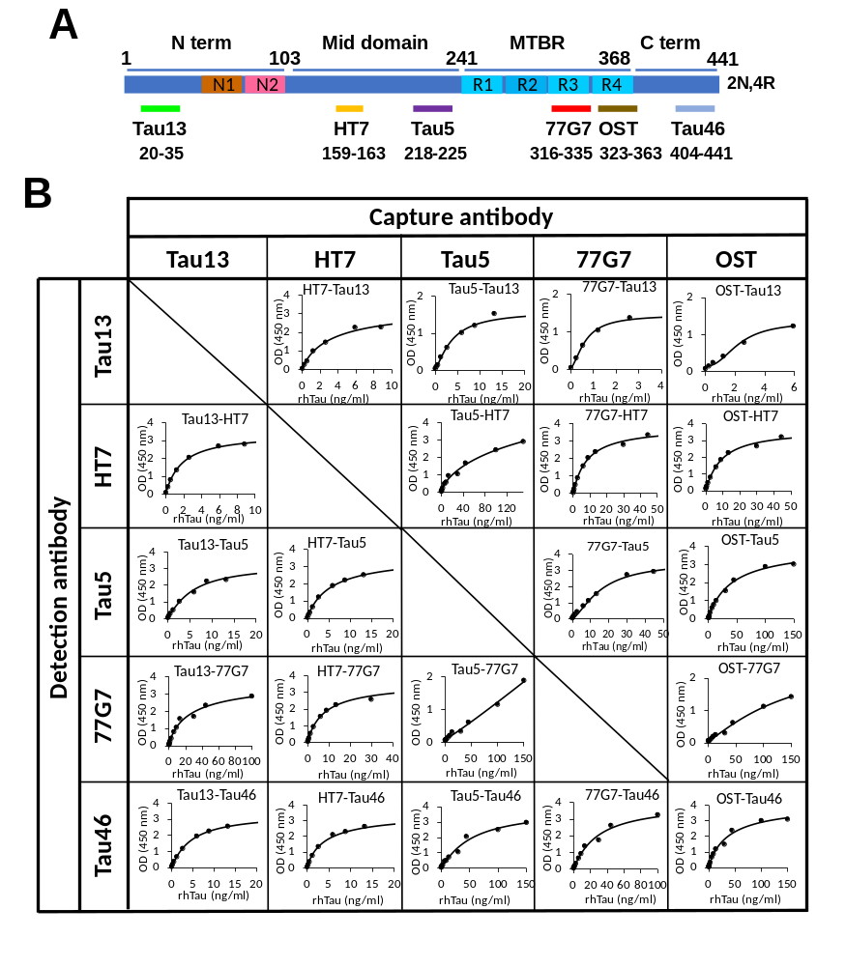
Supplementary Figure 1. Representative standard curve of the tau ELISAs used in the current study. (A) Schematic representations of the longest tau isoform (2N4R) protein showing binding sites of tau antibodies used for the ELISAs in this study. (B) Standard curve of each ELISA using recombinant human tau-441 protein.

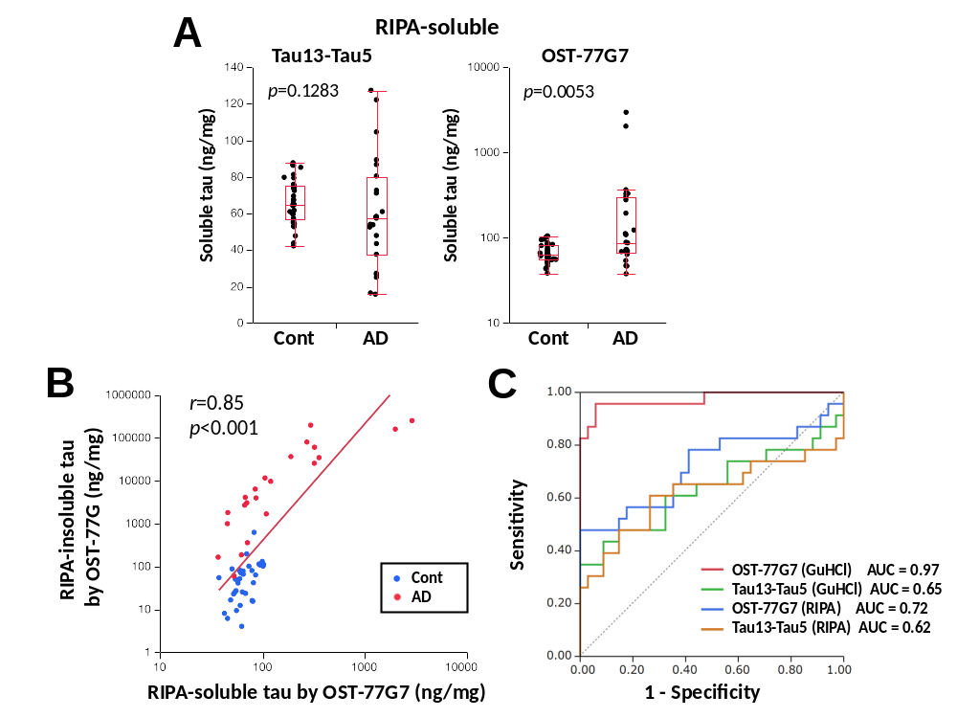
Supplementary Figure 2. Application of tau ELISAs for RIPA-soluble fraction. (A) Tau levels in RIPA-soluble fractions of the frontal cortex from non-AD controls and AD patients detected by Tau13-Tau5 ELISA (left) and OST-77G7 ELISA (right) are plotted with a box-and-whisker diagram. P-values were acquired by the Wilcoxon rank-sum test. (B) Tau levels in RIPA-soluble fraction measured by OST-77G7 ELISA are plotted against tau levels in RIPA-insoluble (GuHCl) fraction measured by OST-77G7 ELISA. Correlation coefficient (r) and P-value were acquired by the Pearson correlation test. Blue dots show individual non-AD controls, while red dots show individual AD patients. (C) ROC curve analysis of tau levels in RIPA-soluble (RIPA) and RIPA-insoluble (GuHCl) fraction measured by each tau ELISA for distinguishing AD patients and non-AD controls with AUC values.

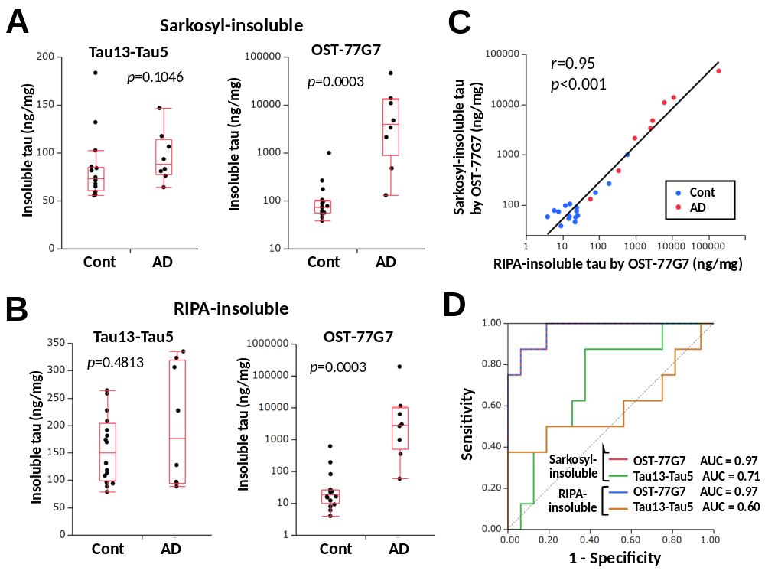Supplementary Figure 3. Similar profile of tau ELISAs irrespective of Sarkosyl- and RIPA- extraction methods. (A&B) Tau levels in Sarkosyl-insoluble fraction (A) or RIPA-insoluble fraction (B) from the frontal cortex of non-AD controls (n=16), and AD patients (n=8) detected by Tau13-Tau5 ELISA (left) and OST-77G7 ELISA (right) are plotted with a box-and-whisker diagram. P-values were acquired by the Wilcoxon rank-sum test. (C) Tau levels in Sarkosyl-insoluble fraction measured by OST-77G7 ELISA are plotted against tau levels in RIPA-insoluble fraction measured by OST-77G7 ELISA. Correlation coefficient (r) and P-value were acquired by the Pearson correlation test. Blue dots show individual non-AD controls, while red dots show individual AD patients. (D) ROC curve analysis of each extraction methods for each tau ELISA for distinguishing AD patients and non-AD cases with AUC values.

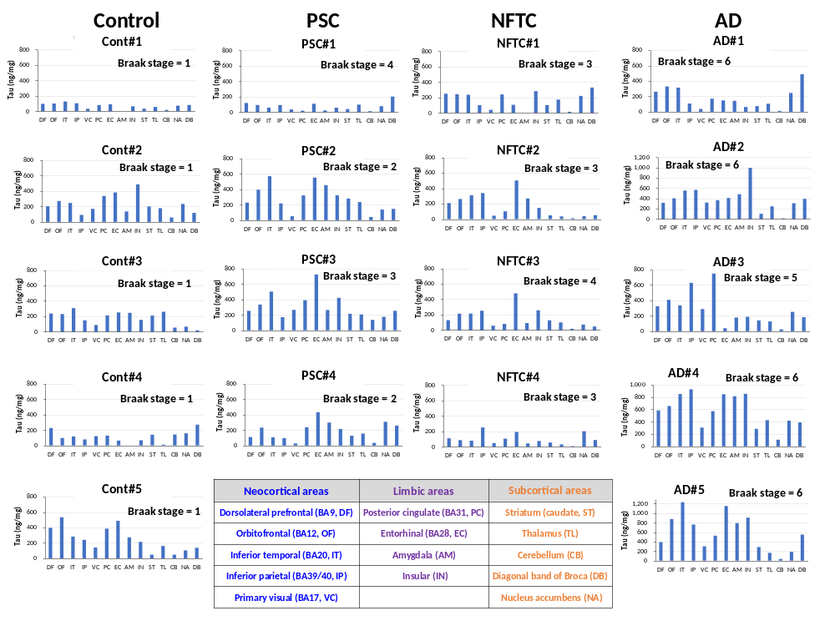Supplementary Figure 4. Amount of tau in the GuHCl fraction in 14 brain regions of individuals with/without PSC, NFTC, and AD, diagnosed by neuropathological assessment (Control = 5 subjects, PSC = 4 subjects, PART = 4 subjects, AD = 5 subjects), as measured by Tau13-Tau5 ELISA. PSC = plaque dominant senile change, PART = primary aging-related tauopathy. The inset table describes each brain region analyzed in the current study, stratified by neocortical areas, limbic areas, and subcortical areas. Blue notation indicates neocortical areas; purple notation indicates limbic areas; and orange notation indicates subcortical areas.

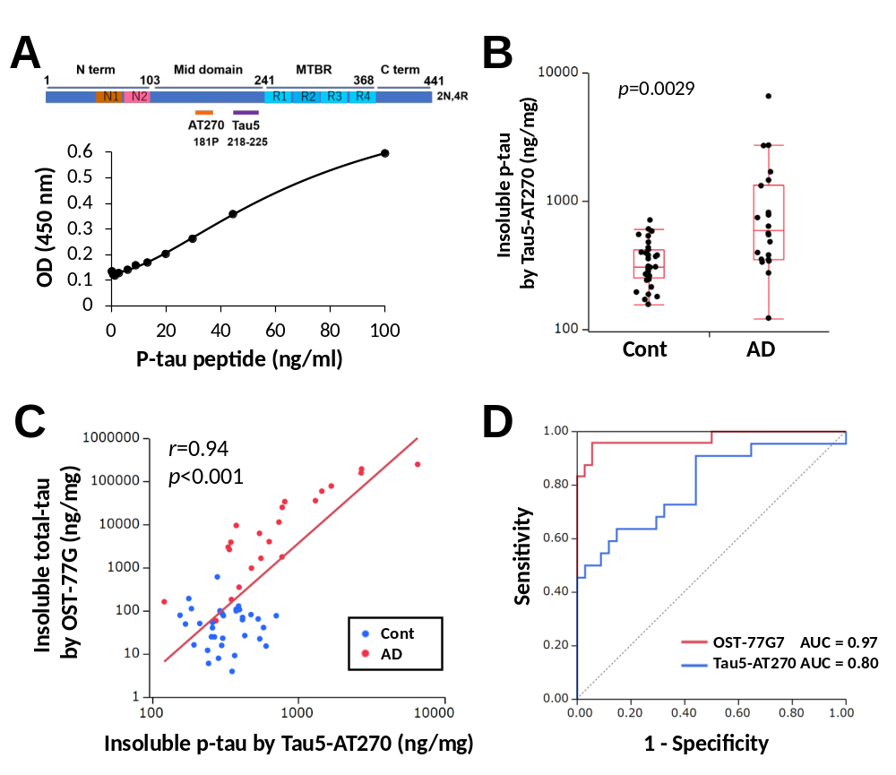
Supplementary Figure 5. Introduction of a phospho-tau ELISA. (A) Schematic representations of the longest tau isoform (2N4R) protein showing binding sites of Tau5 and AT270 antibodies employed in the ELISA (upper), and representative standard curve of the ELISA using synthesized peptide of phospho-tau fragment. (B) Phospho-tau levels in GuHCl fraction detected by Tau5-AT270 ELISA from the frontal cortex of non-AD controls, and AD patients are plotted with a box-and-whisker diagram. P-values were acquired by the Wilcoxon rank-sum test. (C) Phospho-tau levels in GuHCl fraction measured by Tau5-AT270 ELISA are plotted against total-tau levels in GuHCl fraction measured by OST-77G7 ELISA. Correlation coefficient (r) and P-value were acquired by Pearson correlation test. Blue dots show individual controls, while red dots show individual AD patients. (D) ROC curve analysis of phospho-tau levels measured by Tau5-AT270 ELISA (blue) for distinguishing AD patients and non-AD cases with AUC values. Results of total-tau measured by OST-77G7 ELISA (red) is shown as a reference.
Supplementary Table 1. Demographic characteristic of the subjects analyzed as the first cohort (only the frontal cortex).
 | Control | AD | p-value
Number | 36 | 24 | -
Age at death (y) | 79.3 ± 4.2 (70-89) | 81.0 ± 3.3 (75-85) | 0.0914
M: F | 16:20 | 10:14 | 0.832
PMI (h) | 14.9 ± 10.7 (1-45) | 15.2 ± 14.7 (2-59) | 0.536
Braak senile plaque score | 0 (0-3) | 3 (3-3) | <0.0001
CERAD neuritic plaque score | 0 (0-2) | 3 (0-3) | <0.0001
Braak NFT | 1 (1-3) | 5 (4-6) | <0.0001
APOE4−: APOE4+ | 31:5 | 12:12 | 0.0024
Values are mean ± SD (range) for age, and PMI. Values are median (range) for Braak senile plaque score, CERAD neuritic plaque score, and Braak NFT. P-values were acquired by Wilcoxon signed-rank test (numerical data) or chi-square test (categorical data). M = male, F = female, PMI = post mortem interval

Supplementary Table 2. Comparison of Aβ, synaptic/neuronal markers, and neuroinflammatory markers between non-AD control and AD.
 | Control | AD | p-value
Tau in GuHCl (Tau13-HT7, ng/mg) | 557 ± 22 | 1353 ± 254 | 0.0007
Tau in GuHCl (Tau13-Tau5, ng/mg) | 153 ± 9 | 233 ± 32 | 0.0762
Tau in GuHCl (Tau13-77G7, ng/mg) | 316 ± 19 | 886 ± 185 | 0.0006
Tau in GuHCl (Tau13-Tau46, ng/mg) | 106 ± 15 | 412 ± 89 | 0.0005
Tau in GuHCl (OST-Tau13, ng/mg) | 397 ± 19 | 1365 ± 216 | <0.0001
Tau in GuHCl (OST-HT7, ng/mg) | 36.5 ± 3.6 | 260.0 ± 43.4 | <0.0001
Tau in GuHCl (OST-Tau5, ng/mg) | 20.0 ± 2.2 | 551.5 ± 115.2 | <0.0001
Tau in GuHCl (OST-77G7, ng/mg) | 75.1 ± 17.0 | 42066 ± 13896 | <0.0001
Tau in GuHCl (OST-Tau46, ng/mg) | 23.1 ± 4.3 | 1839 ± 481 | <0.0001
Aβ1-40 in GuHCl (ng/mg) | 14.1 ± 4.6 | 1263.3 ± 542.9 | <0.0001
Aβ1-42 in GuHCl (ng/mg) | 49.2 ± 12.6 | 178.6 ± 27.1 | <0.0001
GFAP (ug/mg) | 1625 ± 145 | 2736 ± 327 | 0.0027
CD11b (ng/mg) | 41.8 ± 2.7 | 46.8 ± 3.0 | 0.1454
ApoE in GuHCl (ng/mg) | 10.6 ± 2.2 | 51.8 ± 10.5 | <0.0001
Values are mean ± SE. P-values were acquired by Wilcoxon signed-rank test.

Supplementary Table 3. Comparison of ROC analysis between each ELISAs
 | AUC | Tau13-HT7 |  | Tau13-Tau5 |  | Tau13-77G7 |  | Tau13-Tau46 |  | OST-Tau13 |  | OST-HT7 |  | OST-Tau5 |  | OST-77G7 |  | OST-Tau46
Tau ELISA |  | ΔAUC | p-value | ΔAUC | p-value | ΔAUC | p-value | ΔAUC | p-value | ΔAUC | p-value | ΔAUC | p-value | ΔAUC | p-value | ΔAUC | p-value | ΔAUC | p-value
Tau13-HT7 | 0.79 |  |  | 0.1238 | 0.0055 | -0.002 | 0.9666 | -0.008 | 0.889 | 0.0683 | 0.134 | 0.1528 | 0.0122 | 0.1979 | 0.0037 | 0.213 | 0.0029 | 0.1968 | 0.0038
Tau13-Tau5 | 0.65 | 0.1238 | 0.0055 |  |  | -0.126 | 0.0065 | -0.132 | 0.0044 | 0.1921 | 0.0004 | 0.2766 | <.0001 | 0.3218 | <.0001 | 0.3368 | <.0001 | 0.3206 | <.0001
Tau13-77G7 | 0.76 | -0.002 | 0.9666 | -0.126 | 0.0065 |  |  | -0.006 | 0.834 | 0.066 | 0.0312 | 0.1505 | 0.0026 | 0.1956 | 0.0011 | 0.2106 | 0.0014 | 0.1944 | 0.0011
Tau13-Tau46 | 0.76 | -0.008 | 0.889 | -0.132 | 0.0044 | -0.006 | 0.834 |  |  | 0.0602 | 0.0674 | 0.1447 | 0.0007 | 0.1898 | 0.0006 | 0.2049 | 0.0011 | 0.1887 | 0.0005
OST-Tau13 | 0.84 | 0.0683 | 0.134 | 0.1921 | 0.0004 | 0.066 | 0.0312 | 0.0602 | 0.0674 |  |  | -0.084 | 0.017 | -0.13 | 0.0078 | -0.145 | 0.0107 | -0.128 | 0.0095
OST-HT7 | 0.9 | 0.1528 | 0.0122 | 0.2766 | <.0001 | 0.1505 | 0.0026 | 0.1447 | 0.0007 | -0.084 | 0.017 |  |  | -0.045 | 0.1082 | -0.06 | 0.1185 | -0.044 | 0.0573
OST-Tau5 | 0.96 | 0.1979 | 0.0037 | 0.3218 | <.0001 | 0.1956 | 0.0011 | 0.1898 | 0.0006 | -0.13 | 0.0078 | -0.045 | 0.1082 |  |  | -0.015 | 0.2983 | 0.0012 | 0.9641
OST-77G7 | 0.97 | 0.213 | 0.0029 | 0.3368 | <.0001 | 0.2106 | 0.0014 | 0.2049 | 0.0011 | -0.145 | 0.0107 | -0.06 | 0.1185 | -0.015 | 0.2983 |  |  | 0.0162 | 0.6223
OST-Tau46 | 0.96 | 0.1968 | 0.0038 | 0.3206 | <.0001 | 0.1944 | 0.0011 | 0.1887 | 0.0005 | -0.128 | 0.0095 | -0.044 | 0.0573 | 0.0012 | 0.9641 | 0.0162 | 0.6223
Significant differences are shown as bold text.
Supplementary Table 4. Information of subjects analyzed for multiple brain regions as the second cohort.
Group | ID | Age at death (y) | Sex | APOE | PMI (h) | CDR | Braak senile plaque stage | Braak NFT stage
Control | Cont#1 | 73 | M | E3/E3 | 2.3 | 0 | 0 | 1
Control | Cont#2 | 84 | M | E3/E3 | 2.9 | 0 | 0 | 1
Control | Cont#3 | 78 | M | E3/E3 | 15.3 | 0 | 0 | 1
Control | Cont#4 | 57 | M | E3/E4 | 23.6 | 0 | 0 | 1
Control | Cont#5 | 79 | F | E3/E3 | 11.4 | 0 | 0 | 1
PSC | PSC#1 | 88 | F | E3/E3 | 10.0 | 0.5 | B | 4
PSC | PSC#2 | 79 | M | E3/E4 | 13.8 | 0 | C | 2
PSC | PSC#3 | 80 | M | E3/E3 | 1.5 | 0 | C | 3
PSC | PSC#4 | 86 | M | E3/E4 | 6.4 | N/A | C | 2
NFTC | NFTC#1 | 90 | M | E3/E3 | 6.0 | 0 | 0 | 3
NFTC | NFTC#2 | 93 | F | E3/E3 | 28.3 | N/A | 0 | 3
NFTC | NFTC#3 | 69 | F | E3/E3 | 10.5 | >1 | 0 | 4
NFTC | NFTC#4 | 98 | M | E3/E3 | 23.1 | 0.5 | A | 3
Alzheimer's disease | AD#1 | 88 | M | E4/E4 | 2.1 | 3 | C | 6
Alzheimer's disease | AD#2 | 75 | M | E4/E4 | 9.9 | 3 | C | 6
Alzheimer's disease | AD#3 | 84 | F | E3/E4 | 24.2 | 3 | C | 5
Alzheimer's disease | AD#4 | 91 | F | E3/E3 | 5.1 | 3 | C | 6
Alzheimer's disease | AD#5 | 83 | M | E3/E4 | 7.0 | 2 | C | 6
PSC = plaque dominant senile change, NFTC = NFT-predominant change, CDR = The Cognitive Dementia Rating

