Supplementary material
Comparative polyhydroxyalkanoates production by anaerobic bacteria through submerged and
solid-state fermentation
Swati Samal¹ . Swayamsidha Pati^{1*} . Swati Mohapatra² . Sudipta Maity³ . Ksheerabdhi Tanaya¹ . Deepika Devadarshini¹ . Deviprasad Samantaray^{1*}

¹ Department of Microbiology, CBSH, OUAT, Bhubaneswar-3, Odisha, India
² School of Science, Gujurat State Fertilizer and Chemical University, Fertilizer Nagar, Vigyan
Bhavan, Vadodara, Gujurat, 391750
³ University Innovation Cluster Biotechnology, University of Rajasthan, Rajasthan, India

*Corresponding author: Deviprasad Samantaray
Email: dpsamantaray@yahoo.com, (+91) 9438361937

*Joint corresponding author: Swayamsidha Pati
Email: patiswayamsidha@gmail.com, (+91) 9439498747

Figures
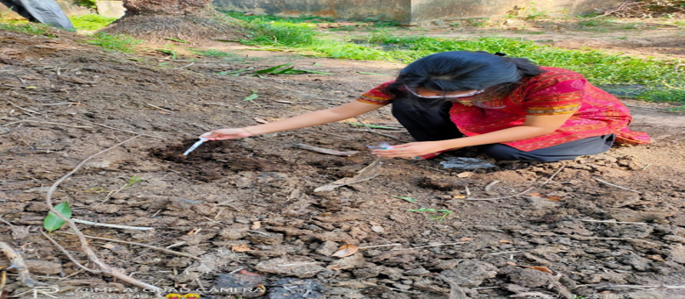

Supplementary Figure S1. Sampling for isolation of anaerobic bacterial isolates

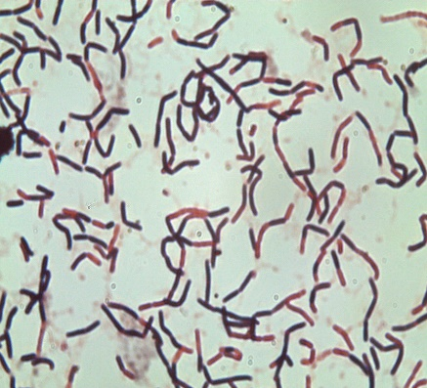
(a)
(b)
(c)

Supplementary Figure S2. Micrograph of bacterial isolates (a) FM3, (b) CM4 & (c) FM5 under Sudan black staining

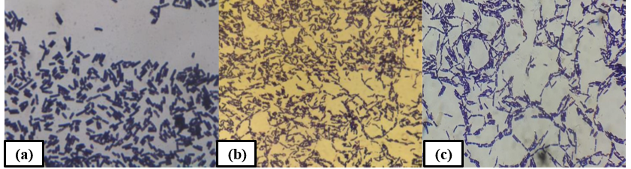

Supplementary Figure S3. Micrograph of bacterial isolates (a) FM3, (b) CM4 & (c) FM5 under Gram’s staining

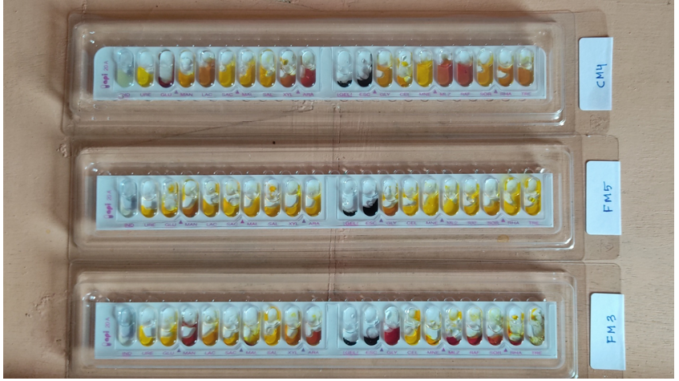
Supplementary Figure S4. Biochemical characterization of PHAs producing anaerobic bacteria

Tables
Supplementary Table S1. Biochemical characterization of PHAs producing anaerobic bacteria
Tests | Active ingredients | FM 3 | FM 5 | CM 4
IND | L-tryptophane | - | - | -
URE | Urea | - | - | -
GLU | D- glucose | + | + | -
MAN | D- mannitol | - | + | +
LAC | D- lactose | + | + | +
SAC | D- saccharose (Sucrose) | ₊ | + | +
MAL | D- maltose | + | + | +
SAL | Salicin | + | + | +
XYL | D- xylose | + | + | -
ARA | L- arabinose | - | + | -
GEL | Gelatin | + | + | +
ESC | Esculin ferric citrate | + | + | +
GLY | Glycerol | - | + | +
CEL | D- cellobiose | + | + | +
MNE | D- mannose | + | + | +
MLZ | D- melezitose | - | + | -
RAF | D- raffinose | - | + | -
SOR | D- sorbitol | - | + | +
RHA | L- rhamnose | - | + | +
TRE | D- trehalose | - | + | +
CAT | Catalase | - | - | -
SPOR | Endospore staining | - | - | -
GRAM | Gram reaction | + | + | +
COCC | Morphology | - | - | -
NB: Bacterial isolates (FM3: Bifidobacterium sp., CM4: Actinomyces sp., FM5: Bifidobacterium sp.)

