Extended Data

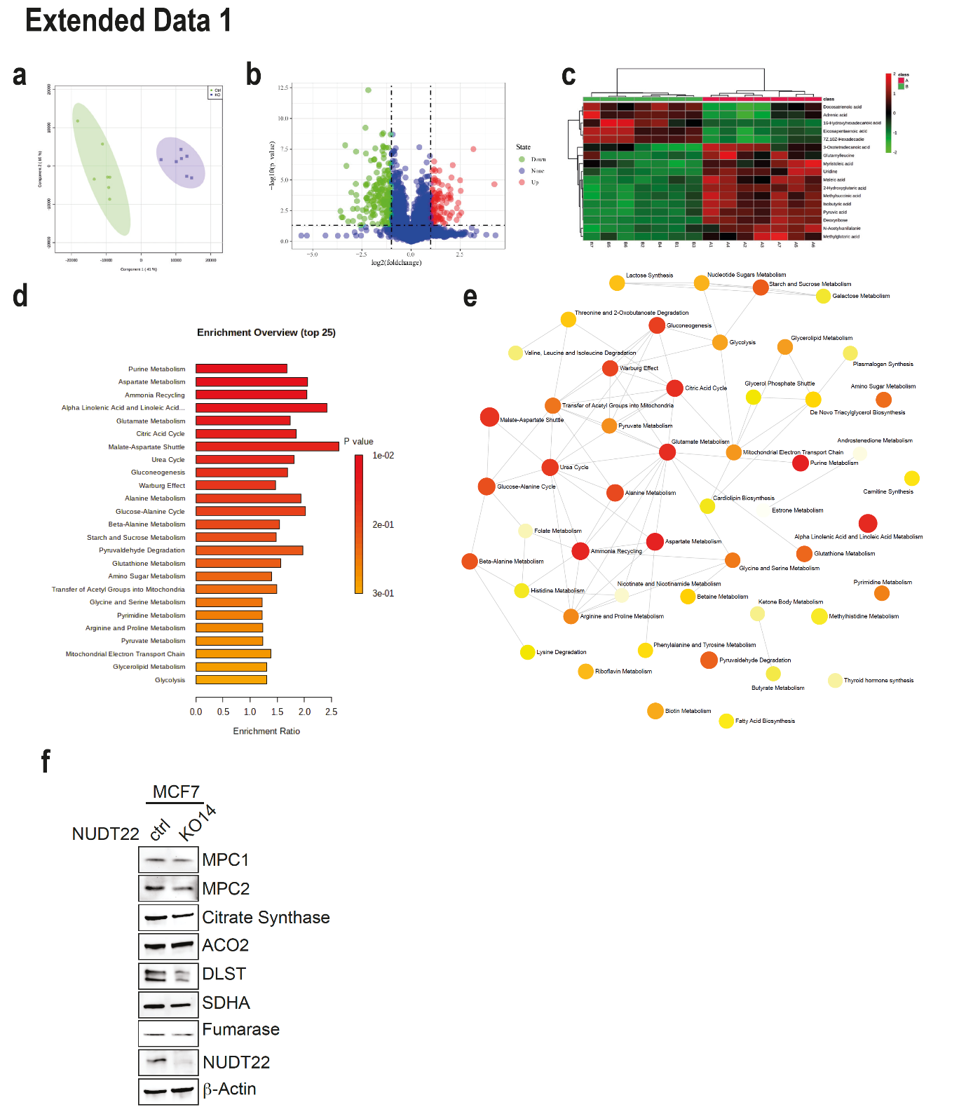

Extended Data Fig. 1
a, Scores scatterplot of the PLS-DA model (neg. mode) for the NUDT22 knockout (KO) (A) and control (ctrl) (B) groups. b, Volcano plot for group (B) vs group (A). The ranges of Y>1.30 and X>1 were significantly increased, while Y>1.30 and X<-1 were significantly decreased. c, Hierarchical cluster analysis of significantly changed metabolites in NUDT22 KO MCF7 cells, d, Enrichment overview of the top 25 metabolic pathways in NUDT22 KO MCF7 cells. e, Network diagram of enrichment analysis. f, Western blot analysis of TCA cycle enzymes in MCF7 NUDT22 KO14 cells.

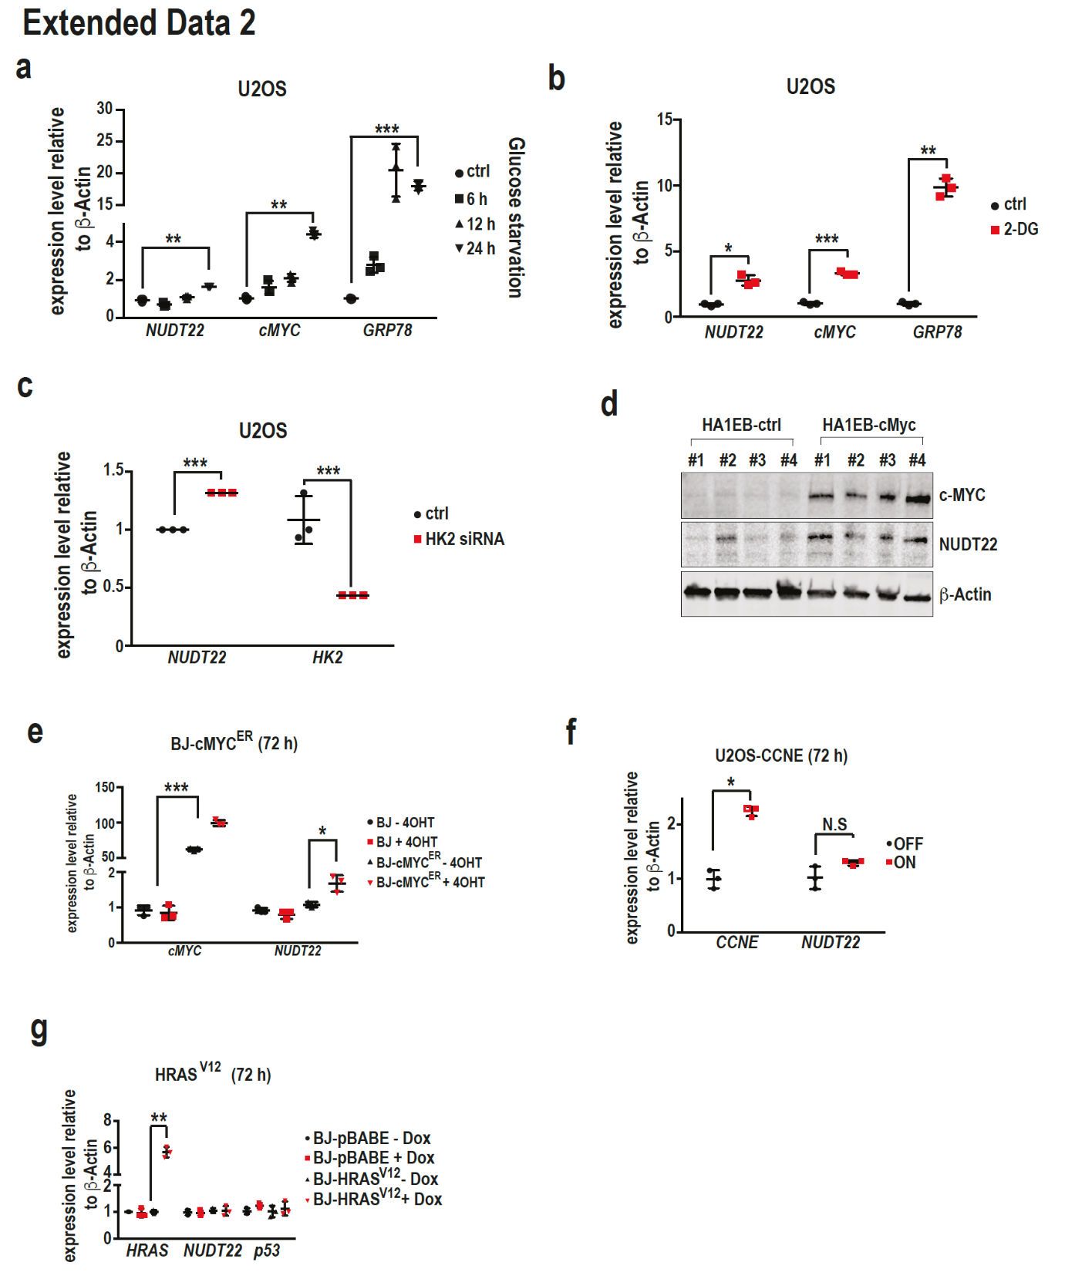

Extended Data Fig. 2.
a, Increased NUDT22 expression after glucose starvation (NUDT22 P=0.0082; cMYC P= 0.0021; GRP78 P=0.0006) b, Increased NUDT22 expression after inhibition of HK2 with 2-DG (NUDT22 P=0.0254; cMYC P=0.0001; GRP78 P=0.0016). cMYC and GRP78 are positive controls. c, Increased NUDT22 expression after HK2 depletion with siRNA (HK2 P=0.006; NUDT22 P<0.001). d, cMYC-overexpressing cells induced NUDT22 expression. e, cMYC-induced NUDT22 expression (cMYC P=0.0006; NUDT22 P=0.0346). f, Overexpression of CCNE had no significant effect on the expression of NUDT22 (CCNE P=0.0126). g, Overexpression of HRAS^{V12} had no effect on either NUDT22 or p53 expression (P=0.0028). P-values were calculated by paired t-test. Data are shown as the mean with SD.

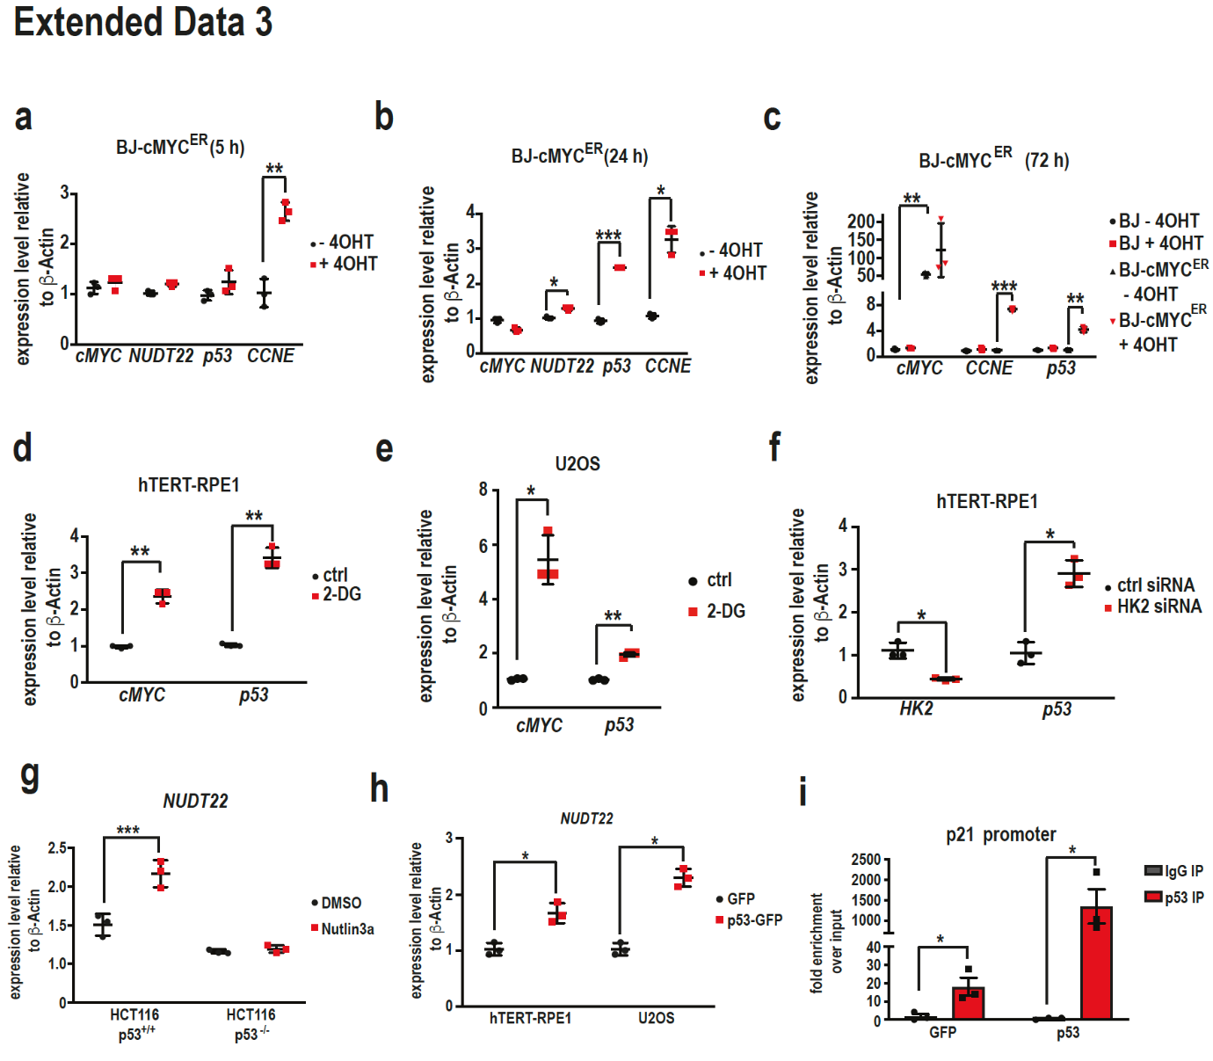

Extended Data Fig. 3
a, Short-term activation of cMYC induced expression of the direct target gene CCNE (P=0.0089) but not of NUDT22 or p53. b, Increased expression of both NUDT22 and p53 after cMYCER activation with tamoxifen (4-OHT) for 24 h (NUDT22 P=0.038; p53 P=0.0006; CCNE P=0.01). c, Activation of cMYCER (4-OHT) for 72 h increased the expression of CCNE and p53 (cMYC P=0.0041; CCNE P=0.0007; p53 P=0.0047). d, The exposure of hTERT-RPE1 cells to 2-DG for 48 h induced cMYC and p53 expression (cMYC P=0.0037; p53 P=0.0033). e Exposure of U2OS cells to 2-DG for 48 h induced cMYC and p53 expression (cMYC P=0.0152; p53 P=0.0054). f, Increased p53 expression after HK2^{siRNA} transfection (HK2 P=0.0314; p53 P=0.0234). g, Nutlin3a exposure induced NUDT22 expression only in the p53^{+/+} HCT116 cell line and not in the isogenic p53^{-/-} HCT116 cell line (NUDT22 P=0.001). h, Increased NUDT22 expression after p53 overexpression (hTERT-RPE1 P=0.0314; U2OS P=0.0144). i, qPCR for the P21 promoter after ChIP with a p53(DO1) antibody. GFP served as a transfection control, (P21 P=0.034 and 0.033). P-values were calculated by paired t-test. Data are presented as the mean values with standard deviation.

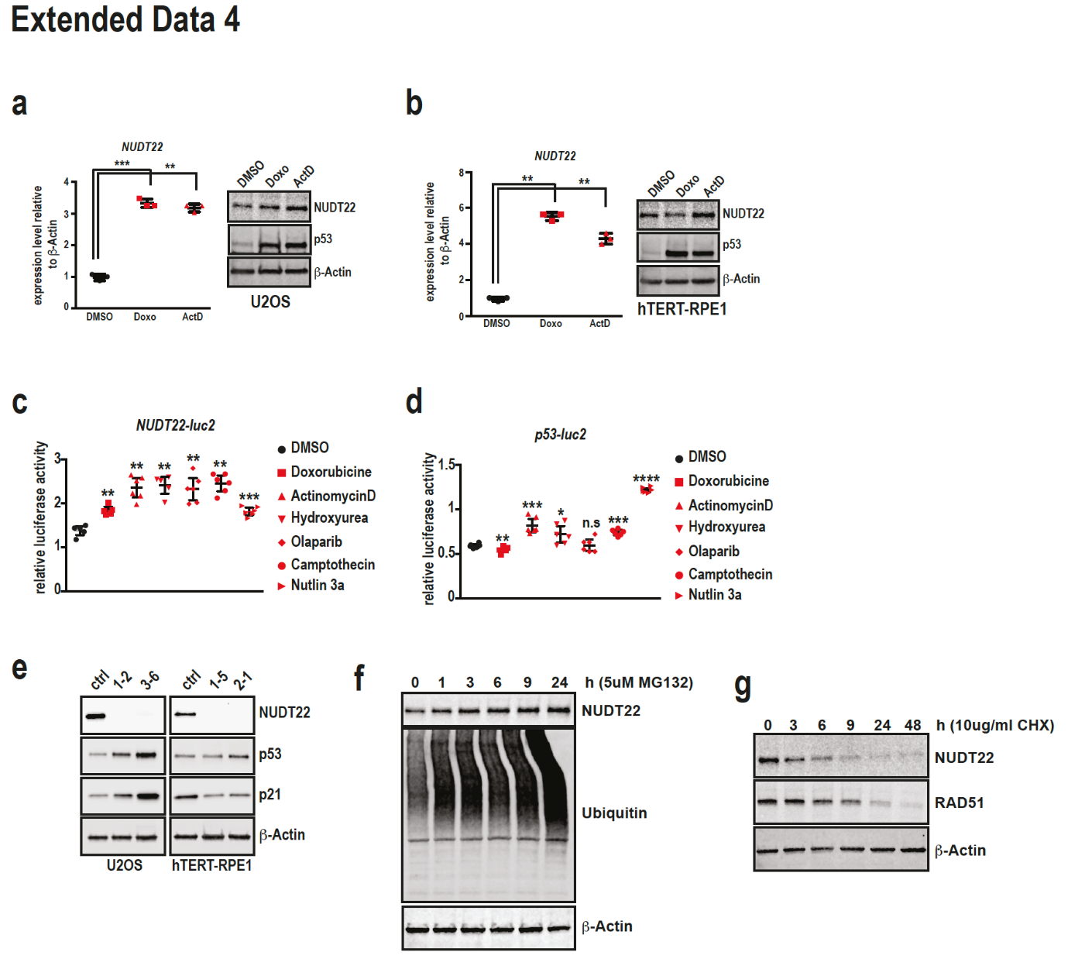

Extended Data Fig. 4
U2OS and hTERT-RPE1 cells were treated with doxorubicin and actinomycin D for 24 h. NUDT22 expression was increased in both cell lines. This is consistent with the stabilization of p53 (a, doxo P=0.0013; actD P=0.0013, b, doxo P=0.0004; actD P=0.0021). c, DNA damaging agents induce transcriptional activation of the NUDT22 reporter. d, The p53-luciferase reporter served as a control. Drug concentrations: doxorubicine (doxo) 5 μM, actinomycin D (actD) 5 nM, hydroxyurea (HU) 2 mM, olaparib 10 μM, camptothecin 10 μM, nutlin3a 2 μM (P-values calculated to DMSO control (NUDT22): doxo P=0.0094; actD P=0.0036; HU P=0.0088; olaparib P=0.0042; CPT P=0.0021; nutlin3a P=0.0003. (p53) doxo P=0.0068; actD P=0.0008; HU P=0.0344; olaparib P=ns; CPT P=0.0003; nutlin3a p<0.0001). e, Increased p53 stability and activity in U2OS cells after NUDT22 knockout. f, NUDT22 protein levels accumulate after proteasome inhibition with 5 μM MG132. g, NUDT22 protein levels were significantly reduced after 6 h of translation inhibition with 10 μg/ml CHX. RAD51 served as a positive control. P-values are calculated by paired t-test in GraphPad Prism. Data are shown as the mean with SD.

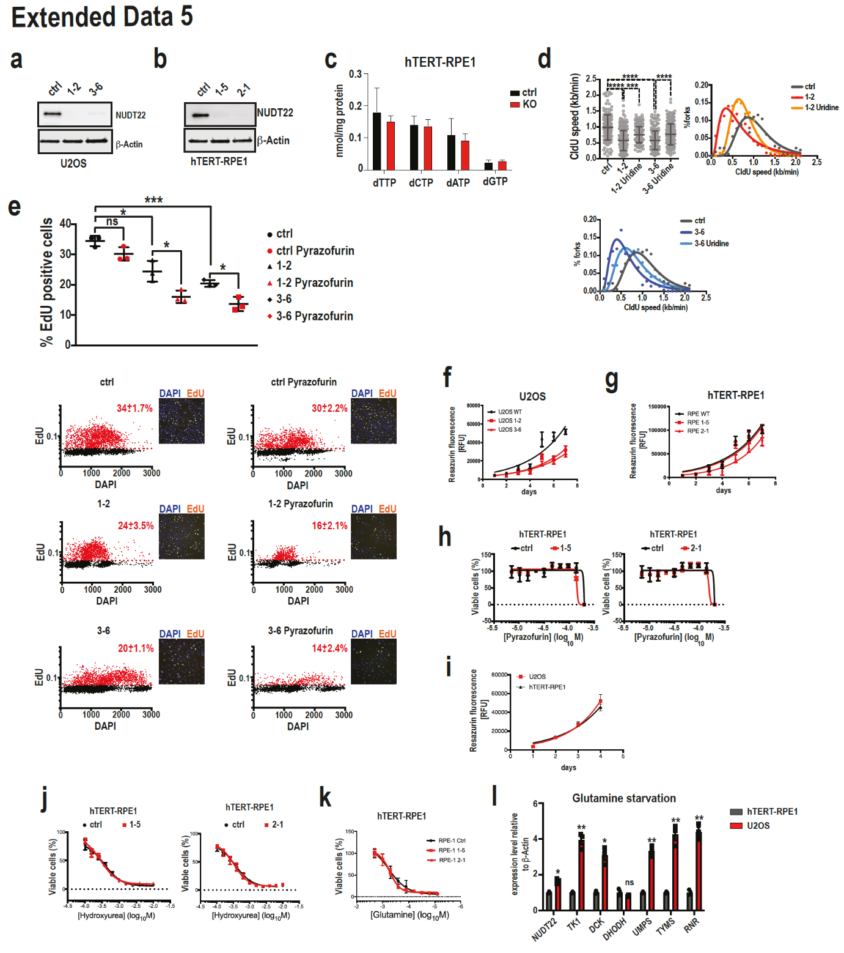

Extended Data Fig. 5
a, U2OS knockout (KO) cells. Two independent clones (1-2; 3-6) are shown. b, hTERT-RPE1 knockout (KO) cells. Two independent clones (1-5; 2-1) are shown. c, LC-MS analysis of hTERT-RPE1 cells. d, Replication fork speed (CldU incorporation) in ctrl and NUDT22 KO cells. e, Quantification of the percentage of EdU-positive cells (ctrl::1-2 P=0.0109; ctrl::3-6 P=0.0003; 1-2 DMSO::1-2 pyrazofurin P=0.0227; 3-6 DMSO::3-6 pyrazofurin P=0.0109)|. P-values were calculated by unpaired t-test. Errors as the mean with SD) and representative images. f, Growth rates of U2OS cells. g, Growth rates of hTERT-RPE1 cells. h, Dose response curves of ctrl and NUDT22 KO hTERT-RPE1 cells exposed to pyrazofurin. i, Growth rate comparison between U2OS and hTERT-RPE1 cells. j, Dose response curves of ctrl and NUDT22 KO hTERT-RPE1 cells exposed to hydroxyurea. k, Dose response curves of ctrl and NUDT22 KO hTERT-RPE1 cells under glutamine starvation. l, Expression levels of pyrimidine synthesis genes after 24 h of glutamine starvation relative to β-actin. Statistical analysis between hTERT-RPE1 and U2OS cells (NUDT22 P=0.0135; TK1 P=0.0071; DCK P=0.0132; DHODH P=ns; UMPS P=0.004; TYMS P=0.01; RNR P=0.0026). P-values were calculated by paired t-test. Data are presented as the mean values with SD.

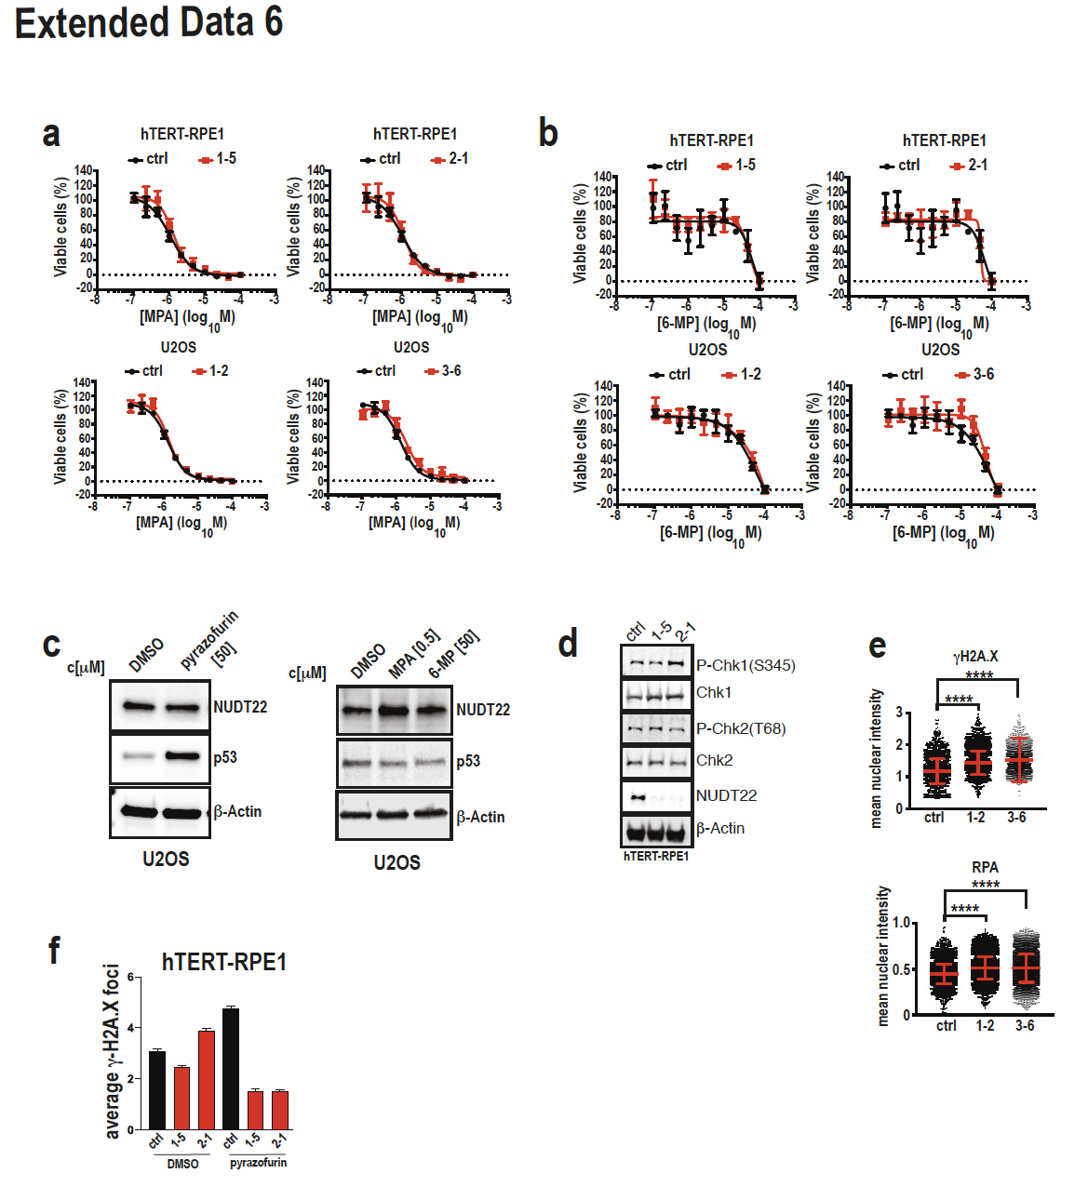

Extended Data Fig. 6

a, Dose response curves of NUDT22 KO hTERT-RPE1 and U2OS cells exposed to MPA and b, 6-MP for 96 h. c, Pyrazofurin at the EC50 for 96 h stabilizes p53 but MPA and 6-MP do not. d, No cell cycle checkpoint activation was observed in NUDT22 KO hTERT-RPE1 cells. e, Quantification of the nuclear intensity of RPA and γH2A.X in NUDT22 KO U2OS cells (P<0.0001. P-values were calculated by the Mann-Whitney test. Data are presented as the mean values with SD). f, Increased DNA damage in hTERT-RPE1 cells after pyrazofurin exposure but no further increase in NUDT22 KO cells.

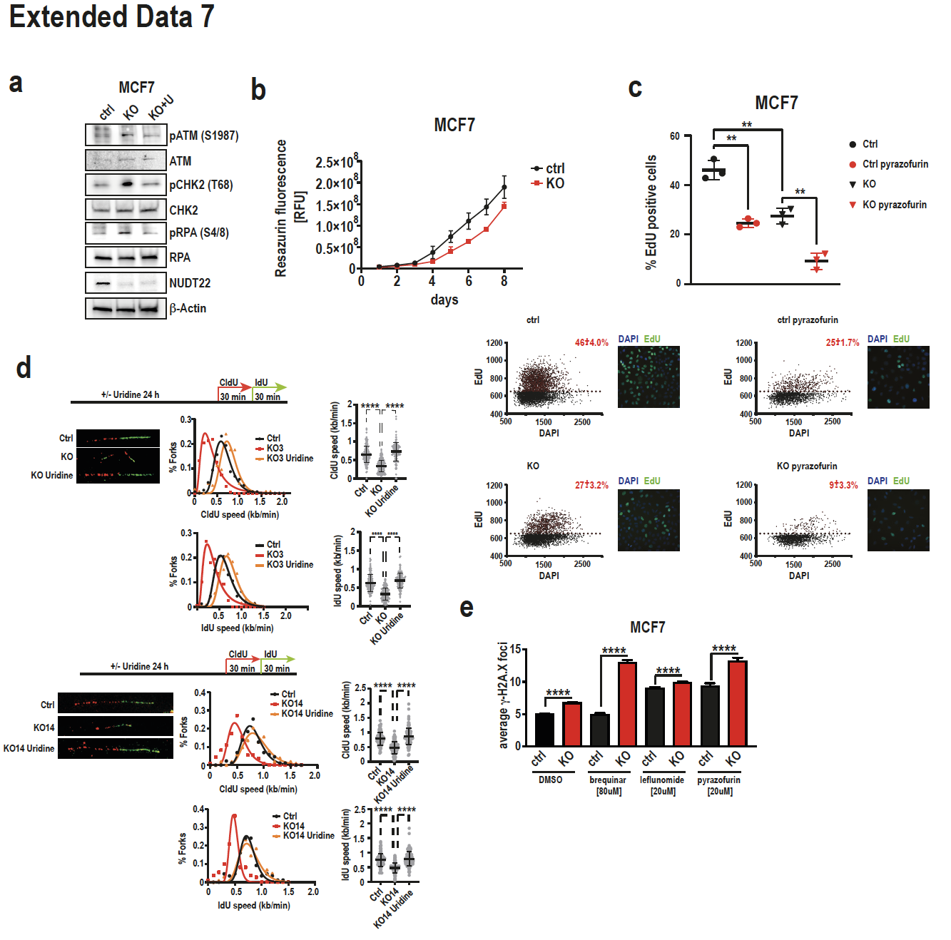

Extended Data Fig. 7

a, Cell cycle checkpoint activation of ctrl and NUDT22 KO MCF7 cells was rescued by uridine supplementation. b, MCF7 NUDT22 KO cells grew slower than their parental control cells. c, NUDT22 KO MCF7 cells have reduced EdU incorporation, which is further reduced by pyrazofurin exposure. d, Reduced replication fork speed in NUDT22 KO MCF7 cells can be rescued by uridine supplementation. e, NUDT22 KO MCF7 cells have increased γH2A.X foci formation, which was further increased with brequinar, leflunomide and pyrazofurin (P<0.0001). P-values were calculated by the Mann-Whitney t-test. Data are shown as the mean with SD.

