Supplementary Materials for

From planetary to regional nitrogen boundaries for targeted policy support
L.F. Schulte-Uebbing*, A.H.W. Beusen, A.F. Bouwman, W. de Vries

*Correspondence to: lena.schulteuebbing@gmail.com

This PDF file includes:
Supplementary Methods
Supplementary Discussion
Supplementary Figures 1 to 6
Supplementary Tables 1 to 6

Supplementary Methods

Critical concentration for N runoff to surface water
IMAGE-GNM calculates surface water N concentration for each 0.5x0.5 degree grid cell based on detailed modelling of water and N flows, removal and retention³⁹. Apart from total N load from within a grid cell, the surface water N concentration in a specific location in a river basin is affected by N load from upstream grid cells. As these dependencies complicate back-calculations of critical N loads and related N inputs per grid cell, we use the N concentration in runoff to surface water as a proxy for actual surface water N concentration. This assumes that if in each grid cell the N concentration in runoff to surface water does not exceed a certain limit, this limit will also never be exceeded in surface water itself.
Based on a critical N concentration in surface water of 2.5 mg N l⁻¹ and an estimated mean global retention fraction of 0.5, we use a limit of 5 mg N l⁻¹ for runoff to surface water. The choice of 5 mg N l⁻¹ as threshold value for N concentration in runoff to surface water was further validated by comparing the extent and spatial distribution of agricultural land in grid cells with surface water N concentration > 2.5 mg N l⁻¹ with that of agricultural land in grid cells with runoff N concentrations > 5.0 mg N l⁻¹ (Supplementary Fig. 4). About 48% of all agricultural land is located in grid cells where surface water N concentration exceeds 2.5 mg l⁻¹, and 51% of all agricultural land is located in grid cells where N concentration in runoff to surface water exceeds 5 mg N l⁻¹, and the spatial distribution for grid cells exceeding the two criteria is almost identical (Supplementary Figure 4).

Full mathematical description of the model for calculating spatially explicit critical inputs
[see Supplementary Tables 3 and 4 for explanations of all variables used in the equations]
Formulas for the calculations of critical N inputs presented in the following sections apply for those grid cells with only one agricultural land use types for which critical inputs are calculated (“ag”) which could either refer to arable land (“ara”) or intensively managed grassland (“igl”), whether or not in combination with natural land (“nat”). For grid cells that contain either a combination of arable land and extensively managed grassland (in which case critical N inputs to arable land are calculated while keeping inputs to extensively managed grassland constant), or a combination of arable land and intensively managed grassland (in which case a certain share of the critical N load is first allocated to arable land and intensively managed grassland, after which critical N inputs for both land use types are calculated), the formulas are slightly different, but the approach is the same.
Total critical agricultural N inputs in view of a given threshold are calculated as:
${Nin}_{ag\left(crit*\right)}={Nfer}_{\left(crit*\right)}+{Nman}_{\left(crit*\right)}+Nfix_{ag}+Ndep_{ag(crit*)}$ (Eq. 1)
Where ‘crit*’ refers to critical values for either the deposition threshold (crit,dep), the surface water threshold (crit,sw) or the groundwater threshold (crit,gw). Nitrogen inputs from deposition at critical N inputs are a linear function of NH₃ emissions due to critical N inputs from fertilizer and manure within the same grid cell, and of constant NO_{x} emissions:
${Ndep}_{ag\left(crit*\right)}=\left({Nfer}_{\left(crit*\right)}*fNH3,fer+{Nman}_{\left(crit*\right)}*fNH3,man+NOx\right)*f_{ag}$ (Eq. 2)
Nitrogen inputs from fertilizer and manure are assumed to change proportionally, i.e., the share of N inputs from fertilizers in total N inputs from manure and fertilizer stays constant to the current share (see also Supplementary Table 4, rows 30–31):
${Nfer}_{\left(crit*\right)}=fNfer*\left({Nfer}_{\left(crit*\right)}+{Nman}_{\left(crit*\right)}\right)$ (Eq. 3)
and thus:
${Nfer}_{\left(crit*\right)}=\frac{fNfer}{1-fNfer}*{Nman}_{\left(crit*\right)}$ (Eq. 4)
Nitrogen loss fractions (e.g. surface runoff fraction, leaching fraction, NH₃ emission fraction) are calculated for each grid cell by dividing losses by total inputs. To calculate NH₃ emission fractions for manure for each land use type (see Supplementary Table 4, rows 11–14), storage NH₃ emissions were allocated to either arable land, intensively managed grassland or extensively managed grassland based on the shares of (effective) manure inputs to each of these land use types (see Supplementary Table 4, rows 8–10).
The crop N removal (N uptake) associated with critical N inputs is calculated as (where Nin_{(crit)} is defined in Eq. 1):
${Nup}_{ag(crit*)}=\left({Nin}_{ag(crit*)}-{Nsro}_{ag(crit*)}\right)*frNup_{ag}$ (Eq. 5)
The associated critical N surplus is calculated as:
${Nsur}_{ag\left(crit*\right)}={Nin}_{ag(crit*)}-{Nup}_{ag\left(crit*\right)}$ (Eq. 6)
Calculation of critical N inputs to limit terrestrial biodiversity loss
First, the total critical deposition per grid cell is calculated by multiplying critical N deposition rates (see Supplementary Table 2) by total grid cell area:
${Ndep}_{(crit,dep)}=Ndep,rate_{crit}*a_tot$ (Eq. 7)
As we assume that total deposition equals total N emissions within a grid cell (see assumption 4), and that NO_{x} emissions are constant, critical NH₃ emissions for agriculture are calculated as the difference between total critical deposition and NO_{x} emissions:
$NH3em_{ag(crit,dep)}= {Ndep}_{(crit,dep)}-NOx$ (Eq. 8)
Critical emissions are written as a function of critical N inputs from fertilizer and critical N inputs from manure, multiplied by emission fractions for manure and fertilizer:
$NH3em_{ag(crit,dep)}= {Nman}_{(crit,dep)}*fNH3,man+Nfer_{(crit,dep)}*fNH3,fer$ (Eq. 9)
Solving Eq. (9) for Nman_{(crit,dep)} while substituting Eq. (4) for Nfer_{(crit,dep)} results in:
${Nman}_{(crit,dep)}= \frac{NH3em_{ag(crit,dep)}}{fNH3,man+fNH3,fer*\frac{fNfer}{1-fNfer}}$ (Eq. 10)
Associated critical inputs from fertilizer are calculated with Eq. (4), and total critical inputs, critical uptake and critical surplus are calculated with Eqs. (1), (5) and (6), respectively.
Calculation of critical N inputs to limit surface water eutrophication
N concentration in runoff is calculated as the total N load to the river basin within a certain grid cell divided by the total runoff:
$Nconc,qtot=\frac{Nload}{qtot}$ (Eq. 11)
Following Eq. (11), the ‘critical N load’ to surface water is calculated as critical N concentration of 5 mg N l⁻¹ multiplied by total runoff:
${Nload}_{(crit,sw)}={Nconc,qtot}_{(crit,sw)}*qtot$ (Eq. 12)
The total critical N load to surface water is the sum of several sources contributing to total N load (see Extended Data Fig. 9b):
${Nload}_{(crit,sw)}=Ngw,{rec}_{ag(crit,sw)}+Ngw,{rec}_{nat(crit,sw)}+{Nsro}_{ag(crit,sw)}+{Nsro}_{nat(crit,sw)}+{Nero}_{ag}+{Nero}_{nat}+{Ngw,fixed}_{ag}+{Ngw,fixed}_{nat}+Nww+Nallo+Naqua+Ndep,sw$ (Eq. 13)
Several sources contributing to total N load are assumed to be constant in the calculations of critical N inputs. These sources are summarized as ‘fixed’ N load:
$Nload,fixed={Nero}_{ag}+{Nero}_{nat}+{Ngw,fixed}_{ag}+{Ngw,fixed}_{nat}+Nww+Nallo+Naqua+Ndep,sw$ (Eq. 14)
We thus can simplify Eq. (13) to:
${Nload}_{(crit,sw)}={Ngw,rec}_{ag(crit,sw)}+{Ngw,rec}_{nat(crit,sw)}+{Nsro}_{ag(crit,sw)}+{Nsro}_{nat(crit,sw)}+Nload,fixed$ (Eq. 15)
To back-calculate critical N inputs from the critical N load, we express all components of the critical N load as functions of fertilizer and manure inputs to agriculture.
Critical N delivery to surface water via surface runoff is a fraction of critical N inputs:
${Nsro}_{ag(crit,sw)}={fsro}_{ag}*{Nin}_{ag(crit,sw)}$ (Eq. 16)
${Nsro}_{nat(crit,sw)}={fsro}_{nat}*{Nin}_{nat(crit,sw)}$ (Eq. 17)
Critical N inputs to agriculture are the sum of critical manure and fertilizer inputs, critical N deposition and (constant) N fixation (see Eq. (1)). N withdrawal or uptake at critical N inputs is calculated as:
${Nup}_{ag(crit,sw)}=\left({Nin}_{ag(crit,sw)}-{Nsro}_{ag(crit,sw)}\right)*frNup_{ag}$ (Eq. 18)
N inputs to natural areas at critical inputs are the sum of N deposition at critical inputs and constant N fixation:
${Nin}_{nat(crit,sw)}={Nfix}_{nat}+{Ndep}_{nat(crit,sw)}$ (Eq. 19)
N deposition on agricultural and natural land at critical N inputs is calculated as:
${Ndep}_{ag(crit,sw)}=f_{ag}*\left({Nman}_{(crit,sw)}*fNH3,man+{Nfer}_{\left(crit,sw\right)}*fNH3,fer+NOx\right)$ (Eq. 20)
${Ndep}_{nat(crit,sw)}=f_{nat}*\left({Nman}_{(crit,sw)}*fNH3,man+{Nfer}_{\left(crit,sw\right)}*fNH3,fer+NOx\right)$ (Eq. 21)
Critical N delivery to surface water via groundwater is a fraction of critical N leaching:
${Ngw,rec}_{ag(crit,sw)}= {fgw,rec,le}_{ag}*{Nle}_{ag(crit,sw)}$ (Eq. 22)
${Ngw,rec}_{nat(crit,sw)}={fgw,rec,le}_{nat}*{Nle}_{nat(crit,sw)}$ (Eq. 23)
Critical N leaching is a fraction of the critical N inputs minus critical N uptake (only for agricultural land) minus critical N surface runoff:
${Nle}_{ag(crit,sw)}={fle}_{,ag}*\left({Nin}_{ag(crit,sw)}-{Nup}_{ag(crit,sw)}-{Nsro}_{ag(crit,sw)}\right)$ (Eq. 24)
${Nle}_{nat(crit,sw)}={fle}_{nat}*\left({Nin}_{nat(crit,sw)}-{Nsro}_{nat(crit,sw)}\right)$ (Eq. 25)
By combining Eqs. (1), (4) and (15)– (25), critical N inputs from manure are calculated from the critical N load to surface water, Nload_{(crit)}, as:
${Nman}_{(crit,sw)}=\frac{{Nload}_{(crit,sw)}-Nload,fixed-{Nfix}_{ag}*v-{Nfix}_{nat}*w-NOx*\left(f_{nat}*w+f_{ag}*v\right)}{v+fNH3,man*\left(f_{ag}*v+f_{nat}*w\right)+\frac{fNfer}{1-fNfer}*\left(v+fNH3,fer*\left(f_{ag}*v+f_{nat}*w\right)\right)}$ (Eq. 26)
Where the variables ‘v’ and ‘w’ are defined as follows:
$v={fsro}_{ag}+{fle}_{ag}*{fgw,rec,le}_{ag}*\left(1-{fNup}_{ag}+{fNup}_{ag}*{fsro}_{ag}-{fsro}_{ag}\right)$ (Eq. 27)
$w={fsro}_{nat}+{fgw,rec,le}_{nat}*{fle}_{nat}*\left(1-{fsro}_{nat}\right)$ (Eq. 28)
Associated critical inputs from fertilizer are calculated with Eq. (4), and total critical inputs, critical uptake and critical surplus are calculated with Eqs. (1), (5) and (6), respectively.
Calculation of critical N inputs to limit groundwater nitrate pollution
critical N leaching is calculated as the critical concentration in groundwater (i.e. 11.6 mg NO₃-N per liter) multiplied by the water flux leaching from the agricultural soil:
${Nle}_{ag(crit,gw)}=\left(1-fsro_{ag}\right)*qtot*f_{ag}*Nconc,le_{ag(crit,gw)}$ (Eq. 29)
By combining Eq. (24) with Eqs. (1), (16), (18) and (20), we calculate critical N inputs from manure related to a critical N leaching to groundwater as:
${Nman}_{(crit,gw)}=\frac{\frac{{Nle}_{ag(crit,gw)}}{{fle}_{ag}*\left(1-{fNup}_{ag}+{fsro}_{ag}*{fNup}_{ag}-{fsro}_{ag}\right)}-{Nfix}_{ag}-NOx*f_{ag}}{1+fNH3,man*f_{ag}+\frac{fNfer}{1-fNfer}*\left(1+fNH3,fer*f_{ag}\right)}$ (Eq. 30)
Associated critical inputs from fertilizer are calculated with Eq. (4), and total critical inputs, critical uptake and critical surplus are calculated with Eqs. (1), (5) and (6), respectively.
Calculation of critical N inputs in view of all three thresholds
Critical N inputs in view of all three thresholds are calculated as the minimum of the three individual critical inputs in each grid cell, according to:
${Nman}_{(crit,all)}=MIN({Nman}_{\left(crit,dep\right)}, {Nman}_{\left(crit,sw\right)}, {Nman}_{\left(crit,gw\right)})$ (Eq. 31)
${Nfer}_{(crit,all)}=MIN({Nfer}_{\left(crit,dep\right)}, {Nfer}_{\left(crit,sw\right)}, {Nfer}_{\left(crit,gw\right)})$ (Eq. 32)
Associated critical inputs from fertilizer are calculated with Eq. (4), and total critical inputs, critical uptake and critical surplus are calculated with Eqs. (1), (5) and (6), respectively.

Calculation of the spatial distribution of N inputs by manure and fertilizer
The availability of manure for application in croplands and grasslands and the amount dropped during grazing varies in the IMAGE model by (changes in) the distribution of animals between pastoral and mixed systems, and changes in the amount of time that ruminants are in the meadow versus the stable; the latter is governed by the amount of grass in the feed rations of ruminants, that may change over time. In grasslands, the N application and N dropped during grazing differs between pastoral and mixed grasslands, and in croplands the manure N application depends on the availability of manure collected in stables or storage systems and ammonia losses from stored manure. In many countries, part of the manure is ending outside the agricultural system, as it is used as building material or fuel, or stored in lagoons. Within a country, the N loading in pastoral grasslands and mixed grasslands, and in croplands in pastoral regions versus croplands in regions dominated by mixed systems, are homogeneous. Fertilizer application rates in croplands and grasslands are largely country-specific, state-specific for the US and province-specific for China.

Method to estimate yield potentials for arable land
We based our estimates of yield potentials for arable land on an assessment by Mueller et al.³⁵, who estimate ‘attainable yields’ for 17 crops and 155 countries by using estimates of harvested area and yield for the year 2000. They use a published dataset on harvested area and yield for 175 crops (grouped into 11 crop groups) on a 10x10km² grid, created by combining national, state, and county level census statistics with a global cropland map based on satellite data⁶⁶. To obtain attainable yields, they calculate climate bins of similar annual precipitation and growing degree days and estimate attainable yields as the 95-percentile yield that is achieved anywhere in a certain climate bin (with certain restrictions, for more detail see Supplementary Information Mueller et al. ³⁵). We acknowledge that ‘bottom-up’ estimates of yield potentials such as for example presented by the Global Yield Gap Atlas (GYGA, www.yieldgap.org) are generally considered more accurate than estimates of yield potentials that use global datasets on weather, soil and crop management such as Mueller et al.⁶⁷; however, bottom-up estimates are currently only available for selected countries and crops and thus do not have the global coverage that we require.

Method to estimate yield potentials for intensively managed grassland
Although there are first efforts to establish a framework for yield gap assessments in grasslands and estimates for grassland yield gaps for certain countries (e.g., the Netherlands and Norway)⁶⁸, no global assessment of yield potentials and yield gaps in grassland is currently available. Grassland yield potentials are determined by climate, soil type, grassland species and management, i.e., grazing or mowing intensity and frequency. As a surrogate for grassland yield potentials, we used results from a study by Rolinski et al.⁶², who extended the Dynamic Global Vegetation Model (DGVM) LPJmL to include an assessment of the effects of four different types of grassland management on harvest, NPP and soil carbon content. They also assess for each grid cell the maximum livestock density that could be supported by potential local grass production under the management option ‘daily grazing without mowing’. We considered the N uptake related to these maximum livestock densities as a ‘maximum’ N uptake for grassland considering climate and soil parameters in each grid cell. The maximum livestock density presented by Rolinski et al.⁶² assumes a feed demand of 4000 g C LSU⁻¹ day⁻¹, which (assuming a C:N ratio of 20:1 in the aboveground part of grass) is equivalent to an annual N removal of 73 kg N LSU⁻¹ ha⁻¹ yr⁻¹.
We extracted the mean maximum livestock density for each of the 26 IMAGE regions from the original data provided by the authors of the study (area-weighted mean based on the area of intensive grassland in each grid cell). The N uptake at maximum livestock density for each region was calculated as:
$Nup@LSDmax_{\left(i\right)}=LSDmax_{\left(i\right)}*73 kg N {LSU}^{-1}{yr}^{-1}$ (Eq. 33)
Where
- Nup@LSDmax_{(i)} = N removal at maximum livestock density for region i [kg N ha⁻¹ yr⁻¹]
- LSD,max_{(i)} = modelled maximum livestock density for region i obtained from ref. (62) [LSU ha⁻¹]
As we required that the maximum N uptake should not be lower than the current (year 2010) N uptake, the maximum N uptake for intensively managed grassland in region i was defined as:
${Nup,max}_{\left(i\right)}=max⁡(Nup@LSDmax_{\left(i\right)}; Nup_{(i)})$ (Eq. 34)

Supplementary Discussion

Results for yield potentials and maximum N uptake for arable land and intensively managed grassland
Supplementary Table 5 shows average actual yields, the derived yield potentials, the ratio between yield potentials and actual yields and the calculated maximum N uptake for arable land and intensively managed grassland per IMAGE region.
Maximum N uptake for arable land was calculated by multiplying current N uptake in arable land for each IMAGE region with the ratio between yield potential and actual crop yield (see ‘Method to estimate yield potentials for arable land’ in Supplementary Methods). Maximum N uptake for intensively managed grassland was calculated by multiplying current N uptake in intensively managed grassland for each IMAGE region with the ratio between maximum N uptake derived from ref.⁶² and current N uptake from IMAGE (see ‘Method to estimate yield potentials for intensively managed grassland’ in Supplementary Methods).
The difference between current N uptake and maximum N uptake in arable land varies from 18% (Western Europe, Japan, Korea) to more than 150% (Northern Africa, Ukraine region, Central Asia). Globally, the maximum N uptake is 56% higher than current N uptake. For intensively managed grassland, maximum N uptake is 86% higher than current N uptake, with regional values ranging from 0% (Canada, South Africa, Middle East, India, Japan) to 299% (Rest of Southern Africa). The estimated increase for Western Europe (4%) is comparable to published estimates of the difference between actual yields and 80% of the water-limited yield potential for the Netherlands (6%) and Norway (27%)⁶⁸.
Yield gaps for arable land and grassland show marked differences within regions, for example for Northern Africa, the yield gap is 37% for grassland and 171% for arable land, for the Middle East, the yield gap increase is 0% for grassland and 117% for arable land, while for Rest of South America, the yield gap is 186% for grassland and 53% for arable land. As the two procedures follow very different approaches (grassland: modelled maximum production based on biophysical parameters, arable land: highest observed yield for zones of similar climate), such differences can be expected.

Plausibility of estimated yield potentials
To assess the plausibility of the data on actual and attainable yields from Mueller et al.³⁵, we compared actual and attainable yields from Mueller et al. with actual yields and (water-limited) yield potentials from the Global Yield Gap Atlas (GYGA). GYGA provides estimates of actual yields and yield potentials for a variety of staple crops at sub-country (regional) level (for zones of similar climate). Sub-national estimates of actual yields are multi-year average yields obtained by farmers under dominant management practices, and are gathered from sub-national statistics, farm surveys and/or local agronomists. Estimates of yield potentials are obtained from crop models for specific weather stations that are scaled up to the country level by using zones of similar climate^{69,70}. GYGA distinguishes between the biophysical yield potential (Yp); i.e. the yield of a crop when grown with water and nutrients non-limiting and biotic stress effectively controlled (crop growth rate only determined by solar radiation, temperature, atmospheric CO₂ and genetic traits that govern the length of the growing season), and the water-limited yield potential (Yw) which is also determined by water availability (and thus rainfall and soil properties). Yp is the most relevant benchmark for irrigated systems, and Yw for rainfed systems.
For six crops (wheat, barley, maize, millet, rice, and sorghum), both GYGA and Mueller et al present data on attainable yields and yield potentials for a number of countries. The ‘attainable yields’ presented by ref. ³⁵ represent the highest yields that are actually achieved by farmers in a certain climate bin under current management and are thus a mix of water-limited yield potentials (for crops where no irrigation occurs anywhere in the climate bin) and irrigated yield potentials. For the best possible comparison with GYGA, we thus calculated the area-weighted average of Yw and Yp for each country and crop based on estimates of both Yw and Yp from GYGA.
For actual yields, estimates from GYGA and Mueller et al. ³⁵ show a good agreement (r² often between 0.7 and 0.9, except for millet and sorghum, see Supplementary Table 6), though GYGA estimates are generally higher for all crops and countries (see Supplementary Fig. 5). The correlation between GYGA yield potentials and Mueller attainable yields at country level is mostly weak, with R² values >0.3 only for rye (see Supplementary Table 6). Again, GYGA estimates are generally higher, which can partially be explained by the more conservative approach of Mueller et al.³⁵ who use actually observed yields in the same climate zone and thus under-estimate yield potentials when a climate zone contains no high-performing region. Because both estimated actual yields and yield potentials from GYGA are higher, the correlation between the ratio Yp/Ya for GYGA and Mueller et al., which we used to estimate maximum crop N uptake in IMAGE, is better than the correlation for yield potentials (between 0.37 and 0.62, except for wheat and sorghum, see Supplementary Table 6).

Choice of cut-off value for critical surpluses and inputs
Imposing a ‘cut-off’-value for critical N inputs (and associated critical N surpluses and N losses) is necessary to avoid unrealistically high values in areas where environmental constraints allow for much higher N inputs than what is sensible from an agronomic perspective. In this study, we defined this cut-off value as the N input needed to obtain crop yield potentials (Nup_{(YP)}) at current N use efficiency (NUE_{(act)}).
Nin_{(crit,max)} = Nup_{(YP)} / NUE_{(act)} (Eq. 35)
Following from the relationship between N input and N surplus (Nsur = Nin*(1-NUE)), the maximum critical N surplus can be derived as:
Nsur_{(crit,max)} = Nup_{(YP)} * (1/NUE_{(act)}) - 1 (Eq. 36)
In regions where environmental constraints are not limiting, this cut-off procedure leads to higher critical N surpluses in regions with higher current surpluses. For example for Japan, where environmental thresholds are not constraining critical N input on ~75% of agricultural land, high critical N surpluses (see Extended Data Table 2) are mainly the result of high current N surpluses. High current surplus in this region occur due to a combination of widespread double- (or triple-) cropping and a low NUE.
An alternative reasoning would be that N losses should be reduced as much as possible, even though higher losses may be acceptable from an environmental perspective. In this case, the cut-off value could be defined as the N surplus associated with achieving crop yield potentials while using best management strategies to reduce N losses as much as possible. The potential to improve NUE and reduce N losses by implementing best management practices varies across regions due to differences in biophysical and socioeconomic conditions, therefore such an analysis was beyond the scope of this study.

Comparison to regional bottom-up N boundary studies
A recent study by Yu et al.⁴³ that derived a boundary for N discharge to surface water in China based on measured surface water N concentrations and model-based estimates of provincial N discharge found that to restore surface water quality, N discharge to surface water would need to be reduced by 64%, from currently 14.5 to 5.2 Mt N yr⁻¹. This study used a threshold for N concentration in surface water of 1 mg N l⁻¹, whereas this study used a threshold concentration of 2.5 mg N l⁻¹ (see also Supplementary Methods). If we implement a threshold of 1 mg N l⁻¹, our model predicts that N discharge to surface water in China needs to be reduced by 71%, from currently 15.2 to 4.4 Mt N yr⁻¹, which is close to the reduction target of 64% estimate by Yu et al. ⁴³.
Another recent study⁴² used an N balance model at a high spatial resolution for the EU to assess spatially explicit boundaries for agricultural N inputs and N losses in view of N deposition onto natural ecosystems to protect terrestrial biodiversity, N concentration in runoff to surface water to protect aquatic ecosystems and nitrate concentrations in leachate to groundwater to avoid adverse health effects. Even though this study made different assumptions on reductions in non-agricultural losses, the resulting aggregated boundaries for N inputs are very comparable to boundaries derived by this study, both terms of the absolute boundaries (in kg N ha⁻¹ yr⁻¹; see Table below) and in terms of the estimated needed reduction (shown in the table in brackets).
 | De Vries et al. 2021 (ref. 42) | This study⁽¹⁾
Current N input (kg N ha⁻¹ yr⁻¹) | 145 | 131
Critical N input – Deposition (kg N ha⁻¹ yr⁻¹) | 100 (-31%) | 91 (-31%)
Critical N input – Surface water (kg N ha⁻¹ yr⁻¹) | 83 (-43%) | 87 (-34%)
Critical N input – Groundwater (kg N ha⁻¹ yr⁻¹) | 147 (+1%) | 118 (-10%)
Critical N input – All impacts (kg N ha⁻¹ yr⁻¹) | 69 (-52%) | 52 (-60%)
⁽¹⁾ Results shown here are for IMAGE regions “Western Europe” and “Central Europe”, which also includes non-EU states such as Switzerland, Norway and Croatia. However, the inclusion of a few additional countries compared to De Vries et al. 2021 who only focused on EU27 only leads to an increase in agricultural area under consideration by 5%.

Defining a planetary N boundary for nitrous oxide emissions

Considerations for defining a planetary boundary for nitrous oxide emissions
Nitrous oxide (N₂O) is a long-lived greenhouse gas. Increasing anthropogenic N fixation (both intentional and unintentional) has led to increasing N₂O emissions from soils, sediments and water bodies. Fertilizer and manure application to soils and contributes two-thirds to direct anthropogenic N₂O emissions⁷¹. In addition, volatization or leaching of N from agricultural systems and re-deposition and processing downwind or downstream leads to increased N₂O emissions from terrestrial and aquatic systems (indirect N₂O emissions). Next to contributing to climate change, N₂O also leads to stratospheric ozone depletion. Due to the strong reduction in CFCs and other ozone-depleting substances regulated under the Montreal Protocol, N₂O is currently the single largest anthropogenic ozone depleting substance (measured by its ozone-depleting potential) and is expected to remain so throughout the 21st century⁷².
Defining a ‘safe operating space’ for N₂O in view of climate impcats is difficult, as warming impact largely depends on concentrations of greenhouse gases other than N₂O. According to the 6th IPCC Assessment, the warming impact of N₂O (expressed as effective radiative forcing) is only 10% of that of CO₂, and contributes 7% of the total forcing of all well-mixed long-lived greenhouse gases (and even less if other climate forcings are also considered). While it would be possible to derive a boundary for N₂O emissions based on a climate target and the assumption that all greenhouse gasses are reduced proportionally, the abatement potential for agricultural N₂O is generally assumed much more limited than for (energy-related) CO₂ emissions. For this reason, emission scenarios consistent with 2 degrees warming often project only minor reductions in N₂O emissions compared to the baseline^{73,74}.
Regarding ozone depletion, the implications of future N₂O trajectories for stratospheric ozone and UV exposure strongly depend on trajectories of CH₄ and CO₂ emissions⁷⁵, with N₂O mitigation becoming especially important in scenarios with strong reductions in these gasses. Even under a very limited or no reduction in N₂O emissions under RCP 2.6 and 4.5 global stratospheric ozone and UV are still expected to return to near historical values by 2100⁷⁵. If CO₂ and CH₄ emissions continue unabated (as represented in RCP 8.5), the increase in ozone through CH₄-induced tropospheric ozone formation and through the effect of CO₂ on tropospheric cooling may even raise ozone above historical levels. In such a scenario, the benefits of N₂O reductions for climate mitigation may have to be balanced against the downsides of more stratospheric ozone and thus less UV exposure⁷⁵.

Implications of meeting planetary N boundaries for global nitrous oxide emissions
While N₂O emissions were not used as a threshold in deriving regional and planetary N boundaries (see Methods), we estimated changes in agricultural N₂O emissions when boundaries for the three thresholds considered (and for all thresholds simultaneously) are respected. For this purpose, we used emission fractions from a paper by Davidson⁷⁶ for N₂O emissions from manure and fertilizer. These emission fractions (that include both direct and indirect emissions) were multiplied with current (year 2010) fertilizer and manure inputs and with critical fertilizer and manure inputs in view of the various thresholds. Results show that reducing N inputs to critical levels in view of the various boundaries would lower N₂O emissions by 18–55%.
 | Current | When respecting threshold for...
 |  | ... deposition | ... surface water | ... groundwater | ... all impacts
N₂O emissions (Tg N₂O-N yr⁻¹) | 3.9 | 2.9 | 2.2 | 3.2 | 1.8
Change compared to current |  | -26% | -43% | -18% | -55%

Major uncertainties and their implications
Our analysis incorporates many uncertainties of different nature, i.e., (1) those associated with uncertainties in statistical data (e.g., fertilizer use); (2) uncertainties associated with inputs derived from statistical information combined with excretion estimates (e.g., animal population statistical data combined with excretion estimates); (3) uncertainties associated with crop uptake estimates (statistics on crop production, crop N contents) and crop residue management (use as feed, burning, incorporation, cultivation of catch crops, etc.); (4) uncertainties in the emission estimates (e.g., leaching, volatilization); (5) uncertainties associated with the thresholds in groundwater, air and surface water and finally (6) uncertainties associated with spatial distribution of all the above.
Over- or underestimation of current inputs (losses) leads to an over- or underestimation of the degree to which thresholds are exceeded. However, quantifying the combined uncertainty is difficult as uncertainty ranges are often not well known. For example, the uncertainty of animal N excretion in different livestock production systems and countries is poorly quantified. Overall, the algorithm used to distribute livestock and manure inputs over pasture areas in IMAGE leads to a more homogenous distribution than the actual distribution. This may imply that local threshold exceedance in areas with intensive livestock systems is underestimated, but it also shows that a more equal distribution of the current livestock population, as proposed by several recent studies^{77,78}, is not sufficient to reduce N pollution below thresholds.
In general, the overall uncertainty declines when moving from the local (grid) level to larger scales such as countries and continents due to aggregation and averaging out of individual uncertainties, but still the uncertainty ranges can be quite wide. For example, Beusen et al.⁷⁹ estimated the uncertainty range for global agricultural ammonia emissions used in the IMAGE model at 27–38 Tg N yr⁻¹, however, uncertainties in such emission inventory approaches may not represent the actual uncertainty under field conditions. Additional individual sources of uncertainties (1)–(4) have been discussed in detail in refs. ^{39,56–58,79–81} and many others, and uncertainties related to all N budget terms and overall N budgets in croplands were recently assessed by Zhang et al.⁸².
Uncertainties in the threshold values (5) vary depending on the type of N flux and the receiving environment:
  - Deposition: Critical deposition rates in terrestrial ecosystems used in this study are mainly derived from Bobbink et al. ¹², who present extensive synthesis of empirical studies but only include a rough ecosystem classification. Most evidence on empirical critical loads comes from Europe⁸³ and the US⁸⁴, with limited applicability to global ecosystems. The broad categorization does not allow to distinguish between sub-categories (e.g., different types of grasslands) that may vary considerably in their sensitivity to N deposition (e.g., de Vries et al.⁸⁵). This will inevitably lead to critical loads that are too high to protect the most sensitive ecosystems, but lower than the least sensitive systems could tolerate. Note that models used to support European air pollution abatement policies⁸⁶ do not use the critical load of the most sensitive habitat within a cell (often near 5 kg N ha⁻¹ yr⁻¹), but rather area-weighted average critical loads of habitat types with varying sensitivities.
  - Surface water: The uniform threshold value of 2.5 mg N l⁻¹ for N concentration in surface water used in this study does not reflect variation in the relation between N concentration and ecological status across surface water types (e.g., rivers, lakes, coastal waters). Thresholds for critical N concentrations for good ecological status reported in the literature vary from 0.5–4.0 mg N l^{-1 87–89}. In addition, assessing eutrophication risk ideally should account for P loads in addition to N loads, as eutrophication risk is related to nutrient imbalances (stoichiometry) rather than to enrichment per se⁹⁰ and reductions in P loads are often equally important in improving water quality⁹¹.
  - Groundwater: although the nitrate threshold for drinking water is a widely used standard, it may well be a severe underestimation of the actual human health threat of nitrate¹⁴. On the other hand, in the current study this threshold everywhere, even though in regions where groundwater is not extracted for drinking water elevated nitrate concentrations do not pose an immediate risk.
  - Groundwater and surface water: calculating the exceedance of the groundwater threshold concentration requires data on the concentration of nitrate in the water that leaches from the subsoil to the top of the upper groundwater layer. Estimating this water flow in itself is a difficult task due to uncertainties in the soil and hydrogeographic conditions, estimating the nitrate concentration in this percolating water adds another uncertainty. Since actual uncertainty ranges for each aspect are not known, it is very difficult to provide uncertainty estimates in the areas with exceedance of the groundwater threshold. The N concentration in runoff is calculated as the total N load to the river basin within a certain grid cell divided by the total runoff. Total N load consists of surface runoff and groundwater discharge, and both include large uncertainties which are hard to quantify due to lack of data to quantify uncertainty ranges. For both N flows (groundwater and surface water) at the scale of the calculations in this paper, only estimates of model sensitivity to changes in input parameters or model coefficients are available. A recent analysis for the year 2015⁹² revealed an important influence of hydrological parameters such as the calculation of total runoff, surface runoff, the porosity of the aquifer parent material, as well as a range of technical agricultural management factors and factors determining the non-agricultural N sources in surface water. The major components of the model sensitivity were the N budget in croplands and the N discharge by point sources.

References
- Monfreda, C., Ramankutty, N. & Foley, J. A. Farming the planet: 2. Geographic distribution of crop areas, yields, physiological types, and net primary production in the year 2000. Global Biogeochem. Cycles 22, 1–19 (2008).
- van Ittersum, M. K. et al. Yield gap analysis with local to global relevance—A review. F. Crop. Res. 143, 4–17 (2013).
- Schils, R. L. M. et al. Framework for yield gap analysis in grasslands. in Grassland Science in Europe, Vol. 23 – Sustainable meat and milk production from grasslands. Proceedings of the 27th General Meeting of the European Grassland Federation Cork, Ireland 17-21 June 2018 (eds. Horan, B. et al.) 23, 90–92 (Wageningen Academic Publishers, 2018).
- van Bussel, L. G. J. et al. From field to atlas: Upscaling of location-specific yield gap estimates. F. Crop. Res. 177, 98–108 (2015).
- Grassini, P. et al. How good is good enough? Data requirements for reliable crop yield simulations and yield-gap analysis. F. Crop. Res. 177, 49–63 (2015).
- Tian, H. et al. A comprehensive quantification of global nitrous oxide sources and sinks. Nature 586, (2020).
- Ravishankara, A. R., Daniel, J. S. & Portmann, R. W. Nitrous oxide (N2O): The dominant ozone-depleting substance emitted in the 21st century. Science 326, 123–125 (2009).
- Rogelj, J. et al. Emission pathways consistent with a 2 °C global temperature limit. Nat. Clim. Chang. 1, 413–418 (2011).
- van Vuuren, D. P. et al. RCP2.6: Exploring the possibility to keep global mean temperature increase below 2°C. Clim. Change 109, 95–116 (2011).
- Butler, A. H. et al. Diverse policy implications for future ozone and surface UV in a changing climate. Environ. Res. Lett. 11, (2016).
- Davidson, E. A. The contribution of manure and fertilizer nitrogen to atmospheric nitrous oxide since 1860. Nat. Geosci. 2, 659–662 (2009).
- van Grinsven, H. J. M. et al. Reducing external costs of nitrogen pollution by relocation of pig production between regions in the European Union. Reg. Environ. Chang. 18, 2403–2415 (2018).
- Bai, Z. et al. China’s pig relocation in balance. Nat. Sustain. 2, 888 (2019).
- Beusen, A. H. W., Bouwman, A. F., Heuberger, P. S. C., Van Drecht, G. & Van Der Hoek, K. W. Bottom-up uncertainty estimates of global ammonia emissions from global agricultural production systems. Atmos. Environ. 42, 6067–6077 (2008).
- Bouwman, L. et al. Exploring global changes in nitrogen and phosphorus cycles in agriculture induced by livestock production over the 1900-2050 period. Proc. Natl. Acad. Sci. U. S. A. 110, 20882–7 (2013).
- De Vries, W., Cellier, P., Erisman, J. W. & Sutton, M. A. Assessment of nitrogen fluxes to air and water from site scale to continental scale: An overview. Environ. Pollut. 159, 3143–3148 (2011).
- Zhang, X. et al. Quantification of global and national nitrogen budgets for crop production. Nat. Food 2021 27 2, 529–540 (2021).
- Bobbink, R. & Hettelingh, J.-P. Review and revision of empirical critical loads and dose-response relationships: Proceedings of an expert workshop, Noordwijkerhout, 23-25 June 2010. (Coordination Centre for Effects, National Institute for Public Health and the Environment, 2011).
- Pardo, L. H. et al. Effects of nitrogen deposition and empirical nitrogen critical loads for ecoregions of the United States. Ecol. Appl. 21, 3049–3082 (2011).
- De Vries, W., Hettelingh, J.-P. & Posch, M. Critical Loads and Dynamic Risk Assessments: Nitrogen, Acidity and Metals in Terrestrial and Aquatic Ecosystems, Environmental. (Springer Netherlands, 2015). doi:10.1007/978-94-017-9508-1
- Hettelingh, J.-P. et al. Effects-Based Integrated Assessment Modelling for the Support of European Air Pollution Abatement Policies BT - Critical Loads and Dynamic Risk Assessments: Nitrogen, Acidity and Metals in Terrestrial and Aquatic Ecosystems. in Critical Loads and Dynamic Risk Assessments: Nitrogen, Acidity and Metals in Terrestrial and Aquatic Ecosystems (eds. de Vries, W., Hettelingh, J.-P. & Posch, M.) 613–635 (Springer Netherlands, 2015). doi:10.1007/978-94-017-9508-1_25
- Camargo, J. A. & Alonso, Á. Ecological and toxicological effects of inorganic nitrogen pollution in aquatic ecosystems: A global assessment. Environ. Int. 32, 831–849 (2006).
- Laane, R. W. P. M. Applying the critical load concept to the nitrogen load of the river Rhine to the Dutch coastal zone. Estuar. Coast. Shelf Sci. 62, 487–493 (2005).
- Poikane, S. et al. Nutrient criteria for surface waters under the European Water Framework Directive: Current state-of-the-art, challenges and future outlook. Sci. Total Environ. 695, 133888 (2019).
- Conley, D. J. et al. Ecology - Controlling eutrophication: Nitrogen and phosphorus. Science 323, 1014–1015 (2009).
- Schindler, D. W., Carpenter, S. R., Chapra, S. C., Hecky, R. E. & Orihel, D. M. Reducing phosphorus to curb lake eutrophication is a success. Environ. Sci. Technol. 50, 8923–8929 (2016).
- Beusen, A. H. W. et al. Exploring river nitrogen and phosphorus loading and export to global coastal waters in the Shared Socio-economic pathways. Glob. Environ. Chang. 72, 102426 (2022).

Supplementary Figures
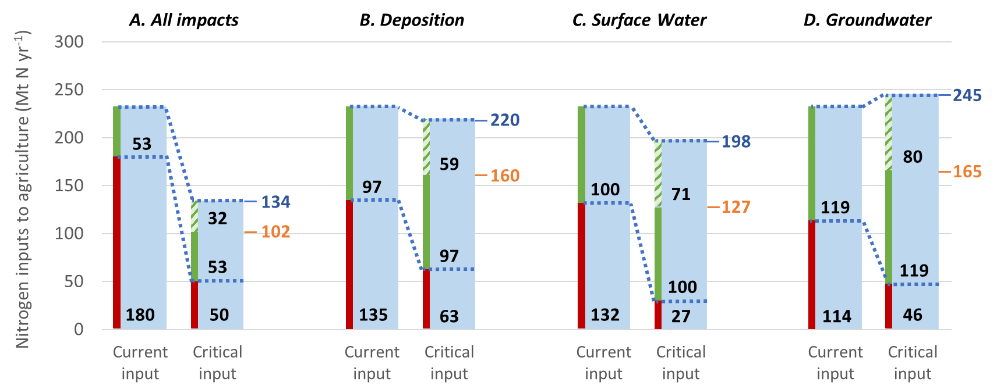
Supplementary Figure 1. Current (2010) and critical agricultural nitrogen (N) inputs for a, all thresholds, b, critical N deposition to limit terrestrial biodiversity loss, c, critical N load to surface water to limit eutrophication and d, critical N leaching to groundwater to meet drinking water standards. For each threshold, left-hand bars show current input split up into input on land where threshold is exceeded (red edges) / not exceeded (green edges), and right-hand bars show corresponding critical input. Striped green bars show allowable increase in N input on land where threshold is not exceeded. Numbers right of critical input bars indicate global N boundaries with (blue) and without (orange) allowing N input to increase where possible within thresholds. Values are in Mt N yr⁻¹. Corresponding results for N surplus are shown in Figure 1 (main text).

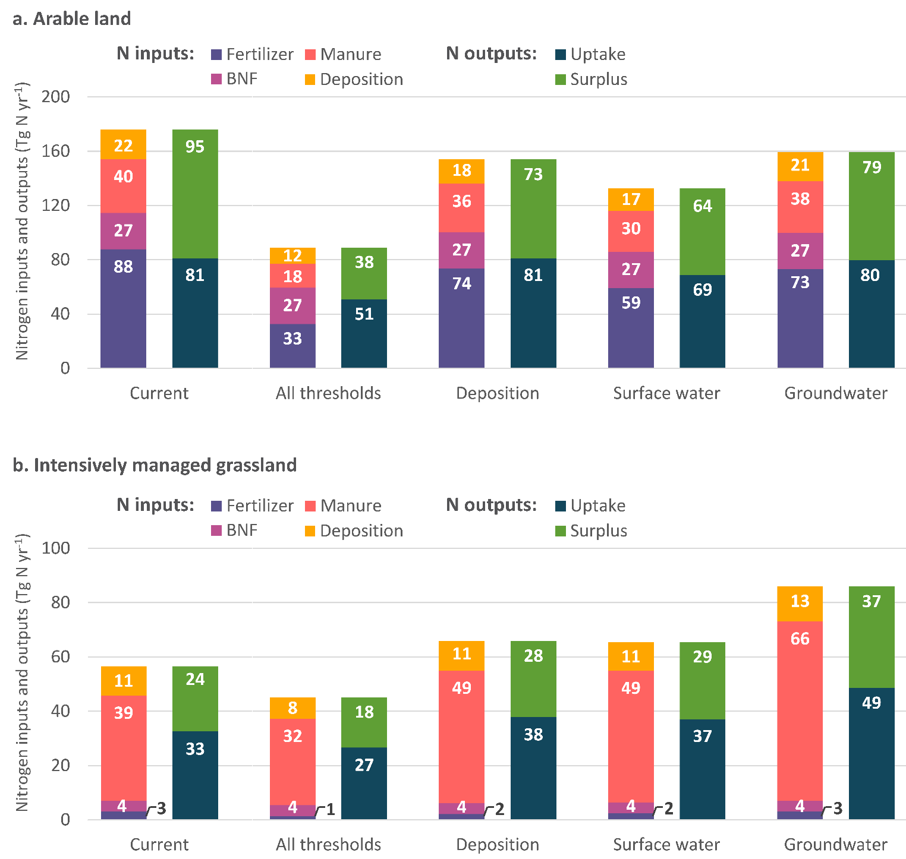
Supplementary Figure 2. Current & critical N inputs & outputs. Current (year 2010) global nitrogen (N) inputs (subdivided into fertilizer, BNF, manure and deposition) and N outputs (subdivided into N uptake and N surplus) and critical N inputs and outputs related to three thresholds (N deposition to limit terrestrial biodiversity loss, N load to surface water to limit eutrophication, and N leaching to groundwater to meet drinking water standards), and for all thresholds combined. Results shown for a, arable land and b, intensively managed grassland. Results for all agricultural land combined are shown in Extended Data Figure 1. To convert inputs and outputs in Mt N yr⁻¹ to average rates in kg N ha⁻¹ yr⁻¹, divide by 1.5 for arable land and by 0.8 for intensively managed grassland.

Arable land
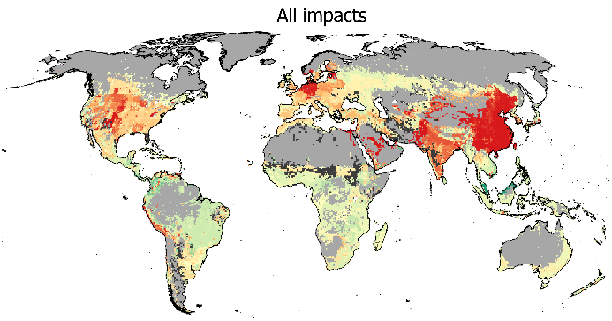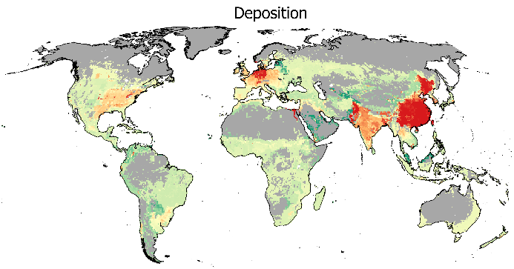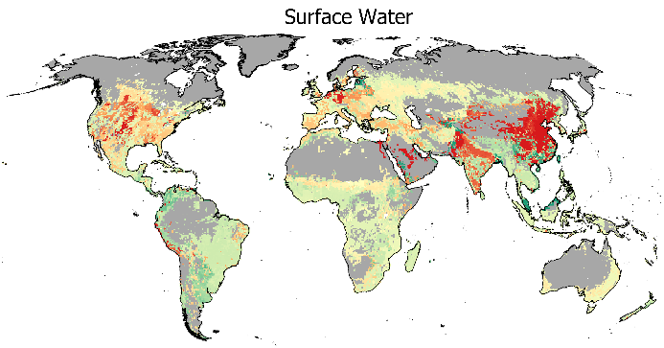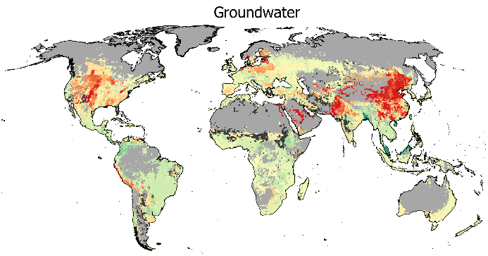
d
c
b
a
Intensively managed grassland
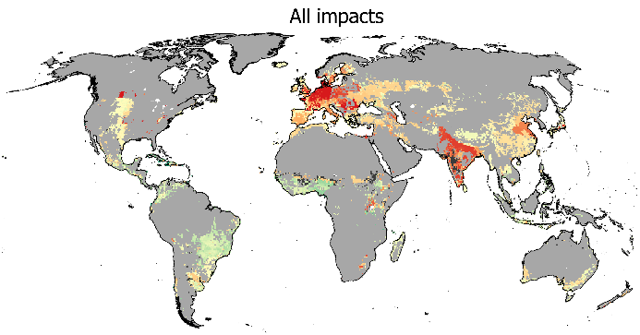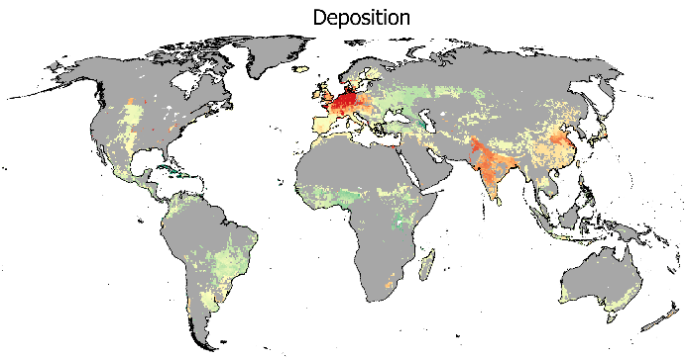
f
e
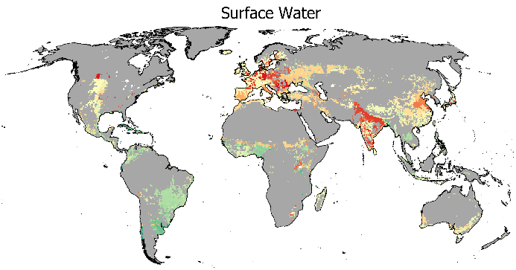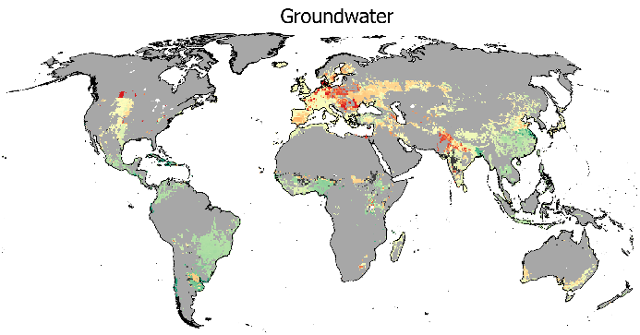
ha
g
Supplementary Figure 3. Spatial variation in the exceedance of critical agricultural nitrogen (N) surplus by current surplus on a-d, arable land and e-h, intensively managed grassland; related to a+e, all impacts combined, b+f, critical deposition to limit terrestrial biodiversity loss, c+g, critical N load to surface water to limit eutrophication, and d+h, critical N leaching to groundwater to meet drinking water standards. Positive values (red) indicate needed reductions, negative values (green) indicate possible increases within thresholds.
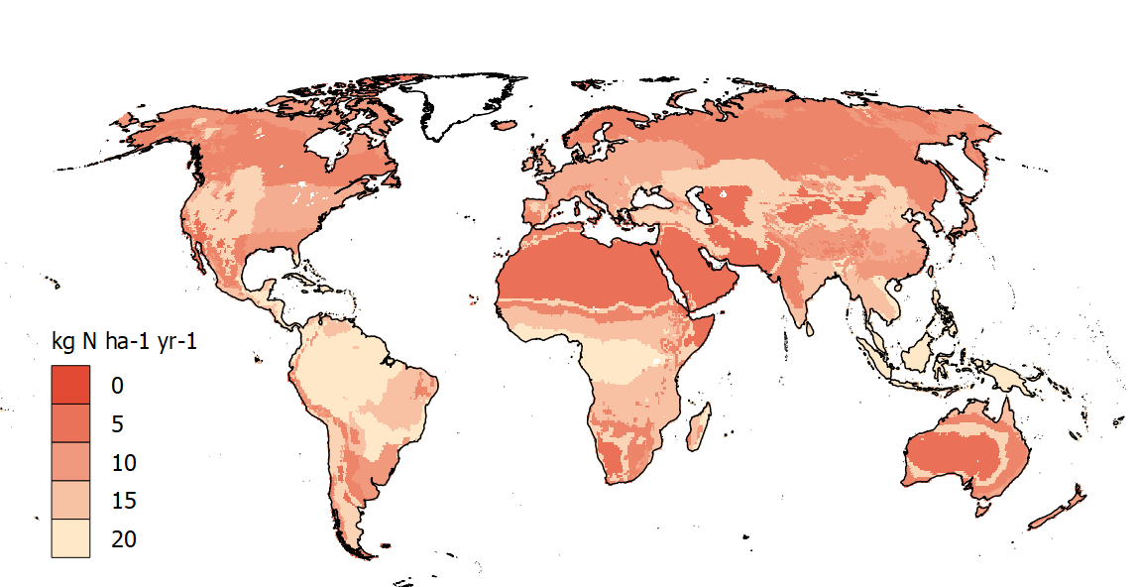
Supplementary Figure 4. Spatial variation in critical N deposition rates (kg N ha⁻¹ yr⁻¹) used in the assessment of critical N inputs to agriculture, based on thresholds presented in Supplementary Table 2 and biome distribution from the IMAGE model for the year 2010.

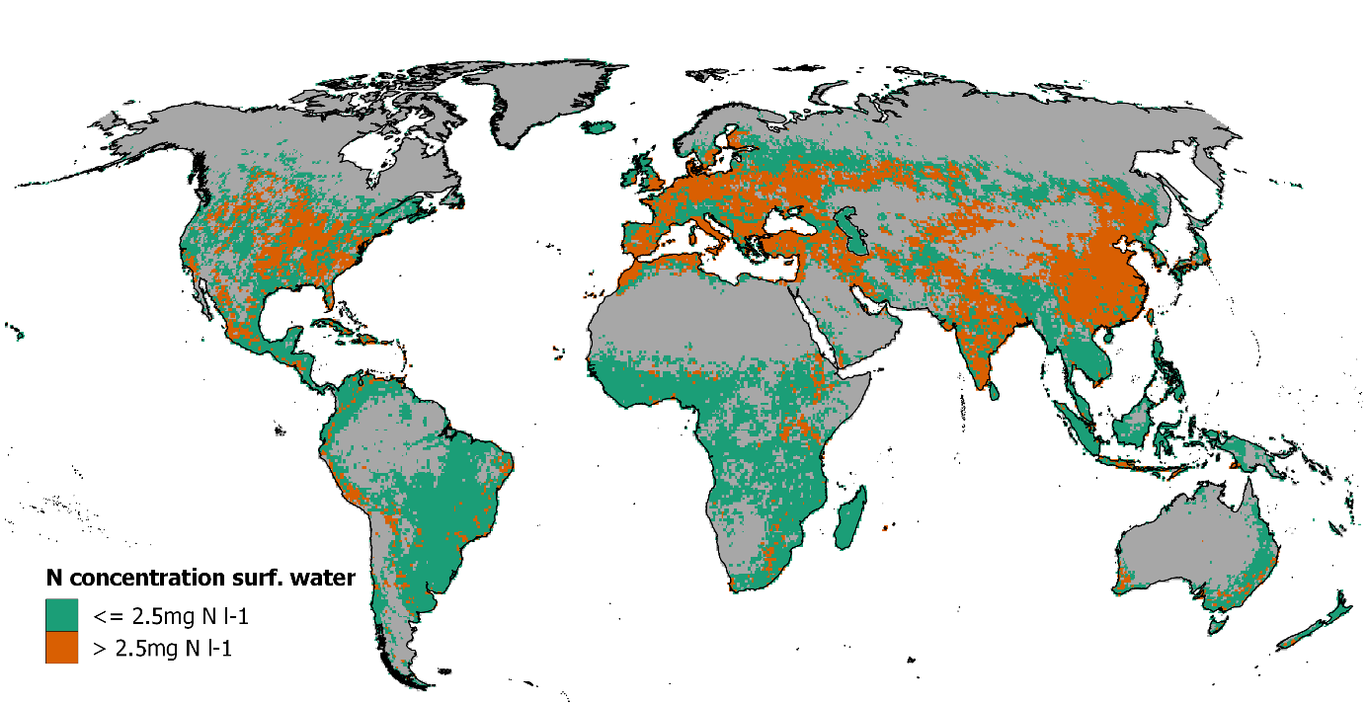
a
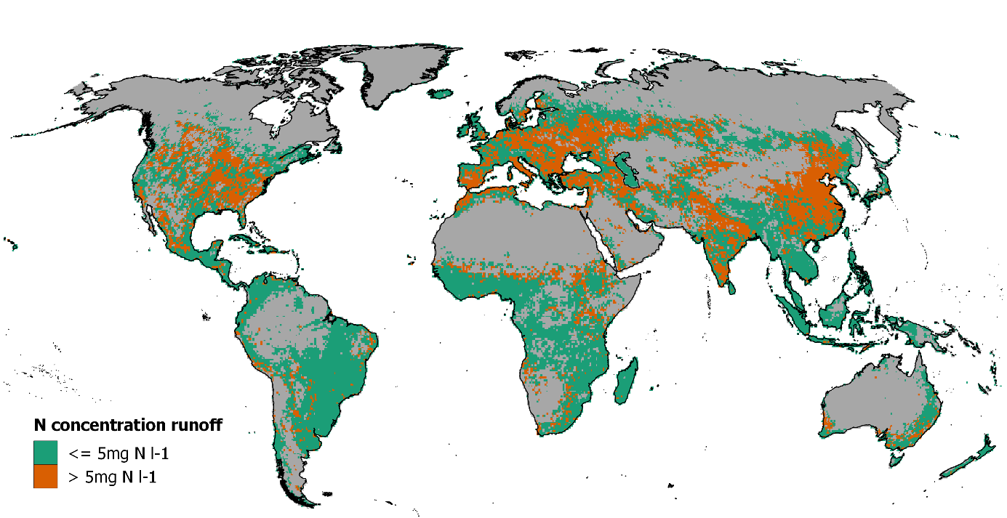
b
Supplementary Figure 5. a, Current (year 2010) N concentration in surface water as dynamically calculated by IMAGE- GNM, b, Current (year 2010) N concentration in runoff, calculated as total N load within a grid cell divided by total runoff. Grid cells with no agricultural land, as well as grid cells with no runoff are shown in grey.

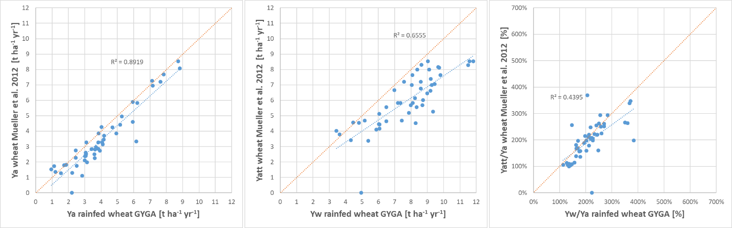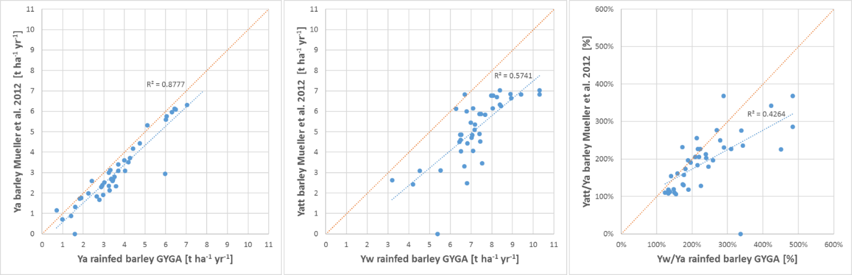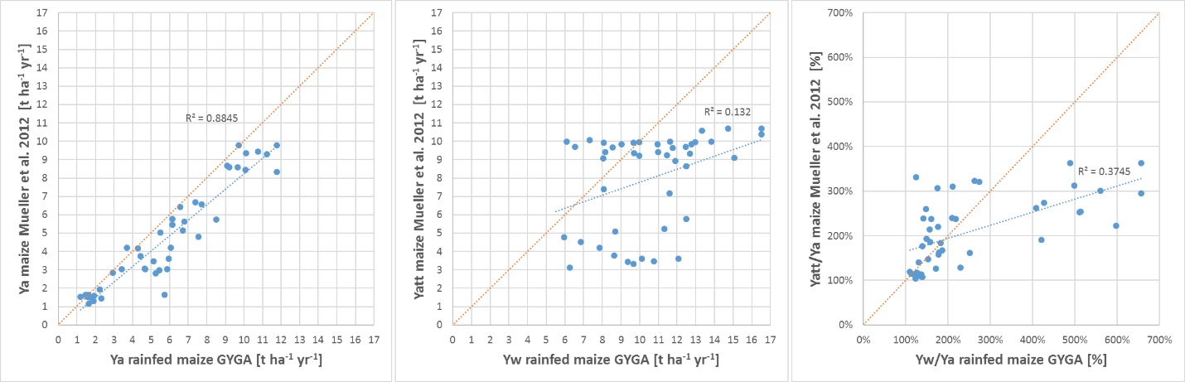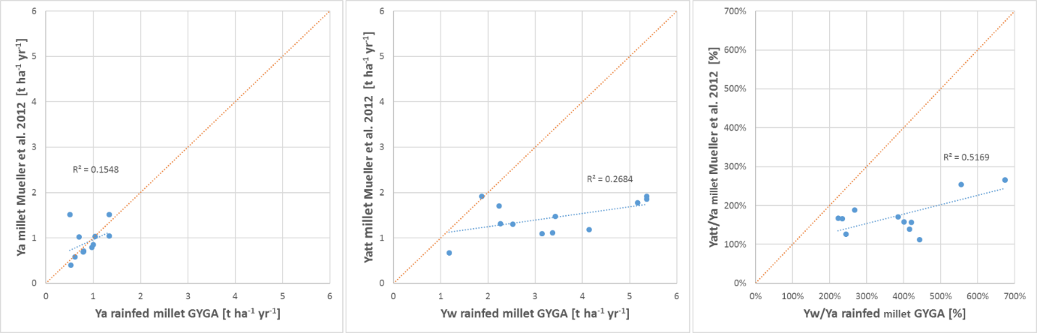
a
b
c
d
(Figure continues on next page)
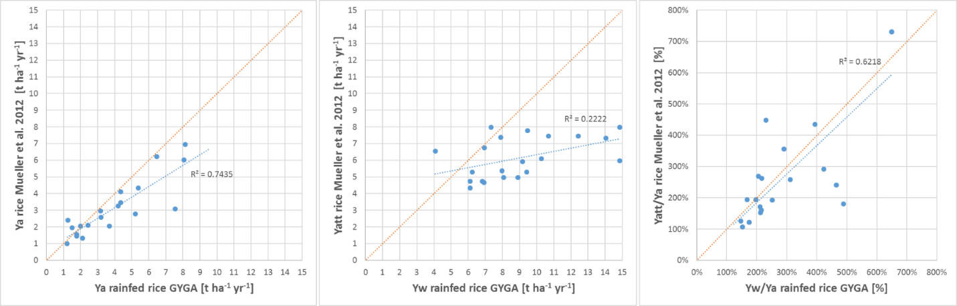
e
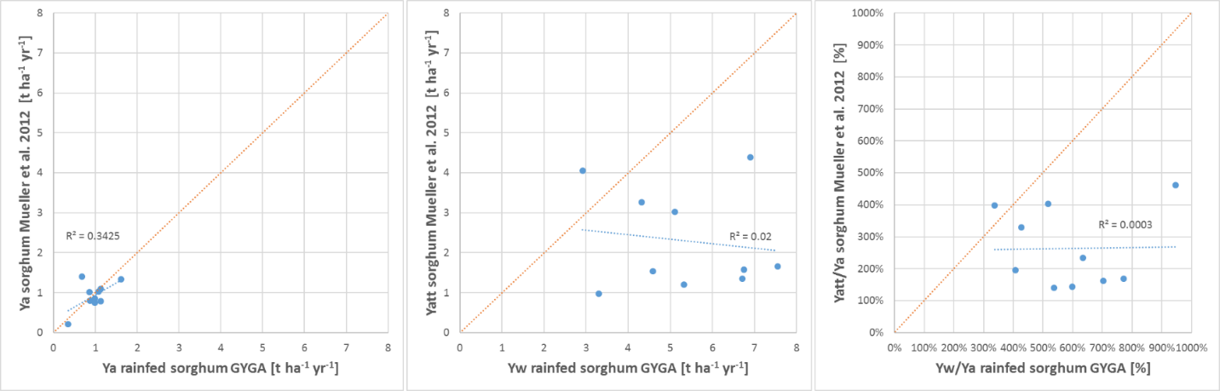
f
Supplementary Figure 6. Scatter plots showing the correlation between country-level estimates for actual yield (Ya) from ref.³⁵ and the Global Yield Gap Atlas (GYGA) (left), correlation between estimates for attainable yield (Yatt) from ref. ³⁵ and water-limited yield potentials (Yw) from GYGA (middle) and correlation between the estimated possible yield increase (ratio Yatt/Ya) from ref. ³⁵ and from GYGA (ratio Yw/Ya) for (A) wheat, (B) barley, (C) maize, (D) millet, (E) rice and (F) sorghum. Each dot is a country for which estimates of yield potentials are available from GYGA and in ref. ³⁵. Summary of R² values is shown in Supplementary Table 6.

Supplementary Tables
Supplementary Table 1. Current (year 2010) and critical total N inputs (all agricultural land) in view of thresholds for three environmental impacts, and for all impacts combined. Both current and critical N inputs are given as rates (kg N ha⁻¹ yr⁻¹) rather than totals, for easier comparison between regions with different agricultural areas. Percentages in brackets show relative difference between critical and current N input. Corresponding current & critical N surpluses are shown in Extended Data Table 2.
 | Agricultural N inputs (all agricultural land; kg N ha⁻¹ yr⁻¹)
IMAGE region | Current N inputs | Critical N inputs: Deposition |  | Critical N inputs: Surface Water |  | Critical N inputs: Groundwater |  | Critical N inputs: All impacts
Canada | 74 | 77 | (5%) | 36 | (-51%) | 38 | (-48%) | 31 | (-58%)
USA | 95 | 85 | (-11%) | 64 | (-33%) | 72 | (-25%) | 41 | (-56%)
Mexico | 69 | 103 | (49%) | 84 | (22%) | 113 | (64%) | 73 | (5%)
Central America | 85 | 144 | (70%) | 151 | (79%) | 168 | (99%) | 124 | (46%)
Brazil | 89 | 138 | (54%) | 165 | (85%) | 168 | (88%) | 131 | (47%)
Rest of South Am. | 92 | 129 | (40%) | 181 | (96%) | 163 | (77%) | 104 | (12%)
Northern Africa | 89 | 67 | (-25%) | 39 | (-56%) | 93 | (5%) | 23 | (-74%)
Western Africa | 39 | 87 | (124%) | 85 | (120%) | 87 | (125%) | 69 | (78%)
Eastern Africa | 59 | 98 | (66%) | 65 | (11%) | 88 | (49%) | 55 | (-7%)
South Africa | 66 | 74 | (13%) | 79 | (20%) | 90 | (38%) | 56 | (-15%)
Western Europe | 141 | 91 | (-35%) | 102 | (-28%) | 139 | (-1%) | 61 | (-57%)
Central Europe | 109 | 92 | (-15%) | 50 | (-54%) | 71 | (-34%) | 31 | (-72%)
Turkey | 80 | 131 | (63%) | 35 | (-56%) | 75 | (-7%) | 30 | (-62%)
Ukraine region | 63 | 112 | (76%) | 29 | (-54%) | 32 | (-49%) | 21 | (-67%)
Central Asia | 55 | 101 | (82%) | 31 | (-43%) | 34 | (-38%) | 18 | (-67%)
Russia region | 35 | 75 | (116%) | 31 | (-10%) | 36 | (5%) | 25 | (-27%)
Middle East | 84 | 96 | (15%) | 32 | (-62%) | 52 | (-38%) | 21 | (-75%)
India | 161 | 85 | (-47%) | 96 | (-41%) | 149 | (-7%) | 45 | (-72%)
Korea region | 140 | 106 | (-24%) | 105 | (-25%) | 141 | (1%) | 78 | (-44%)
China region | 152 | 73 | (-52%) | 61 | (-60%) | 112 | (-27%) | 31 | (-80%)
Southeastern Asia | 130 | 154 | (19%) | 186 | (44%) | 203 | (57%) | 146 | (12%)
Indonesia region | 116 | 143 | (23%) | 148 | (27%) | 152 | (31%) | 139 | (20%)
Japan | 236 | 247 | (4%) | 226 | (-4%) | 251 | (6%) | 205 | (-13%)
Oceania | 43 | 57 | (33%) | 44 | (1%) | 44 | (3%) | 37 | (-14%)
Rest of South Asia | 236 | 86 | (-64%) | 137 | (-42%) | 179 | (-24%) | 55 | (-77%)
Rest of Southern Afr. | 27 | 71 | (161%) | 63 | (130%) | 61 | (124%) | 56 | (106%)
World | 100 | 95 | (-5%) | 86 | (-15%) | 106 | (5%) | 58 | (-42%)
Note: Regional differences in critical agricultural N inputs are caused by differences in both (i) the acceptable N input from an environmental perspective and (ii) the cut-off value (maximum critical N input) in regions where the environmentally acceptable N input is higher than the cut-off value. The former is determined by properties of the agricultural system, sensitivity of the ecosystem, and N loading caused by non-agricultural sources; the latter is calculated as the current regional N input times the regional yield gap (see Methods and Supplementary Discussion).
Supplementary Table 2. Critical nitrogen (N) deposition thresholds per IMAGE biome used in the calculation of critical N inputs from critical deposition to limit terrestrial biodiversity loss, and source from which threshold was obtained. Note that the presented critical deposition thresholds reflect averages for broad biome categories, whereas certain sub-categories may have lower or higher critical N deposition thresholds.
IMAGE Biome | Critical N deposition threshold  [kg N ha⁻¹ yr⁻¹] | Source & explanation
Ice | n.a. | --
Tundra | 10.0 | Mean value of the range of 5–15 kg N ha⁻¹ yr⁻¹ for alpine tundra, alpine/ subalpine scrub, and grassland proposed by ref. ¹².
Wooded tundra | 10.0 | Same critical threshold as for ‘Tundra’.
Boreal forest | 7.5 | Mean value of the range of 5–10 kg N ha⁻¹ yr⁻¹ for boreal forests proposed by ref. ¹².
Cool coniferous forest | 7.5 | Same as for ‘boreal forest’
Temperate mixed forest | 12.5 | Mean value of the range of 10–15 kg N ha⁻¹ yr⁻¹ for temperate forests proposed by ref. ¹².
Temperate deciduous forest | 12.5 | Same critical threshold as for ‘temperate mixed forest’.
Warm mixed forest | 10.0 | Critical threshold assumed to be between the thresholds proposed by ref. ¹² for Mediterranean forest (3–10 kg N ha⁻¹ yr⁻¹) and temperate forests (10–15 kg N ha⁻¹ yr⁻⁻¹)
Tropical forest | 20.0 | The global assessment by Bobbink et al.¹² does not provide deposition thresholds for tropical ecosystems. However, critical thresholds will likely be higher than for temperate forests, as tropical forests (and savannahs) are mainly P limited. The value of 20 kg N ha⁻¹ yr⁻¹ is a rough estimate based on data presented by ref. ¹² as well as on Bouwman et al. (unpublished), who propose a threshold of 15–35 kg N ha⁻¹ yr⁻¹ for tropical forests and 13–26 kg N ha⁻¹ yr⁻¹ for tropical woodland.
Tropical woodland | 20.0 | Same critical threshold as for ‘tropical forest’.
Scrubland | 7.5 | Mean value of the range of 5–10 kg N ha⁻¹ yr⁻¹ for Mediterranean grasslands proposed by ref. ¹².
Grassland and steppe | 17.5 | Mean value of the range of 10–25 kg N ha⁻¹ yr⁻¹ for temperate heathlands proposed by ref. ¹².
Savanna | 15.0 | Based on Bouwman et al. (unpublished).
Hot desert | 5.0 | Critical threshold of 5 kg N ha⁻¹ yr⁻¹ for semidesert and desert proposed by ref. ¹².

Supplementary Table 3. List of all input datasets used in the calculation of critical N inputs (all datasets are outputs from the IMAGE model). Names in the first column are those used in the equations provided in the Supplementary Methods. The addition ‘ara’ refers to arable land, ‘igl’ refers to intensively managed grassland, ‘egl’ refers to extensively managed grassland and ‘nat’ refers to natural land.
Variable name | Description | Unit
a_tot, a_ara, a_igl, a_egl, a_nat | Area: total grid cell area (a_tot) and area of arable land, intensively managed grassland, extensively managed grassland and natural land | ha
Nfix_ara, Nfix_igl, Nfix_egl, Nfix_nat | N inputs from biological fixation on arable land, intensively managed grassland, extensively managed grassland and natural land | kg N yr⁻¹
Nfer_ara, Nfer_igl | N inputs from synthetic fertilizer on arable land and intensively managed grassland | kg N yr⁻¹
Nman_ara, Nman_igl, Nman_egl | N inputs form manure on arable land, intensively managed grassland and extensively managed grassland | kg N yr⁻¹
NH3,fer_ara, NH3,fer_igl | NH₃ emissions from fertilizer application on arable land and intensively managed grassland | kg N yr⁻¹
NH3,spr_ara, NH3,spr_igl, NH3,spr_egl | NH₃ emissions from manure spreading on arable land, intensively managed grassland and extensively managed grassland | kg N yr⁻¹
NH3,graz_igl, NH3,graz_egl | NH₃ emissions from manure deposited during grazing for intensively and extensively managed grassland | kg N yr⁻¹
NH3,stor | NH₃ emissions from manure storage | kg N yr⁻¹
Ndep | Total N Deposition | kg N yr⁻¹
Nup_ara, Nup_igl, Nup_egl | Crop N uptake | kg N yr⁻¹
Nsro_ag, Nsro_nat | N surface runoff on agricultural and natural soils | kg N yr⁻¹
Nle_ag, Nle_nat | N leaching from agricultural and natural soils | kg N yr⁻¹
Ngw_ag, Ngw_nat | N delivery to surface water via sub-surface runoff from agricultural and natural soils | kg N yr⁻¹
Nero_ag, Nero_nat | N inputs from soil erosion on agricultural and natural soils | kg N yr⁻¹
Nallo | Direct N input to surface water from allochthonous organic matter | kg N yr⁻¹
Ndep,sw | Direct N input to surface water from deposition on water bodies | kg N yr⁻¹
Nww | Direct N input to surface water from wastewater | kg N yr⁻¹
Naqua | Direct N input to surface water from aquaculture | kg N yr⁻¹
qtot | Total runoff (precipitation surplus), i.e. precipitation minus evapotranspiration | Litres
Biome | identifying each grid cell as belonging to one of 14 global biomes | -
fgw,rec_ag, fgw_rec,nat | Fraction of N delivered to surface water via groundwater (Ngw) that is affected by recent inputs for agricultural and natural soils. | -

Supplementary Table 4. Variable names, equations and units for intermediate variables in the calculation of critical N inputs. Variables used in the equations are either IMAGE input datasets listed in Supplementary Table 3 (regular font), or from this table (italic font, number in superscript denotes the row number where equation for the respective variable can be found). Note that ‘ag’ in equations 1–30 refers generically to agricultural land, while the variable names given here are specified for either arable land (‘ara’) or intensively managed grassland (‘igl’).
Nr | Variable name | Equation | Unit
Land use fractions
1 | f_ara | = a_ara / a_tot | -
2 | f_igl | = a_igl / a_tot | -
3 | f_egl | = a_egl / a_tot | -
4 | f_nat | = a_nat / a_tot | -
Total NH₃ emissions
5 | NH3,tot | = NH3,fer_ara + NH3,fer_igl + NH3,spr_ara + NH3,spr_igl + NH3,spr_egl + NH3,graz_igl +, NH3,graz_egl + NH3,stor | kg N yr⁻¹
Corrected N deposition
6 | Ndep,corr | = MAX(Ndep, NH3,tot⁽⁵⁾) | kg N yr⁻¹
NO_{x} emissions
7 | NOx | = Ndep,corr⁽⁶⁾ - NH3,tot⁽⁵⁾ | kg N y⁻¹
Allocation of NH3 emissions from storage to different land use types
8 | NH3,stor_ara | = Nman_ara / (Nman_ara + Nman_igl + Nman_egl) * NH3,stor | kg N yr⁻¹
9 | NH3,stor_igl | = Nman_igl / (Nman_ara + Nman_igl + Nman_egl) * NH3,stor | kg N yr⁻¹
10 | NH3,stor_egl | = Nman_egl / (Nman_ara + Nman_igl + Nman_egl) * NH3,stor | kg N yr⁻¹
NH3 emission fractions for inputs from fertilizer (fer) and manure (man)
11 | fNH3,fer_ara | = NH3_fer_ara / Nfer_ara | -
12 | fNH3,fer_igl | = NH3_fer_igl / Nfer_igl | -
13 | fNH3,man_ara | = (NH3,spr_ara + NH3,stor_ara⁽⁸⁾) / Nman_ara | -
14 | fNH3,man_igl | = (NH3,spr_igl + NH3,stor_igl⁽⁹⁾ + NH3,graz_igl) / Nman_igl | -
N deposition per land use type
15 | Ndep_ara | = Ndep,corr⁽⁶⁾ * f_ara⁽¹⁾ | kg N yr⁻¹
16 | Ndep_igl | = Ndep,corr⁽⁶⁾ * f_igl⁽²⁾ | kg N yr⁻¹
17 | Ndep_egl | = Ndep,corr⁽⁶⁾ * f_egl⁽³⁾ | kg N yr⁻¹
18 | Ndep_nat | = Ndep,corr⁽⁶⁾ * f_nat⁽⁴⁾ | kg N yr⁻¹
Total N inputs
19 | Nin_ara | = Nfer_ara + Nman_ara + Nfix_ara + Ndep_ara⁽¹⁵⁾ | kg N yr⁻¹
20 | Nin_igl | = Nfer_igl + Nman_igl + Nfix_igl + Ndep_igl⁽¹⁶⁾ | kg N yr⁻¹
21 | Nin_egl | = Nman_egl + Nfix_egl + Ndep_egl⁽¹⁷⁾ | kg N yr⁻¹
22 | Nin_nat | = Nfix_nat + Ndep_nat⁽¹⁸⁾ | kg N yr⁻¹
23 | Nin_ag | = Nin_ara⁽¹⁹⁾ + Nin_igl⁽²⁰⁾ + Nin_egl⁽²¹⁾ | kg N yr⁻¹
Surface runoff fraction for agricultural and natural land
24 | fsro_ag | = Nsro_ag / Nin_ag⁽²³⁾ | -
25 | fsro_nat | = Nsro_nat / Nin_nat⁽²²⁾ | -
Leaching fraction for agricultural and natural land
26 | fle_ag | = Nle_ag / (Nin_ag⁽²³⁾ – Nup_ag – Nsro_ag) | -
27 | fle_nat | = Nle_nat / (Nin_nat⁽²⁰⁾ – Nsro_nat) | -
N uptake fraction
28 | fNup_ara | Nup_ara / (Nin_ara⁽¹⁹⁾ – Nin_ara⁽¹⁹⁾ * fsro_ag⁽²⁴⁾) | -
29 | fNup_igl | Nup_igl / (Nin,igl⁽²⁰⁾ – Nin_igl⁽²⁰⁾ * fsro_ag⁽²⁴⁾) | -
Fraction of N fertilizer N inputs in total inputs from manure + fertilizer
30 | fNfer_ara | = Nfer_ara / (Nfer_ara + Nman_ara) | -
31 | fNfer_igl | = Nfer_igl / (Nfer_igl + Nman_igl) | -
Share of N groundwater load that is affected by recent inputs
32 | Ngw,rec_ag | = Ngw_ag * fgw,rec_ag | kg N yr⁻¹
33 | Ngw,rec_nat | = Ngw_nat * fgw,rec_nat | kg N yr⁻¹
Share of N groundwater load that is not affected by recent inputs (‘legacy groundwater N’)
34 | Ngw,fixed_ag | = Ngw_ag * (1 - fgw,rec_ag) | kg N y⁻¹
35 | Ngw,fixed_nat | = Ngw_nat * (1 - fgw,rec_nat) | kg N y⁻¹
Fraction of recent groundwater N load to leaching
36 | fgw,rec,le_ag | = Ngw,rec_ag⁽³²⁾ / Nle_ag | -
37 | fgw,rec,le_nat | = Ngw,rec_nat⁽³³⁾ / Nle_nat | -

Supplementary Table 5. Average actual crop yields (Ya), average yield potentials (Yp), ratio Yp/Ya and the maximum N uptake used to cap critical N inputs for both arable land (left) and intensively managed grassland (right), per IMAGE region. For arable land, values for Ya and Yp represent area-weighted averages over 17 different crops, and thus differences between regions reflect both variations in agricultural performance as well as in crop mix.
 | Arable Land |  |  |  | Intensively Managed Grassland
 | Actual yield (Ya)⁽¹⁾ | Yield potential (Yp)⁽²⁾ | Ratio Yp/Ya | Maximum N uptake (Nup,max)⁽³⁾ | Actual yield (Ya)⁽⁴⁾ | Yield potential (Yp)⁽⁵⁾ | Ratio Yp/Ya | Maximum N uptake (Nup,max)⁽⁶⁾
IMAGE Region | t ha⁻¹ yr⁻¹ | t ha⁻¹ yr⁻¹ | - | kg N ha⁻¹ yr⁻¹ | kg N ha⁻¹ yr⁻¹ | kg N ha⁻¹ yr⁻¹ | - | kg N ha⁻¹ yr⁻¹
Canada | 2.6 | 3.4 | 1.27 | 41.4 | 118.6 | 73.1 | 0.62 | 118.6
USA | 5.2 | 6.5 | 1.25 | 97.6 | 19.5 | 45.6 | 2.34 | 45.6
Mexico | 6.8 | 10.7 | 1.57 | 58.8 | 31.6 | 77.9 | 2.47 | 77.9
Central America | 19.2 | 34.5 | 1.80 | 59.7 | 51.4 | 120.4 | 2.34 | 120.4
Brazil | 12.8 | 17.2 | 1.34 | 133.4 | 34.5 | 85.8 | 2.49 | 85.8
Rest of S. Amer. | 4.9 | 7.5 | 1.53 | 150.6 | 33.4 | 95.4 | 2.86 | 95.4
Northern Africa | 1.7 | 4.6 | 2.71 | 125.6 | 29.7 | 40.5 | 1.37 | 40.5
Western Africa | 2.3 | 5.3 | 2.36 | 54.3 | 32.9 | 86.8 | 2.64 | 86.8
Eastern Africa | 2.1 | 5.2 | 2.42 | 44.6 | 42.9 | 77.8 | 1.81 | 77.8
South Africa | 6.4 | 11.8 | 1.85 | 50.2 | 81.3 | 76.1 | 0.94 | 81.3
Western Europe | 8.3 | 9.8 | 1.18 | 101.7 | 99.0 | 102.8 | 1.04 | 102.8
Central Europe | 4.8 | 9.5 | 1.98 | 108.5 | 86.5 | 113.3 | 1.31 | 113.3
Turkey | 3.6 | 6.4 | 1.80 | 72.8 | 33.2 | 66.1 | 1.99 | 66.1
Ukraine region | 3.8 | 10.0 | 2.63 | 85.0 | 55.6 | 91.1 | 1.64 | 91.1
Central Asia | 1.3 | 3.9 | 2.93 | 65.7 | 23.7 | 35.6 | 1.50 | 35.6
Russia region | 2.6 | 6.3 | 2.39 | 41.5 | 36.9 | 83.6 | 2.26 | 83.6
Middle East | 2.7 | 5.8 | 2.17 | 77.8 | 41.0 | 29.1 | 0.71 | 41.0
India | 4.3 | 6.5 | 1.51 | 71.1 | 46.0 | 28.2 | 0.61 | 46.0
Korea region | 6.3 | 7.4 | 1.18 | 64.5 | 89.5 | 109.8 | 1.23 | 109.8
China region | 5.4 | 8.1 | 1.50 | 128.9 | 37.0 | 67.5 | 1.83 | 67.5
Southeast Asia | 7.0 | 10.4 | 1.48 | 109.3 | 70.3 | 101.3 | 1.44 | 101.3
Indonesia region | 7.4 | 9.4 | 1.27 | 86.1 | 58.2 | 86.4 | 1.49 | 86.4
Japan | 8.0 | 9.4 | 1.18 | 85.2 | 150.7 | 115.6 | 0.77 | 150.7
Oceania | 4.0 | 5.9 | 1.49 | 27.7 | 38.0 | 50.3 | 1.32 | 50.3
Rest of S. Asia | 4.4 | 8.2 | 1.87 | 88.9 | 59.9 | 94.2 | 1.57 | 94.2
Rest of S. Africa | 2.9 | 7.3 | 2.55 | 38.0 | 24.4 | 97.5 | 3.99 | 97.5
World | 5.0 | 7.9 | 1.56 | 83.0 | 39.8 | 73.9 | 1.86 | 73.9
⁽¹⁾ Average crop yield (year 2000) from ref. ³⁵.
⁽²⁾ Average crop yield at 100% of attainable yield from ref. ³⁵.
⁽³⁾ Calculated as the mean N uptake for arable land per region from the IMAGE model for the year 2010, multiplied by the ratio Yp/Ya.
⁽⁴⁾ Area-weighted mean N uptake for intensively managed grassland per IMAGE region from the IMAGE model for the year 2010.
⁽⁵⁾ Calculated as the area-weighted mean maximum Livestock Density per IMAGE region, obtained from ref.⁶², multiplied with a conversion factor of 73 kg N LSU⁻¹ yr⁻¹. The conversion factor is estimated by assuming a feed demand of 4 kg C LSU⁻¹ d⁻¹ ⁶² and a C:N ratio in the aboveground-part of grass of 20:1 (4*365/20=73).
⁽⁶⁾ Calculated as the maximum of Ya and Ya*(Yp/Ya).
Supplementary Table 6. Comparison between estimates of actual yields, yield potentials and the ratio yield potential/actual yield from the Global Yield Gap Atlas and Mueller et al.³⁵ for six crops. R² values shown are for a liner fit which is not necessarily x=y, so high values can also occur if estimates from one source are consistently lower or higher. Scatter plots are shown in Supplementary Fig. 6.
Crop | Number of countries in comparison | r² value for actual yields (Ya) | r² value for yield potentials (Yp) | r² value for ratio Yp/Ya
Wheat | 47 | 0.89 | 0.66 | 0.44
Barley | 39 | 0.88 | 0.57 | 0.43
Maize | 43 | 0.88 | 0.13 | 0.37
Millet | 11 | 0.15 | 0.27 | 0.52
Rice | 20 | 0.74 | 0.22 | 0.62
Sorghum | 10 | 0.34 | 0.02 | 0.003

